Annex 1 - Summary of the bias risk of the studies with their respective result in each item of the evaluation.
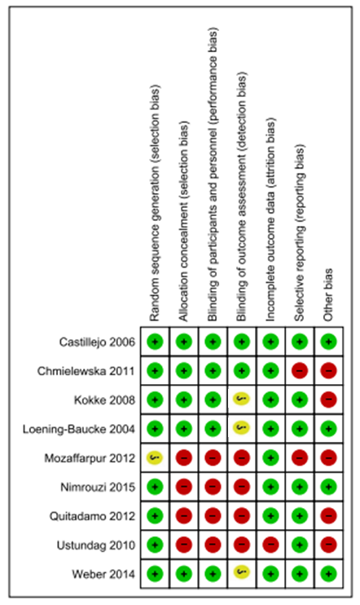
- = low risk of bias; = high risk of bias; = undetermined risk of bias.

