Supplementary Figures

Supplementary Figure 1 - Schematic overview of procedure steps for each case included in the study.

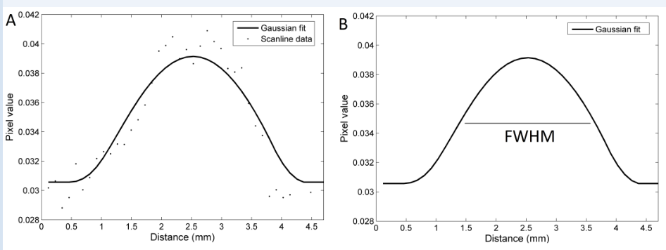

Supplementary Figure 2 - A, one-dimensional scanline profile of the line that is drawn in the bowel loop (dots) fitted by a Gaussian function (line); B, full-width at half-maximum (FWHM) measurement calculated over the Gaussian fit. This distance in millimeters is inferred from the pixel dimension available in DICOM information.

* p < 0.05, significant differences between groups (paired Mann-Whitney U test).

Supplementary Figure 3 - Quantitative analysis of comparisons between the full-width at half-maximum (FWHM) measurements of distended and normal loops in the bowel wall thickening (BWT) group (median = 10.30 and 15.13, respectively). Each box shows the lower and upper boundaries of the box, indicating the 25th and 75th percentiles. The solid horizontal line in the box indicates the median. The whiskers above and below the box represent the standard deviation.

* p < 0.05, significant differences between groups (paired Mann-Whitney U test).

Supplementary Figure 4 - Quantitative comparisons of wavelet energy measurements of normal and pneumatosis loops in the intestinal pneumatosis (IP) group. Each box shows the lower and upper boundaries of the box, indicating the 25th and 75th percentiles. The solid horizontal line in the box indicates the median. The whiskers above and below the box represent the standard deviation.

