JPED-D-20-00137 Supplementary material

Figure S1 - ROC curve for predicting significant hyperbilirubinemia using t
he uCB.
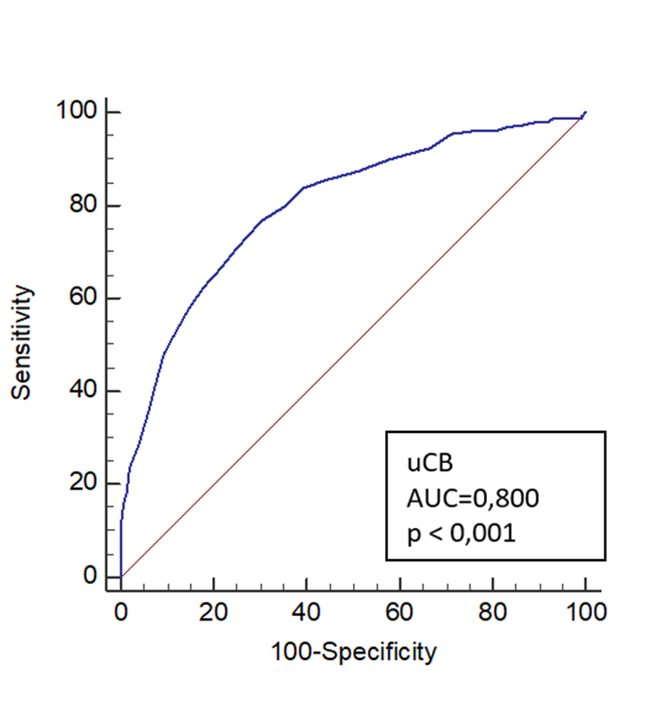
uCB, umbilical cord bilirubin; AUC, area under the curve.

