JPED-D-20-00216 – Supplementary Material

Supplementary Material 1 - Ultrasonographic assessment of left internal jugular vein performed during the abdominal compression maneuver. A progressive increase in the cross-sectional area occurs as abdominal pressure increases.
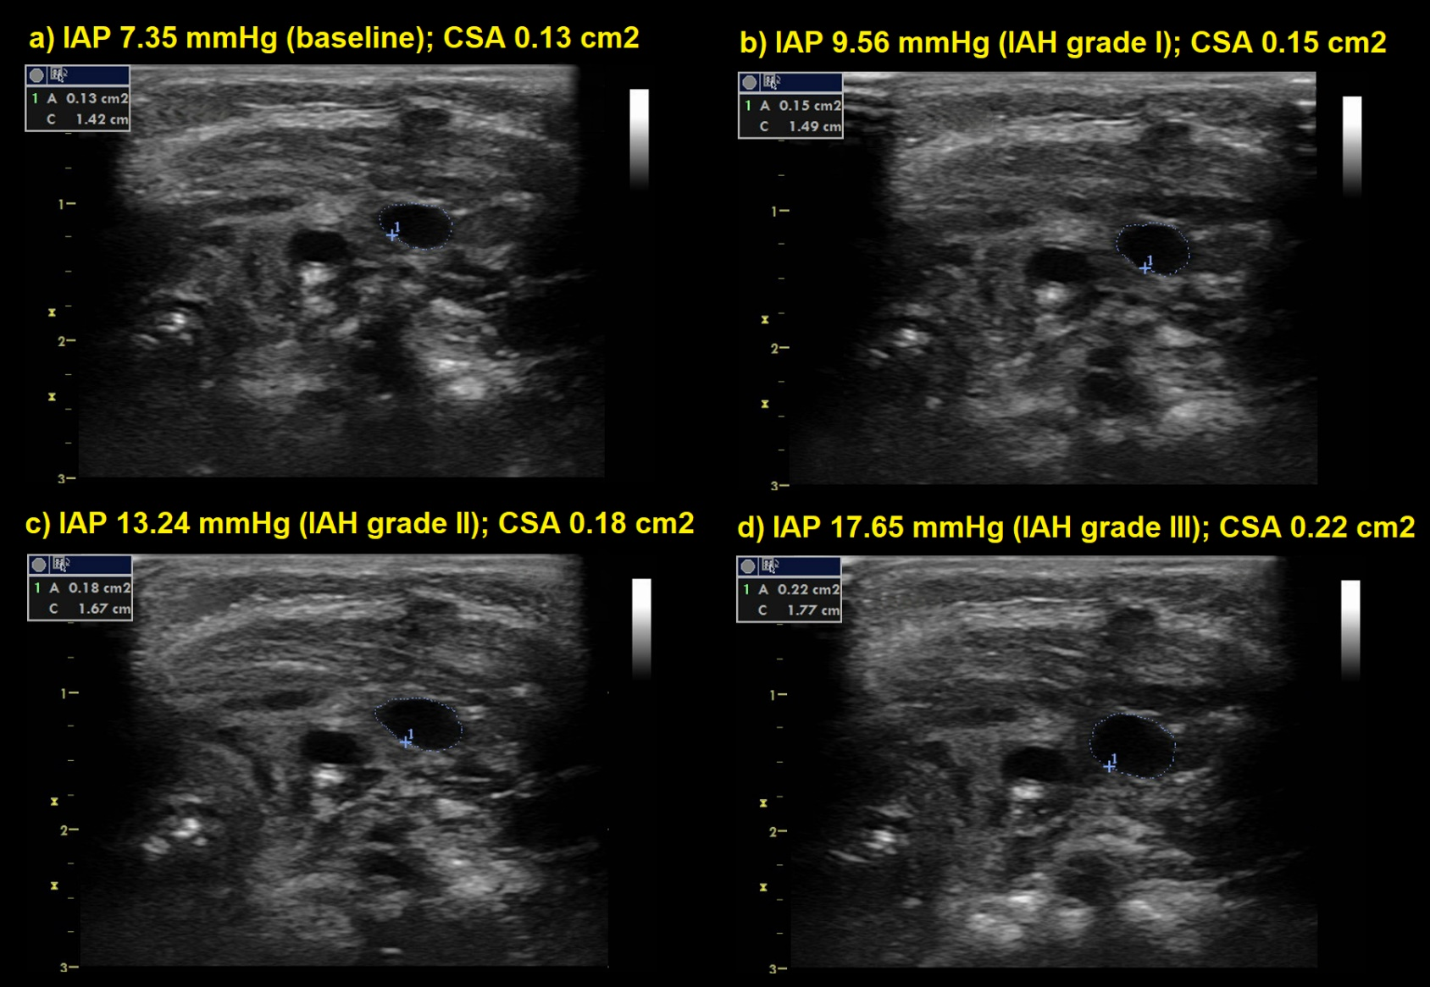
IAP, intra-abdominal pressure; IAH, intra-abdominal hypertension; CSA, cross-sectional area.

Supplementary Material 2 - Main studies that have evaluated the influence of intra-abdominal pressure on cardiac index.
Study | n | Ageª | IAP (mmHg) | Hemodynamic changes
Sakka et al.²⁴ | 8 | 3.5 ± 1.3 years | 12 | 13% reduction in CI
Kardos et al.²⁵ | 30 | 13 ±2.3 years | 12-13 | 25% reduction in CI
Gueugniaud et al.²⁶ | 12 | 23 ± 5 months | 10 | 33% reduction in SVI
De Waal et al.²¹ | 13 | 20 ± 9 months | 5 | 22% increase in CI
IPA, intra-abdominal pressure; CI, cardiac index; SVI, stroke volume index.
ª Data expressed as mean and standard deviation.

