JPED-D-21-00282 – Supplementary Material

Supplementary Table 1 - Baseline characteristics of the enrolled PPHN patients (n = 45).
Characteristic | Total  (n = 45)
Gestational age (weeks) | 39.0 ± 1.9
Birth weight (g) | 3,035 ± 470
Male | 30 (66.7)
Age  PPHN subjects from retrospective data (years) (n = 20)  PPHN subjects from prospective recruitment (days) (n = 25) | 2.3 (1.0-3.5)  2 (1-4)
Perinatal history  APGAR Score at 1 minute (IQR)  APGAR Score at 5 minutes (IQR) | 8 (7-9)  9 (8-9)
Causes of PPHN, n (%)  Meconium aspiration syndrome  Transient tachypnea of the newborn  Congenital pneumonia  Respiratory distress syndrome  Neonatal sepsis  Idiopathic PPHN  Birth asphyxia | 20 (44.4)  10 (22.2)  6 (13.3)  5 (11.1)  2 (4.4)  1 (2.2)  1 (2.2)
Treatment modalities of PPHN, n (%)  High-frequency oscillatory ventilation  Intravenous iloprost  Intragastric sildenafil  Inhaled nitric oxide  Intravenous milrinone  Hydrocortisone  Sedation  Analgesia  Inotropic agents | 31 (68.9)  14 (31.1)  36 (80.0)  41 (91.1)  23 (51.1)  20 (44.4)  45 (100)  45 (100)  45 (100)
Outcomes  Length of supplemental oxygenation (days) (IQR)  Length of stay (days) (IQR)  In-hospital mortality, n (%) | 22 (15-30)  22 (15-34)  2 (4.4)
PPHN, persistent pulmonary hypertension of the newborn; IQR, interquartile range.

Supplementary Table 2 - Genotype and allele distribution of significant SNPs in 6 candidate genes (p-value < 0.05) observed in 45 PPHN patients and 294 control subjects.
Gene | SNPs ID | Genotypes | Genotype frequency (%) |  | OR  (95% CI)  (Model) | Allele | Allele frequency (%) |  | OR  (95% CI) | p-value
 |  |  | Patient | Control |  |  | Patient | Control
BMPR2 | rs79171078  (A>G) | AA | 42 (93) | 287 (98) | 1.00  4.10 (0.95-17.79)  (dominant) | A | 87 (97) | 579 (99) | 1.00  3.99 (0.94-17.01) | 0.0782
 |  | AG/GG | 3 (7) | 5 (2) |  | G | 3 (3) | 5 (1)
EPAS1 | rs17034984  (C>T) | CC | 36 (80) | 280 (96) | 1.00  5.38 (2.15-13.49)  (dominant) | C | 81 (90) | 573 (98) | 1.00  4.89 (2.03-11.82) | 0.001
 |  | TC/TT | 9 (20) | 13 (4) |  | T | 9 (10) | 13 (2)
 | rs77238140  (G>A) | GG | 40 (89) | 286 (97) | 1.00  4.47 (1.39-14.33)  (dominant) | G | 85 (94) | 580 (99) | 1.00  4.26 (1.36-13.34) | 0.0199
 |  | GA/AA | 5 (11) | 8 (3) |  | A | 5 (6) | 8 (1)
 | rs2121267  (T>C) | TT | 39 (87) | 191 (65) | 1.00  3.51 (1.44-8.56)  (dominant) | T | 83 (92) | 477 (81) | 1.00  2.76 (1.24-6.13) | 0.0072
 |  | TC/CC | 6 (13) | 103 (35) |  | C | 7 (8) | 113 (19)
 | rs6726454  (A>G) | AA/AG | 5 (11) | 81 (28) | 1.00  3.04 (1.16-7.98)  (recessive) | A | 5 (6) | 86 (15) | 1.00  2.91 (1.15-7.39) | 0.019
 |  | GG | 40 (89) | 213 (72) |  | G | 85 (94) | 502 (85)
 | rs4953344  (T>C) | TT | 32 (71) | 252 (86) | 1.00  2.44 (1.18-5.02)  (dominant) | T | 77 (86) | 544 (93) | 1.00  2.09 (1.08-4.05) | 0.0389
 |  | TC/CC | 13 (29) | 42 (14) |  | C | 13 (14) | 44 (7)
 | rs2346176  (T>C) | TT/TC | 18 (40) | 154 (52) | 1.00  1.65 (0.87-3.13)  (recessive) | T | 18 (20) | 181 (31) | 1.00  1.78 (1.03-3.07) | 0.0461
 |  | CC | 27 (60) | 140 (48) |  | C | 72 (80) | 407 (69)
 | rs1374749  (G>A) | GG/AG | 16 (36) | 168 (57) | 1.00  2.42 (1.26-4.64)  (recessive) | G | 20 (22) | 194 (33) | 1.00  1.74 (1.03-2.94) | 0.039
 |  | AA | 29 (64) | 126 (43) |  | A | 70 (78) | 393 (67)
 | rs1868089  (C>T) | CC/TC | 7 (16) | 87 (30) | 1.00  2.28 (0.98-5.31)  (recessive) | C | 7 (8) | 92 (16) | 1.00  2.20 (0.99-4.91) | 0.0538
 |  | TT | 38 (84) | 207 (70) |  | T | 83 (92) | 496 (84)
 | rs6758592  (T>C) | TT/TC | 20 (44) | 184 (63) | 1.00  2.09 (1.11-3.94)  (recessive) | T | 25 (28) | 236 (40) | 1.00  1.74 (1.07-2.85) | 0.027
 |  | CC | 25 (56) | 110 (37) |  | C | 65 (92) | 352 (60)
 | rs4953345  (T>A) | TT | 38 (84) | 208 (71) | 1.00  2.19 (0.94-5.10)  (dominant) | T | 83 (92) | 495 (84) | 1.00  2.13 (0.95-4.76) | 0.0733
 |  | TA/AA | 7 (16) | 84 (29) |  | A | 7 (8) | 89 (15)
PDE-3A | rs10770682  (G>A) | GG | 17 (38) | 164 (56) | 1.00  2.11 (1.11-4.02)  (dominant) | G | 56 (62) | 435 (74) | 1.00  1.77 (1.11-2.82) | 0.0213
 |  | AG/AA | 28 (62) | 128 (44) |  | A | 34 (38) | 149 (26)
 | rs57238599  (A>G) | AA | 34 (76) | 263 (89) | 1.00  2.74 (1.26-5.96)  (dominant) | A | 79 (88) | 555 (94) | 1.00  2.34 (1.14-4.82) | 0.0345
 |  | AG/GG | 11 (24) | 31 (11) |  | G | 11 (12) | 33 (6)
 | rs6487091  (A>G) | AA/AG | 5 (11) | 73 (25) | 1.00  2.64 (1.01-6.95)  (recessive) | A | 5 (6) | 75 (13) | 1.00  2.49 (0.98-6.32) | 0.0529
 |  | GG | 40 (89) | 221 (75) |  | G | 85 (94) | 513 (87)
VEGFA | rs3025012  (A>G) | AA/AG | 41 (91) | 286 (97) | 1.00  3.49 (1.01-12.01)  (recessive) | A | 64 (71) | 481 (82) | 1.00  1.83 (1.11-3.02) | 0.0222
 |  | GG | 4 (9) | 8 (3) |  | G | 26 (29) | 107 (18)
ENG | rs34116890  (A>G) | AA | 43 (96) | 240 (82) | 1.00  4.84 (1.14-20.59)  (dominant) | A | 88 (98) | 533 (91) | 1.00  4.54 (1.09-18.95) | 0.0228
 |  | AG/GG | 2 (4) | 54 (18) |  | G | 2 (2) | 55 (9)
NOTCH3 | rs10404382  (C>A) | CC | 3 (7) | 5 (2) | 1.00  4.13 (0.95-17.91)  (dominant) | C | 20 (22) | 82 (14) | 1.00  1.76 (1.02-3.05) | 0.0559
 |  | CA/CC | 42 (93) | 289 (98) |  | A | 70 (78) | 506 (86)

Supplementary Figure 1 - Gene network of 11 candidate genes from the present study and other genes that had been shown to be associated with PPHN. A, Full network. The edges indicate both functional and physical protein associations; B, Physical subnetwork. The edges indicate that the proteins are part of a physical complex. Potential protein-protein interaction network was done using STRING (http://string-db.org/).
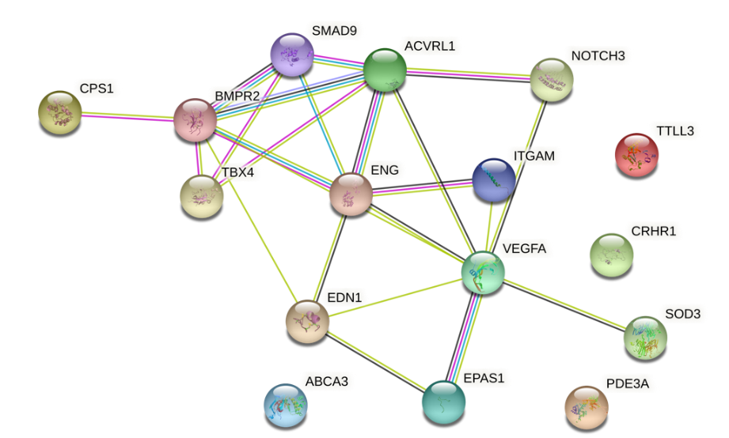
A

B

