Supplemental Online Content

Supplementary Table 1. Characteristics of multisystem inflammatory syndrome (MIS-C)
Supplementary Table 2. Quality and bias assessments of included studies^{a,b}
Supplementary Table 3. Links to all studies included in this systematic review
Supplementary Figures. Results of the meta-analyses of all characteristics from the included studies: forest plots and funnel plots

Supplementary Table 1. Characteristics of multisystem inflammatory syndrome (MIS-C)
 | RCPCHª  (1st May 2020)³  Paediatric multisystem inflammatory syndrome temporally associated with COVID-19 | US/CDC^{b}  (14th May 2020)²  Multisystem Inflammatory Syndrome in Children (MIS-C) | WHO^{c}  (15th May 2020)¹  Multisystem Inflammatory Syndrome in children and adolescents temporally related to COVID-19
Characteristic | Fever >38.5 | Fever, laboratory evidence of  inflammation | Fever >3 days AND elevated markers of  inflammation (ESR, CRP or procalcitonin)
Age | Child | <21 years | 0-19 years
Main features | persistent fever, inflammation (neutrophilia, elevated CRP and lymphopaenia) and evidence of single or multi-organ dysfunction (shock, cardiac, respiratory, renal, gastrointestinal or neurological disorder) with additional features. This may include children fulfilling full or partial criteria for Kawasaki disease. | Evidence of clinically severe illness requiring hospitalization, with multisystem (>2) organ involvement (cardiac, renal respiratory, hematologic, gastrointestinal, dermatologic or neurological) | At least Two of the following:  -Rash or bilateral non-purulent conjunctivitis or muco-cutaneous inflammation signs (oral, hands or feet).  -Hypotension or shock.  -Features of myocardial dysfunction, pericarditis, valvulitis, or coronary abnormalities (including ECHO findings or elevated Troponin/NT-proBNP),  -Evidence of coagulopathy (by PT, PTT, elevated d-Dimers).  -Acute gastrointestinal problems (diarrhea, vomiting, or abdominal pain).
Exclusion criteria | Exclusion of any other microbial cause, including bacterial sepsis, staphylococcal or streptococcal shock syndromes, infections associated with myocarditis such as enterovirus (waiting for results of these investigations should not delay seeking expert advice). | No alternative plausible diagnoses | No other obvious microbial cause of inflammation, including bacterial sepsis, staphylococcal or streptococcal shock syndromes.
SARS-CoV2  status | SARS-CoV-2 PCR testing may be positive or negative | Positive for current or recent SARS-CoV2 infection by RT- PCR, serology or antigen test or COVID-19 exposure within the 4 weeks prior to the onset of symptoms | Evidence of COVID-19 (RT-PCR, antigen test or serology positive), or likely contact with patients with COVID-19.
ªRCPCH: Royal College of Paediatrics and Child Health; ^{b}. US-CDC: United States -Centers for Disease Control and Prevention; ^{c}. WHO: World Health Organization; MAS: macrophage activation syndrome; ESR: Erythrocyte sedimentation rate; CRP: C reactive protein.

Supplementary Table 2. Quality and bias assessments of included studies^{a,b}
ªGeneral analysis: Some methodological components were evaluated: The study had clear objectives; detailed description of the study participants; adequate description of signs, symptoms, and clinical outcomes; the presence of SARS-CoV-2 determined by PCR and/or serology; and use of appropriate statistical methods to address the study issue. A study received a score of 2 if the criteria were fully met, a score of 1 if the criteria were partly met, and 0 if none of the criteria was met. Only studies that reached a total score of ≥7 were included in this systematic review.
Articles  2020/2021 | Did the study have clear objectives for the characterization of MIS-C / PIMS-TS? | Does the study present a detailed ethnic and physical description of the patients? | Does the study present an adequate clinical description of the patients? | Does the study report the presence of SARS-CoV-2 by PCR and / or serology in all patients? | Does the study present the data using appropriate statistical methods? | Risk of bias in data analysis? | Inclusion in study  (Qualitative or Meta-analysis/Quantitative) | Total
Abdel-Mannan et al 2020 | 2 | 1 | 2 | 2 | 1 | Medium | Qualitative | 8
Abdel-Haq et al 2021 | 2 | 2 | 2 | 2 | 2 | Low | Meta-analysis | 10
Acharrya et al 2020. | 2 | 1 | 2 | 2 | 0 | Medium-High | Qualitative | 7
Alkan et al 2021 | 2 | 2 | 2 | 2 | 2 | Low | Meta-analysis | 10
Bahrami et al 2020 | 2 | 1 | 2 | 2 | 0 | Medium-High | Qualitative | 7
Balasubramanian et al 2020 | 2 | 1 | 2 | 2 | 0 | Medium-High | Qualitative | 7
Bapst et al 2020 | 2 | 1 | 2 | 2 | 0 | Medium-High | Qualitative | 7
Bektaş et al 2021 | 2 | 2 | 2 | 2 | 2 | Low | Meta-analysis | 10
Belhadjer et al 2020 | 2 | 1 | 2 | 2 | 2 | Low | Meta-analysis | 9
Belot et al 2020 | 2 | 1 | 2 | 1 | 1 | Medium-High | Meta-analysis | 7
Blondiaux et al 2020 | 2 | 1 | 2 | 2 | 1 | Medium | Qualitative | 8
Blumfield et al 2021 | 2 | 1 | 2 | 2 | 1 | Medium | Meta-analysis | 8
Buonsenso et al 2020 | 2 | 1 | 2 | 2 | 0 | Medium-High | Qualitative | 7
Capone et al 2020 | 2 | 2 | 2 | 1 | 2 | Low | Meta-analysis | 9
Carter et al 2020 | 2 | 2 | 2 | 2 | 2 | Low | Meta-analysis | 10
Cattalini et al 2021 | 2 | 2 | 2 | 2 | 2 | Low | Meta-analysis | 10
Cheung et al 2020 | 2 | 2 | 2 | 2 | 2 | Low | Meta-analysis | 10
Chiotos et al 2020 | 2 | 2 | 2 | 2 | 2 | Low | Meta-analysis | 10
Cogan et al 2020 | 2 | 1 | 2 | 2 | 0 | Medium-High | Qualitative | 7
Dallan et al 2020 | 2 | 1 | 2 | 1 | 1 | Medium-High | Qualitative | 7
Dasgupta and Finch | 2 | 1 | 2 | 2 | 0 | Medium-High | Qualitative | 7
Davies et al 2020 | 2 | 2 | 2 | 1 | 2 | Low | Meta-analysis | 9
De Paulis et al 2020 | 2 | 1 | 2 | 2 | 0 | Medium-High | Qualitative | 7
Deza Leon et al 2020 | 2 | 1 | 2 | 2 | 0 | Medium-High | Qualitative | 7
Dhanalakshmi et al 2020 | 2 | 1 | 2 | 2 | 2 | Low | Meta-analysis | 9
Dionne et al 2020 | 2 | 1 | 2 | 2 | 2 | Low | Meta-analysis | 9
Diorio et al 2020 | 2 | 2 | 2 | 1 | 2 | Low | Meta-analysis | 9
Dolhnikoff et al 2020 | 2 | 1 | 2 | 2 | 0 | Medium-High | Qualitative | 7
Dolinger et al 2020 | 2 | 1 | 2 | 2 | 0 | Medium-High | Qualitative | 7
Domico et al 2020. | 2 | 1 | 2 | 2 | 0 | Medium-High | Qualitative | 7
Dufort et al 2020 | 2 | 2 | 2 | 1 | 2 | Low | Meta-analysis | 9
Farias et al 2020 | 2 | 1 | 2 | 2 | 2 | Low | Meta-analysis | 9
Farias et al 2020 | 2 | 2 | 2 | 1 | 1 | Medium | Qualitative | 8
Feldstein et al 2020 | 2 | 2 | 2 | 2 | 2 | Low | Meta-analysis | 10
Flood et al 2021 | 2 | 2 | 2 | 2 | 2 | Low | Meta-analysis | 10
Giannattasio et al 2021 | 2 | 1 | 2 | 2 | 0 | Medium-High | Qualitative | 7
Godfred-Cato et al 2020 | 2 | 2 | 2 | 1 | 2 | Low | Meta-analysis | 9
Greene et al 2020 | 2 | 1 | 2 | 2 | 0 | Medium-High | Qualitative | 7
Grimaud et al 2020 | 2 | 1 | 2 | 2 | 2 | Low | Meta-analysis | 9
Gruber et al 2020 | 2 | 1 | 2 | 2 | 2 | Low | Meta-analysis | 9
Gupta et al 2020 | 2 | 1 | 2 | 2 | 0 | Medium-High | Qualitative | 7
Hameed et al 2020 | 2 | 1 | 2 | 2 | 2 | Low | Meta-analysis | 9
Heidemann et al 2020 | 2 | 1 | 2 | 1 | 1 | Medium-High | Qualitative | 7
Hutchison et al 2020 | 2 | 1 | 2 | 2 | 0 | Medium-High | Qualitative | 7
Jain et al 2020 | 2 | 1 | 2 | 1 | 2 | Medium | Meta-analysis | 8
Joshi et al 2020 | 2 | 1 | 2 | 1 | 1 | Medium-High | Qualitative | 7
Kashyap et al 2021 | 2 | 2 | 2 | 1 | 1 | Medium-High | Meta-analysis | 8
Kaushik et al 2020 | 2 | 2 | 2 | 2 | 2 | Low | Meta-analysis | 10
Kest et al 2020 | 2 | 1 | 2 | 1 | 1 | Medium-High | Qualitative | 7
Khesrani et al 2020 | 2 | 1 | 2 | 2 | 0 | Medium-High | Qualitative | 7
Klocperk et al 2020 | 2 | 1 | 2 | 2 | 0 | Medium-High | Qualitative | 7
Lang et al 2020 | 2 | 1 | 2 | 1 | 1 | Medium-High | Qualitative | 7
Lee and Margolskee | 2 | 1 | 2 | 1 | 1 | Medium | Qualitative | 8
Lee et al 2020 | 2 | 2 | 2 | 2 | 2 | Low | Meta-analysis | 10
Lee et al 2020 | 2 | 1 | 2 | 1 | 1 | Medium-High | Qualitative | 7
Licciardi et al 2020 | 2 | 1 | 2 | 1 | 1 | Medium-High | Qualitative | 7
Lin et al 2020 | 2 | 1 | 2 | 2 | 0 | Medium-High | Qualitative | 7
Mamishi et al 2020 | 2 | 1 | 2 | 2 | 1 | Medium | Meta-analysis | 8
Mehler et al 2021 | 2 | 2 | 2 | 2 | 2 | Low | Meta-analysis | 10
Meredith et al 2021 | 2 | 1 | 2 | 2 | 0 | Medium-High | Qualitative | 7
Miller et al 2020 | 2 | 2 | 2 | 2 | 2 | Low | Meta-analysis | 10
Mills et al 2021 | 2 | 2 | 2 | 1 | 2 | Low | Qualitative | 9
Moghadam et al 2020 | 2 | 1 | 2 | 2 | 0 | Medium-High | Qualitative | 7
Moraleda et al 2020 | 2 | 1 | 2 | 2 | 2 | Low | Meta-analysis | 9
Nathan et al 2020 | 2 | 1 | 2 | 2 | 1 | Medium | Qualitative | 8
Ng et al 2020 | 2 | 1 | 2 | 1 | 1 | Medium-High | Qualitative | 7
Nguyen et al 2020 | 2 | 1 | 2 | 2 | 0 | Medium-High | Qualitative | 7
Okarska-Napierała et al 2020 | 2 | 1 | 2 | 2 | 0 | Medium-High | Qualitative | 7
Paolino and Willians | 2 | 1 | 2 | 1 | 1 | Medium-High | Qualitative | 7
Patnaik et al 2021 | 2 | 2 | 2 | 2 | 2 | Low | Meta-analysis | 10
Penner et al 2021 | 2 | 2 | 2 | 2 | 2 | Low | Meta-analysis | 10
Pereira et al 2020 | 2 | 1 | 2 | 2 | 2 | Low | Meta-analysis | 9
Perez-Toledo et al 2020 | 2 | 1 | 2 | 1 | 2 | Medium | Meta-analysis | 8
Pouletty et al 2020 | 2 | 1 | 2 | 2 | 2 | Low | Meta-analysis | 9
Prata-Barbosa et al 2020 | 2 | 2 | 2 | 2 | 2 | Low | Meta-analysis | 10
Prieto et al 2021 | 2 | 2 | 2 | 1 | 1 | Medium | Meta-analysis | 8
Ramcharan et al 2020 | 2 | 2 | 2 | 1 | 2 | Low | Meta-analysis | 9
Rauf et al 2020 | 2 | 1 | 2 | 2 | 0 | Medium-High | Qualitative | 7
Regev et al 2020 | 2 | 1 | 2 | 2 | 0 | Medium-High | Qualitative | 7
Riollano-Cruz et al 2020 | 2 | 2 | 2 | 2 | 2 | Low | Meta-analysis | 10
Riphagen et al 2020 | 2 | 2 | 2 | 1 | 2 | Low | Meta-analysis | 9
Roberts et al 2021 | 2 | 2 | 2 | 2 | 2 | Low | Meta-analysis | 10
Rodriguez-gonzalez et al 2020 | 2 | 1 | 2 | 2 | 0 | Medium-High | Qualitative | 7
Rogo et al 2020 | 2 | 1 | 2 | 1 | 1 | Medium-High | Qualitative | 7
Sadiq et al 2020 | 2 | 1 | 2 | 2 | 2 | Low | Meta-analysis | 9
Saeed and Shorofa | 2 | 1 | 2 | 2 | 0 | Medium-High | Qualitative | 7
Sandoval et al 2021 | 2 | 2 | 2 | 2 | 2 | Low | Meta-analysis | 10
Schupper et al 2020 | 2 | 1 | 2 | 2 | 0 | Medium-High | Qualitative | 7
Shenker et al 2020 | 2 | 1 | 2 | 2 | 0 | Medium-High | Qualitative | 7
Torres et al 2020 | 2 | 1 | 2 | 1 | 2 | Medium | Meta-analysis | 8
Toubiana et al 2020 | 2 | 1 | 2 | 2 | 2 | Low | Meta-analysis | 9
Vari et al 2020 | 2 | 1 | 2 | 2 | 0 | Medium-High | Qualitative | 7
Verdoni et al 2020 | 2 | 1 | 2 | 2 | 2 | Low | Meta-analysis | 9
Verkuil et al 2020 | 2 | 1 | 2 | 2 | 0 | Medium-High | Qualitative | 7
Webb et al 2020 | 2 | 2 | 2 | 2 | 2 | Low | Meta-analysis | 10
Whittaker et al 2020 | 2 | 2 | 2 | 1 | 2 | Low | Meta-analysis | 9
Yonker et al 2020 | 2 | 2 | 2 | 1 | 1 | Medium | Meta-analysis | 8
Yozgat et al 2020 | 2 | 1 | 2 | 2 | 0 | Medium-High | Qualitative | 7

^{b}Observational cohort studies and case reports were evaluated using some aspects of the Newcastle-Ottawa Scale (NOS). This assessment confirmed the inclusion of the study and the risk of bias in this systematic review. Aspects evaluated included selection and definition of controls, representativeness of the cases, comparability of cases and controls based on design or analysis, assessment of outcome, and risk of bias in data analysis. Each aspect can be answered with yes, no, or partially.

Articles  2020/2021 | Selection and definition of controls |  | Representativeness of the cases | Comparability of cases and controls on the basis of the design or analysis | Assessment of outcome | Risk of bias in data analysis?
Abdel-Mannan et al 2020 |  | Yes | Yes | Yes | Yes | Low
Acharrya et al 2020. |  | Yes | Yes | Yes | Yes | Low
Bahrami et al 2020 |  | Yes | Yes | Yes | Yes | Low
Balasubramanian et al 2020 |  | Yes | Yes | Yes | Yes | Low
Bapst et al 2020 |  | Yes | Yes | Yes | Yes | Low
Bektaş et al 2021 |  | Yes | Yes | Yes | Yes | Low
Blondiaux et al 2020 |  | Yes | Yes | Yes | Yes | Low
Buonsenso et al 2020 |  | Yes | Yes | Yes | Yes | Low
Cogan et al 2020 |  | Yes | Yes | Yes | Yes | Low
Dallan et al 2020 |  | Yes | Yes | Yes | Yes | Low
Dasgupta and Finch |  | Yes | Yes | Yes | Yes | Low
De Paulis et al 2020 |  | Yes | Yes | Yes | Yes | Low
Deza Leon et al 2020 |  | Yes | Yes | Yes | Yes | Low
Dolhnikoff et al 2020 |  | Yes | Yes | Yes | Yes | Low
Dolinger et al 2020 |  | Yes | Yes | Yes | Yes | Low
Domico et al 2020 |  | Yes | Yes | Yes | Yes | Low
Farias et al 2020 |  | Yes | Yes | Yes | Yes | Low
Giannattasio et al 2021 |  | Yes | Yes | Yes | Yes | Low
Greene et al 2020 |  | Yes | Yes | Yes | Partially | Medium
Gupta et al 2020 |  | Yes | Yes | Yes | Partially | Medium
Heidemann et al 2020 |  | Yes | Yes | Yes | Yes | Low
Hutchison et al 2020 |  | Yes | Yes | Yes | Yes | Low
Joshi et al 2020 |  | Yes | Yes | Yes | Yes | Low
Kest et al 2020 |  | Yes | Yes | Yes | Yes | Low
Khesrani et al 2020 |  | Yes | Yes | Yes | Yes | Low
Klocperk et al 2020 |  | Yes | Yes | Yes | Yes | Low
Lang et al 2020 |  | Yes | Yes | Yes | Yes | Low
Lee and Margolskee 2020 |  | Yes | Yes | Yes | Yes | Low
Lee et al 2020 |  | Yes | Yes | Yes | Yes | Low
Licciardi et al 2020 |  | Yes | Yes | Yes | Yes | Low
Lin et al 2020 |  | Yes | Yes | Yes | Yes | Low
Maghadam et al 2020 |  | Yes | Yes | Yes | Yes | Low
Meredith et al 2021 |  | Yes | Yes | Yes | Yes | Low
Mills et al 2021 |  | Yes | Yes | Yes | Yes | Low
Nathan et al 2020 |  | Yes | Yes | Yes | Yes | Low
Ng et al 2020 |  | Yes | Yes | Yes | Partially | Medium
Nguyen et al 2020 |  | Yes | Yes | Yes | Yes | Low
Okarska-Napierała et al 2020 |  | Yes | Yes | Yes | Yes | Low
Paolino and Willians |  | Yes | Yes | Yes | Yes | Low
Rauf et al 2020 |  | Yes | Yes | Yes | Yes | Low
Regev et al 2020 |  | Yes | Yes | Yes | Yes | Low
Rodriguez-gonzalez et al 2020 |  | Yes | Yes | Yes | Partially | Medium
Rogo et al 2020 |  | Yes | Yes | Yes | Yes | Low
Saeed and Shorofa |  | Yes | Yes | Yes | Partially | Medium
Schupper et al 2020 |  | Yes | Yes | Yes | Yes | Low
Shenker et al 2020 |  | Yes | Yes | Yes | Yes | Low
Vari et al 2020 |  | Yes | Yes | Yes | Yes | Low
Verkuil et al 2020 |  | Yes | Yes | Yes | Yes | Low
Yozgat et al 2020 |  | Yes | Yes | Yes | Yes | Low

Supplementary Table 3. Links to all studies included in this systematic review

Abdel-mannan et al 2020. https://jamanetwork.com/journals/jamaneurology/fullarticle/2767979.doi:10.
Abdel-Haq et al 2021. https://www.ncbi.nlm.nih.gov/pmc/articles/PMC7810600/pdf/431_2021_Article_3935.pdf
Acharrya et al 2020. https://www.ncbi.nlm.nih.gov/pmc/articles/pmc7444159/pdf/13312_2020_article_1924.pdf
Alkan et al 2021. https://www.ncbi.nlm.nih.gov/pmc/articles/PMC8100744/pdf/10067_2021_Article_5754.pdf
Akhmerov and Marbán. https://www.ahajournals.org/doi/epub/10.1161/circresaha.120.317055
American Academy of Pediatrics, 2020. https://www.aappublications.org/news/2020/07/13/covid19miscguidance
Bahrami et al 2020. https://onlinelibrary.wiley.com/doi/full/10.1111/jpc.15048
Balasubramanian et al 2020. Https://www.ncbi.nlm.nih.gov/pmc/articles/pmc7387261/pdf/13312_2020_article_1901.pdf
Bapst et al 2020. https://www.ncbi.nlm.nih.gov/pmc/articles/pmc7358104/pdf/bcr-2020-236986.pdf
Bektaş et al 2021. https://www.ncbi.nlm.nih.gov/pmc/articles/PMC7553133/pdf/main.pdf
Belhadjer et al 2020. https://www.ahajournals.org/doi/epub/10.1161/circulationaha.120.048360
Belot et al 2020. https://www.ncbi.nlm.nih.gov/pmc/articles/pmc7336112/pdf/eurosurv-25-22-1.pdf
Binstadt et al 2020. https://pediatrics.aappublications.org/content/pediatrics/116/1/e89.full.pdf
Blondiaux et al 2020. https://www.ncbi.nlm.nih.gov/pmc/articles/pmc7294821/pdf/radiol.2020202288.pdf
Blumfield et al 2021. https://www.ajronline.org/doi/full/10.2214/AJR.20.24032
Buonsenso et al 2020. https://journals.lww.com/pidj/fulltext/2020/08000/cytokine_profile_in_an_adolescent_with_pediatric.39.aspx
Burns, 2007. https://www.nejm.org/doi/full/10.1056/NEJMp068268?query=TOC
Capone et al 2020. https://www.ncbi.nlm.nih.gov/pmc/articles/pmc7293762/pdf/main.pdf
Carter et al 2020. https://www.nature.com/articles/s41591-020-1054-6
Cattalini et al 2021. https://ped-rheum.biomedcentral.com/track/pdf/10.1186/s12969-021-00511-7.pdf
CDC. 2020. https://emergency.cdc.gov/han/2020/han00432.asp
Cheung et al 2020. https://jamanetwork.com/journals/jama/fullarticle/10.1001/jama.2020.10374
Chiotos et al 2020. https://academic.oup.com/jpids/article/9/3/393/5848127
Cogan et al 2020. https://europepmc.org/article/med/32760733#free-full-text
Colomba et al 2020. https://kopernio.com/viewer?Doi=10.1016/j.jpeds.2018.06.034&route=2
Dallan et al 2020. https://www.thelancet.com/action/showpdf?Pii=s2352-4642%2820%2930164-4
Dasgupta and Finch. https://www.ncbi.nlm.nih.gov/research/coronavirus/publication/32580256
Davies et al 2020. https://www.thelancet.com/action/showPdf?pii=S2352-4642%2820%2930215-7
De Paulis et al 2020. https://journals.lww.com/pidj/Fulltext/2020/10000/Multisystem_Inflammatory_Syndrome_Associated_With.27.aspx
Deza Leon et al 2020. https://www.ncbi.nlm.nih.gov/pmc/articles/PMC7313914/pdf/piaa061.pdf
Dhanalakshmi et al 2020. https://www.ncbi.nlm.nih.gov/pmc/articles/PMC7678572/pdf/13312_2020_Article_2025.pdf
Dionne et al 2020. https://pediatrics.aappublications.org/content/pediatrics/early/2020/10/28/peds.2020-009704.full.pdf
Diorio et al 2020. https://www.jci.org/articles/view/140970/pdf
Dolhnikoff et al 2020. https://www.thelancet.com/action/showPdf?pii=S2352-4642%2820%2930257-1
Dolinger et al 2020. https://www.ncbi.nlm.nih.gov/pmc/articles/PMC7268863/pdf/jpga-publish-ahead-of-print-10.1097.mpg.0000000000002809.pdf
Domico et al 2020. https://www.heartrhythmcasereports.com/action/showPdf?pii=S2214-0271%2820%2930189-5
Dufort et al 2020. https://www.nejm.org/doi/full/10.1056/NEJMoa2021756
Duval and Tweedie, 2000. https://onlinelibrary.wiley.com/doi/abs/10.1111/j.0006-341X.2000.00455.x?sid=nlm%3Apubmed
Farias et al 2020. https://patua.iec.gov.br/handle/iec/4192
Farias et al 2020. https://www.scielo.br/pdf/rpp/v38/pt_1984-0462-rpp-38-e2020165.pdf
Feldstein et al 2020. https://www.nejm.org/doi/full/10.1056/NEJMoa2021680
Flood et al 2021. https://www.sciencedirect.com/science/article/pii/S2666776221000521?via%3Dihub
Giannattasio et al 2020. https://onlinelibrary.wiley.com/doi/full/10.1002/jmv.26189
Godfred-Cato et al 2020. https://www.cdc.gov/mmwr/volumes/69/wr/pdfs/mm6932e2-H.pdf
Gordon et al 2020. https://www.ncbi.nlm.nih.gov/pmc/articles/pmc2870533/pdf/nihms160351.pdf
Greene et al 2020. https://www.ncbi.nlm.nih.gov/pmc/articles/PMC7274960/pdf/main.pdf
Grimaud et al 2020. https://annalsofintensivecare.springeropen.com/articles/10.1186/s13613-020-00690-8
Gruber et al 2020. https://www.ncbi.nlm.nih.gov/pmc/articles/PMC7359537/pdf/nihpp-2020.07.04.20142752.pdf
Gupta et al 2020. https://www.nature.com/articles/s41591-020-0968-3
Hameed et al 2020. https://pubs.rsna.org/doi/pdf/10.1148/radiol.2020202543
Heidemann et al 2020. https://www.amjcaserep.com/download/index/idArt/925779
Higgins et al 2020. 2003. https://www.ncbi.nlm.nih.gov/pmc/articles/PMC192859/pdf/3270557.pdf
Hutchison et al 2020. https://www.ncbi.nlm.nih.gov/pmc/articles/PMC7324340/pdf/main.pdf
Inciardi et al 2020. https://jamanetwork.com/journals/jamacardiology/article-abstract/2763843
Jain et al 2020. https://congenitalcardiologytoday.com/2020/08/04/cardiovascular-magnetic-resonance-in-myocarditis-related-to-multisystem-inflammatory-syndrome-in-children-associated-with-covid-19/
Jenco M 2020. https://www.aappublications.org/news/aapnewsmag/2020/07/13/covid19miscguidance.full.pdf
Joshi et al 2020. https://www.sciencedirect.com/science/article/pii/s2666084920306707#bib6
Kashyap et al 2021. https://www.ncbi.nlm.nih.gov/pmc/articles/PMC8284036/
Kaushik et al 2020. https://www.ncbi.nlm.nih.gov/pmc/articles/PMC7293760/pdf/main.pdf
Kest et al 2020. https://www.ncbi.nlm.nih.gov/pmc/articles/PMC7383305/pdf/CRIPE2020-8875987.pdf
Khesrani et al 2020. https://www.ncbi.nlm.nih.gov/pmc/articles/PMC7439099/pdf/main.pdf
Klocperk et al 2020. https://www.frontiersin.org/articles/10.3389/fimmu.2020.01665/full
Lang et al 2020. https://www.ncbi.nlm.nih.gov/pmc/articles/PMC7543556/pdf/piaa117.pdf
Lee and Margolskee. https://ashpublications.org/blood/article/136/7/914/461742/Leukoerythroblastosis-and-plasmacytoid-lymphocytes
Lee et al 2020. https://www.jacionline.org/action/showPdf?pii=S0091-6749%2820%2931170-2
Lee et al 2020. https://www.jci.org/articles/view/141113/pdf
Licciardi et al 2020. https://pediatrics.aappublications.org/content/pediatrics/146/2/e20201711.full.pdf
Lin et al 2020. http://www.ajnr.org/content/ajnr/early/2020/08/20/ajnr.A6755.full.pdf
Maghadam et al 2020. https://www.amjmed.com/article/S0002-9343(20)30608-2/fulltext
Makino et al 2020. https://onlinelibrary.wiley.com/doi/full/10.1111/ped.13809
Mamishi et al 2020. https://www.ncbi.nlm.nih.gov/pmc/articles/PMC7484297/pdf/S095026882000196Xa.pdf
Mehler et al 2021. https://www.ijidonline.com/action/showPdf?pii=S1201-9712%2821%2900355-6
Meredith et al 2021. https://www.preprints.org/manuscript/202006.0118/v1
Miller et al 2020. https://www.ncbi.nlm.nih.gov/pmc/articles/PMC7270806/pdf/main.pdf
Mills et al 2021. https://journals.lww.com/pidj/Fulltext/2021/09000/Hyponatremia_in_Patients_With_Multisystem.19.aspx
Moher et al 2020, 2009. https://journals.plos.org/plosmedicine/article?id=10.1371/journal.pmed.1000097
Moraleda et al 2020. https://academic.oup.com/cid/advance-article/doi/10.1093/cid/ciaa1042/5876334
Nathan et al 2020. https://europepmc.org/articles/pmc7564665/bin/jcm-09-02950-s001.pdf
Ng et al 2020. https://onlinelibrary.wiley.com/doi/full/10.1002/jmv.26206
Nguyen et al 2020. https://www.ncbi.nlm.nih.gov/pmc/articles/PMC7389873/pdf/cureus-0012-00000008915.pdf
Oba et al 2020. https://www.scielo.br/pdf/eins/v18/2317-6385-eins-18-eRW5774.pdf
Okarska-Napierała et al 2020. https://www.gastrojournal.org/article/S0016-5085(20)35118-0/pdf
Paolino and Williams. https://www.ncbi.nlm.nih.gov/pmc/articles/PMC7404579/pdf/PBC-9999-e28551.pdf
Patnaik et al 2021. https://www.ncbi.nlm.nih.gov/pmc/articles/PMC8278175/
Penner et al 2021. https://www.thelancet.com/action/showPdf?pii=S2352-4642%2821%2900138-3
Pereira et al 2020. https://www.scielo.br/pdf/clin/v75/1807-5932-clin-75-e2209.pdf
Perez-toledo et al 2020. https://www.ncbi.nlm.nih.gov/pmc/articles/PMC7302282/pdf/nihpp-2020.06.05.20123117.pdf
Pouletty et al 2020. https://www.ncbi.nlm.nih.gov/pmc/articles/PMC7299653/pdf/annrheumdis-2020-217960.pdf
Prata-barbosa et al 2020. https://www.sciencedirect.com/science/article/pii/S225555362030080X
Prieto et al 2021. https://www.clinicalmicrobiologyandinfection.com/action/showPdf?pii=S1198-743X%2820%2930616-9
Ramcharan et al 2020. https://www.ncbi.nlm.nih.gov/pmc/articles/PMC7289638/
Rauf et al 2020. https://link.springer.com/article/10.1007/s12098-020-03357-1
RCPCH, 2020. https://www.rcpch.ac.uk/resources/guidance-paediatric-multisystem-inflammatory-syndrome-temporally-associated-covid-19
Regev et al 2020. https://journals.lww.com/pidj/Fulltext/2020/08000/Pediatric_Inflammatory_Multisystem_Syndrome_With.32.aspx
Riollano-cruz et al 2020. https://www.ncbi.nlm.nih.gov/pmc/articles/PMC7361761/pdf/JMV-9999-na.pdf
Riphagen et al 2020. https://www.ncbi.nlm.nih.gov/pmc/articles/PMC7204765/pdf/main.pdf
Roberts et al 2021. https://adc.bmj.com/content/archdischild/early/2021/07/07/archdischild-2021-322290.full.pdf?with-ds=yes
Rodriguez-gonzalez et al 2020. https://www.ncbi.nlm.nih.gov/pmc/articles/PMC7324758/pdf/S1047951120001857a.pdf
Rogo et al 2020. https://www.ncbi.nlm.nih.gov/pmc/articles/PMC7454706/pdf/piaa087.pdf
Sadiq et al 2020. https://www.thelancet.com/cms/10.1016/S2352-4642(20)30256-X/attachment/e26166e7-6168-4d22-8ffa-67acf23303e9/mmc1.pdf
Saeed and Shorofa. https://www.ncbi.nlm.nih.gov/pmc/articles/PMC7468313/pdf/main.pdf
Sandoval et al 2021. https://journals.sagepub.com/doi/pdf/10.1177/0883073821989164
Schupper et al 2020. https://www.ncbi.nlm.nih.gov/pmc/articles/PMC7314616/pdf/381_2020_Article_4755.pdf
Shenker et al 2020. https://europepmc.org/article/med/32712284#free-full-text
Tavazzi et al 2020. https://onlinelibrary.wiley.com/doi/full/10.1002/ejhf.1828
Tissières P, Teboul JL. https://www.ncbi.nlm.nih.gov/pmc/articles/PMC7376531/pdf/13613_2020_Article_717.pdf
Torres et al 2020. https://www.sciencedirect.com/science/article/pii/S1201971220306913
Toubiana et al 2020. https://www.bmj.com/content/bmj/369/bmj.m2094.full.pdf
Vari et al 2020. https://www.ncbi.nlm.nih.gov/pmc/articles/PMC7329651/pdf/main.pdf
Verdoni et al 2020. https://www.ncbi.nlm.nih.gov/pmc/articles/PMC7220177/pdf/main.pdf
Verkuil et al 2020. https://www.thelancet.com/action/showPdf?pii=S0140-6736%2820%2931725-6
Webb et al 2020. https://www.ncbi.nlm.nih.gov/pmc/articles/PMC7442431/
Wei X et al 2020. H. https://www.ncbi.nlm.nih.gov/pmc/articles/PMC7188134/pdf/ehaa333.pdf
Wells et al 2020. http://www.ohri.ca/programs/clinical_epidemiology/oxford.asp
Whittaker et al 2020. https://www.ncbi.nlm.nih.gov/pmc/articles/PMC7281356/
WHO. https://www.who.int/news-room/commentaries/detail/multisystem-inflammatory-syndrome-in-children-and-adolescents-with-covid-19
Xia et al 2020. https://www.ncbi.nlm.nih.gov/pmc/articles/PMC7168071/pdf/PPUL-55-1169.pdf
Yonker et al 2020. https://www.jpeds.com/action/showPdf?pii=S0022-3476%2820%2931023-4
Yozgat et al 2020. https://onlinelibrary.wiley.com/doi/10.1111/dth.13770

Supplementary Figures. Results of the meta-analyses of all characteristics from the included studies: forest plots and funnel plots.

Male gender
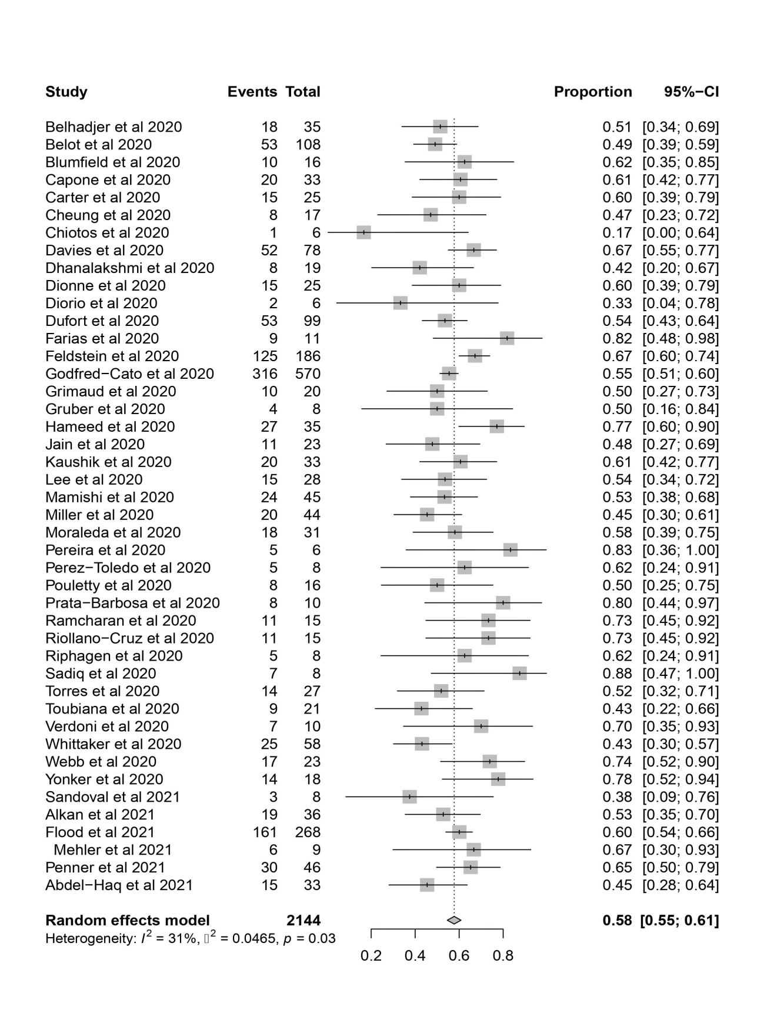
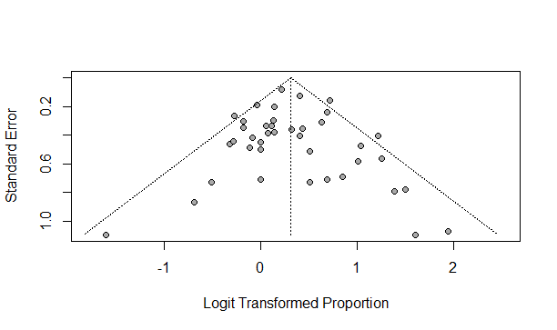

Caucasian/white ethnicity
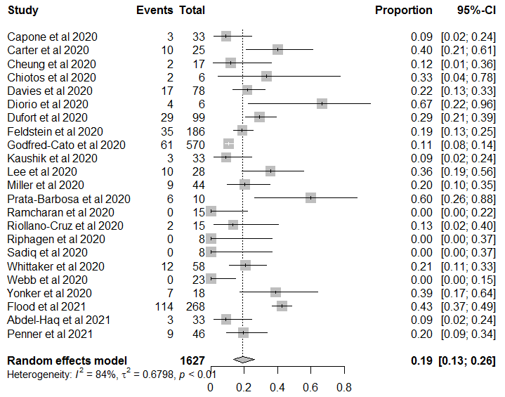
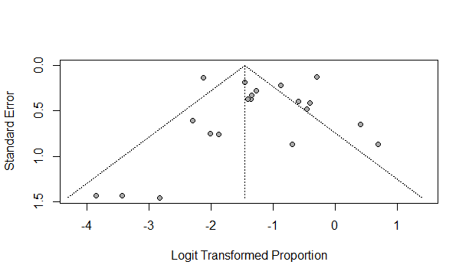

African American/Black ethnicity
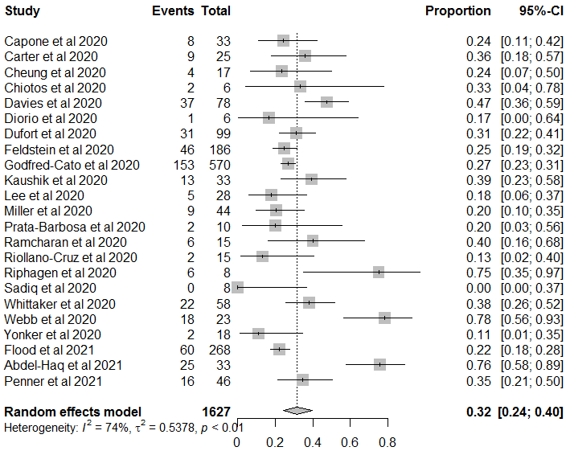
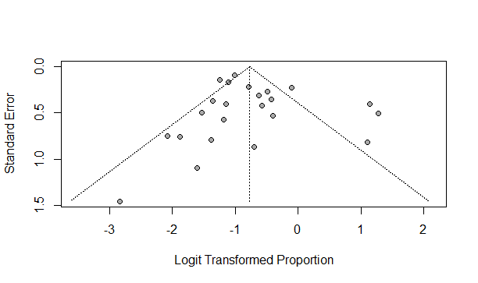

Asian ethnicity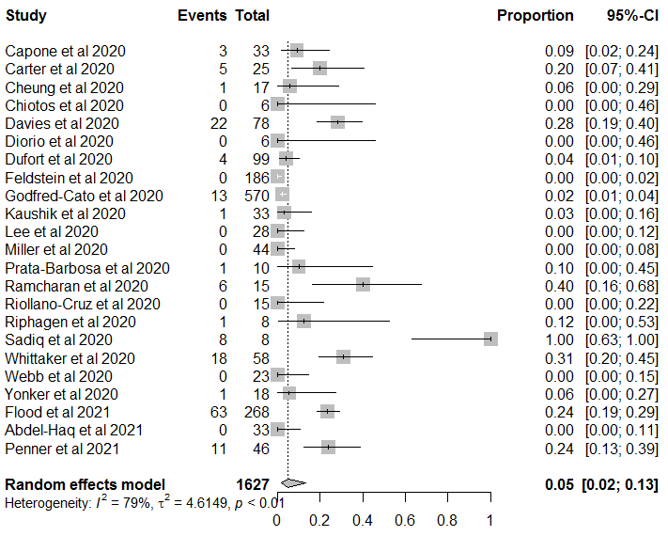
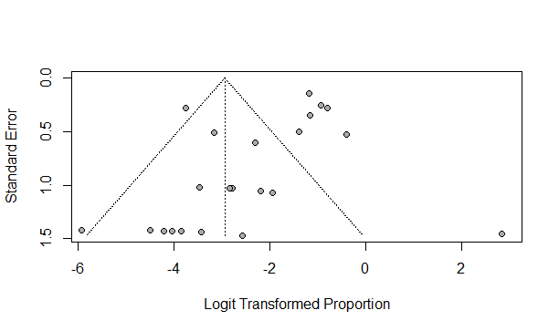

Hispanic ethnicity
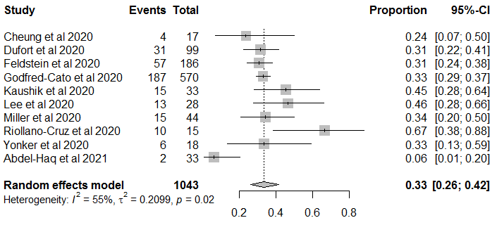
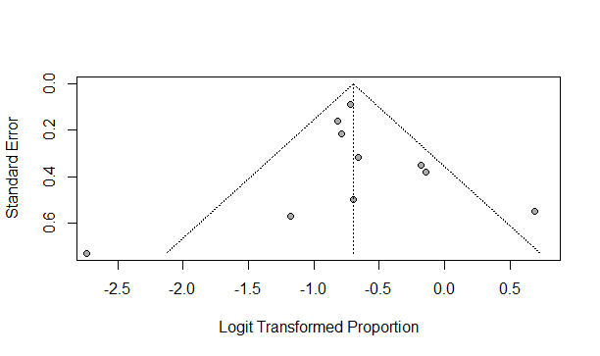

multiracial or others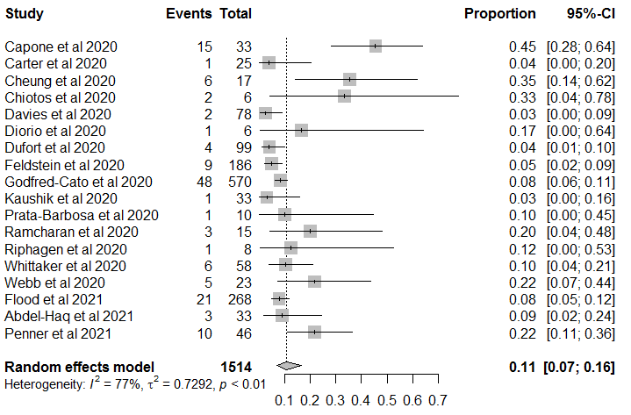
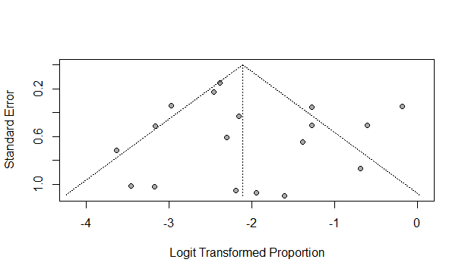

unreported or specified ethnicity
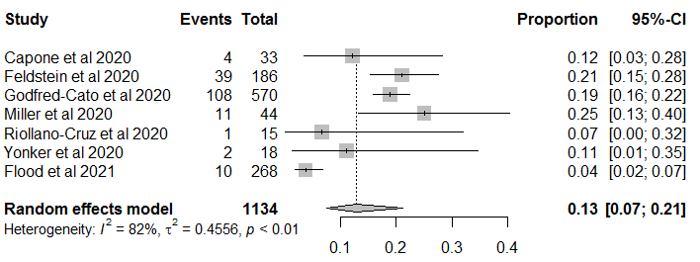
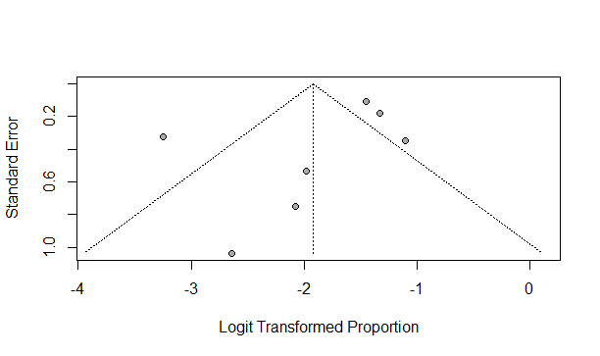

Symptoms - fever
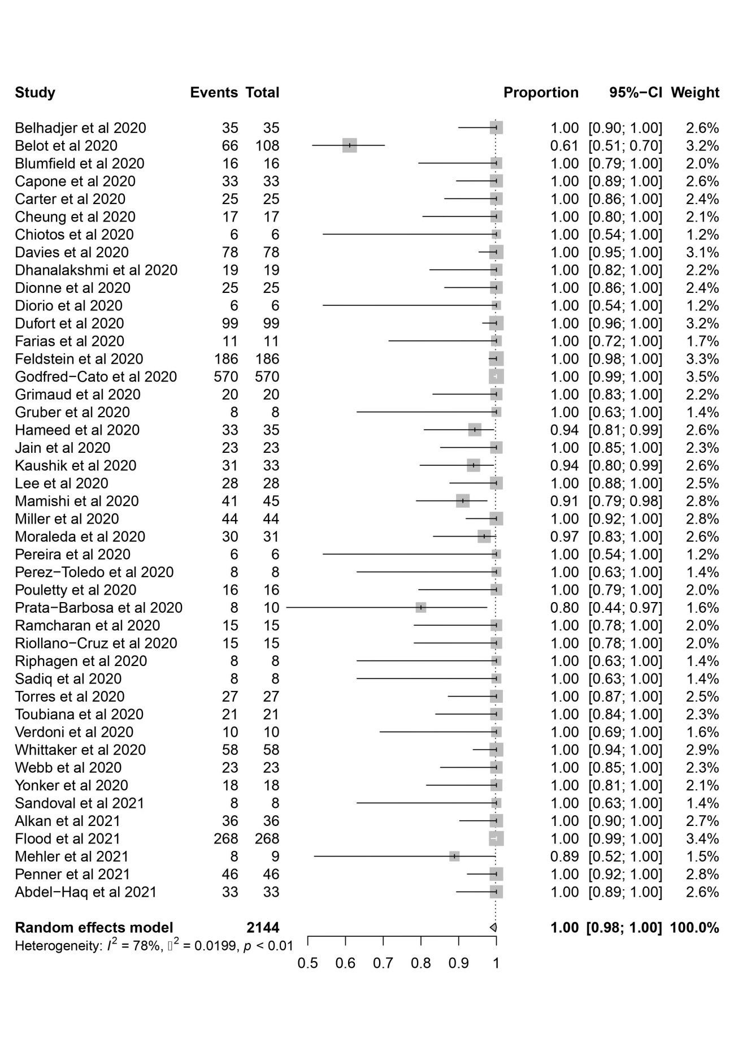
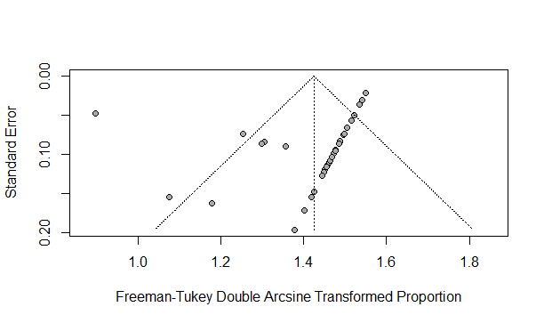

Symptoms - dyspnea
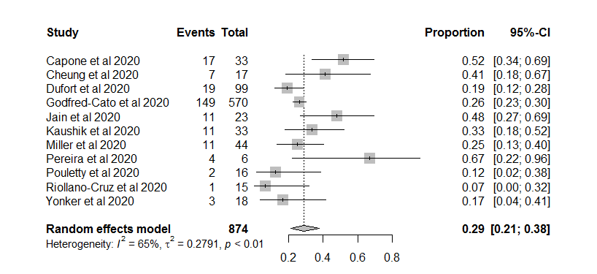
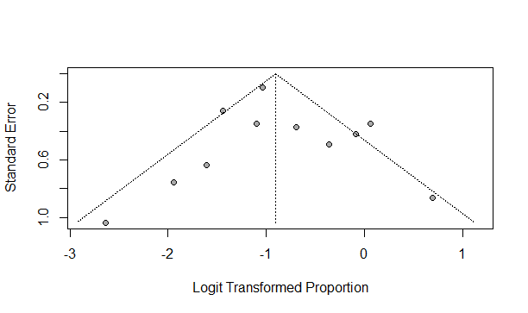

Symptoms – vomiting
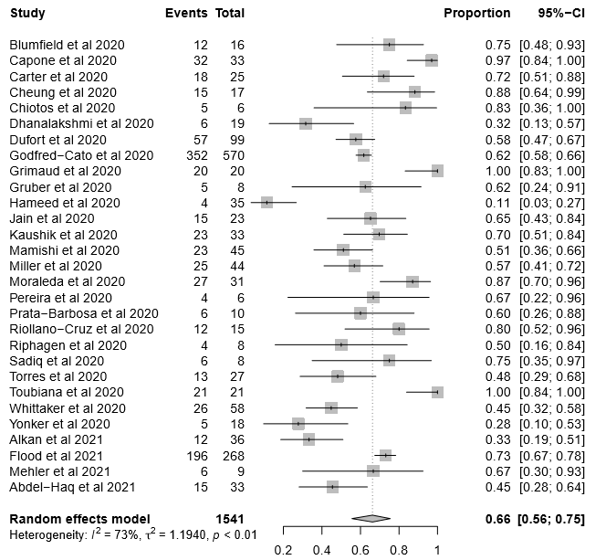
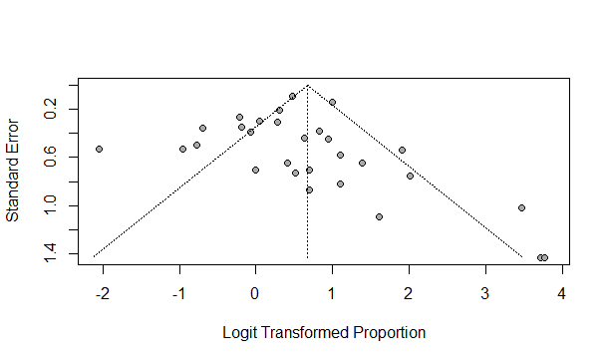

Symptoms – cough
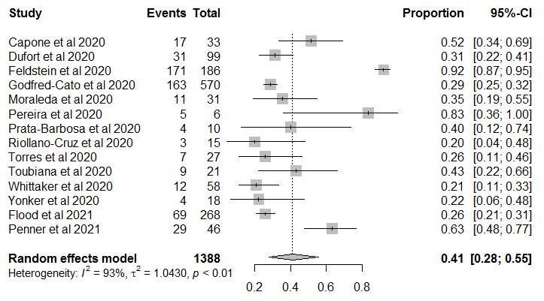
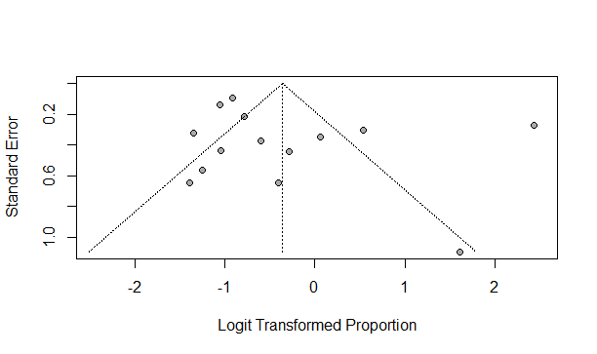

Symptoms - cojunctivitis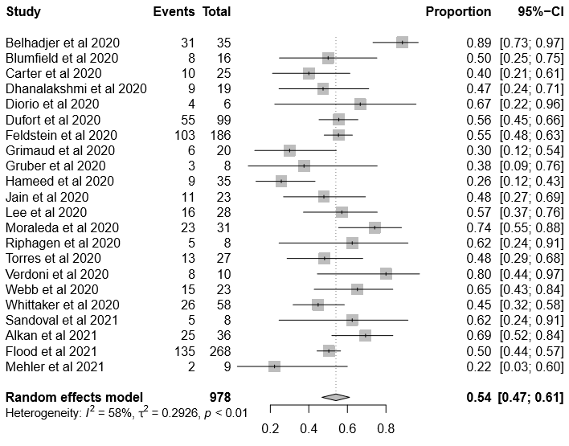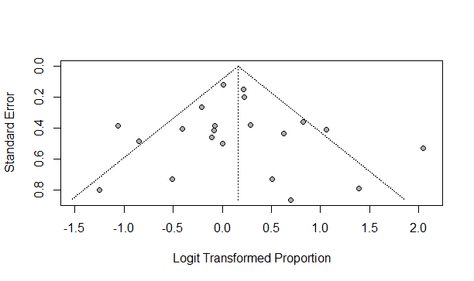

Symptoms – headache
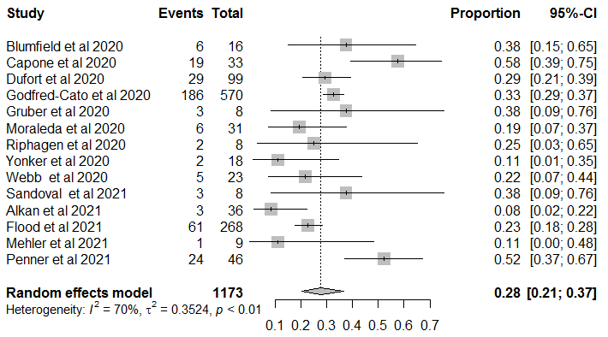
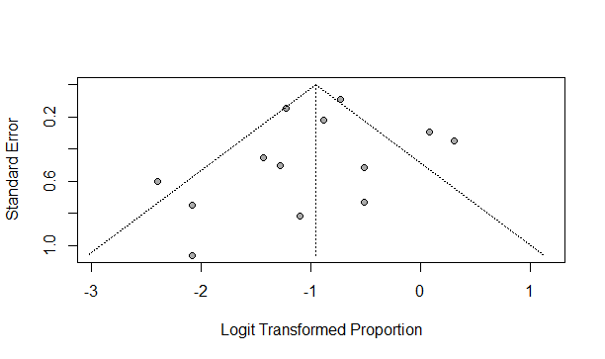

Symptoms - abdominal pain
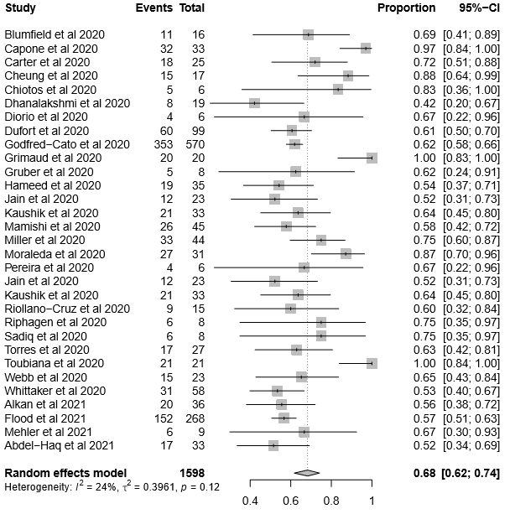
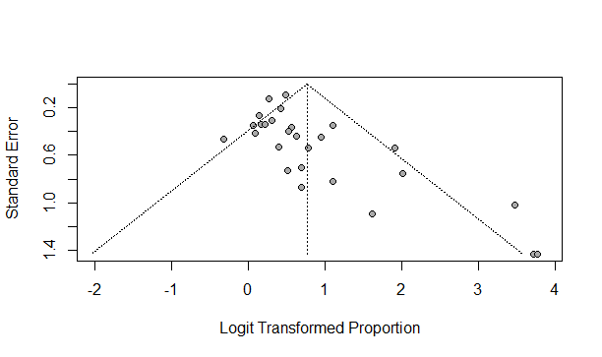

Symptoms - rash/erythema
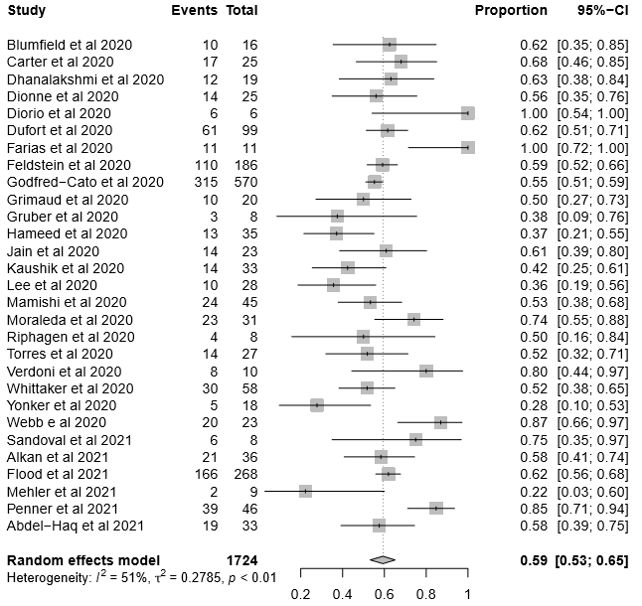
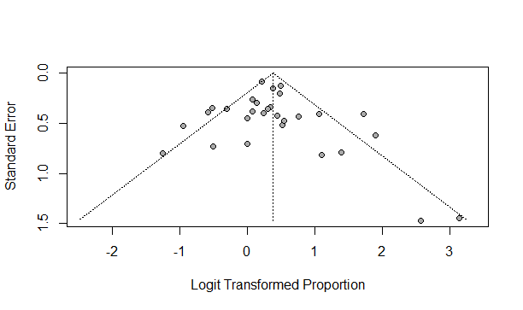

Symptoms - sore throat
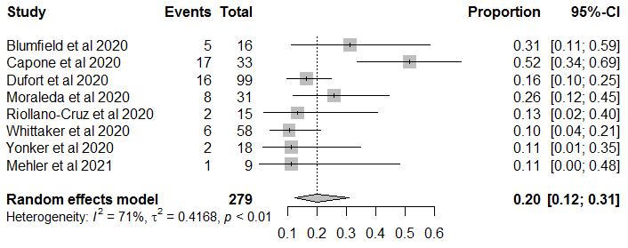
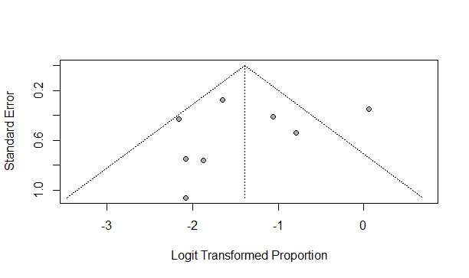

Symptoms - diarrhoea
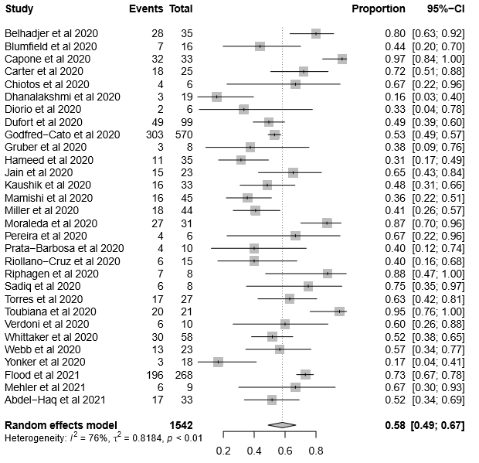
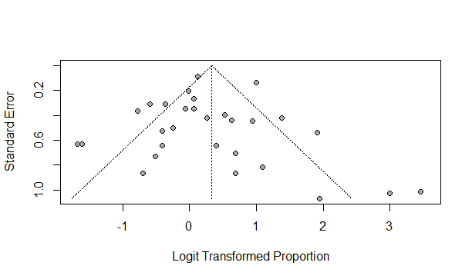

Non-specific gastrointestinal symptoms (GI symptoms)
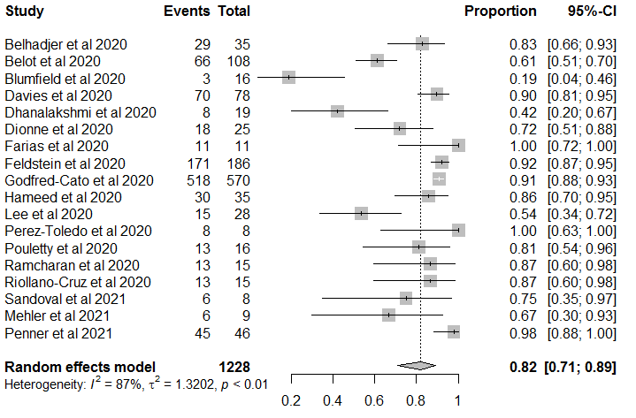
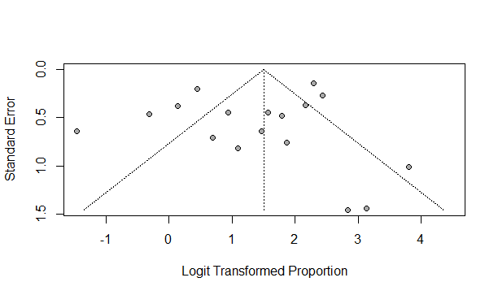

SHOCK
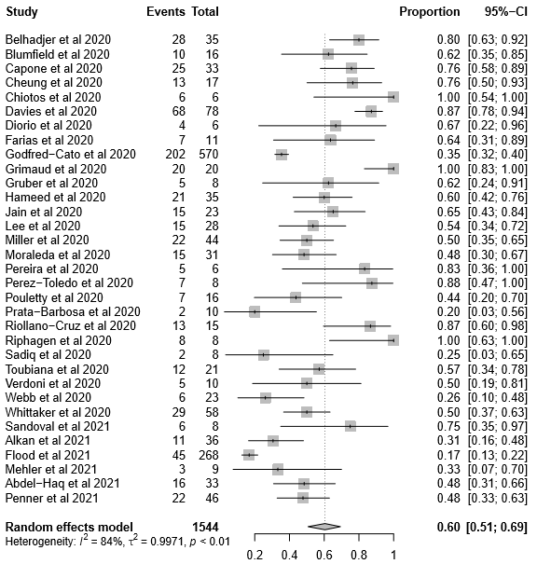
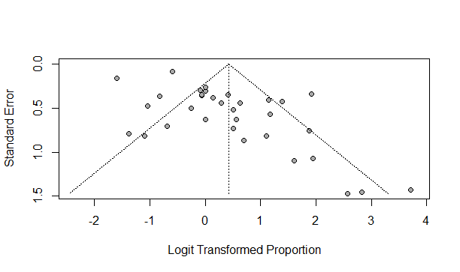

Hypotension
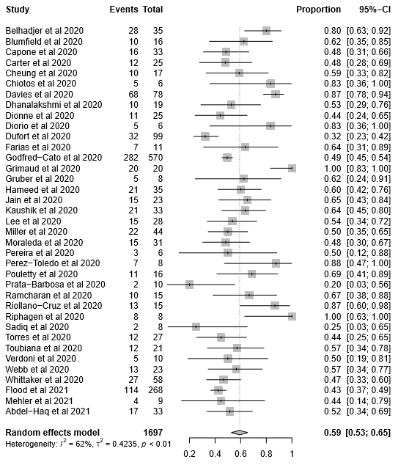
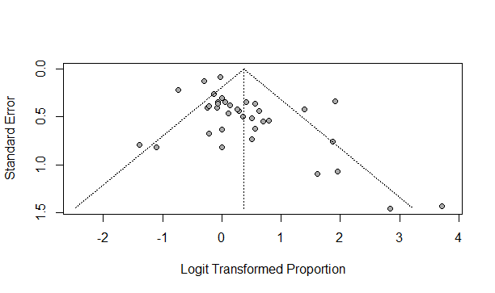

Pediatric intensive care unit (PICU)
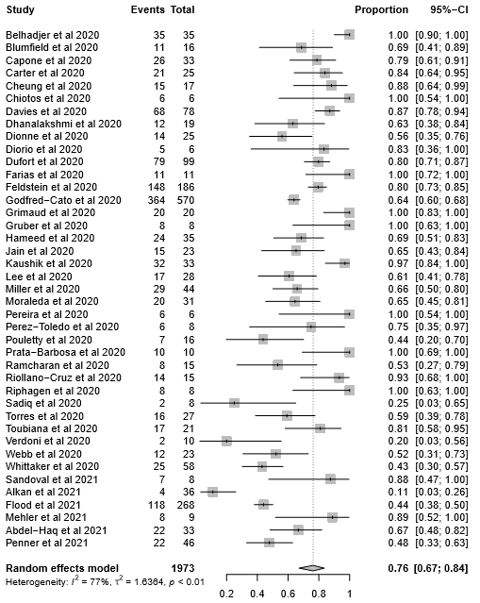
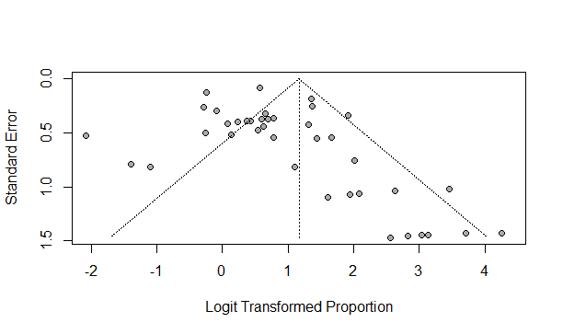

COMORBIDITIES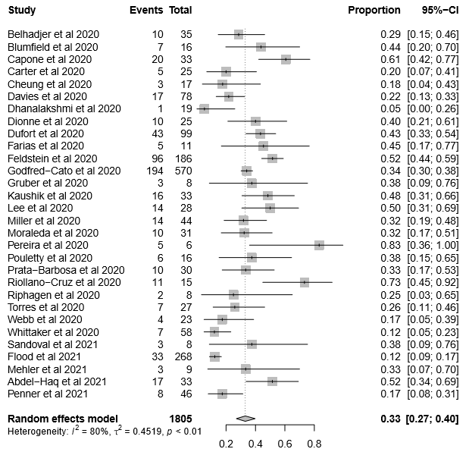
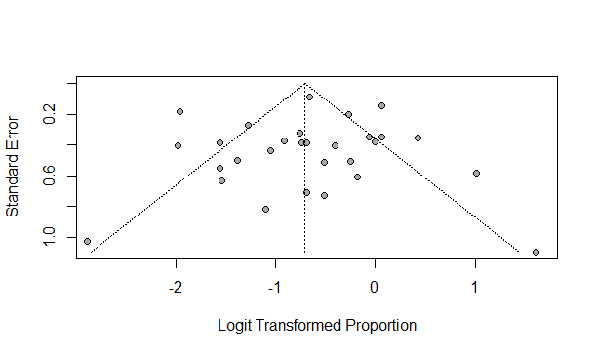

INOTROPICS
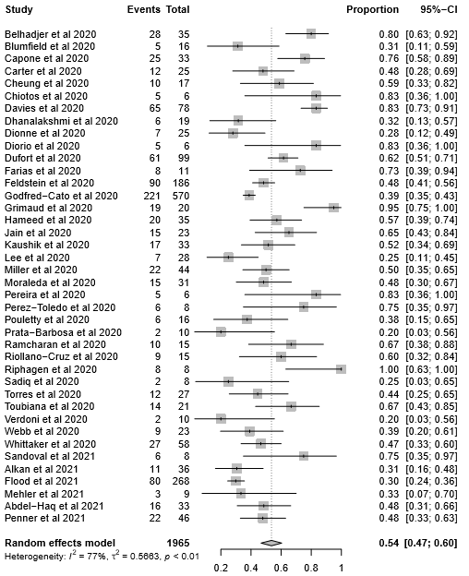
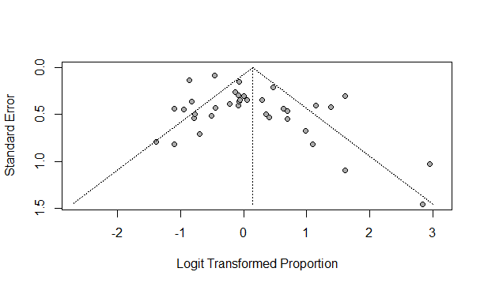
STEROIDES
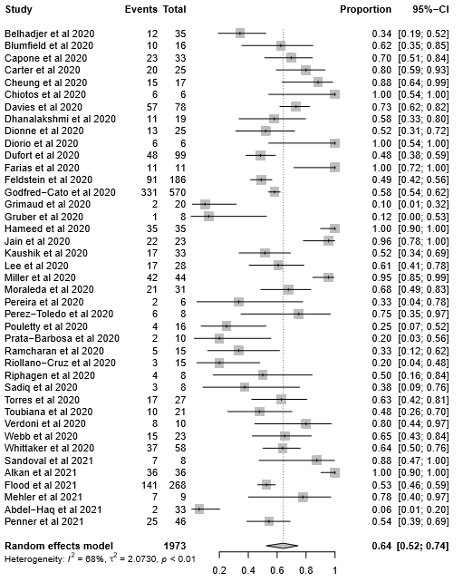

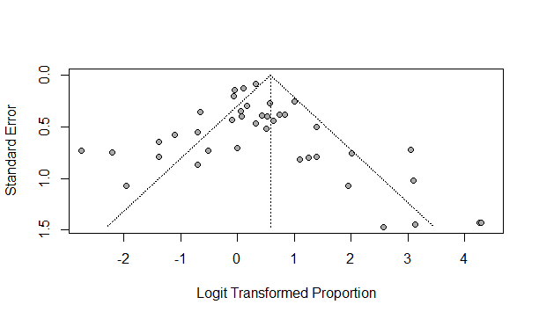

IVIG
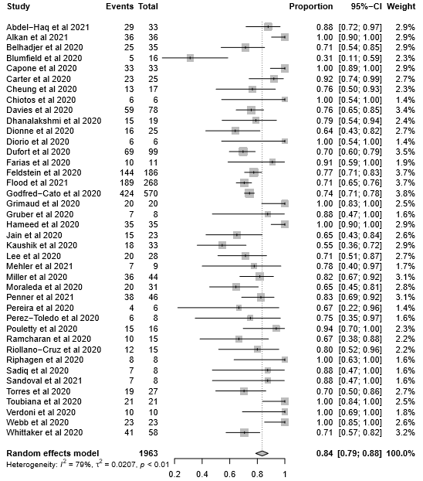
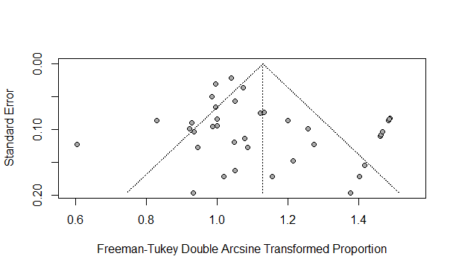

ANTIBIOTICS
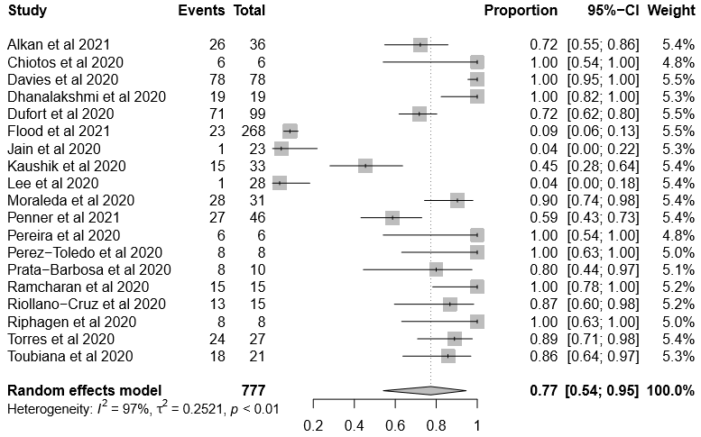
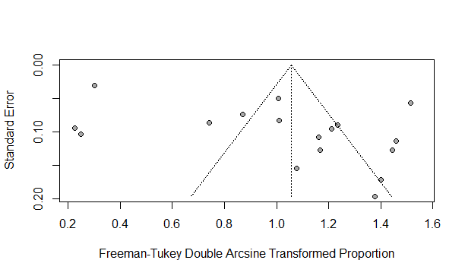

Antiplatelet/ Anticoagulation
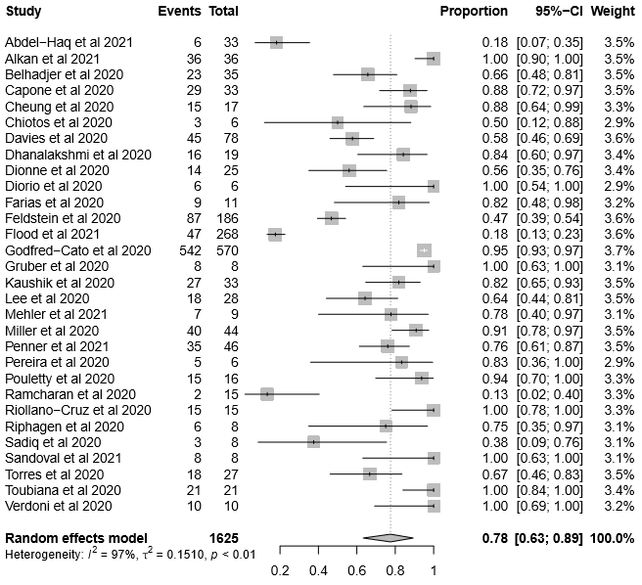
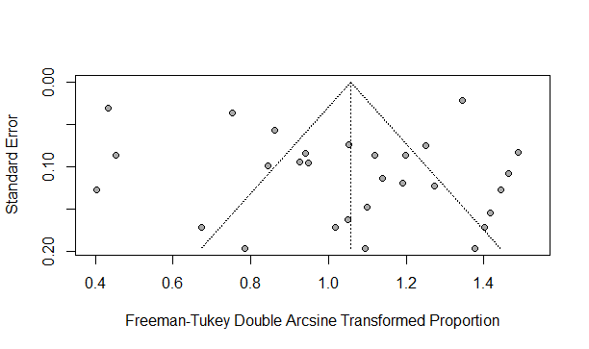

Biologic immunomodulation
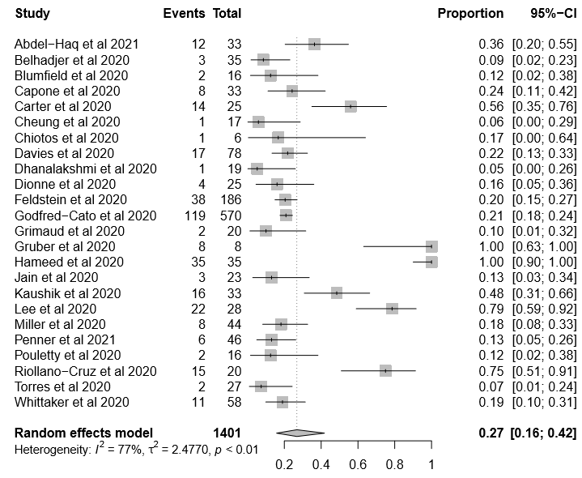
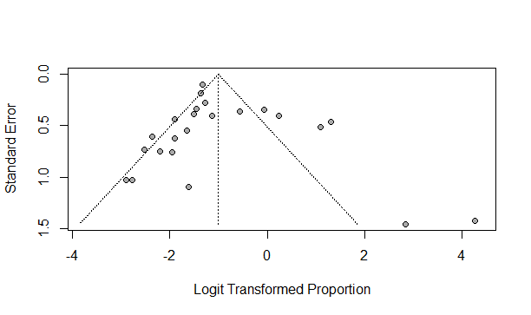

ANTIVIRAL THERAPY
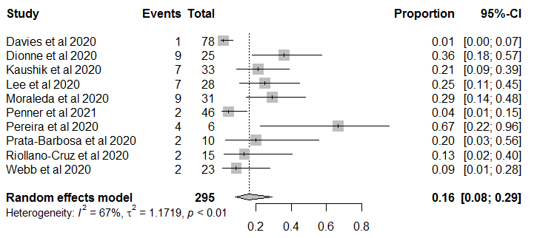
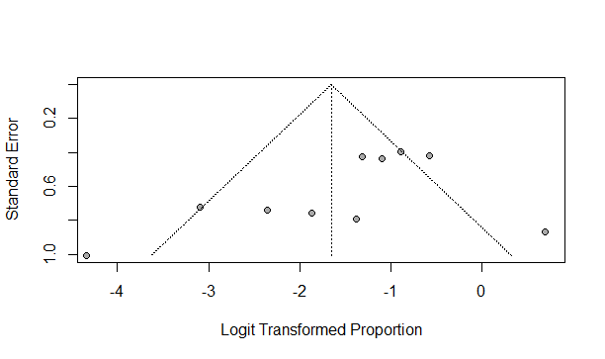

RESPIRATORY SUPPORT (MV/NIV/ HFNC)
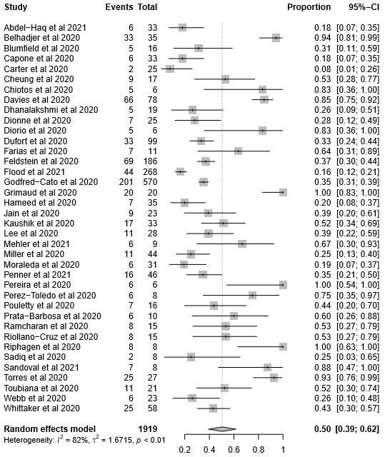
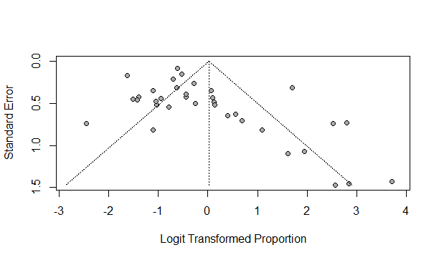

ECMO
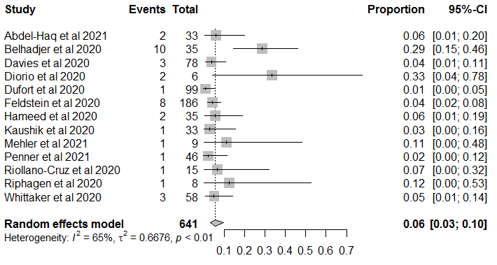
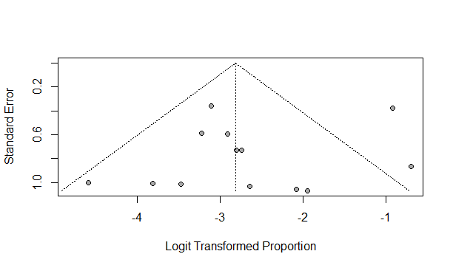

RECOVERED PATIENTS
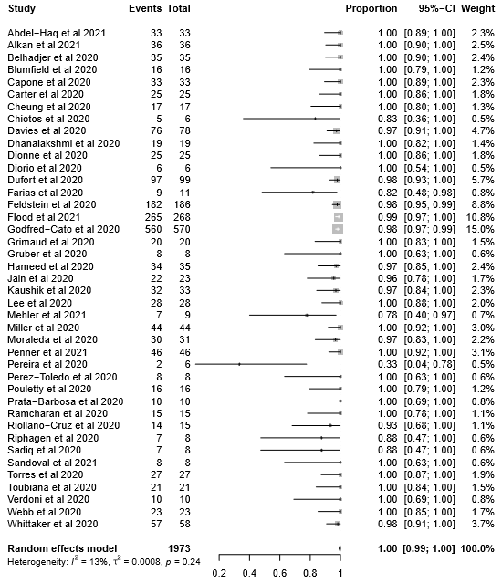
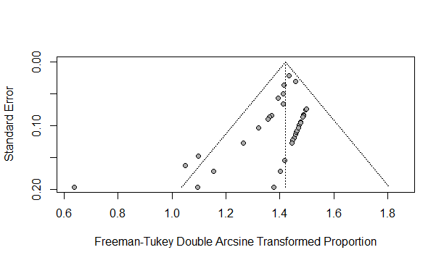
DEATH
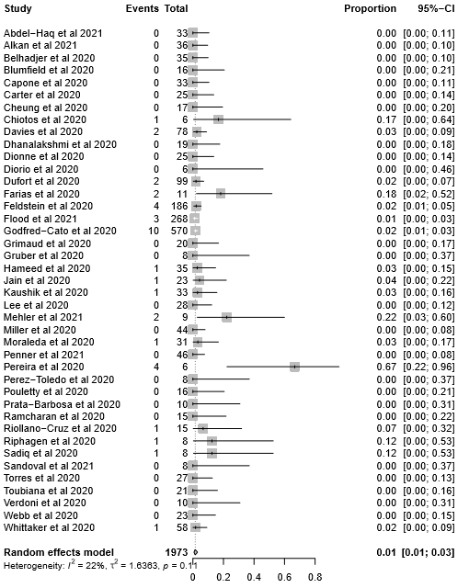
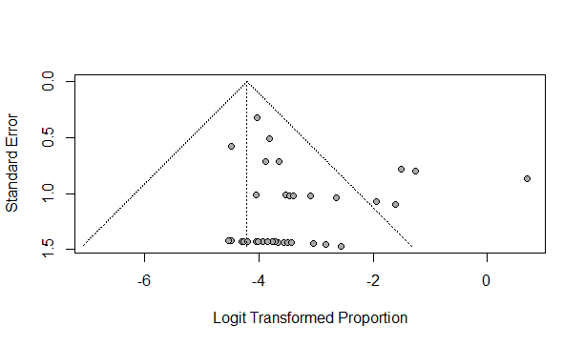

CARDIAC SYMPTOMS
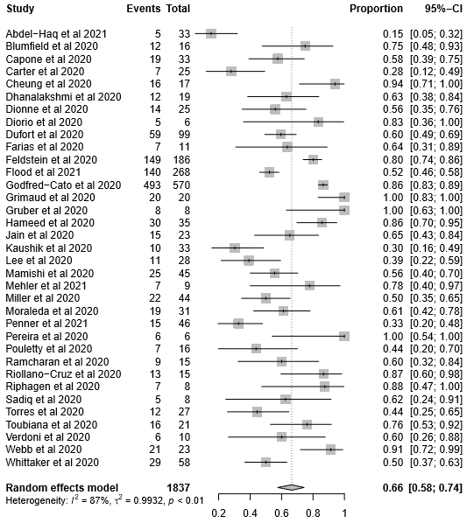
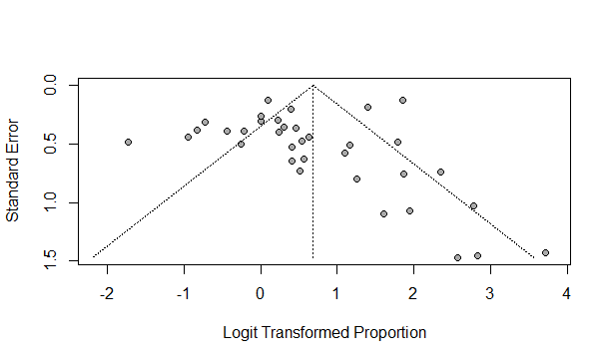

NEUROLOGIC SYMPTOMS
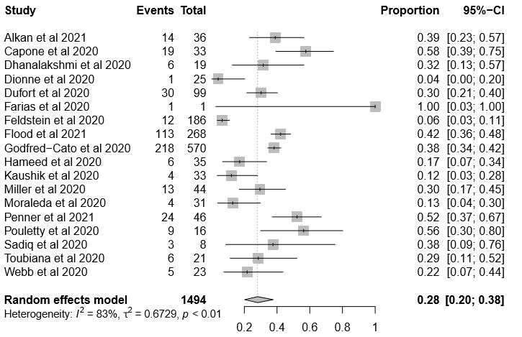
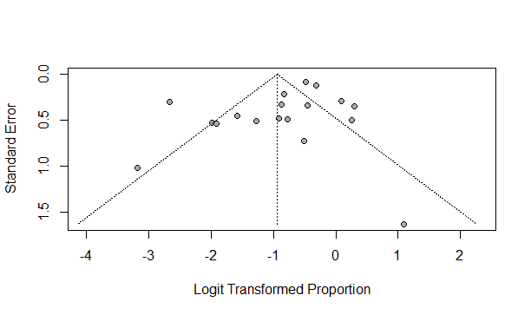

RESPIRATORY SYMPTOMS
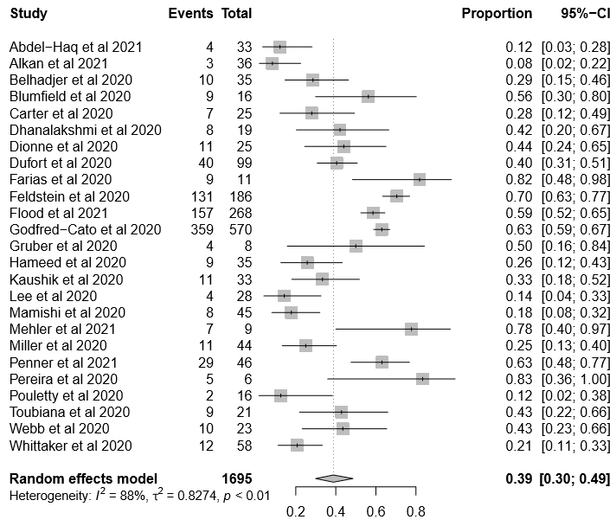
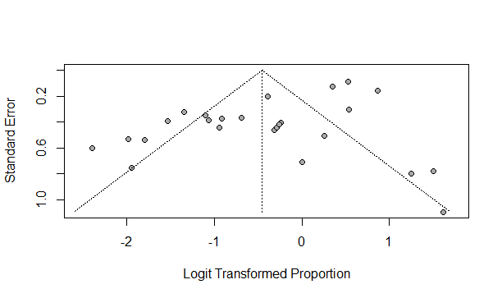

Exams RT-PCR
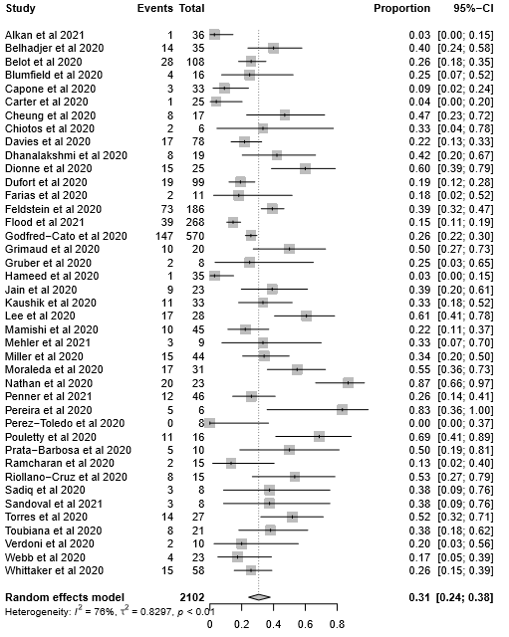
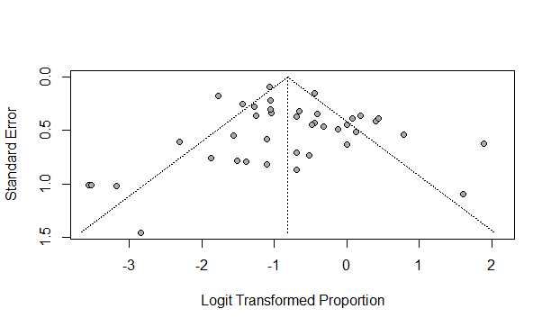

Exams SOROLOGY
