JPED-D-21-00418 - Supplementary material

Supplementary Figure 1 - Frequency of rhinovirus and SARS-CoV-2 detection. Lighter shading indicates that only the single pathogen was detected, and darker shading indicates the pathogen was detected in combination with at least one other pathogen. (A) 93.1% of rhinovirus single detection, and 6.9% of co-detection of adenovirus, coronavirus NL63, enterovirus or Mycoplasma pneumoniae, and (B) 99.0% of SARS-CoV-2 single detection, and 1.0% of co-detection of enterovirus.
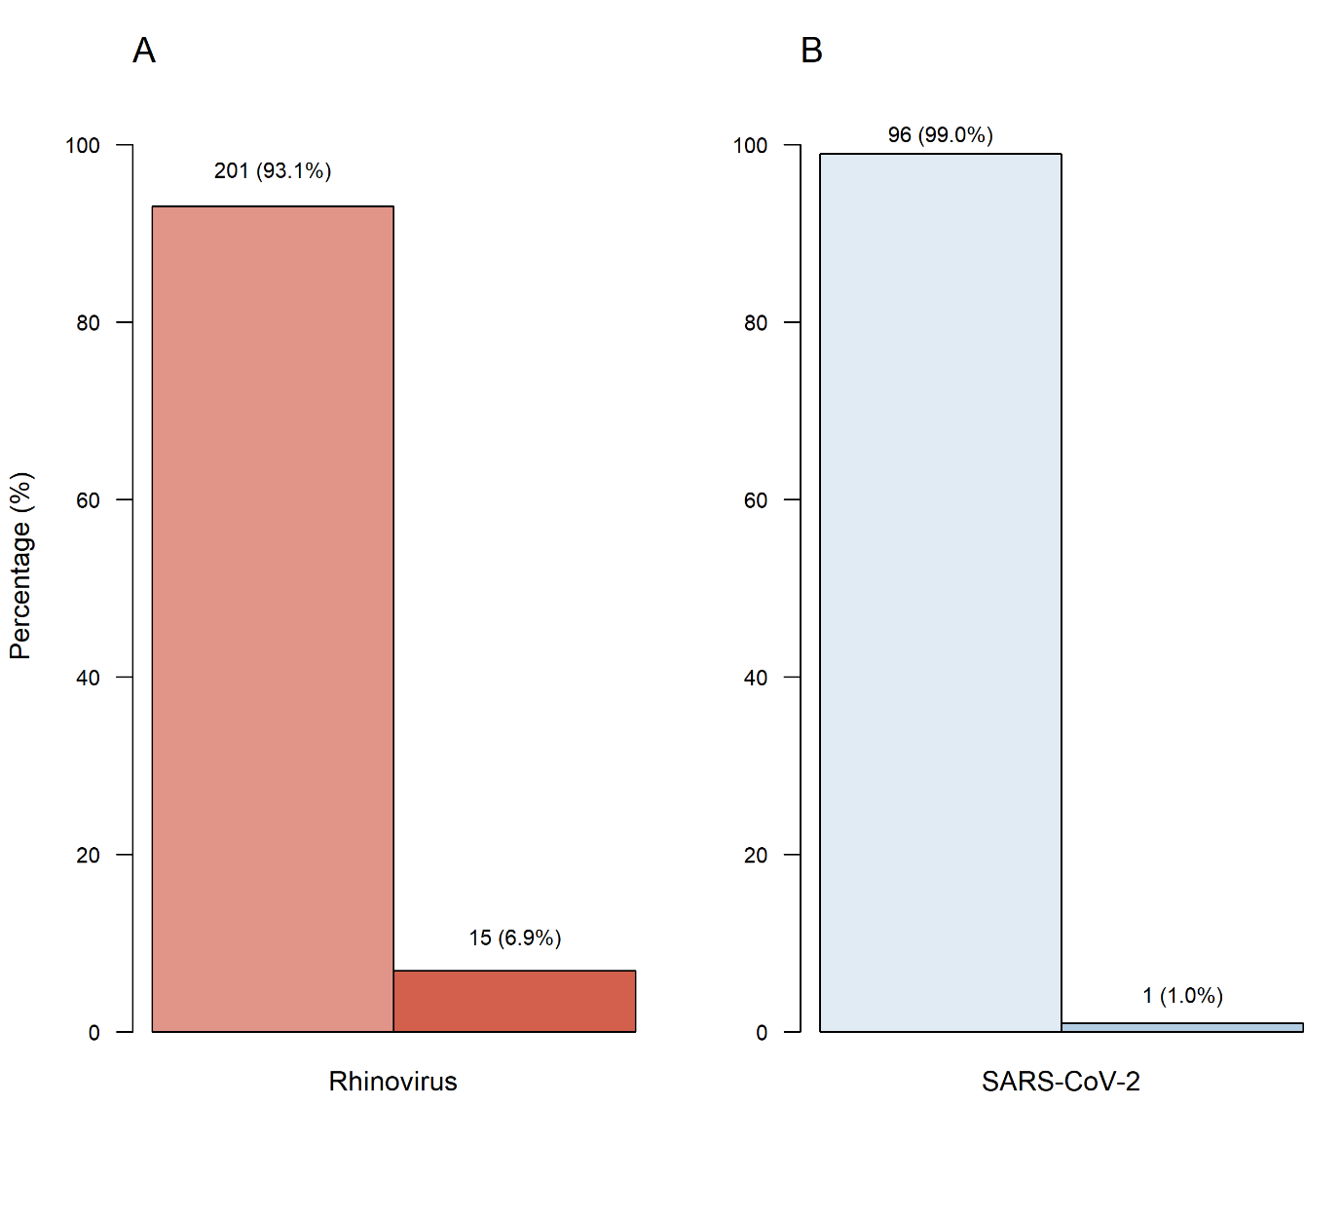

Supplementary Table 1 - Probe access code for the target pathogens used in the real time PCR respiratory panel. (RVSA) Respiratory syncytial virus type A. (RVSB) Respiratory syncytial virus type B.
Organisms | Target | Assay ID
Bacteria | Bordetella pertussis | Ba06439623_s1
 | Chlamydophila pneumoniae | Ba06439616_s1
 | Mycoplasma pneumoniae | Ba06439620_s1
Viruses | Adenovirus 1 and 2 | Vi99990001_po
 | Bocavirus | Vi99990003_po
 | Coronavirus HKU1 | Vi06439674_s1
 | Coronavirus 229E | Vi06439671_s1
 | Coronavirus NL63 | Vi06439673_s1
 | Coronavirus OC43 | Vi06439646_s1
 | Influenza A H1 | Vi99990009_po
 | Influenza A H3 | Vi06439630_s1
 | Influenza B PAN | Vi06439668_s1
 | Human Enterovirus | Vi06439631_s1
 | Metapneumovirus | Vi99990004_po
 | Parainfluenza 1 | Vi06439642_s1
 | Parainfluenza 2 | Vi06439672_s1
 | Parainfluenza 3 | Vi06439670_s1
 | RSVA | Vi99990014
 | RSVB | Vi99990015
 | Rhinovirus | Vi99990016_po

Supplementary Table 2 - Clinical and demographic characteristics, and pathogen detection of the included subjects. (IQR) Interquartile range. (FLU) Influenza. (ICU) Intensive care units.
Characteristics | Total  (n = 436) | Losses  (n = 14)
Age, median (IQR) | 5.4 (2.0-10.2) | 7.3 (1.6-10.3)
Female sex, n (%) | 233 (53.4) | 9 (64.3)
Racial or ethnic group
Caucasian, n (%) | 301/417 (72.2) | -
Non-caucasian, n (%) | 116/417 (27.8) | -
Duration of symptoms at inclusion
Days, median (IQR) | 3.0 (1.0-4.0) | 2.0 (2.0-2.0)
Duration of symptoms at hospitalization
Days, median (IQR) | 2.0 (1.0-5.2) | -
Hospital at inclusion
Private hospital, n (%) | 215 (49.3) | 4 (28.6)
Public hospital, n (%) | 221 (50.7) | 10 (71.4)
Pathogens
Adenovirus | 6/434 (1.4) | 0 (0.0)
Chlamydophila pneumoniae | 1/434 (0.2) | 0 (0.0)
Coronavirus NL63 | 2/434 (0.5) | 0 (0.0)
Enterovirus | 7/434 (1.6) | 0 (0.0)
Human metapneumovirus | 2/434 (0.5) | 0 (0.0)
Mycoplasma pneumoniae | 6/434 (1.4) | 0 (0.0)
Rhinovirus | 216/434 (49.8) | 10 (71.4)
SARS-CoV-2 | 97 (22.2) | 5 (35.7)
Coinfections
Rhinovirus and SARS-CoV-2 | 31 (7.1) | 2 (14.3)
SARS-CoV-2 and enterovirus | 1 (0.2) | 0 (0.0)
Rhinovirus and others | 15 (3.4) | 0 (0.0)
None pathogens | 145 (33.3) | 13 (92.9)
Use of azithromycin at inclusion
Yes, n (%) | 14 (3.2) | 0 (0.0)
Use of other antibiotics at inclusion
Yes, n (%) | 13 (3.0) | 0 (0.0)
FLU vaccination
Yes, n (%) | 262 (60.1) | -
Underlying medical conditions
Asthma, n (%) | 68 (15.6) | 4 (28.6)
Diabetes mellitus, type 1, n (%) | 1 (0.2) | 0 (0.0)
Obesity, n (%) | 1/233 (0.4) | 0 (0.0)
Hypertension, n (%) | 1 (0.2) | 0 (0.0)
Symptoms at inclusion
Cough, n (%) | 313/435 (72.0) | 10 (71.4)
Coryza, n (%) | 302 (69.3) | 10 (71.4)
Sore throat, n (%) | 163/388 (42.0) | 8/12 (66.7)
Stuffy nose, n (%) | 218/432 (50.5) | 8 (57.1)
Dyspnea, n (%) | 148/429 (34.5) | 3 (21.4)
Sputum production, n (%) | 154 (35.3) | 4 (28.6)
Nausea, n (%) | 121/419 (28.9) | 8 (57.1)
Diarrhea, n (%) | 112/434 (25.8) | 2 (14.3)
Vomiting, n (%) | 99/436 (22.7) | 4 (28.6)
Fever, n (%) | 302/435 (69.4) | 11 (78.6)
Headache, n (%) | 195/373 (52.3) | 7/10 (70.0)
Malaise, n (%) | 201/425 (47.3) | 8 (57.1)
Myalgia, n (%) | 97/386 (22.2) | 4/11 (36.4)
Chills, n (%) | 118/413 (28.6) | 5/12 (41.7)
Dysgeusia, n (%) | 40/322 (12.4) | 2/9 (22.2)
Anosmia, n (%) | 39/324 (12.0) | 3/9 (33.3)
Appetite loss, n (%) | 212/432 (49.1) | 10 (71.4)
Conjunctivitis, n (%) | 82/432 (19.0) | 3/13 (23.1)
Skin rash, n (%) | 32/433 (7.4) | 1 (7.1)
Hospitalization
Use of supplemental oxygen, n (%) | 21 (4.8) | -
Admission at ICU, n (%) | 4 (0.9) | -
Use of invasive mechanical ventilation, n (%) | 0 (0.0) | -
Deaths, n (%) | 0 (0.0) | -

Supplementary Table 3 - Absolute number of tested pathogens and the frequency of detected ones.
Pathogen | Tested | Detected | Percent
Adenovirus | 434 | 6 | 1.4
Bocavirus | 434 | 0 | 0.0
Bordetella pertussis | 434 | 0 | 0.0
Chlamydophila pneumoniae | 434 | 1 | 0.2
Other Coronaviridae
Coronavirus HKU1 | 433 | 0 | 0.0
Coronavirus OC43 | 434 | 0 | 0.0
Coronavirus NL63 | 434 | 2 | 0.5
Coronavirus 229E | 434 | 0 | 0.0
Enterovirus | 434 | 7 | 1.6
Influenza
Influenza A (H1) | 434 | 0 | 0.0
Influenza A (H3) | 434 | 0 | 0.0
Influenza B | 434 | 0 | 0.0
Human metapneumovirus | 434 | 2 | 0.5
Mycoplasma pneumoniae | 434 | 6 | 1.4
Parainfluenza virus
Parainfluenza 1 | 434 | 0 | 0.0
Parainfluenza 2 | 434 | 0 | 0.0
Parainfluenza 3 | 434 | 0 | 0.0
Rhinovirus | 434 | 216 | 49.8
Respiratory syncytial virus
Respiratory syncytial virus A | 434 | 0 | 0.0
Respiratory syncytial virus B | 434 | 0 | 0.0

