JPED-D-21-00446 - Supplementary Material

Supplementary material 1 - Three pairs of sph-CT and USG images of the preoperative evaluation of three different patients with neuroblastoma.
(A) and (D) lesion involving 50% of the aorta; a white arrowhead shows the aorta, and a black arrowhead indicates the tumor. (B) and (E) tumor involving more than 50% of the circumference of the left renal artery; small white arrows indicate the artery with contrast in the sph-CT image and colored in blue in the Doppler USG. (C) and (F) Neuroblastoma of the right adrenal gland without a cleavage plane with the kidney both in sph-CT and USG images and that moved “en block” in the dynamic assessment.
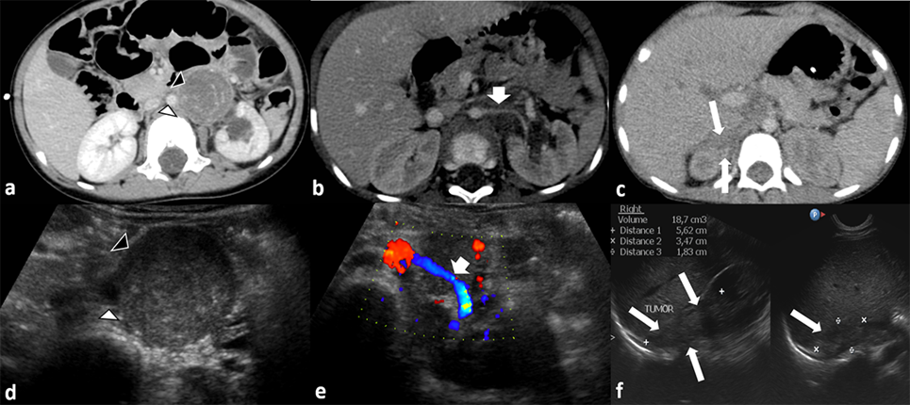

Supplementary material 2 - Performance of USG and CT examinations in assessing the invasion of adjacent structures (according to Groups 1-4).
 | SEN (%) | SPE (%) | PPV (%) | NPV (%) | AC (%)
Group 1 (solid organs)
CT | 93.1 | 84.1 | 75.6 | 95.8 | 87.3
95% CI | 85.9-96.8 | 77.7-88.9 | 67.1-83.0 | 91.2-98.1 | 82.6-90.9
USG | 88.7 | 95.1 | 90.8 | 93.9 | 92.8
95% CI | 80.7-93.7 | 90.5-97.4 | 82.9-95.3 | 89.1-96.7 | 89.0-95.4
p | 0.446 | 0.002 | 0.011 | 0.614 | 0.055
Group 2 (vessels)
CT | 91.2 | 91 | 82.2 | 95.8 | 91.1
95% CI | 83.6-95.4 | 86.3-94.2 | 73.6-88.4 | 92-97.9 | 87.3-93.9
USG | 92.3 | 92.1 | 83.2 | 96.6 | 92.2
95% CI | 85.0-96.2 | 87.7-95 | 74.7-89.2 | 93.2-98.3 | 88.6-94.7
p | 0.999 | 0.836 | 0.999 | 0.882 | 0.852
Group 3 (GI organs)
CT | 85.7 | 80 | 60 | 94.1 | 81.5
95% CI | 60-95.9 | 65.2-89.5 | 38.7-96.9 | 80.9-98.4 | 69.2-89.6
USG | 63.6 | 97.9 | 87.5 | 92.2 | 91.5
95% CI | 35.5-84.8 | 89.1-99.6 | 52.9-97.8 | 81.5-96.9 | 81.7-96.3
p | 0.417 | 0.016 | 0.337 | 0.999 | 0.196
Group 4 (musc. structures)
CT | 81.8 | 85.2 | 64.3 | 93.6 | 84.4
95% CI | 65.6-91.3 | 77.1-90.8 | 49.2-77 | 86.6-97 | 77.4-89.6
USG | 74.2 | 97.3 | 88.5 | 93.1 | 92.3
95% CI | 56.7-86.3 | 92.3-99 | 71-96 | 87-96.5 | 86.7-95.6
p | 0.664 | 0.004 | 0.056 | 0.999 | 0.065
95%CI, 95% confidence interval; AC, accuracy; CT, computed tomography; NPP, negative predictive value; PPV, positive predictive value; SEN, sensitivity; SPE, specificity; USG, ultrasonography; GI: gastrointestinal; NPV, negative predictive value. p- comparison by the Chi-Squared test and Yates correction.

