JPED-D-22-00108 - Supplementary Material

Figure 1 - Stages of study.
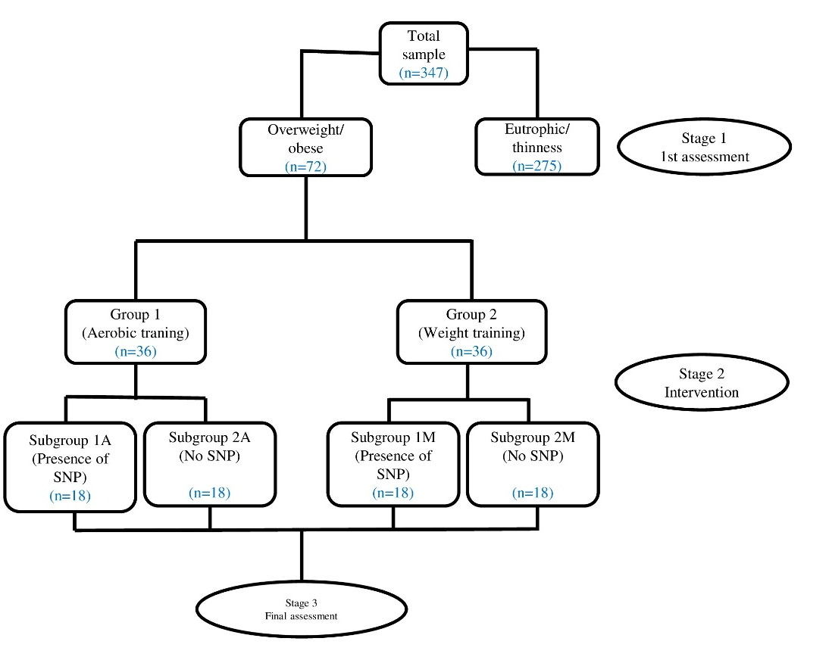
SNP, single nucleotide polymorphisms.

