JPED-D-22-00093 – Supplementary Material

Figure S1 - Flow diagram of patient inclusion.

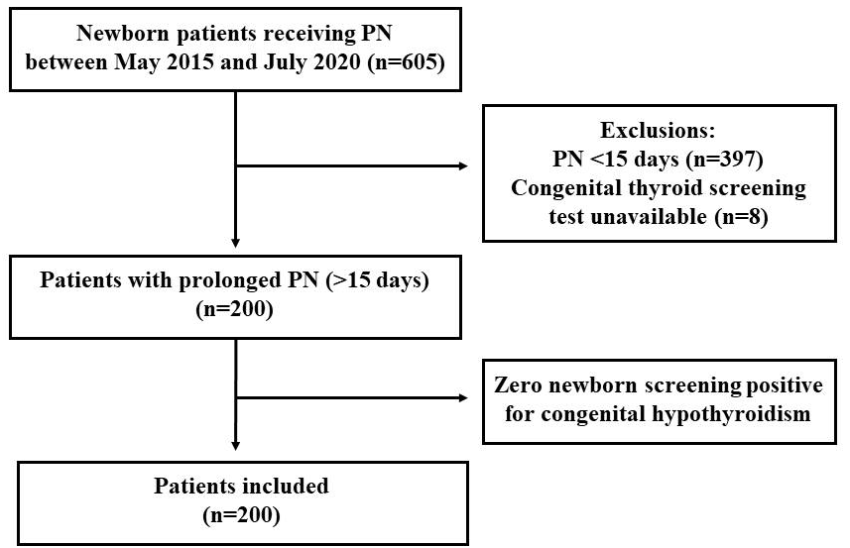

Table S1 - Evaluation of thyroid function in newborns receiving PN >15 days.
First measurement (n = 143)
Variable | Value
Age, days ª | 43 (31–67)
TSH, mU/L | 3.76 (2.24–6.13)
fT4, ng/dL | 1.20 ± 0.38
CRP, mg/L | 11.8 (1.10–24.4)
Second measurement (n = 68)
Variable | Value
Age, days ^{b} | 62 (48–90)
TSH, mU/L | 4.86 (2.77–7.15)
fT4, ng/dL | 1.20 ± 0.39
CRP, mg/L | 8.0 (1.0–22.9)
CRP, C-reactive protein; PN, parenteral nutrition; TSH, thyroid-stimulating hormone; fT4, free thyroxine.
Note: Data expressed as n (%), mean ± SD, or median (interquartile range).
ª Age at first measurement.
^{b} Age at second measurement.

Table S2 - Comparisons between newborns receiving PN >15 days according to TSH measurement: measured versus not measured.
Variables | TSH measured  (n = 143) | TSH not measured  (n = 57) | p
Age at PN initiation, daysª | 1 (1–1) | 2 (1–3) | <.001
Sex, male^{b} | 81 (57.3) | 28 (49.1) | .37
Cesarean delivery^{b} | 102 (71.3) | 38 (66.7) | .63
GA, weeks^{c} | 29 ± 4 | 36 ± 4 | <.001
GA classification, preterm^{b} | 133 (93.0) | 23 (40.4) | <.001
Apgar, 1-minute^{c} | 5 ± 2 | 6 ± 3 | .004
Apgar, 5-minute^{c} | 7 ± 2 | 8 ± 2 | .002
Birth weight, gª | 1030 (765–1535) | 2675 (1995–3108) | <.001
Birth weight classification^{b}
ELBW | 69 (48.3) | 4 (7.0) | <.001
VLBW | 36 (25.2) | 3 (5.3)
LBW | 26 (18.2) | 16 (28.1)
Normal | 12 (8.4) | 33 (57.9)
Length, cm^{c} | 36.8 ± 5.4 | 45.2 ± 4.8 | <.001
Head circumference, cm^{c} | 26.2 ± 3.7 | 31.9 ± 3.4 | <.001
Thoracic circumference, cm^{c} | 23.3 ± 4.2 | 29.3 ± 3.8 | <.001
Abdominal circumference, cm^{c} | 21.7 ± 4.5 | 28.1 ± 4.9 | <.001
Supplemental PN^{b} | 142 (99.3) | 51 (89.5) | .003
PN duration, daysª | 36 (23–49) | 24 (18–30) | <.001
Length of hospital stay, daysª | 89 (62–123) | 35 (27–49) | <.001
Death^{b} | 14 (9.8) | 9 (15.8) | .34
ELBW, extremely low birth weight; GA, gestational age; LBW, low birth weight; PN, parenteral nutrition; TSH, thyroid-stimulating hormone; VLBW, very low birth weight.
Note: Data expressed as n (%), mean ± SD, or median (interquartile range), and p<.05 is considered statistically.
ª Mann-Whitney test.
^{b} Chi-square test.
^{c} Student’s T-test.

Table S3 - Comparisons between newborns with PN >15 days receiving inorganic (Lugol’s) iodine: hypothyroidism versus normal TSH.
Variables | Hypothyroidism  (n = 10) | Normal TSH  (n = 13) | p
Age at PN initiation, daysª | 1 ( 1–4) | 1 (1–2) | .74
Sex, male^{b} | 5 (50.0) | 10 (76.9) | .22
Cesarean delivery^{b} | 7 (70.0) | 9 (69.2) | .97
GA, weeksª | 27 (25–35) | 32 (26–35) | .31
GA classification, preterm^{b} | 9 (90.0) | 11 (84.6) | .70
Apgar, 1-minuteª | 4 (2–5) | 7 (2–8) | .13
Apgar, 5-minuteª | 7 (5–8) | 8 (4–9) | .61
Birth weight, gª | 683 (593–2110) | 1250 (660–2618) | .38
Length, cmª | 32.0 (30.0–43.5) | 38.0 (30.5–46.5) | .45
Head circumference, cmª | 23.0 (21.9–31.3) | 28.0 (22.5–30.5) | .48
Thoracic circumference, cmª | 20.0 (19.0–21.0) | 25.3 (19.6–29.8) | .18
Abdominal circumference, cmª | 17.8 (17.1–19.6) | 20.3 (17.4–27.5) | .20
Supplemental PN^{b} | 10 (100.0) | 13 (100.0) | -
PN duration, daysª | 84 (41–123) | 63 (48–197) | .69
Length of hospital stay, daysª | 127 (71–184) | 166 (115–240) | .29
GA, gestational age; PN, parenteral nutrition; TSH, thyroid-stimulating hormone.
Note: Data expressed as n (%), mean ± SD, or median (interquartile range), and p<.05 is considered statistically.
ª Mann-Whitney test.
^{b} Chi-square test.

