Supplementary Material:
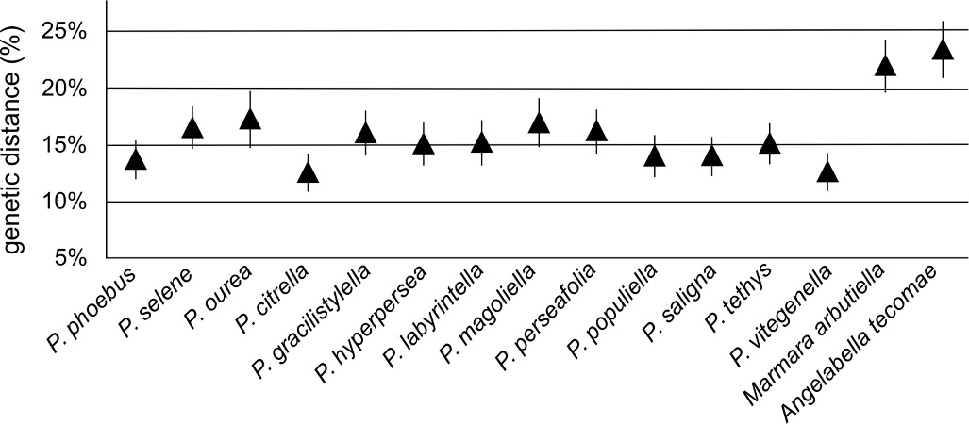
Fig. S1. Graph depicting pairwise genetic distance (in percentage) between P. hemera and other congeners, as well as outgroups (Angelabella and Marmara) based on 660 base pairs of the ‘DNA barcode’ region of the cytochrome oxidase I (COI) gene, using the Kimura 2-parameter model.

