Supplementary Material

Figure S2 A, Correlation between composite Z scores on postoperative 7th day and duration of anesthesia. B, Correlation between composite Z scores on postoperative 7th day and duration of Trendelenburg.
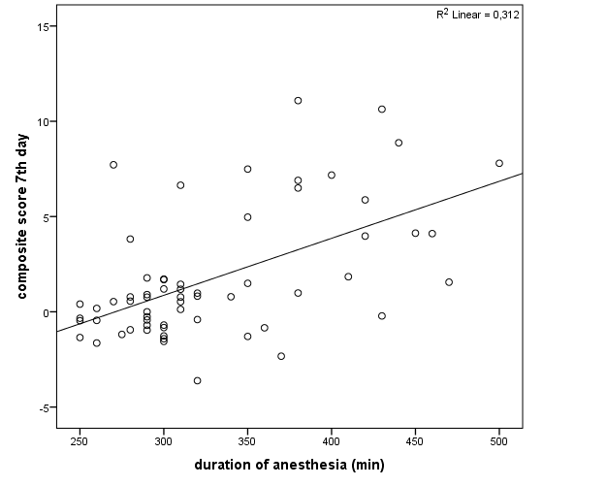
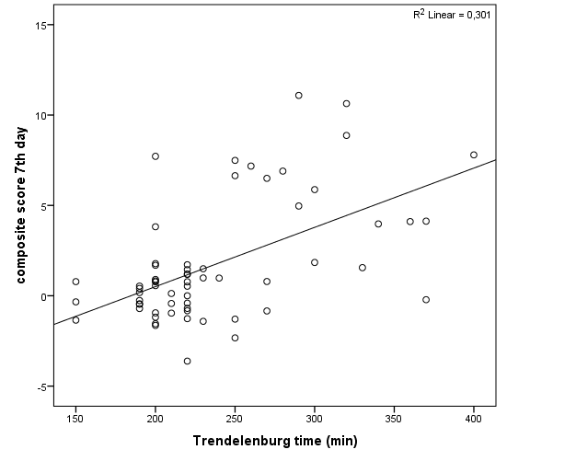

Figure S3 A, ROC curves of S100B for patients with POCD on postoperative 7th day. B, ROC curves of S100B for patients with POCD on postoperative 3rd month.
