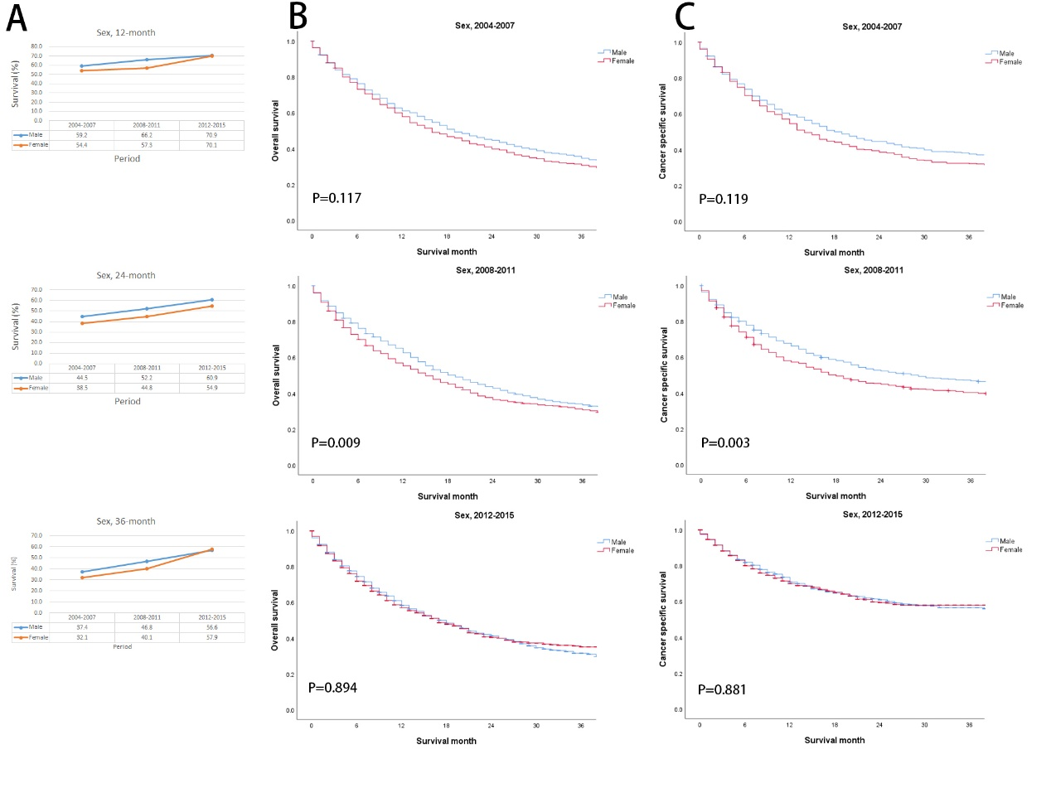
Supplemental online Figure 1. Analysis of survival advanced Upper tract urothelial carcinoma patients at 18 Surveillance, Epidemiology, and End Results Program sites according to sex from 2004 to 2015. (A): 12-, 24-, and 36-month relative survival rates (RSRs) according to sex. (B): Kaplan-Meier survival curves for overall survival according to sex and study periods. (C): Kaplan-Meier survival curves for cancer specific survival according to sex and study periods.

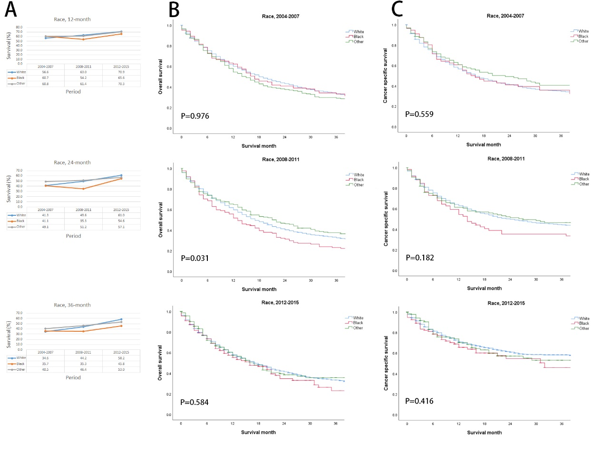
Supplemental online Figure 2. Analysis of survival advanced Upper tract urothelial carcinoma patients at 18 Surveillance, Epidemiology, and End Results Program sites according to race from 2004 to 2015. (A): 12-, 24-, and 36-month relative survival rates (RSRs) according to race. (B): Kaplan-Meier survival curves for overall survival according to race and study periods. (C): Kaplan-Meier survival curves for cancer specific survival according to race and study periods.

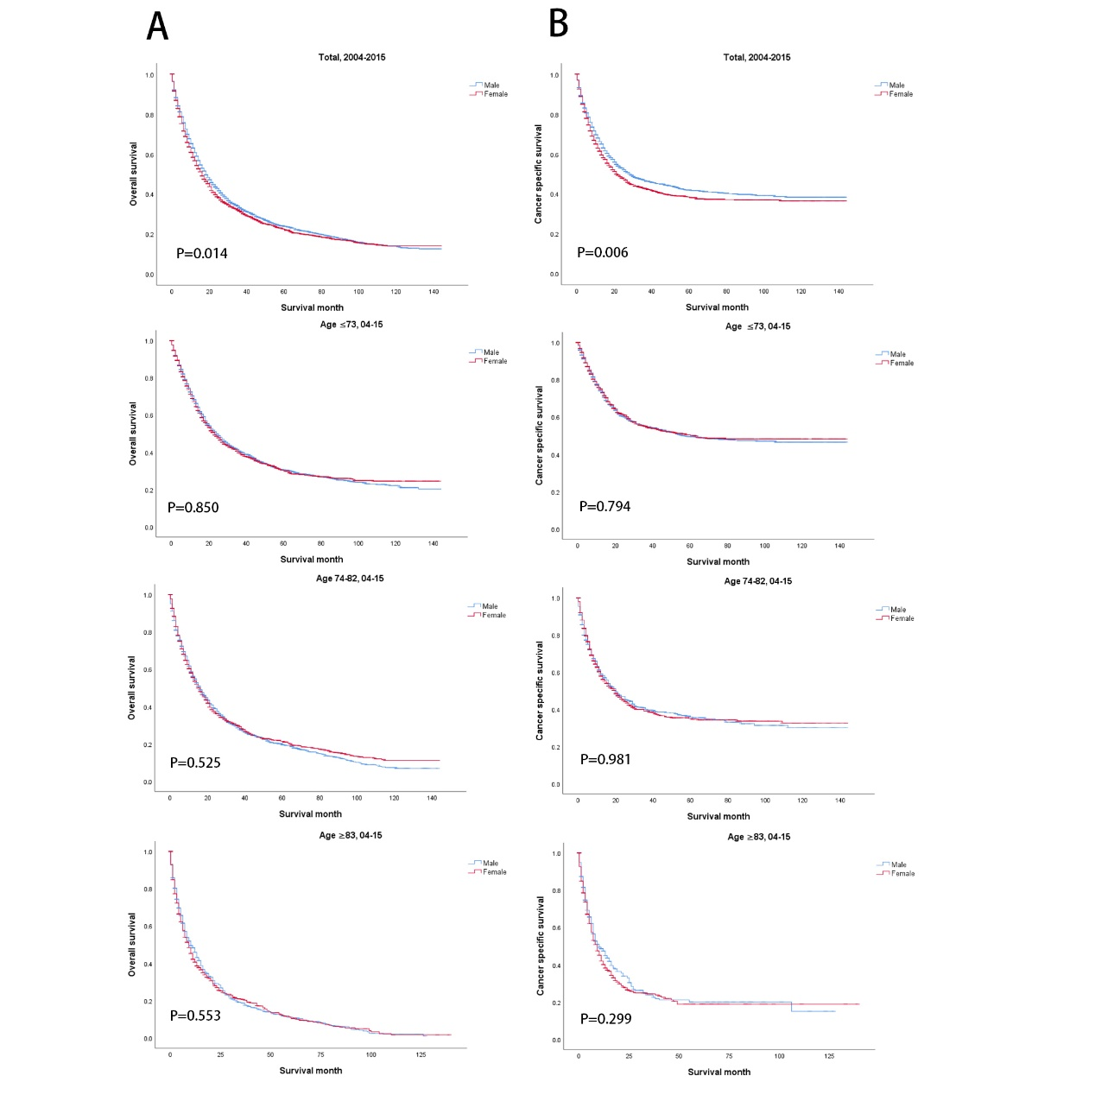
Supplemental online Figure 3. Analysis of survival advanced Upper tract urothelial carcinoma patients at 18 Surveillance, Epidemiology, and End Results Program sites according to sex from 2004 to 2015. (A): Kaplan-Meier survival curves for overall survival according to sex and age. (B): Kaplan-Meier survival curves for cancer specific survival according to sex and age.

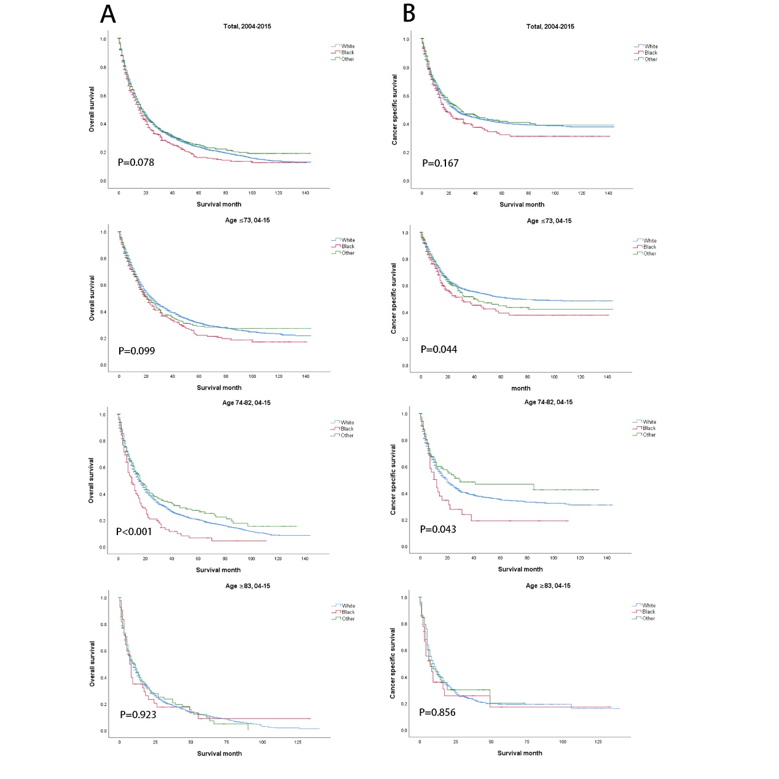
Supplemental online Figure 4. Analysis of survival advanced Upper tract urothelial carcinoma patients at 18 Surveillance, Epidemiology, and End Results Program sites according to race from 2004 to 2015. (A): Kaplan-Meier survival curves for overall survival according to race and age. (B): Kaplan-Meier survival curves for cancer specific survival according to race and age.

Supplemental Table 1. Incidence of I-II UTUC and III-IV UTUC based mortality rate per 100000 patients diagnosed with UTUC with time
Variables | Incidence rate % (n*)
 | 2004-2007 | 2008-2011 | 2012-2015
Stage
I-II | 0.64 (2116) | 0.63 (2160) | 0.58 (2058)
III-IV | 0.69 (2287) | 0.74 (2524) | 0.77 (2712)
Age(years)**
≤73 | 0.37 (1162) | 0.40 (1303) | 0.43 (1434)
74-82 | 6.40 (849) | 6.61 (883) | 6.69 (928)
≥83 | 5,63 (276) | 5.93 (338) | 5.50 (350)
Sex**
Male | 0.82 (1329) | 0.88 (1493) | 0.92 (1607)
Female | 0.57 (958) | 0.59 (1031) | 0.62 (1105)
Race**
White | 0.80 (2014) | 0.85 (2199) | 0.88 (2334)
Black | 0.25 (103) | 0.29 (125) | 0.30 (135)
Other*** | 0.47 (168) | 0.48 (196) | 0.53 (235)
SES*
Poor | 0.67 (1457) | 0.71 (1613) | 0.72 (1696)
Rich | 0.75 (830) | 0.79 (910) | 0.85 (1016)
*. referring to the possible occurrence of the disease within the 18 SEER Sites at the same time.
**. the incidence rate of stage III-IV UTUC.
***. American Indian, Aleutian, Alaskan Native, Eskimo (includes all indigenous populations of the western hemisphere), Chinese and Japanese.

Supplemental Table 2. Thirty six-month relative survival rates in stage III-IV UTUC at 18 Surveillance, Epidemiology, and End Results Program sites according to sex, age group, and study periods from 2004 to 2015
Age group, years | Mean±SEM (n)
 | Male | Female
2004-2007
All | 37.4±1.9 (656) | 32.1±2.1 (505)
≤73 | 49.4±2.5 (396) | 48.4±3.4 (221)
74-82 | 23.5±3.1 (184) | 25.9±3.3 (179)
≥83 | 9.2±3.3 (76) | 8.6±2.7 (105)
2008-2011
All | 46.8±1.8 (789) | 40.1±2.1 (570)*
≤73 | 54.2±2.3 (462) | 52.6±3.2 (251)
74-82 | 41.8±3.2 (234) | 39.4±3.6 (186)
≥83 | 22.6±4.3 (93) | 17.5±3.3 (133)
2012-2015
All | 56.6±2.0 (1142) | 57.9±2.2 (811)
≤73 | 63.2±2.7 (623) | 67.4±3.1 (370)
74-82 | 53.9±3.5 (355) | 56.6±4.1 (259)
≥83 | 36.1±5.8 (164) | 42.6±4.6 (182)
* p<0.01 compared with the previous period.
Abbreviation: SEM, standard error of the mean.

Supplemental Table 3. Thirty six-month relative survival rates in stage III-IV UTUC at 18 Surveillance, Epidemiology, and End Results Program sites according to race, age group, and study periods from 2004 to 2015
Age group, years | Mean±SEM (n)
 | White | Black | Other
2004-2007
All | 34.6±1.5 (1009) | 35.7±6.4 (56) | 40.5±5.1 (96)
≤73 | 49.0±2.2 (522) | 42.1±8.0 (38) | 53.6±6.7 (57)
74-82 | 24.2±2.4 (328) | 16.7±10.8 (12) | 36.8±10.3 (23)
≥83 | 8.8±2.2 (159) | 33.3±10.2 (6) | 6.3±6.1 (16)
2008-2011
All | 44.2±1.4 (1183) | 38.8±6.4 (59) | 46.4±4.8 (117)
≤73 | 55.3±2.0 (611) | 43.5±7.8 (41) | 43.5±6.5 (61)*
74-82 | 39.6±2.6 (369) | 22.2±13.9 (9) | 55.8±7.9 (43)
≥83 | 19.2±2.8 (204) | 11.1±10.5 (9) | 30.8±12.8 (13)
2012-2015
All | 58.2±1.6 (1676) | 45.8±7.9 (95) | 53.0±5.2 (182)
≤73 | 66.4±2.1 (837) | 49.5±10.6 (62) | 60.0±7.0 (94)
74-82 | 56.5±2.8 (535) | 38.4±13.2 (21) | 43.9±10.2 (58)
≥83 | 39.3±3.9 (304) | 40.0±14.6 (12) | 48.7±10.7 (30)
* p<0.01 compared with the previous period.
Abbreviation: SEM, standard error of the mean.

Supplemental Table 4. Thirty six-month relative survival rates in stage III-IV UTUC at 18 Surveillance, Epidemiology, and End Results Program sites according to SES, age group, and study periods from 2004 to 2015
Age group, years | Mean±SEM (n)
 | Poor | Rich
2004-2007
All | 34.1±1.7 (743) | 36.4±2.9 (418)
≤73 | 49.3±2.6 (383) | 48.5±3.3 (234)
74-82 | 22.2±2.6 (255) | 30.6±4.4 (108)
≥83 | 7.6±2.6 (105) | 10.5±3.5 (76）
2008-2011
All | 41.1±1.7 (882) | 49.3±2.3 (477)**
≤73 | 50.6±2.3 (465) | 59.4±3.1 (248)**
74-82 | 35.5±2.9 (280) | 51.5±4.3 (140)*
≥83 | 20.6±3.5 (137) | 18.0±4.1 (89)
2012-2015
All | 56.7±1.9 (1213) | 57.7±2.5 (740)
≤73 | 64.5±2.6 (621) | 65.5±3.3 (372)
74-82 | 55.3±3.3 (377) | 54.0±4.6 (237)
≥83 | 38.1±4.5 (255) | 42.8±6.1 (131)
* p<0.01 compared with the previous period.
** p<0.05 compared with the previous period.
Abbreviation: SEM, standard error of the mean; SES, socioeconomic status.

