Supplementary Table S1: Quality Assessment (QUADAS) of included studies in meta-analysis.
Author | Representative patients and correct selection | Gold Standard adequate | Acceptable delay between test and GS | All patients did test and GS | All patients did the same GS | Test independence of GS | Blinded GS | Blinded test | Uninterpretable results | Explained losses
Angeletti²⁰ | Y | Y | U | Y | Y | Y | U | U | Y | Y
Riederer⁸ | Y | Y | U | Y | Y | Y | U | U | Y | Y
Egli²¹ | Y | Y | U | Y | Y | Y | U | U | Y | Y
Martinez²³ | Y | Y | Y | Y | Y | Y | U | U | Y | Y
Tadros²⁸ | Y | Y | U | Y | Y | Y | U | U | Y | Y
Schieffer²⁴ | Y | Y | N | Y | Y | Y | Y | Y | Y | Y
Rodriguez-Sanchez²⁶ | U | Y | U | Y | Y | Y | U | U | Y | Y
Gray²⁹ | U | Y | U
Martiny³⁰ | Y | Y | U | Y | Y | Y | U | U | Y | Y
Jamal³¹ | Y | Y | U | Y | Y | Y | U | U | Y | Y
Leli³² | Y | Y | U | Y | Y | Y | U | U | Y | Y
Chen³³ | Y | Y | U | Y | Y | Y | U | U | Y | Y
Nonneman³⁴ | Y | Y | Y | Y | Y | Y | Y | Y | Y | Y
March–Rosselló³⁵ | Y | Y | U | Y | Y | Y | U | U | Y | U
Clerc³⁶ | Y | Y | U | Y | Y | Y | U | U | Y | Y
Hoyos-Mallecot³⁷ | Y | Y | Y | Y | Y | Y | U | U | Y | Y
Lagacé-Wiens³⁸ | Y | Y | U | Y | Y | Y | U | U | Y | Y
Meex⁶ | Y | Y | U | Y | Y | Y | U | U | Y | Y
Saffert³⁹ | Y | Y | U | Y | Y | Y | U | U | Y | Y
Vlek⁴⁰ | Y | Y | Y | Y | Y | Y | U | U | Y | Y
Martiny⁴¹ | Y | Y | U | Y | Y | Y | U | U | Y | Y
Buchan⁴² | Y | Y | Y | Y | Y | Y | U | U | Y | Y
Loonen⁴³ | Y | Y | U | Y | Y | Y | U | U | Y | Y
Klein⁴⁴ | Y | Y | Y | Y | Y | Y | U | U | Y | Y
Juiz¹⁶ | Y | Y | Y | Y | Y | Y | U | U | Y | Y
Fulsgsam⁴⁵ | Y | Y | Y | Y | Y | Y | U | U | Y | Y
Schubert⁴⁶ | Y | Y | U | Y | Y | Y | U | U | Y | Y
Kok⁴⁷ | Y | Y | U | Y | Y | Y | U | U | Y | Y
Ferreira¹² | Y | Y | U | Y | Y | Y | U | U | Y | Y
Haigh²⁵ | Y | Y | U | Y | Y | Y | U | U | Y | Y
Chebotar²² | Y | Y | U | Y | Y | Y | U | U | Y | Y
Mestas²⁷ | Y | Y | U | Y | Y | Y | U | U | Y | Y
Y: yes; N: not: U: unclear

Supplementary Figure S2. Funnel plot to investigate publication bias for the selected studies in Gram negative bacteria (A) in Enterobacteriaceae (B) and in Gram negative bacteria (C)
B
A
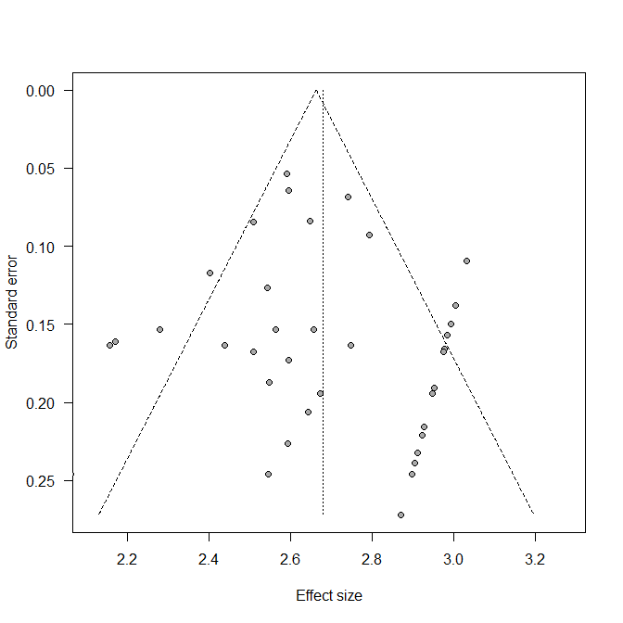
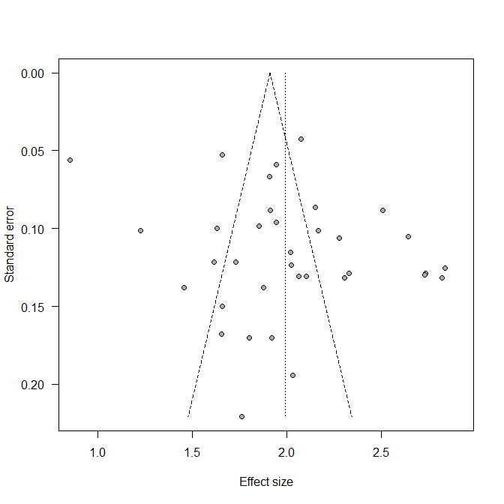
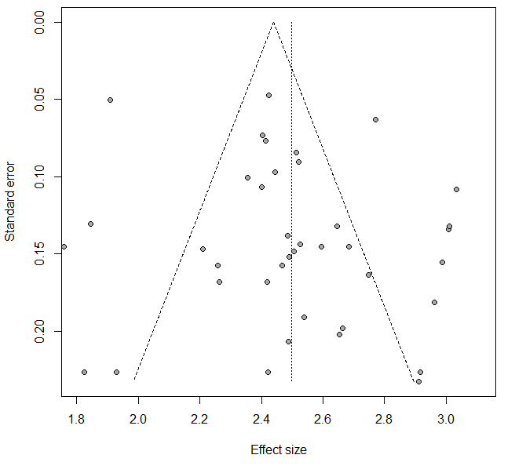
C

