**SURVEY**

PRESENCE OF TOXIC SUBSTANCES AND CONFIDENCE IN FOOD PRODUCTS

**Question 1**

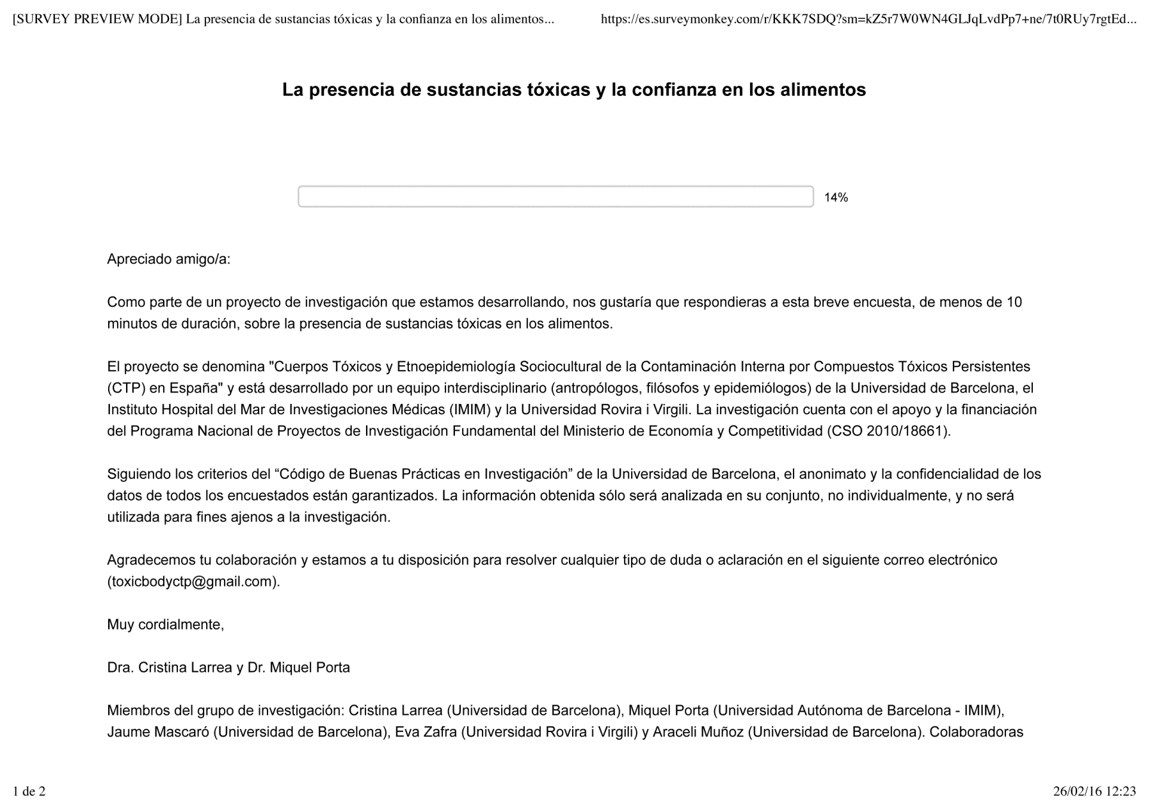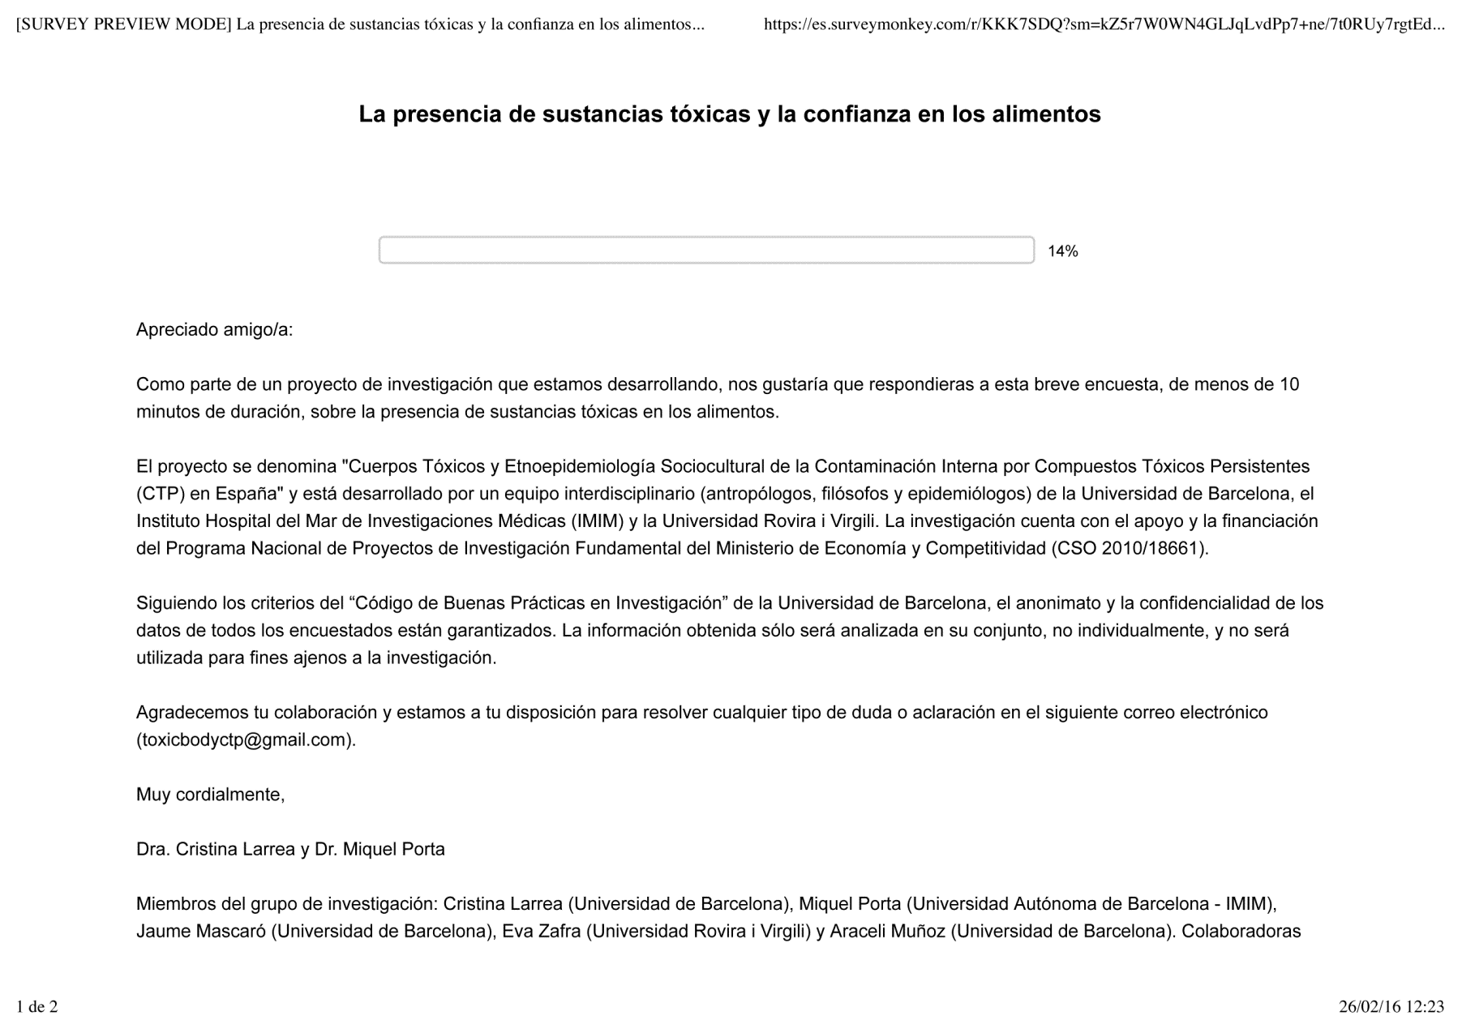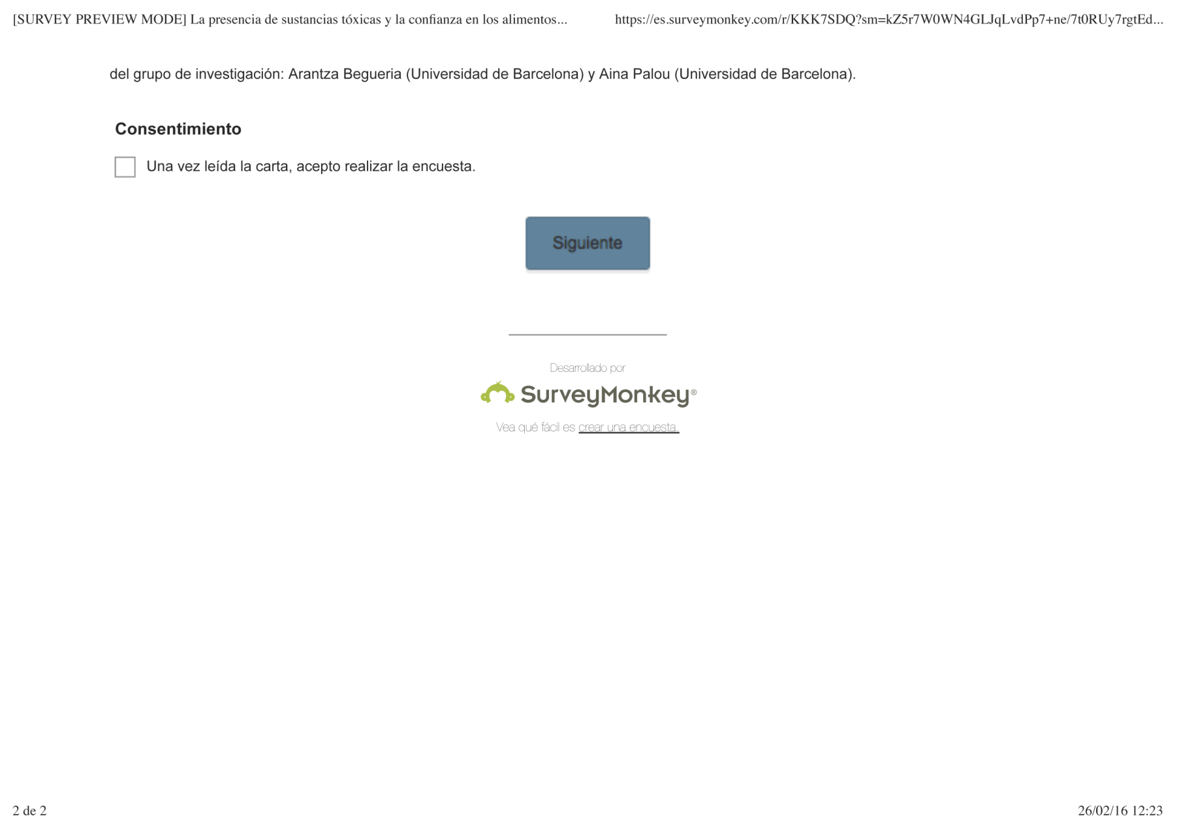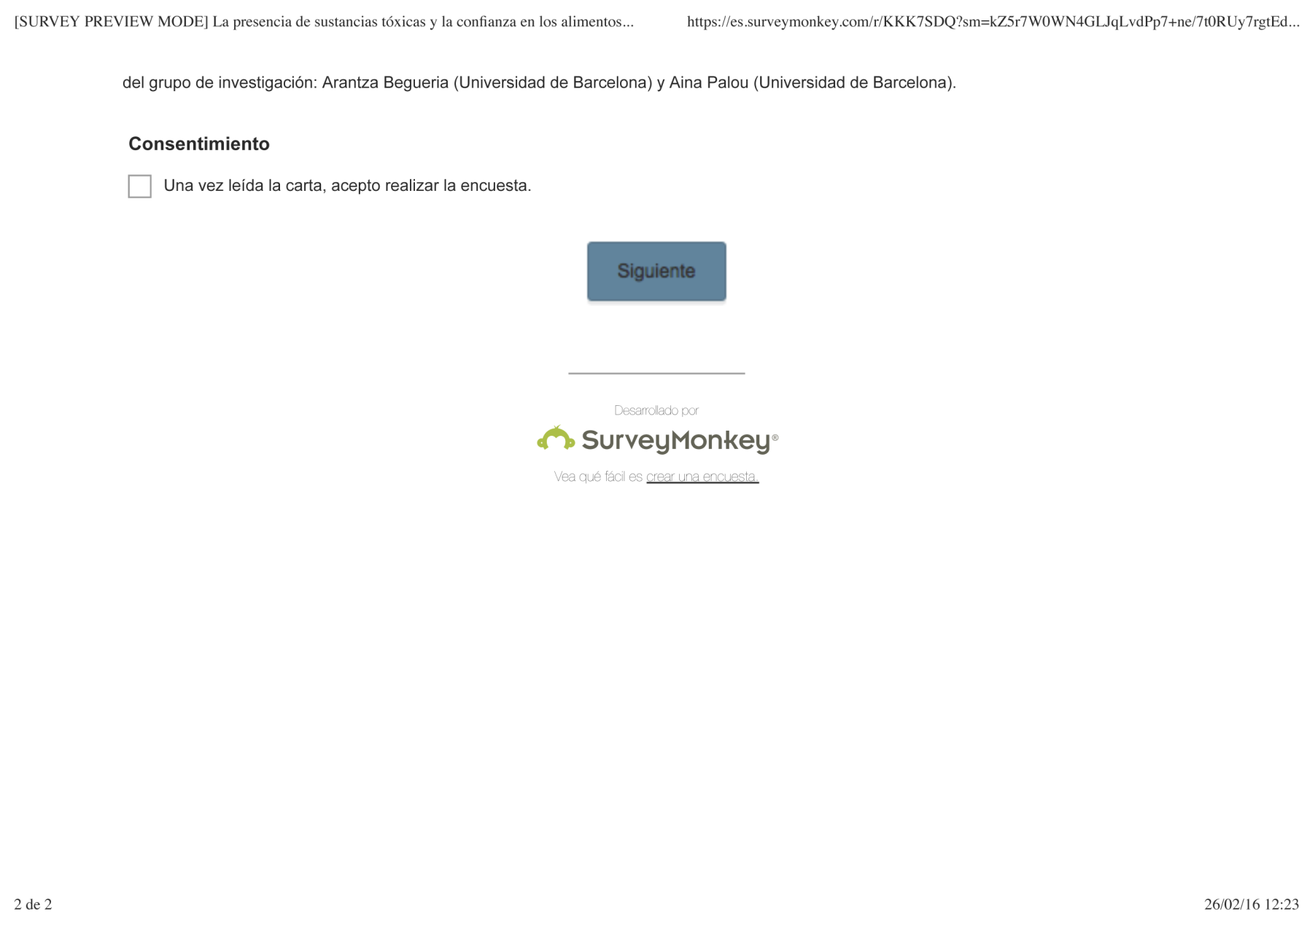

Dear friend,

As a part of a research project we are developing, we would like you to answer this brief survey, which will take you less than 10 minutes, about the presence of toxic substances in food.

The project is called “Toxic bodies and sociocultural ethno-epidemiology of internal contamination from persistent organic pollutants (POPs) in Spain”. It is developed by an interdisciplinary team (anthropologists, philosophers, and epidemiologists) from the University of Barcelona, the Hospital del Mar Institute of Medical Research – IMIM, and the University Rovira i Virgili. The study is supported in part by a research grant from the National Programme for Fundamental Research Projects from The Ministry of Economy and Competitiveness (CSO 2010/18661).

Following the “Code of good practice in research” from the University of Barcelona, the anonymity and confidentiality of the data are guaranteed. The information obtained will be analyzed only in its totality, not individually, and will not be used by any external source.

We appreciate your collaboration and we are at your service to solve any questions regarding this survey at toxicbodyctp@gmail.com.

Cordially,

Dr. Cristina Larrea and Dr. Miquel Porta

Research group members: Cristina Larrea (University of Barcelona), Miquel Porta (Autonomous University of Barcelona - IMIM), Jaume Mascaró (University of Barcelona), Eva Zafra (University Rovira i Virgili) and Araceli Muñoz (University of Barcelona). Research group collaborators: Arantza Begueria (University of Barcelona) and Aina Palou (University of Barcelona).

* **Question 1: Consent**

I have read the letter and I accept to participate in the survey.

**Question 6**

**Question 5**

**Question 4**

**Question 3**

**Question 2**

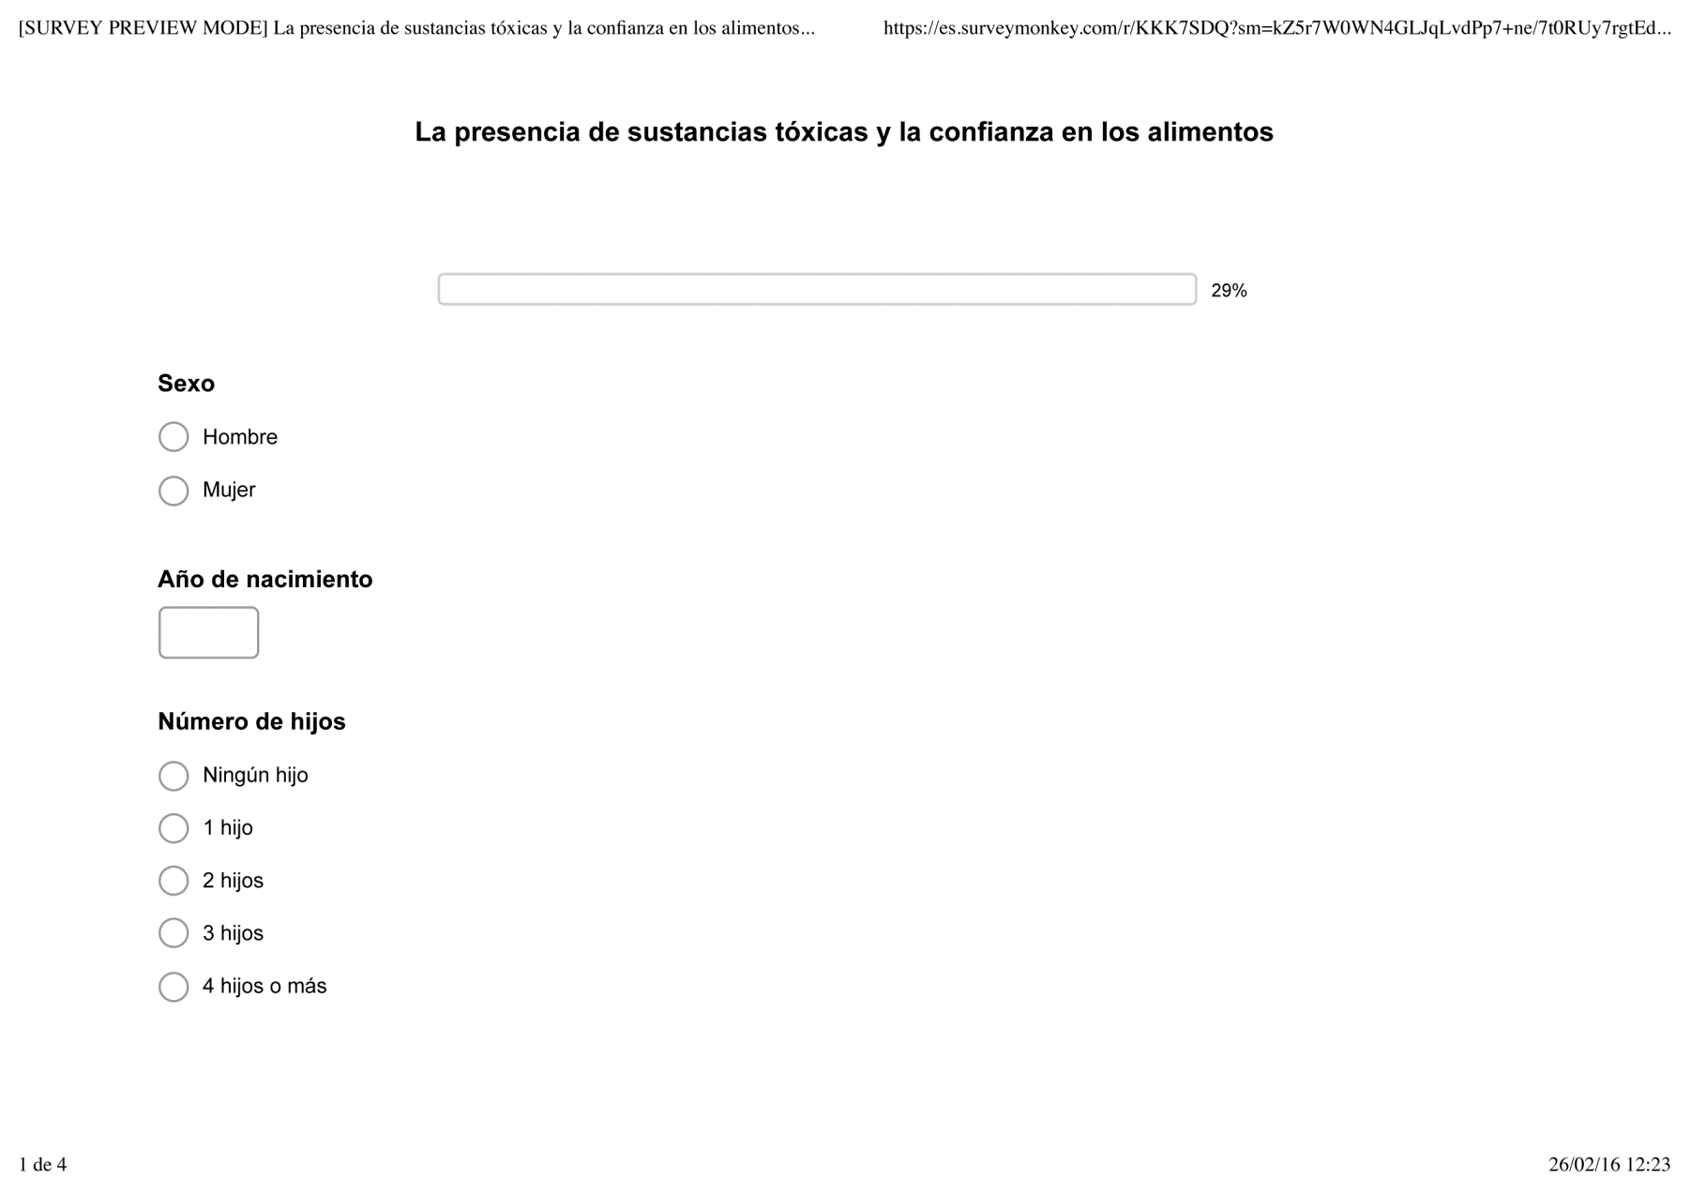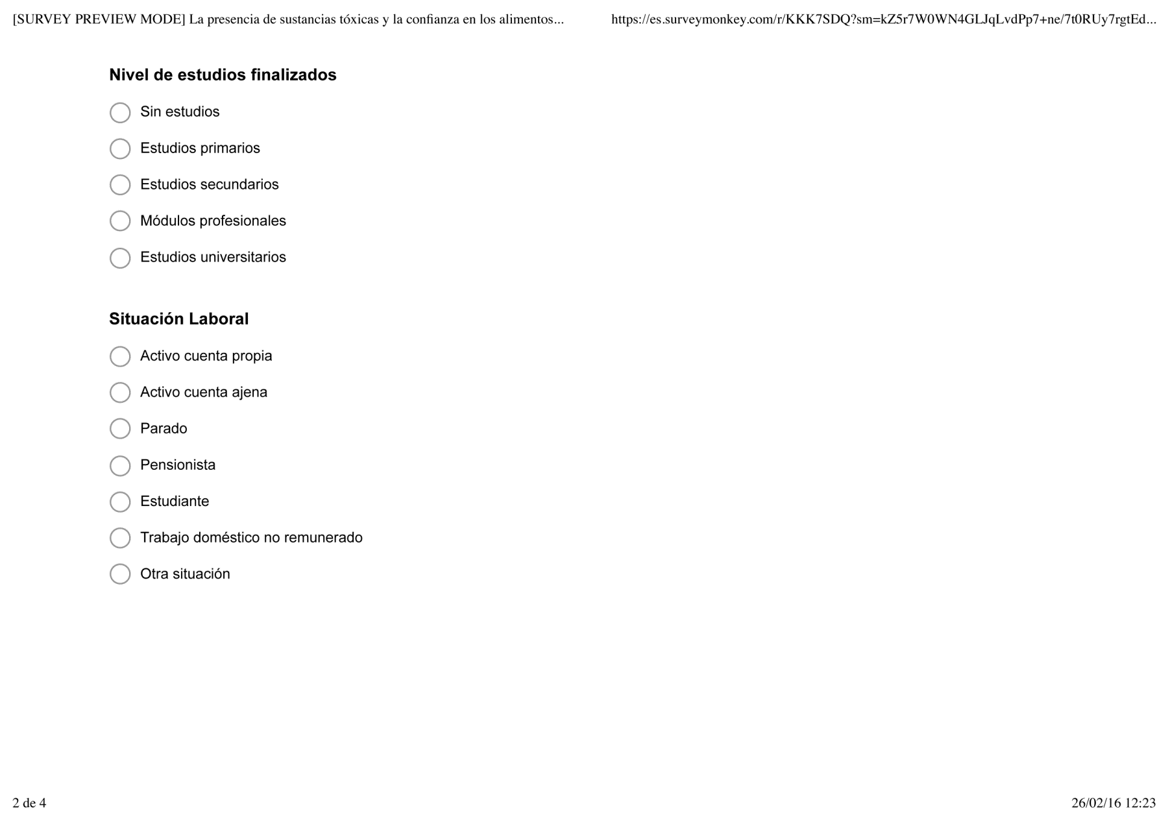

* **Question 2: Sex**

Male / Female

* **Question 3: Year of birth**
* **Question 4: Number of children**

I don’t have children

1 child

2 children

3 children

4 or more children

* **Question 5: What is your highest level of education?**

Without formal education

Primary education

Secondary education

Specialized technical training

University

* **Question 6: Employment status**

Self-employed

Working for a company

Unemployed

Retired

Student

Homemaker

Other situations

**Question 7**

**Question 8**

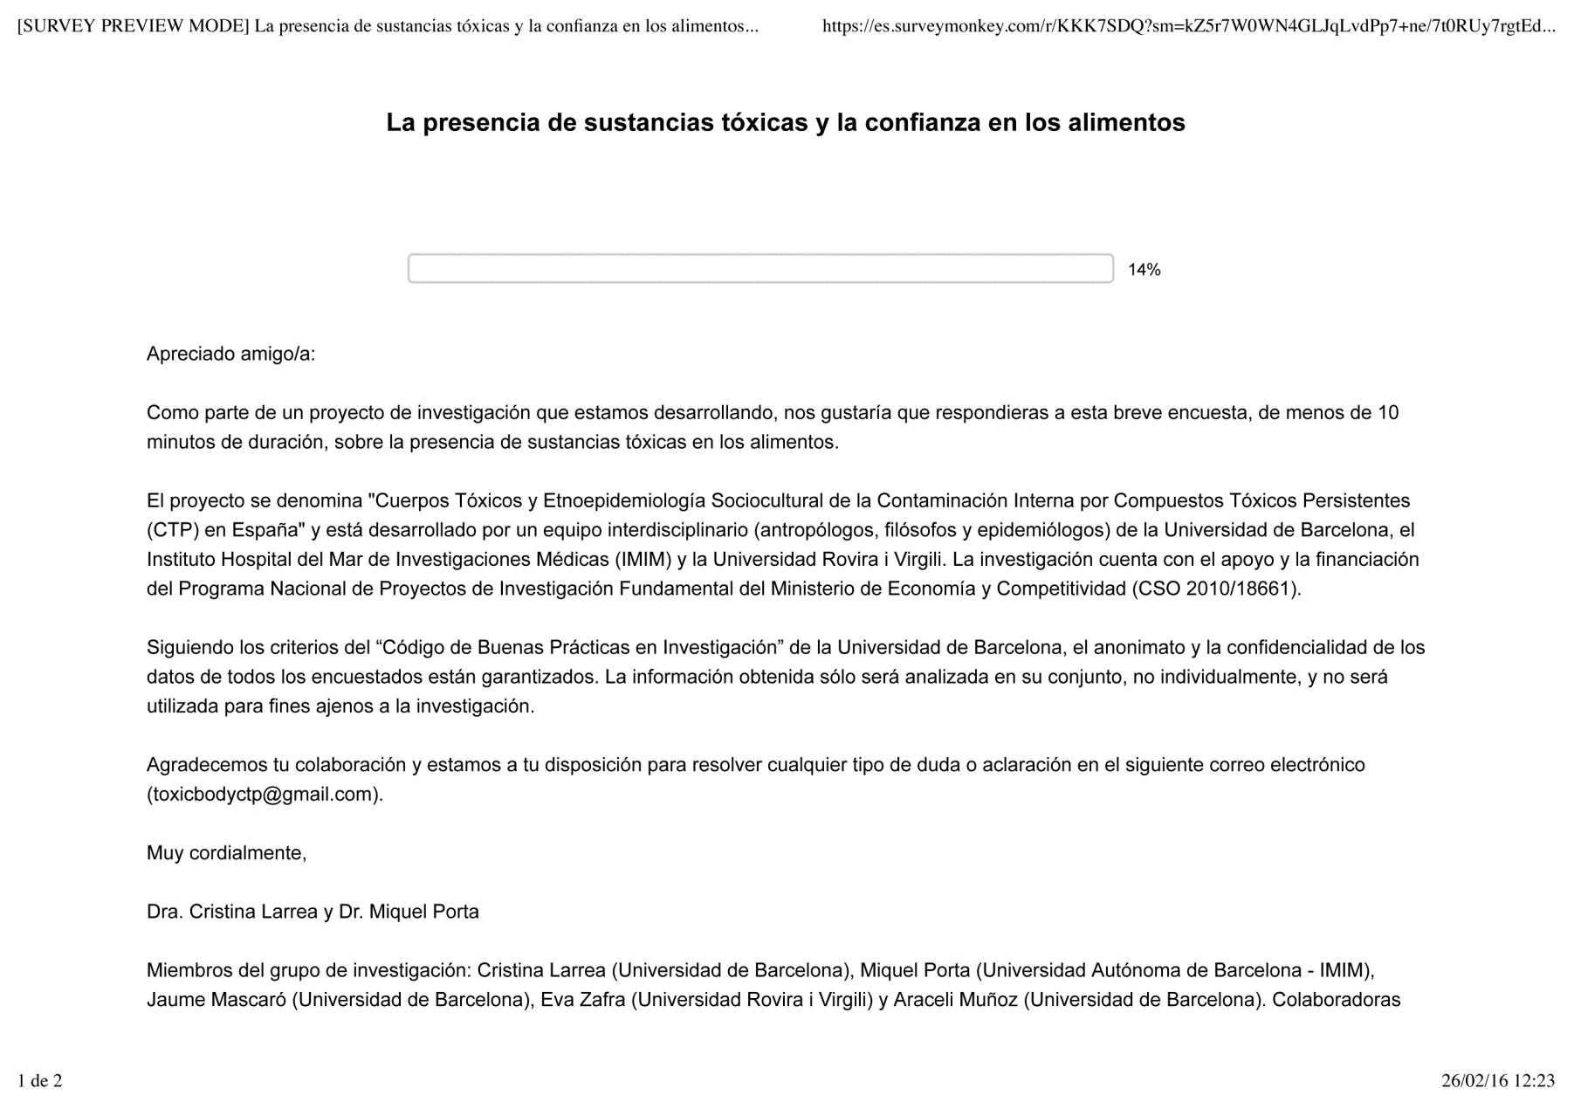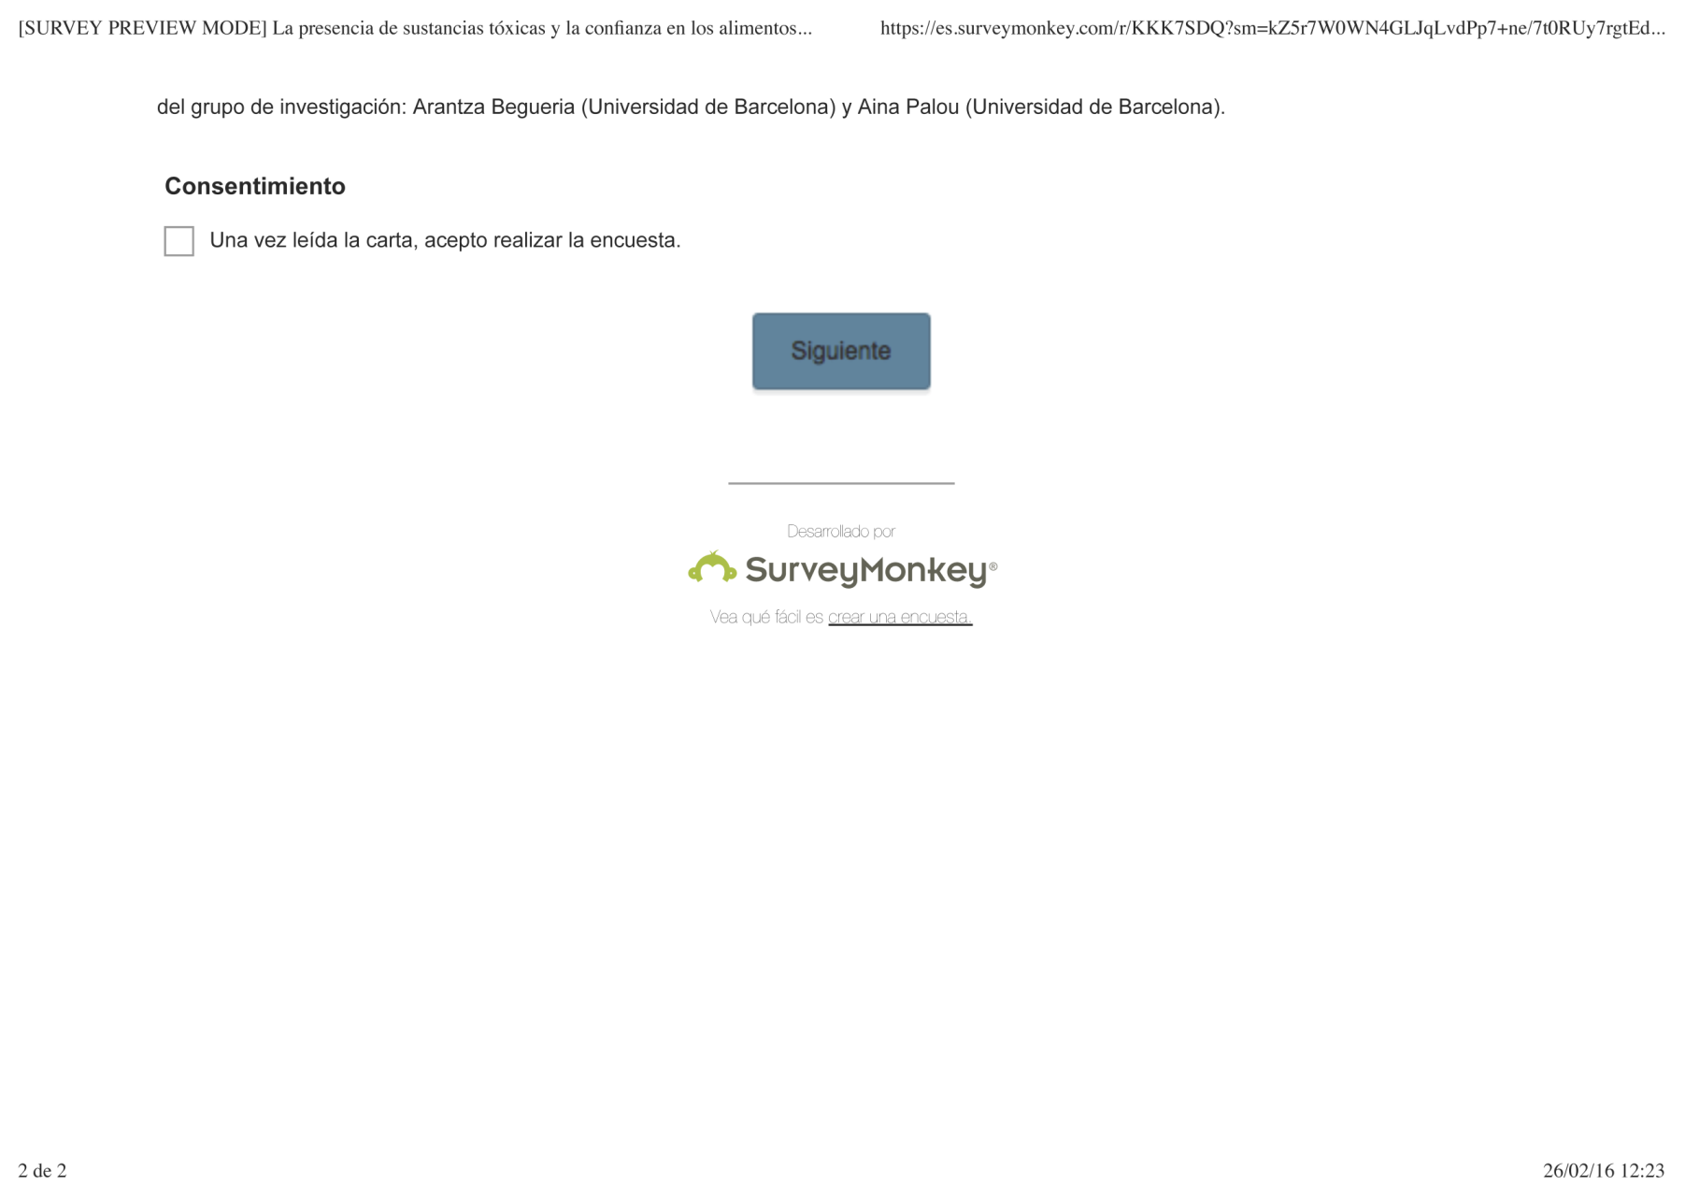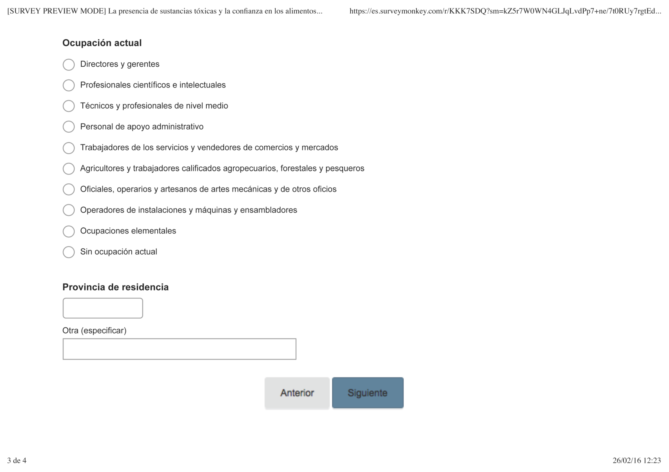

* **Question 7: Occupation**

Directors and managers

Scientific and intellectual professionals

Technicians and associate professionals

Administrative type employees

Service and sales workers

Skilled agricultural, forestry and fishery workers

Craft and related trades workers

Installations and machinery operators

Elementary occupations

Currently not working

* **Question 8: Province of residence**

**Question 11**

**Question 9**

**Question 10**

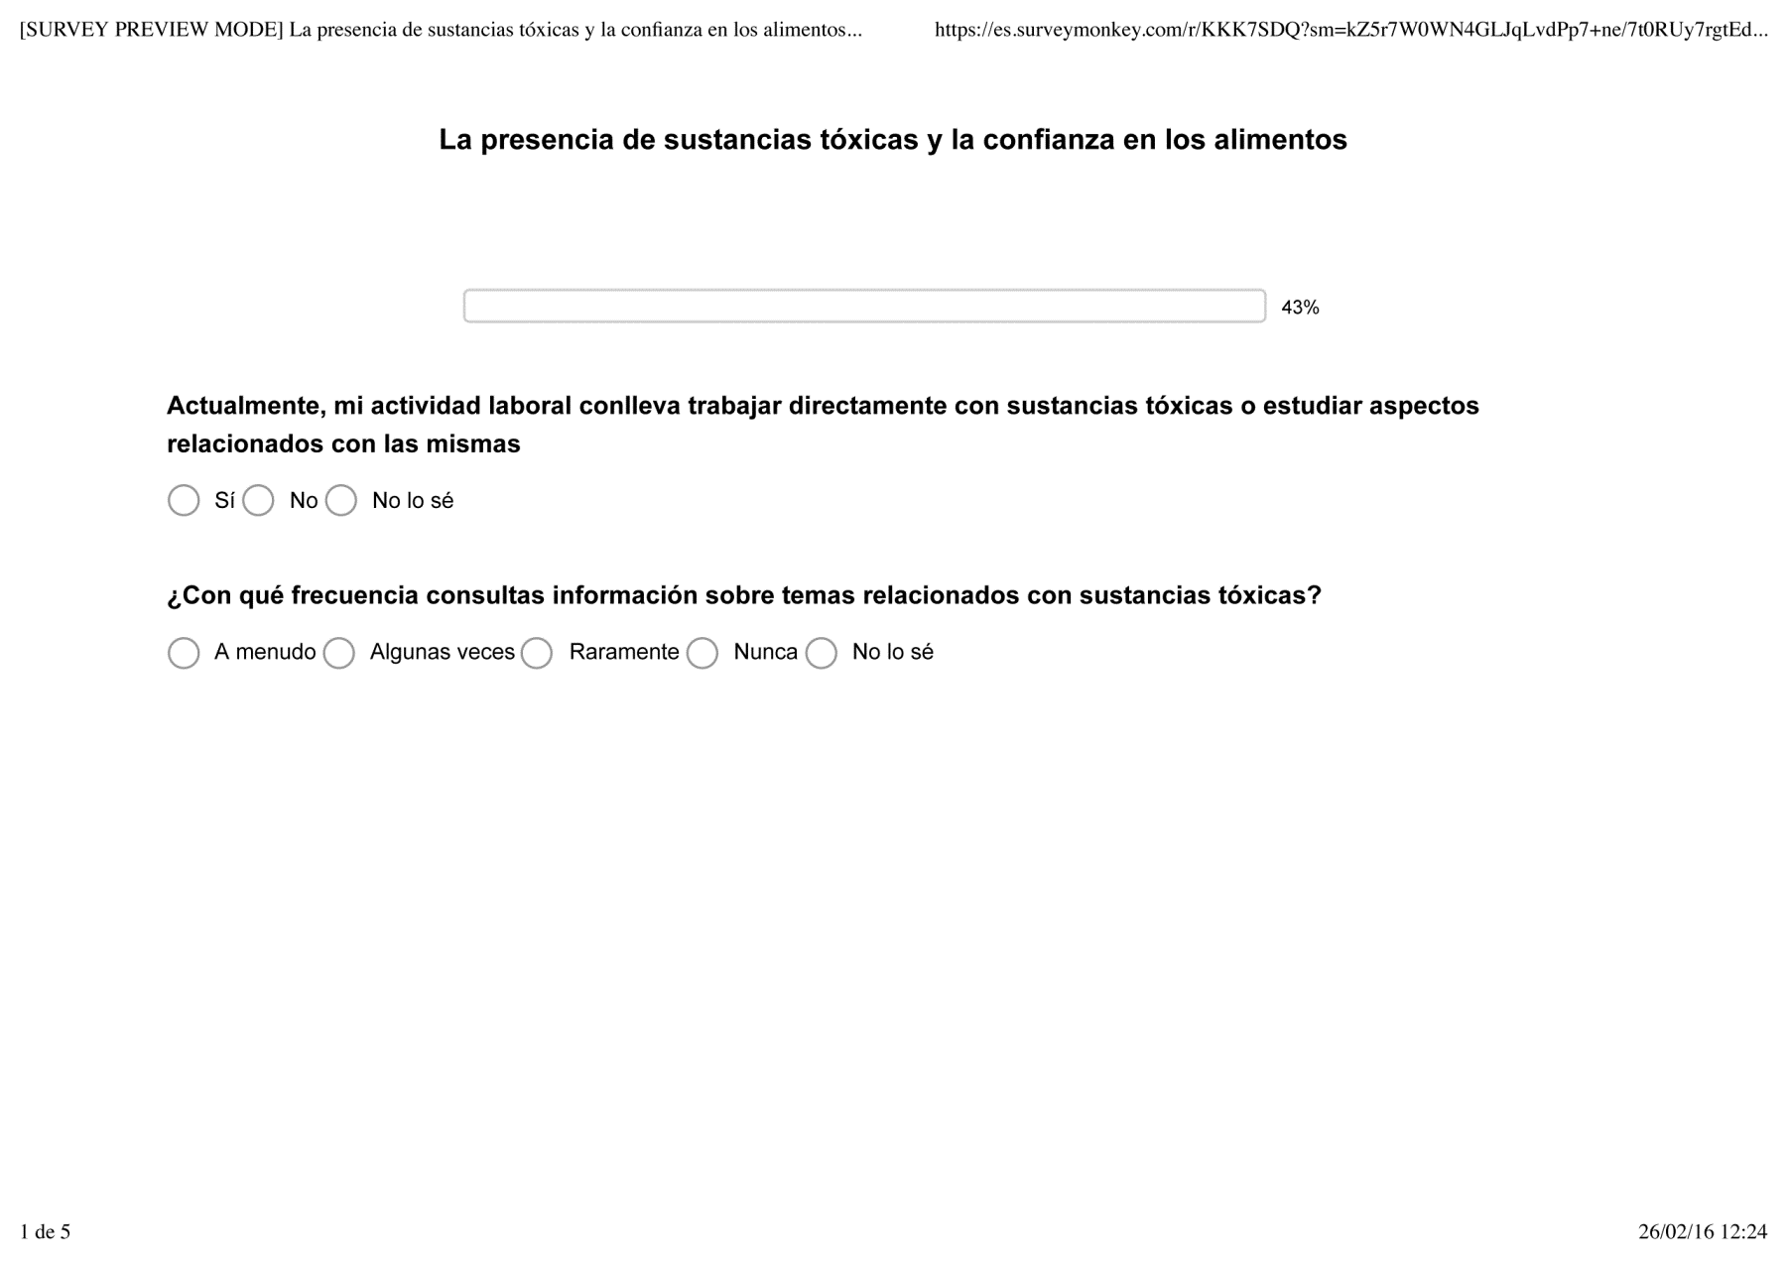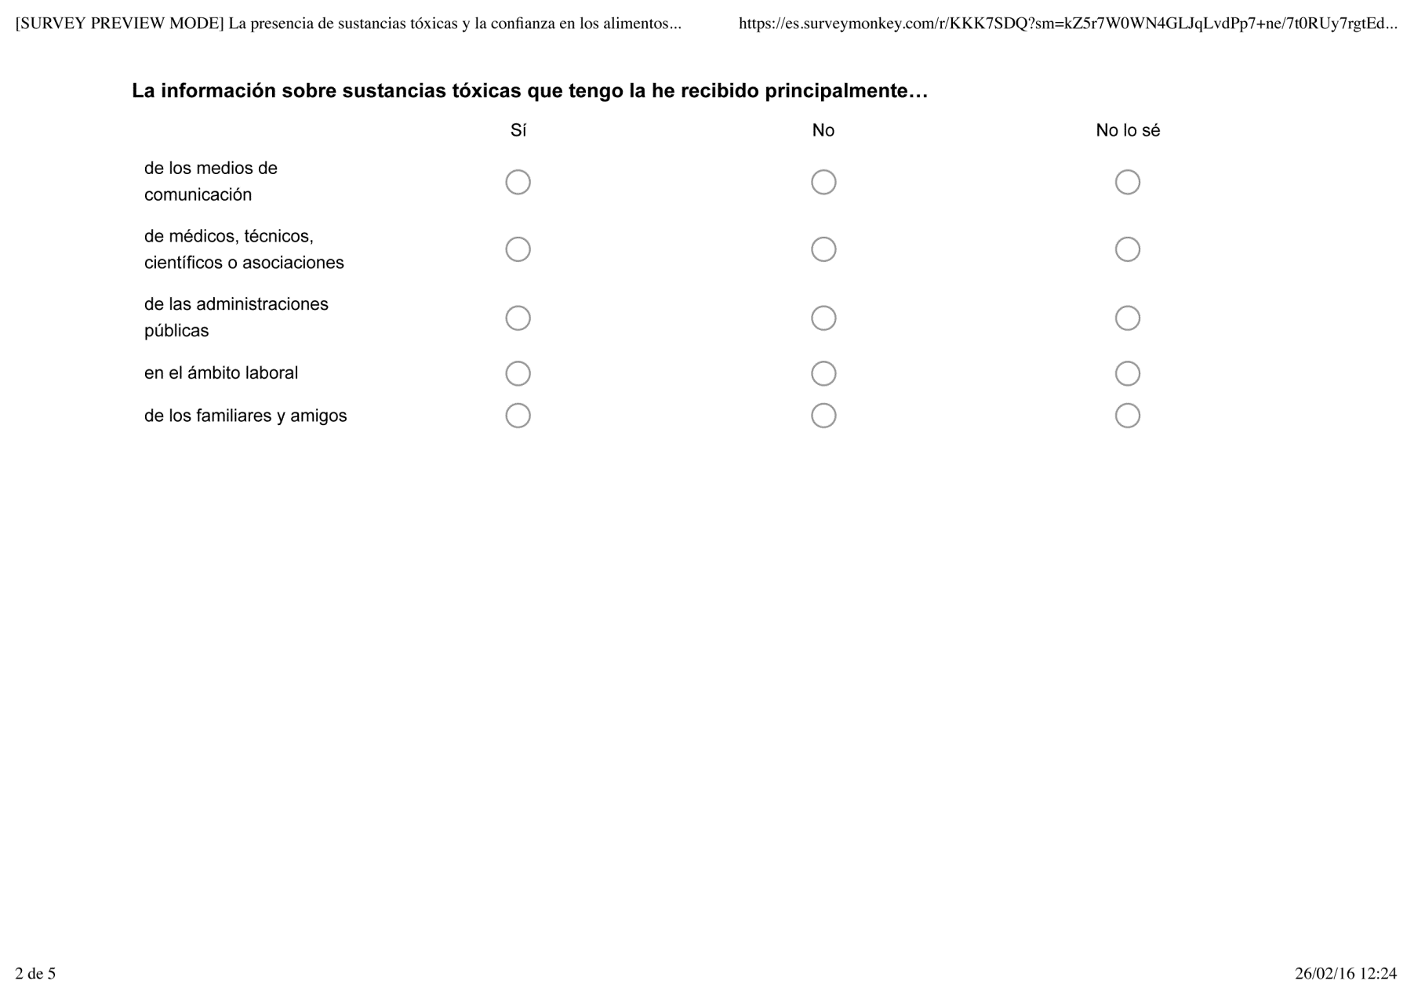

* **Question 9: Currently, my work activity implies working with toxic substances or study aspects related to them.**

Yes No Don’t know

* **Question 10: How often do you consult information about issues related to toxic substances?**

Often Sometimes Rarely Never Don’t know

* **Question 11: I have received the information about toxic substances I have mainly from…**

**Yes No Don’t know**

Mass media

Clinicians, technicians, scientists or associations

Public administration

Workplace

Family and friends

**Question 12**

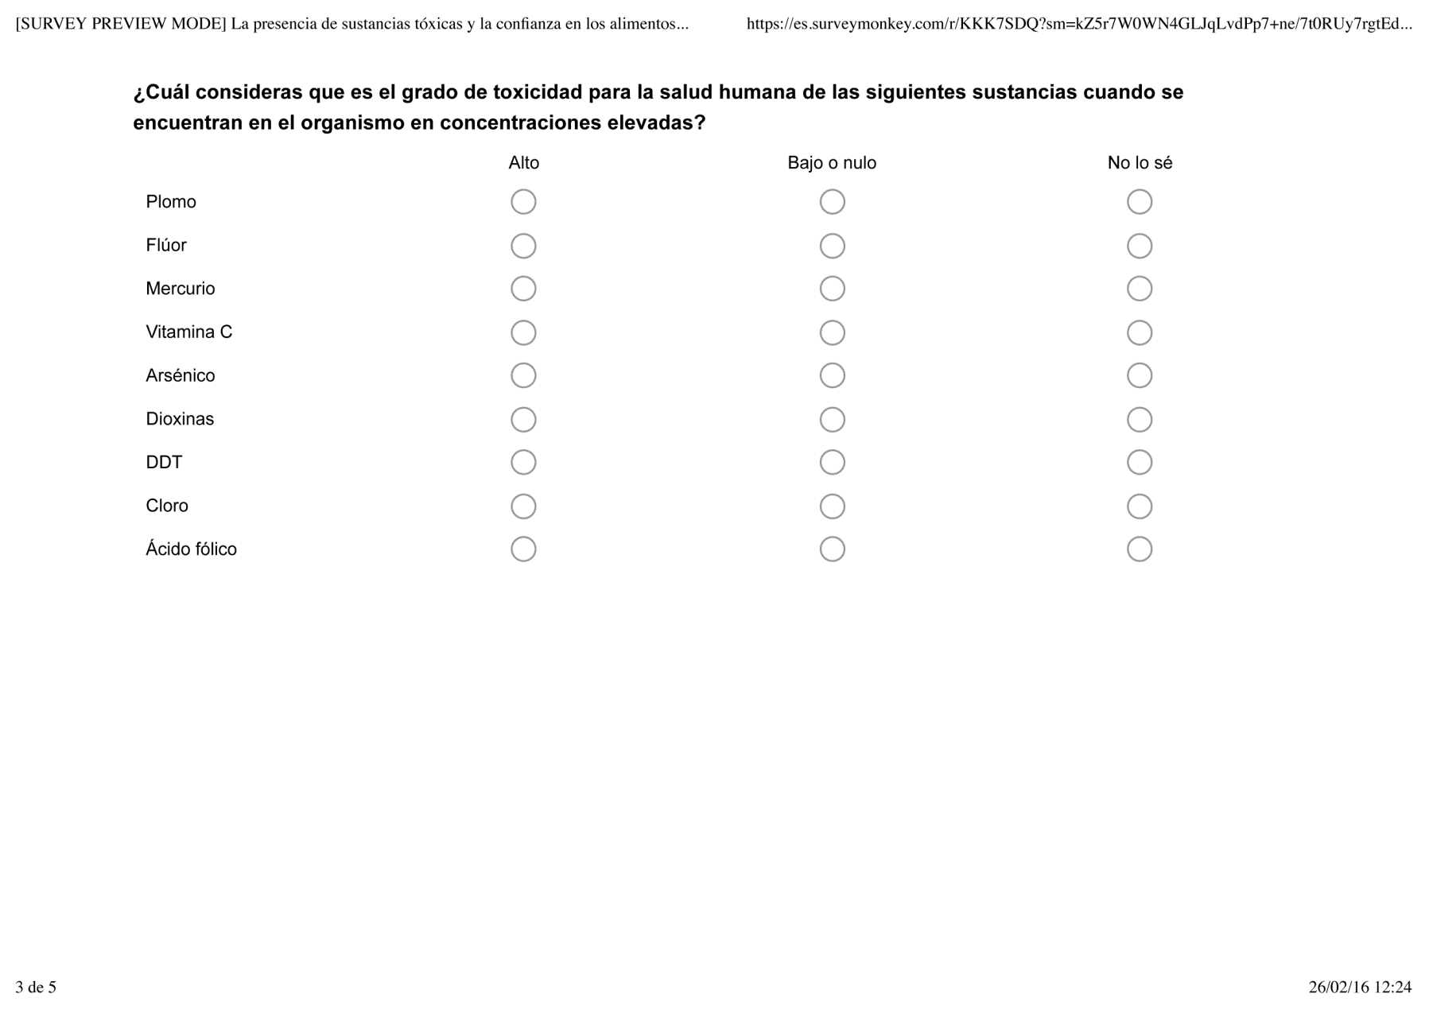

* **Question 12: Which do you think is the degree of toxicity for human health of these substances when they are at high body concentrations?**

**High Low or non-existent Don’t know**

Lead

Fluoride

Mercury

Vitamin C

Arsenic

Dioxins

DDT

Chlorine

Folic acid

**Question 13**

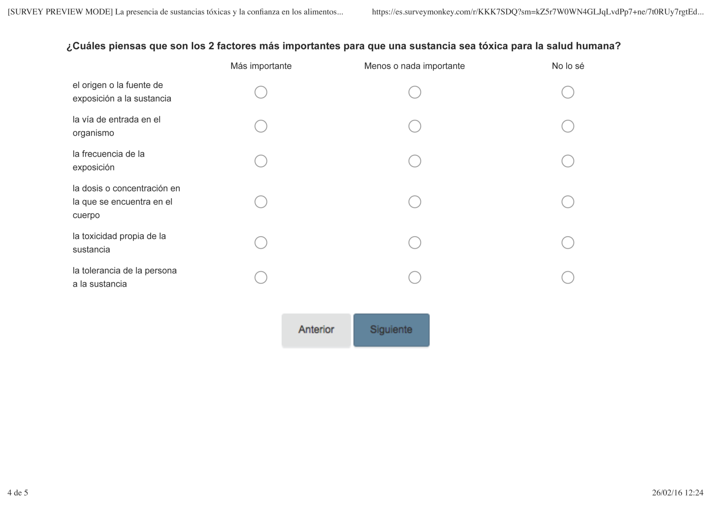

* **Question 13: Which do you think are the 2 most important factors for a substance to be toxic for human health?**

**More important Less or not important Don’t know**

Origin or source of exposure to the substance

Route of entry into the body

Frequency of exposure

Body concentration

Toxicity of the substance itself

Tolerance to the substance

**Question 14**

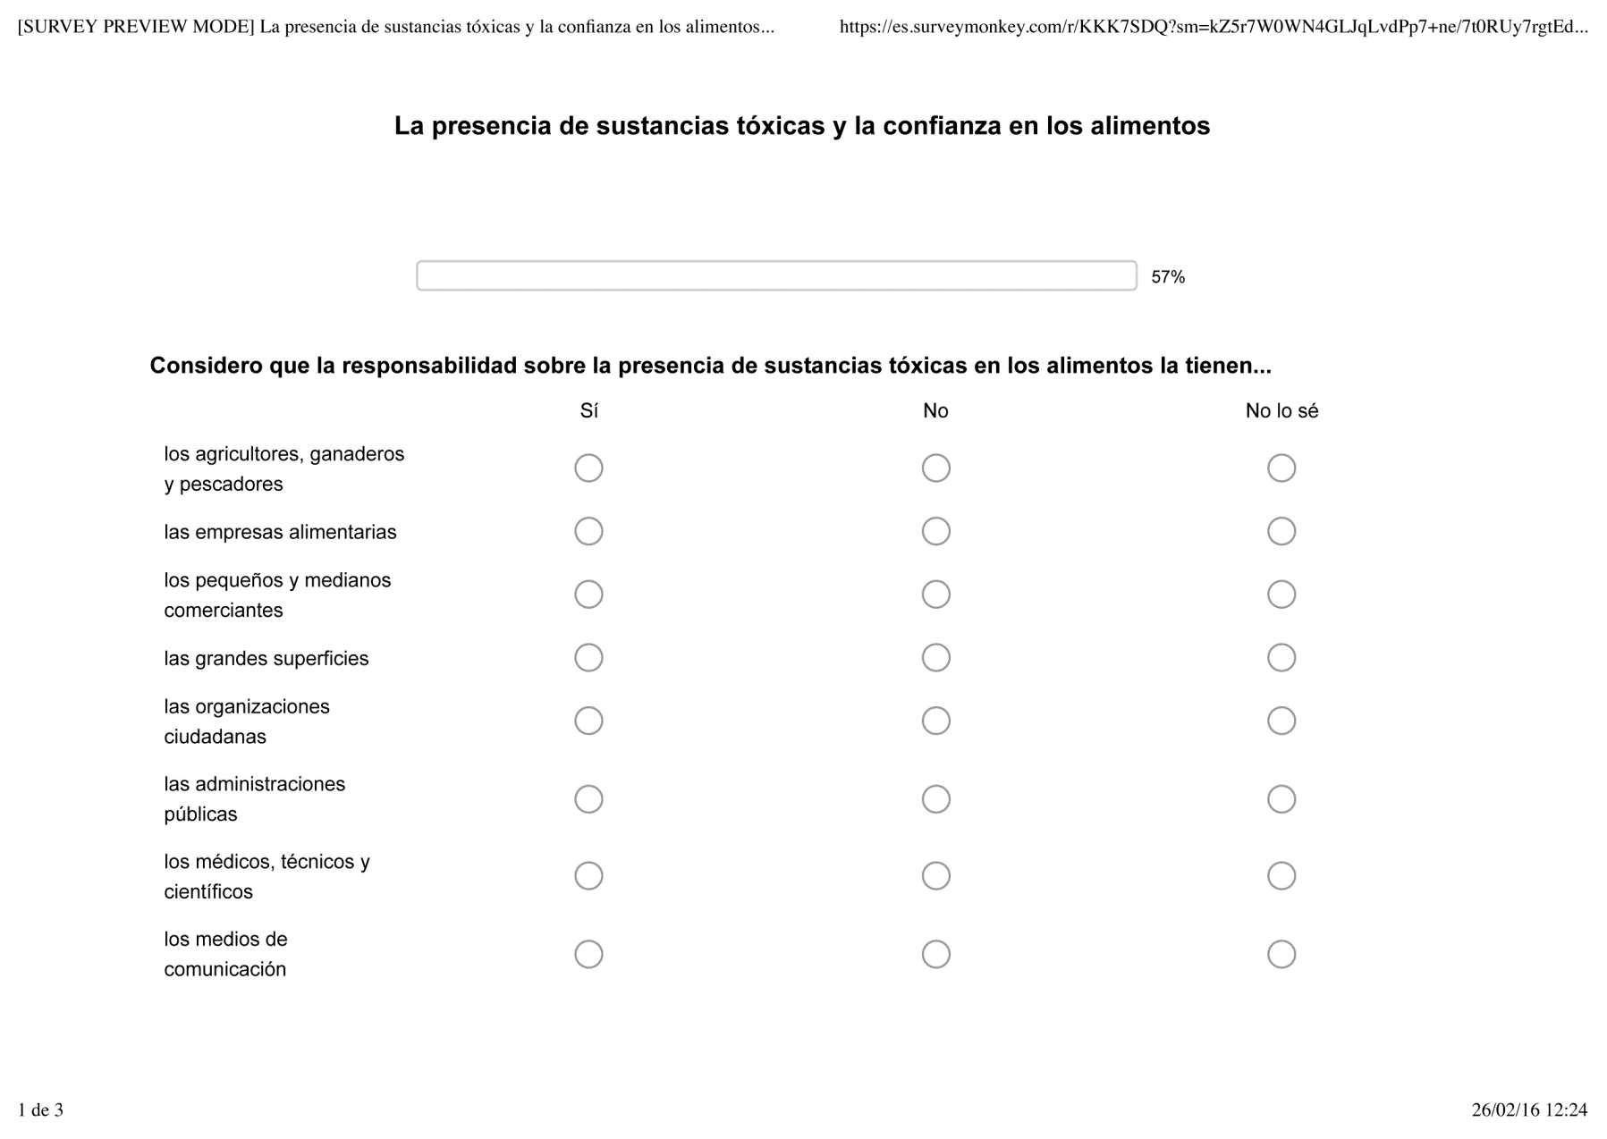

* **Question 14: The responsibility of the presence of toxic substances in food belongs to…**

**Yes No Don’t know**

Farmers and fishermen

Food businesses

Small and medium sized commerce

Shopping malls

Citizen organizations

Public administrations

Clinicians, technicians and scientists

Mass media

**Question 16**

**Question 15**

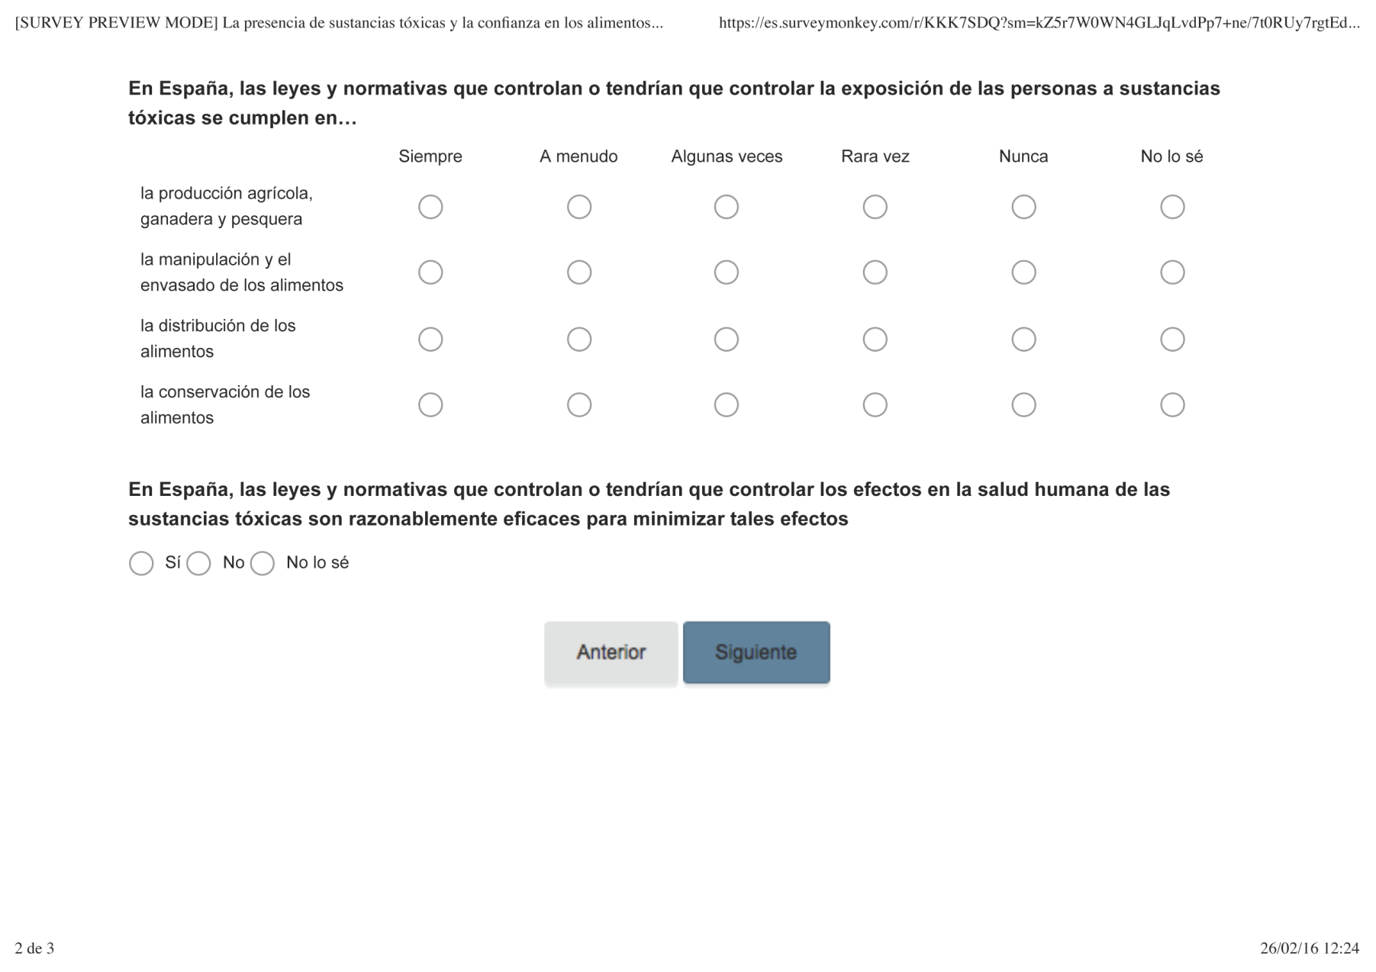

* **Question 15: In Spain, laws and regulations that control or should control human exposure to toxic substances are enforced in**…

**Always Often Sometimes Hardly ever Never Don’t know**

Agriculture and fisheries production

Manipulation and food packaging

Food distribution

Food conservation

* **Question 16: In Spain,** **laws and regulations that control or should control human exposure to toxic substances are effective**

Yes No Don’t know

**Question 18**

**Question 17**

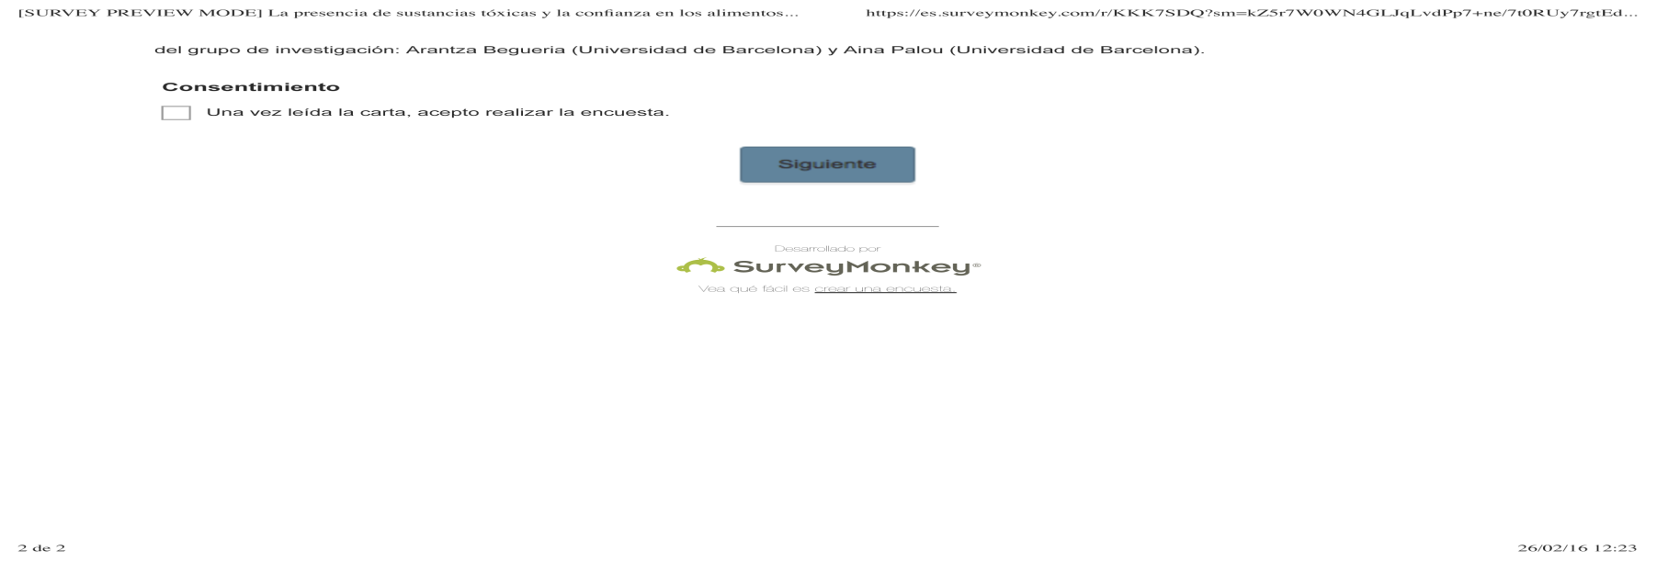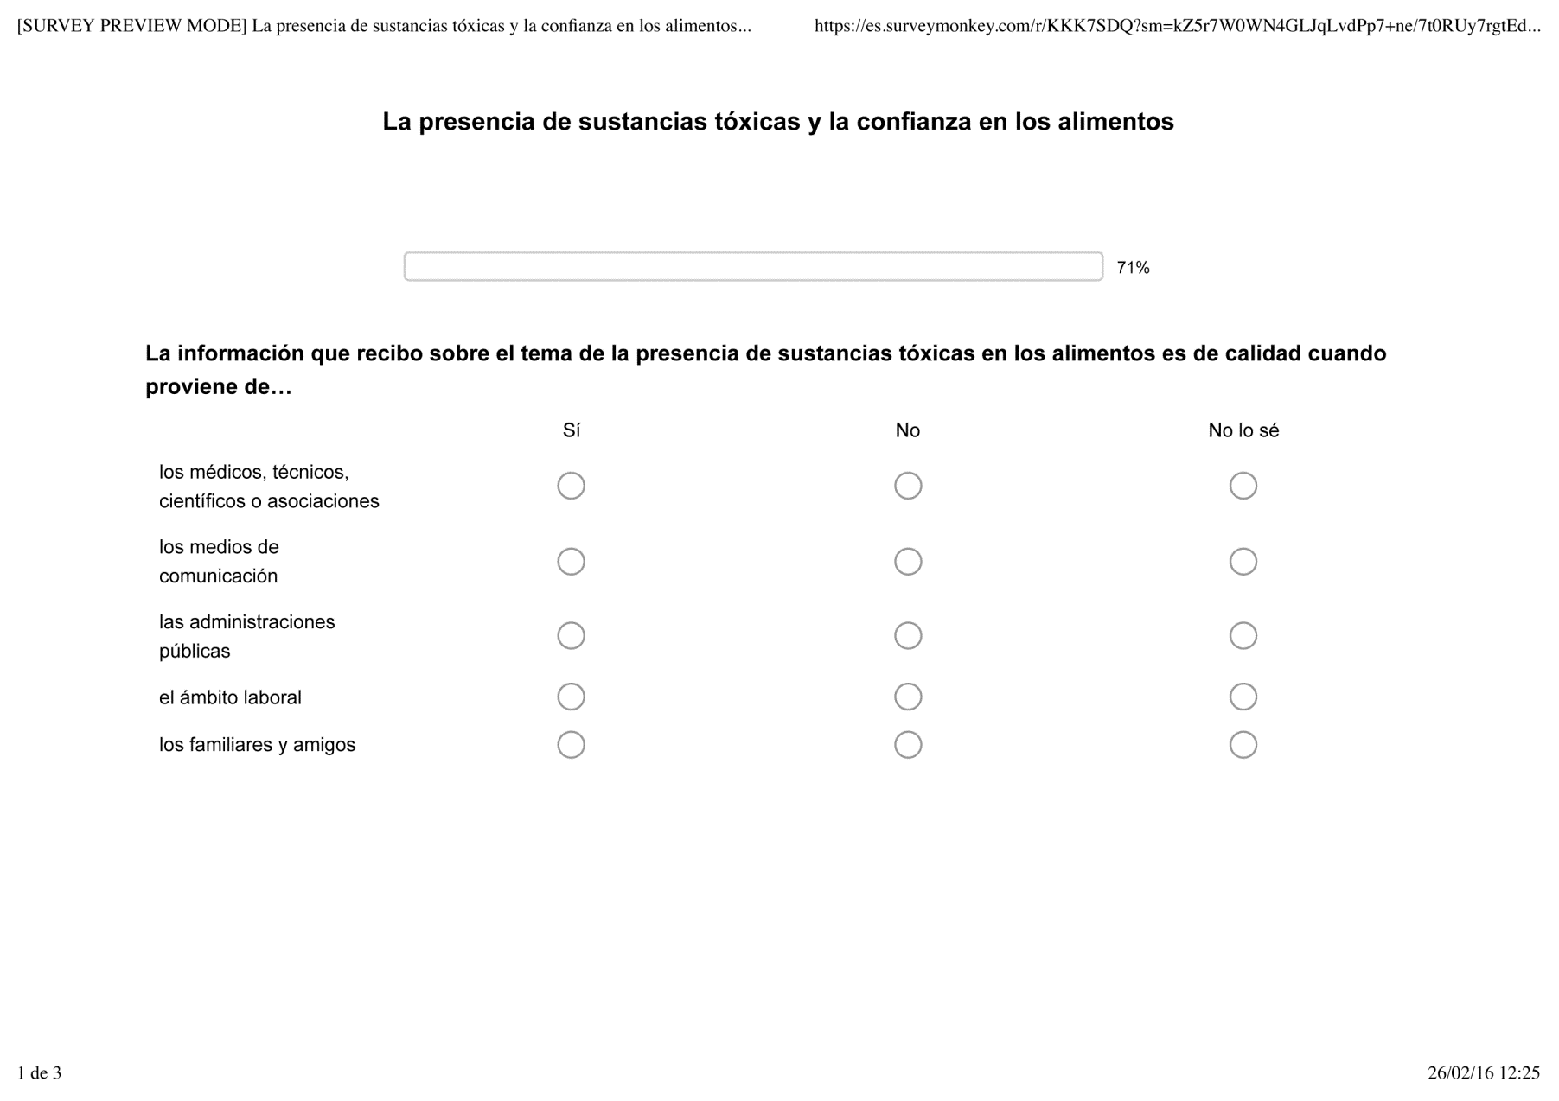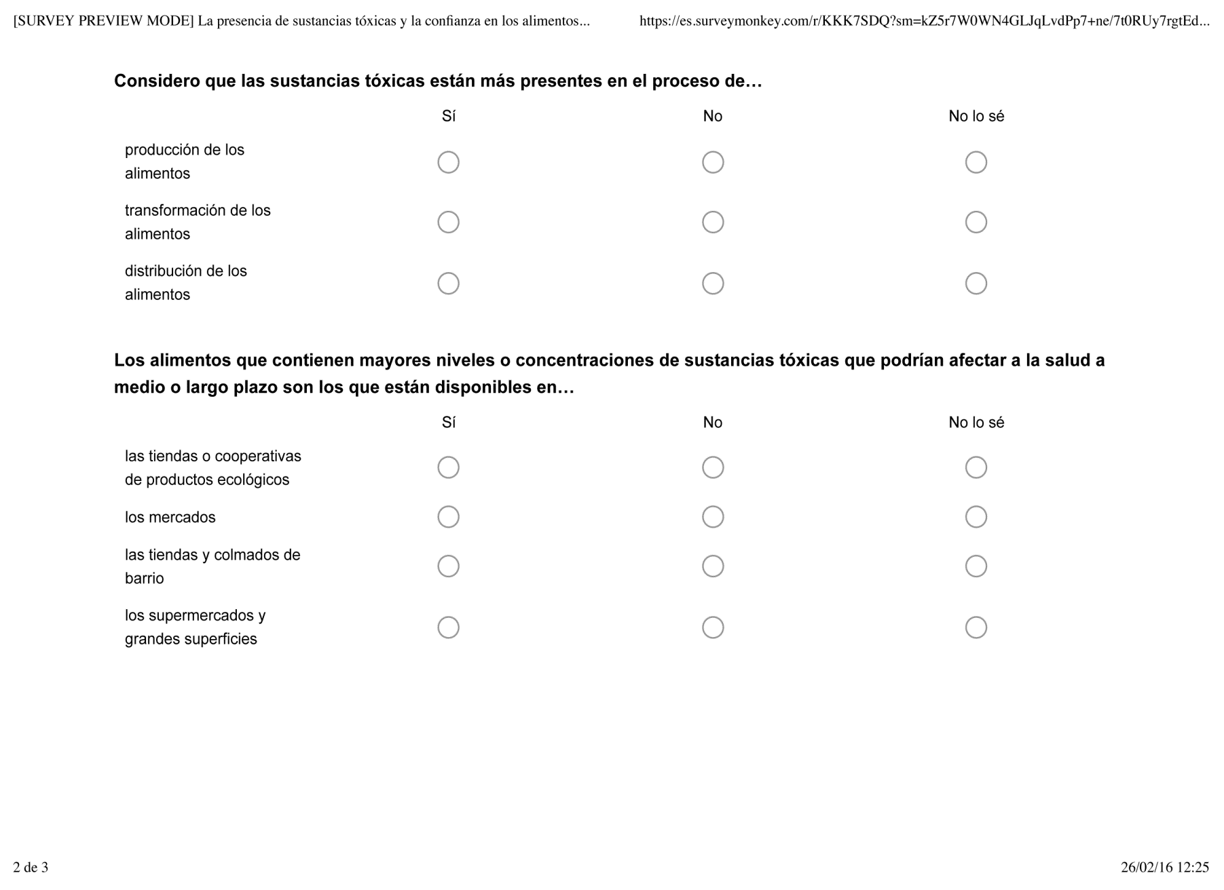

* **Question 17: I have received good quality information about toxic substances mainly from…**

**Yes No Don’t know**

Mass media

Clinicians, technicians, scientists or associations

Public administration

Workplace

Family and friends

* **Question 18: I consider that toxic substances are more present in the process of…**

**Yes No Don’t know**

Food production

Food processing

Food distribution

**Question 20**

**Question 19**

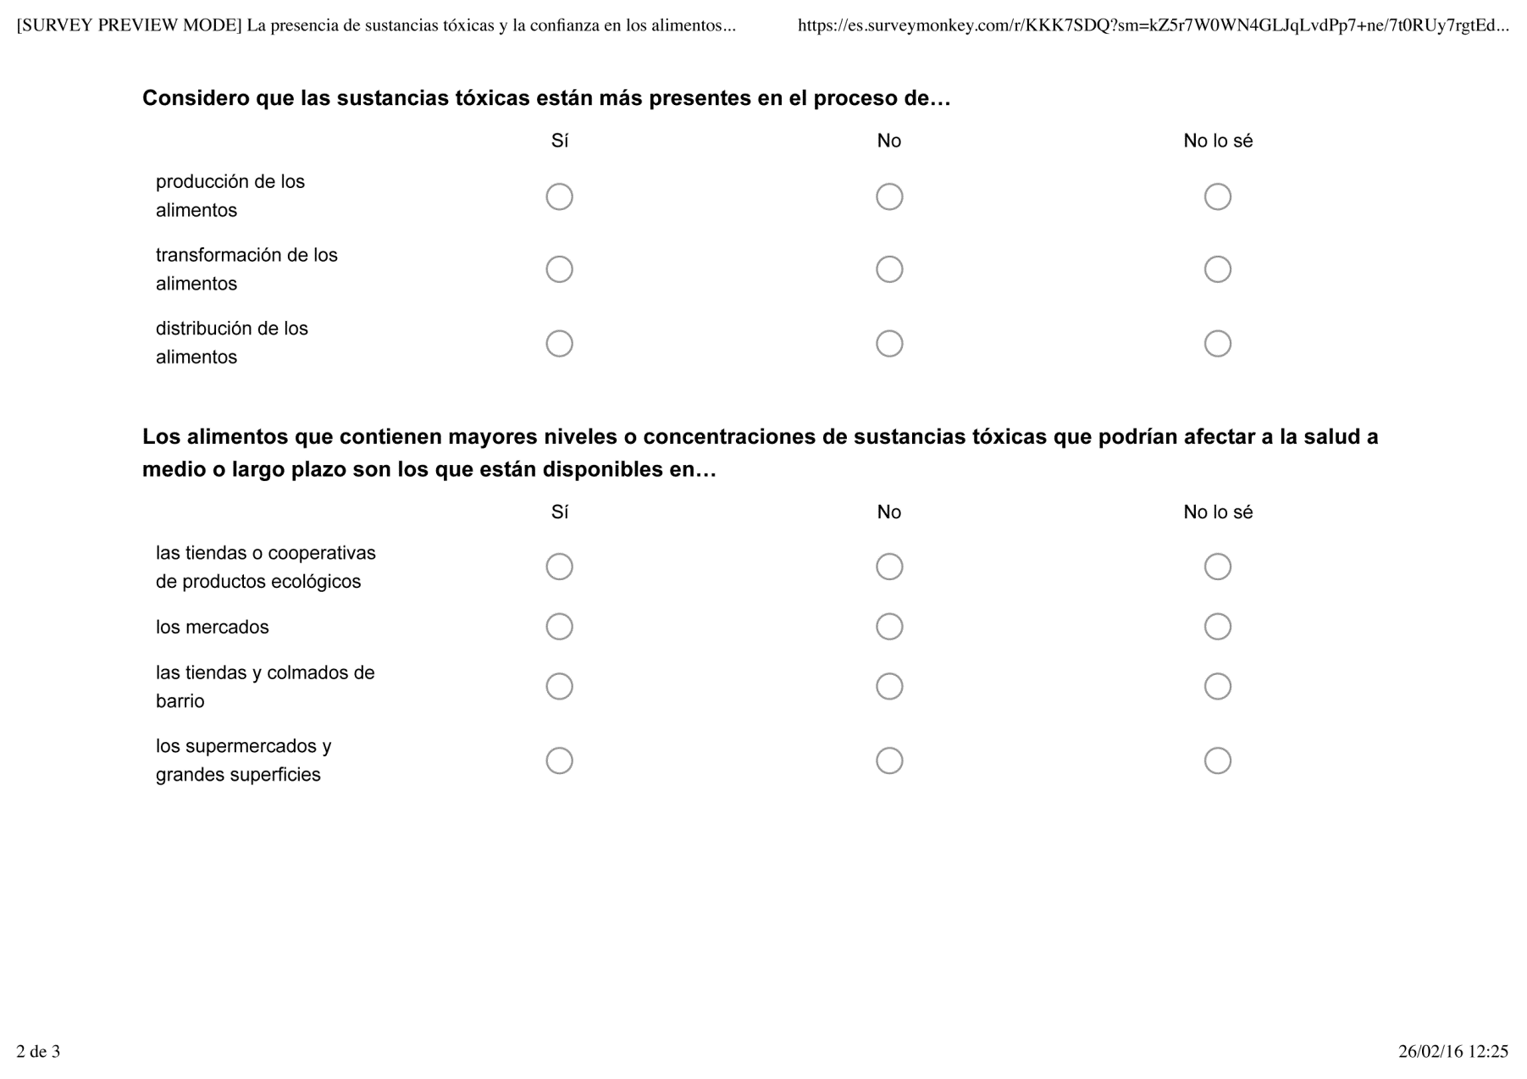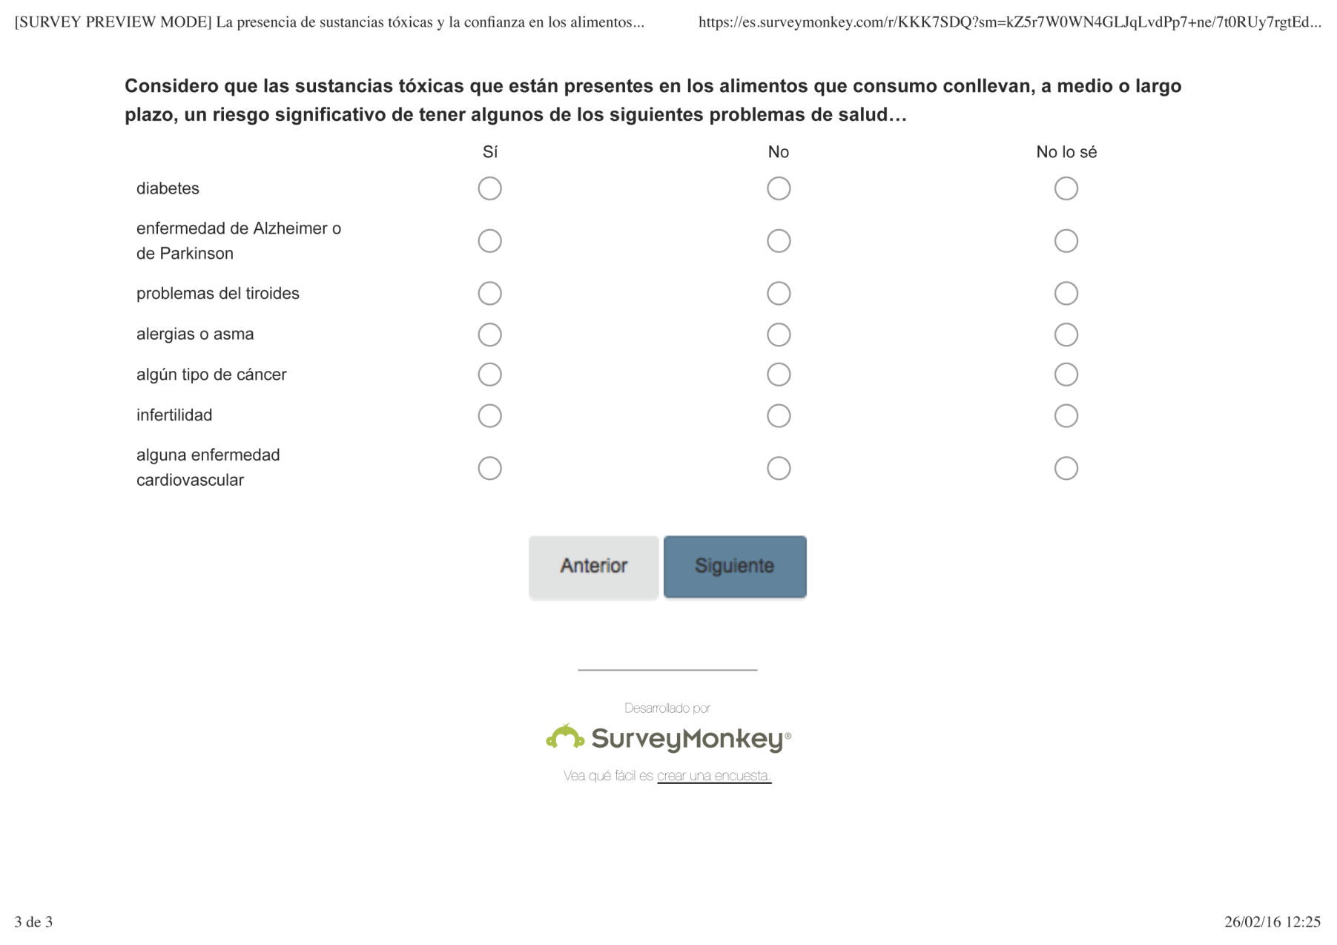

* **Question 19: Foods containing higher concentrations of toxic substances that may affect human health in the mid- or long-term are available in…**

**Yes No Don’t know**

Organic food stores

Markets

Neighbourhood shops

Supermarkets and shopping malls

* **Question 20: I consider that the toxic substances in the food I consume imply, at medium or long-term, a significant risk of having some of the following health problems…**

**Yes No Don’t know**

Diabetes

Alzheimer's or Parkinson’s disease

Thyroid problems

Allergies or asthma

Some type of cancer

Infertility

Some cardiovascular disease

**Question 21**

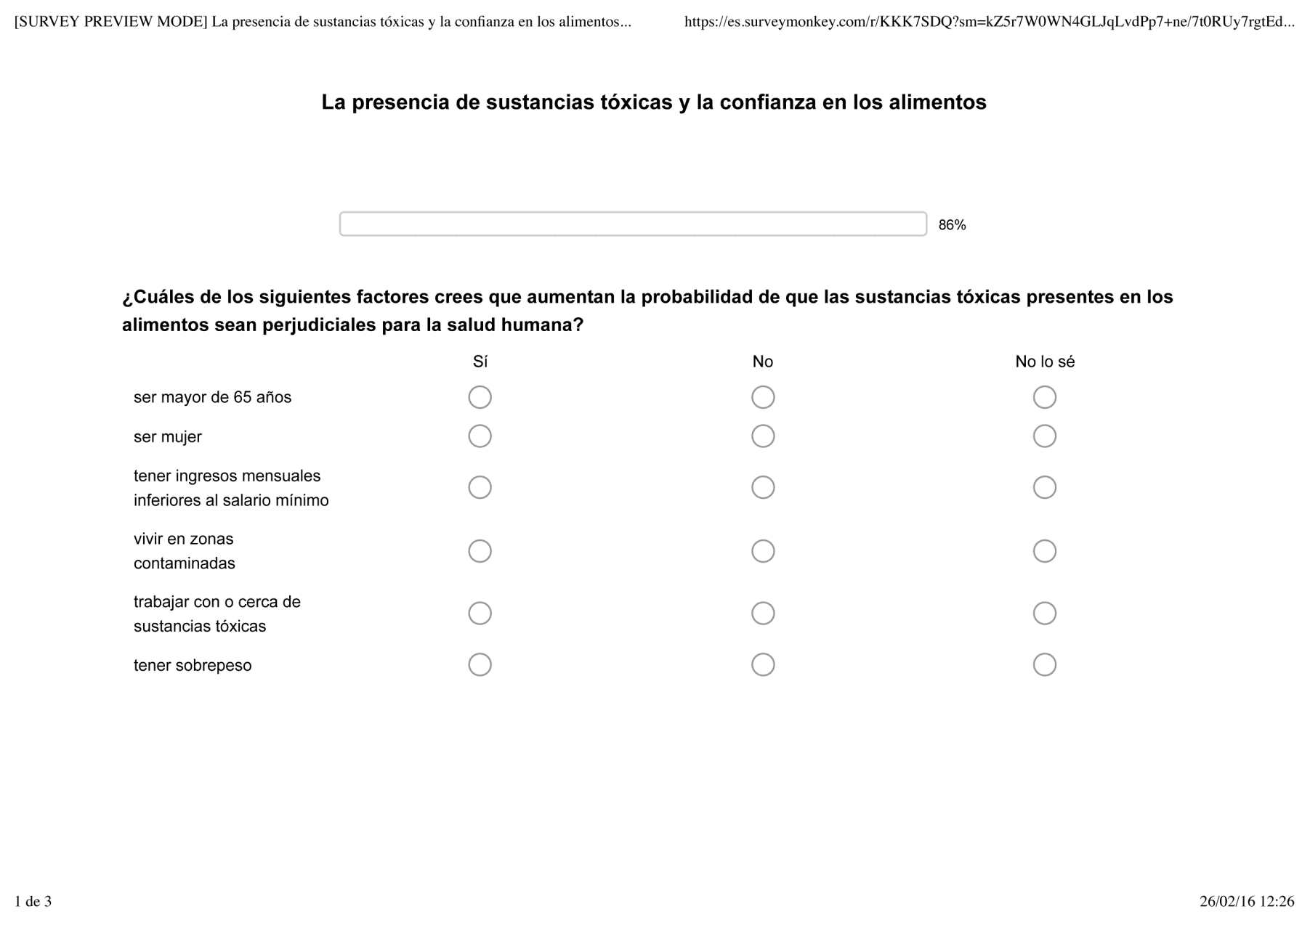

* **Question 21: Which of the following factors increase the likelihood of toxic substances in food being harmful to human health?**

**Yes No Don’t know**

Be older than 65 years

Be a woman

Have a monthly salary lower than the minimum wage

Live in a polluted area

Work with or near toxic substances

Have overweight

**Question 24**

**Question 22**

**Question 23**

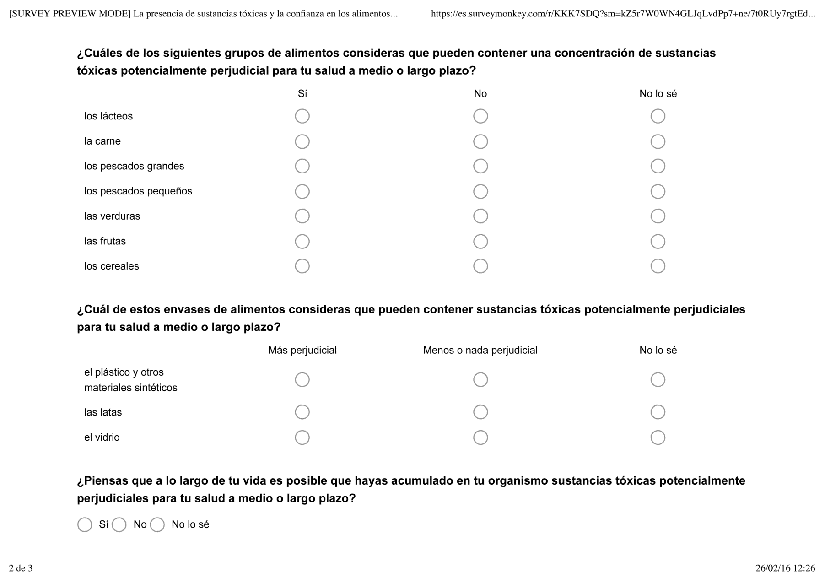

* **Question 22: Which of the following food groups may contain toxic substances concentrations potentially dangerous to your health at medium or long-term?**

**Yes No Don’t know**

Milk products

Meat

Big fishes

Small fishes

Vegetables

Fruits

Cereals

* **Question 23: Which of these food packaging may contain toxic substances potentially dangerous to your health at medium or long-term?**

**More dangerous Less or not dangerous Don’t know**

Plastic and other synthetic materials

Cans

Glass

* **Question 24: Do you think that throughout your life you may have accumulated in your body toxic substances potentially dangerous to your health at mid- or long-term?**

Yes No Don’t know

**Comments**

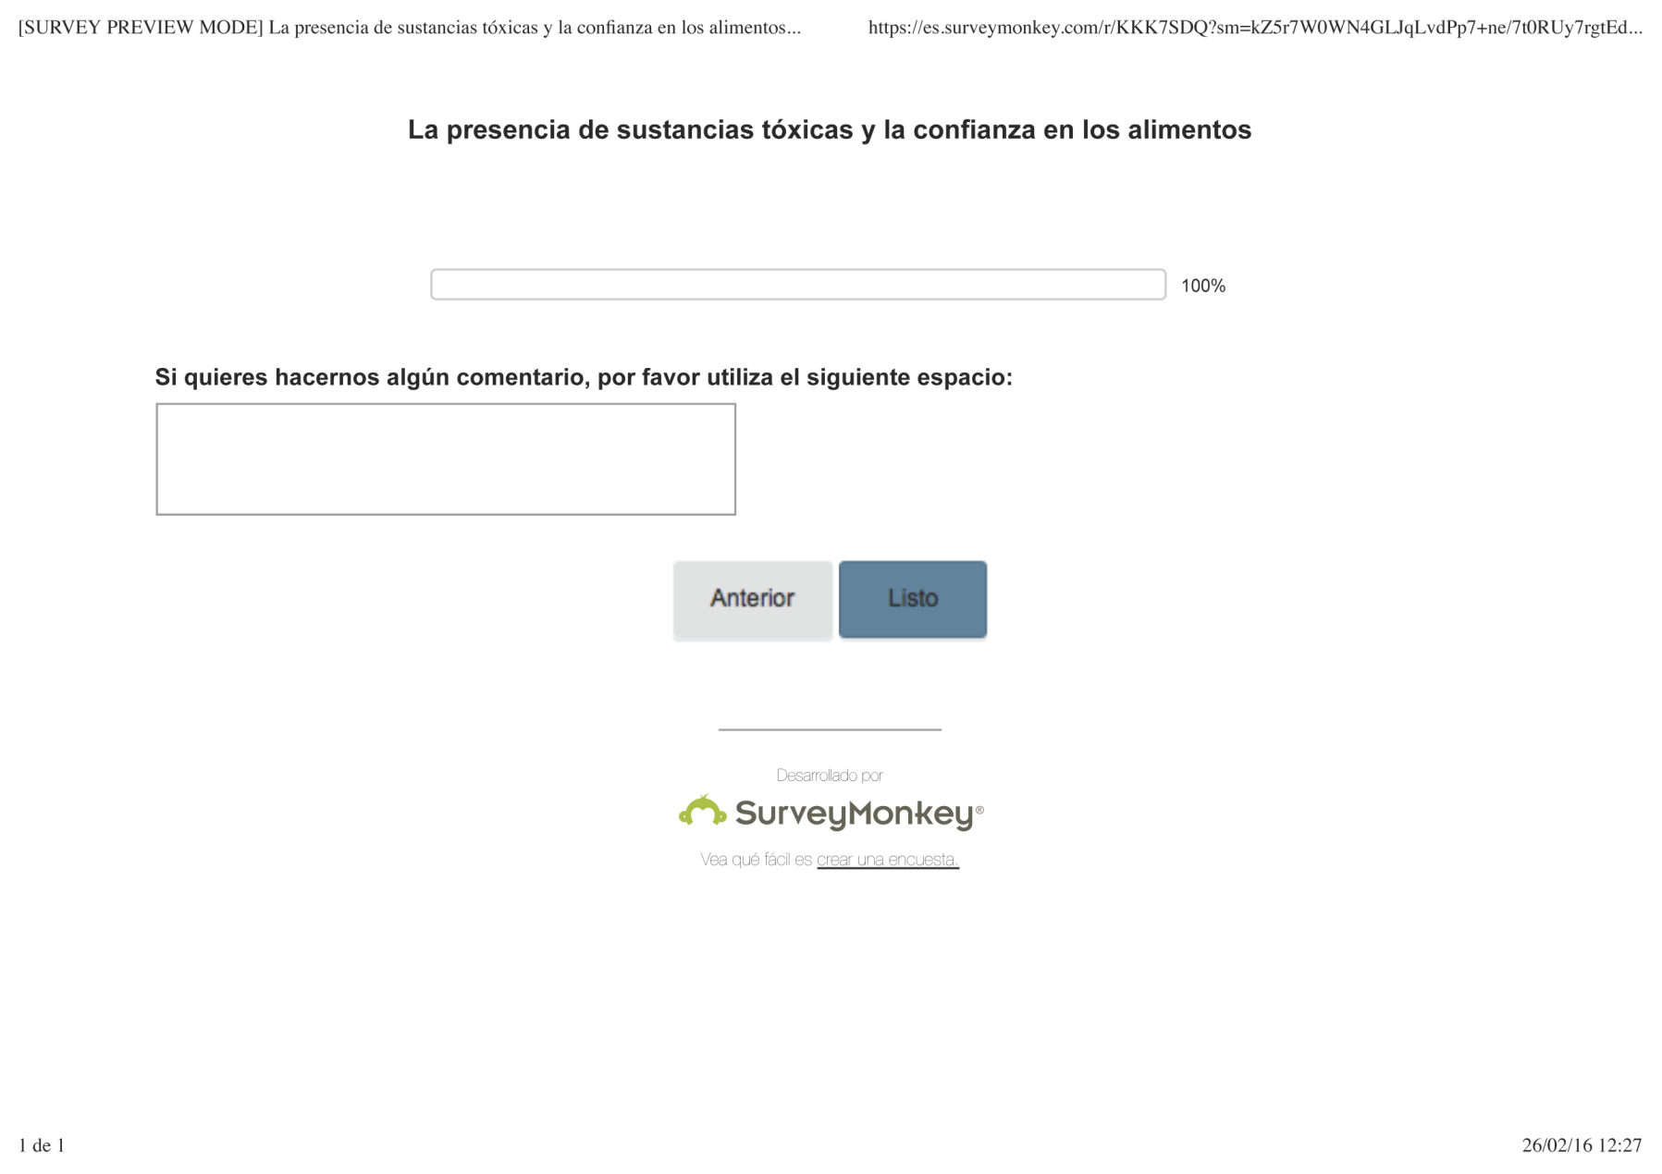

* **Comments: If you wish to make any further comments please use the space below:**