Appendix
Model description
Instead of Markov models, we used DES to represent the natural history of early BC because of its capacity to take into account the patient history in its progression through the model¹. The DES model developed for the study reproduced two identical populations of patients whose pathways were different according to the criteria applied for the prescription of chemotherapy. In turn, the simulated populations constituted representations of the patients included in the sample of participating hospitals, in order to simulate the population on which real data were available. The follow-up period with the populations started from the moment they were evaluated in order to make a decision about the adjuvant treatment until the end of their lives, either due to death derived from a recurrence or due to causes other than BC. Figure A1 shows the flow diagram of the natural history of hormone Receptor positive/HER2 negative early breast cancer. The path that each patient followed depended on her initial characteristics (age, stage and menopause status) and by the risk group and criteria applied (oncotype or clinical-pathological) which determined her probability of developing recurrence. Patients’ initial characteristics (age, stage and menopause status) were assigned by jointly sampling from the patient-level dataset to preserve the correlations among them. The model also included the probability of receiving granulocyte colony-stimulating factor (G-CSF) and toxicity associated to the chemotherapy. Patients who recurred were assigned two “time-to-death” values. First, death caused by breast cancer and, second, by other causes. The minimum of both times determined the age of death. A discount of 3% per annum was applied both for costs and for utility measured in quality adjusted life years². In a complementary way, a calculation was carried out in which no discount was applied. The time-horizon was the life of the patients.
To stabilize the results, each simulation run included 10,000 entities or “patients” which followed different paths according to their characteristics¹. Figure A3 shows the ICER behaves according to the number of entities. The parameters of the model and the distributions applied in the probabilistic processing were derived from the clinical study with 401 patients³ and from the literature and are shown in Tables I and II.^{4–9}. Table I also describes the order of uncertainty applied for each parameter. The likelihood of, first, treatment with chemotherapy³, and cancer recurrence by type of treatment⁴ came from the literature. For those who recurred, the time until death was assigned by applying survival tables obtained from the work by Arrospide et al.¹⁰. Mortality due to causes other than BC was obtained from the general mortality rates of the Basque population (Basque Statistical Institute) and, by discounting BC mortality, a Gompertz function was defined to assign time until death.¹⁰ The age, stage and pre or postmenopausal condition of the simulated patients reproduced the distribution of the sample studied.³ The condition of menopause determined the type of hormonal treatment administered (tamoxifen or aromatase inhibitors). The parameters, such as the stage, that differentiated the assignment of chemotherapy and the reclassification of patients, constituted a key point for the comparison of the two evaluated technologies. The analysis with one or another technique established a future risk and its application did not modify the characteristics of the patients. The calculation of the probabilities from the field data allowed configuring the model to evaluate the economic impact produced by the technological change in the treatment criterion.
The utilities of the different states in relation to the BC (Fig. A2) were estimated following the work of Stout et al. based on the loss of utility caused by the treatment according to each age group and health status.⁵ In Stout et al. and related work, patients suffer a significant reduction in quality of life during the adjuvant and end-of-life chemotherapy stage as a consequence of metastasis. The procedure begins by establishing the utility for each age group in the general population. For that, we used data from the 2011-2012 Spanish National Health Survey, which contains the EQ-5D-5L instrument.^{6,7} The data of 21,007 adults from the sample were downloaded from the Spanish Statistical Office website where more detailed description about the methodology of this survey can be found.⁷ Applying the approach described by Briggs et al.¹¹ a 1-gamma function was parameterized.

Cost analysis

The baseline case assumed the perspective of the health system, incorporating only health-care costs, which were calculated by multiplying the use of resources by each unit cost³. An analysis was then added from the societal perspective in which costs for loss of productivity due to sick leave due to chemotherapy were included.³ The unit costs were obtained from the analytical accounting system of the Basque Health Service in 2014, the pharmacy service and the literature^{2,3} and are shown in Table II. The time lost as paid work was estimated from the perspective of human capital.^{2,12} The unit cost of lost productivity for each patient was estimated from the average monthly gross salary in Spain in 2014 (€ 1881), calculated in the Survey of the Spanish Labor Force carried out by the Spanish National Institute of Statistics in 2014 and the duration of treatment for each chemotherapy regimen.

Probabilistic model

First, the calculation of the incremental cost-effectiveness ratio (ICER), composed of incremental cost and incremental effectiveness, was carried out through a deterministic analysis using the mean of each parameter. Subsequently, a probabilistic sensitivity analysis was developed with 1000 simulations in which the applied values ​​varied in each replication according to the distributions used.¹¹ The result of each trial is summarized in an ICER used to obtain the confidence intervals (percentiles 2.5 and 97.5), the cost-effectiveness plane and the acceptability curves. The first consists of the representation in a plane of the incremental cost and the incremental effectiveness of each simulation.¹¹ The second, the acceptability curve, is based on the calculation of the percentage of simulations in which the alternative studied has an incremental cost-effectiveness ratio lower than the threshold for different values for this ratio. That percentage also equates to the probability that the incremental net benefit will be greater than zero. The curve is obtained by projecting that calculation based on the threshold value.¹¹
In some simulations, the preferred strategy, based on the analysis of the net benefit of the whole set of simulations, is not optimal, leading to an opportunity loss. This loss is the difference between the maximum net profit attainable (with perfect information) and the net benefit associated with the most favored strategy. The opportunity loss is calculated for each simulation as the difference between the maximum benefit achieved in that simulation and the net benefit of the favorite strategy. In the case where the maximum net profit reached in that simulation coincides with that of the most favored strategy, no loss of opportunity will have been incurred. But, given parameter uncertainty, in some simulations the preferred strategy would have been the rejected one and, thus, a negative net benefit would have occurred. The average opportunity loss of all simulations is calculated later, and represents the expected cost of the uncertainty, which is equivalent to the total expected value of perfect information (EVPI) per patient. This estimate is multiplied by the target population of the technology for the next five years (1505 patients according to the Basque Cancer Registry) to obtain the population EVPI. To calculate the partial EVPI (EVPPI) associated with two groups of parameters (risk score distribution and adverse effects probabilities), the process is repeated, fixing this group at mean values ​​and keeping the distributions in the rest. The obtained EVPI is subtracted from the total to estimate the EVPPI associated with each group of parameters.^{11,13}

Model validation

The external validation of the model was established by comparing the 10-year recurrence probability to the data from the literature,⁴ since the model does not apply these probabilities but rather allocates times to events in a competitive manner. As internal validation, the life expectancy of the women without metastasis was estimated, which should coincide with the life expectancy of the general population.
The literature does not include studies analyzing the probability of recurrence of breast cancer patients along full lifespan. Currently several studies are in progress in this area. However, the survival of early stage breast cancer patients has been evaluated over smaller time horizons (5 and 10 years).^{14,15} The investigations developed by Paik et al.⁴ established the recurrence likelihood of patients according to recurrence score and adjuvant treatment.
As the model time horizon was patients’ entire life, we calculated by calibration that probability. This figure was validated by reproducing the 10-year probability. This figure was obtained as a surrogate result.

Patient Recurrence Risk and adjuvant treatment | Model recurrence probability at 10 years | Paik et al.⁴ recurrence probability at 10 years
Low risk patient treated with HT | 0.0320 | 0.032
Intermediate risk patient treated with HT | 0.0913 | 0.091
High risk patient treated with HT | 0.3964 | 0.395
Low risk patient treated with CHT + HT | 0.0449 | 0.044
Intermediate risk patient treated with CHT + HT | 0.1064 | 0.109
High risk patient treated with CHT + HT | 0.1192 | 0.119

References

1. Caro JJ, Möller J, Karnon J, et al. Discrete event simulation for health technology assessment. 1st ed. Boca Raton, London, New York: Chapman and Hall/CRC; 2015. 374 p.
2. López Bastida J, Oliva J, Antoñanzas F, et al. Propuesta de guía para la evaluación económica aplicada a las tecnologías sanitarias. Gac Sanit. 2010;24:154-70.
3. Martínez del Prado P, Álvarez-López I, Domínguez-Fernández S, et al. Clinical and economic impact of the 21-gene recurrence score assay in adjuvant therapy decision making in patients with early-stage breast cancer: pooled analysis in 4 Basque Country university hospitals. Breast Cancer (Dove Med Press). 2018;10:189-99.
4. Paik S, Tang G, Shak S, et al. Gene expression and benefit of chemotherapy in women with node-negative, estrogen receptor-positive breast cancer. J Clin Oncol. 2006;24:3726-34.
5. Stout NK, Rosenberg MA, Trentham-Dietz A, et al. Retrospective cost-effectiveness analysis of screening mammography. J Natl Cancer Inst. 2006;98:774-82.
6. Ramos-Goñi JM, Craig BM, Oppe M, et al. Handling data quality issues to estimate the Spanish EQ-5D-5L value set using a hybrid interval regression approach. Value in Health. 2018;21:596-604.
7. Spanisht National Health Statistics. Spanish National Health Survey 2011-2012. (Accessed 2/3/2017.) Available at: http://www.ine.es/dyngs/INEbase/en/operacion.htm?c=Estadistica_C&cid=1254736176783&menu=resultados&secc=1254736195295&idp=1254735573175
8. Vilaprinyo E, Rué M, Marcos-Gragera R, et al. Estimation of age- and stage-specific Catalan breast cancer survival functions using US and Catalan survival data. BMC Cancer. 2009;9:98.
9. Arrospide A, Soto-Gordoa M, Acaiturri T, et al. Coste del tratamiento del cáncer de mama por estadio clínico en el País Vasco. Rev Esp Salud Publica. 2015;89:93-7.
10. Arrospide A, Rue M, van Ravesteyn NT, et al. Evaluation of health benefits and harms of the breast cancer screening programme in the Basque Country using discrete event simulation. BMC Cancer. 2015;15:671.
11. Briggs AH, Claxton K, Sculpher MJ. Decision modelling for health economic evaluation. Oxford University Press; 2006. 250 p.
12. Drummond MF, Sculpher MJ, Torrance GW, et al. Methods for the economic evaluation of health care programmes. 3rd ed. Oxford: OUP Oxford; 2005. 400 p.
13. Mar J, Gutiérrez-Moreno S, Chilcott J. Análisis coste-efectividad de tipo probabilístico del tratamiento de la apnea del sueño. Gac Sanit. 2006;20:47-53.
14. Coates AS, Winer EP, Goldhirsch A, et al. Tailoring therapies — improving the management of early breast cancer: St Gallen International Expert Consensus on the Primary Therapy of Early Breast Cancer 2015. Ann Oncol. 2015;26:1533-46.
15. Goldhirsch A, Winer EP, Coates AS, et al. Personalizing the treatment of women with early breast cancer: highlights of the St Gallen International Expert Consensus on the Primary Therapy of Early Breast Cancer 2013. Ann Oncol. 2013;24:2206-23.

Table I
Parameter groups and distributions used for the calculation of the partial expected value of perfect information.
Group | Variable | Distribution |  | Source
Treatment decision | Risk Score | Dirichlet compound by:
 |  |  | Gamma (222,1) | ¹⁰
 |  |  | Gamma (153,1) | ¹⁰
 |  |  | Gamma (26,1) | ¹⁰
 | Chemotherapy | Dirichlet compound by:
 |  |  | Gamma (28,1) | ¹⁰
 |  |  | Gamma (21,1) | ¹⁰
 |  |  | Gamma (14,1) | ¹⁰
 |  |  | Gamma (3,1) | ¹⁰
 |  |  | Gamma (66,1) | ¹⁰
 |  |  | Gamma (17,1) | ¹⁰
 |  |  | Gamma (74,1) | ¹⁰
 |  |  | Gamma (4,1) | ¹⁰
Adverse effects | Toxicity | Beta (15,84) |  | ¹⁰
 | G-CSF | Beta (31,68) |  | ¹⁰

Table II
Utilities of different phases of early stage breast cancer patients by age groups.
 | General population | Chemotherapy | Chemotherapy toxicity | Hormonotherapy | Metastasis
Utility respect to general population | 100% | 90% | 85% | 95% | 70%
Age group: 16-44 | 0.9709 | 0.8738 | 0.8253 | 0.9224 | 0.6796
Age group: 45-64 | 0.8989 | 0.8090 | 0.7641 | 0.8540 | 0.6292
Age group: 65-74 | 0.8333 | 0.7500 | 0.7083 | 0.7916 | 0.5833
Age group: 75-84 | 0.7610 | 0.6849 | 0.6469 | 0.7230 | 0.5327
Age group: ≥85 | 0.6048 | 0.5443 | 0.5141 | 0.5746 | 0.4234

Table III
Mean, median and 95% confidence intervals for ICER in the probabilistic approach.
 | ICER (mean) | ICER (median) | ICER (CI)
Health service perspective with discount | 16,176 | 12,713 | (4,722 to 51,345)
Social perspective with discount | -4,572 | -4,974 | (-27,249 to 27,115)
Health service perspective without discount | 9,003 | 7,001 | (2,419 to 28,335)
Social perspective with discount | -2,825 | -2,988 | (-16,044 to 15,217)
CI: confidence intervals; ICER: incremental cost-effectiveness ratio; QALY: quality adjusted life year.

Figure A1. Early Stage Breast Cancer modelling diagram.
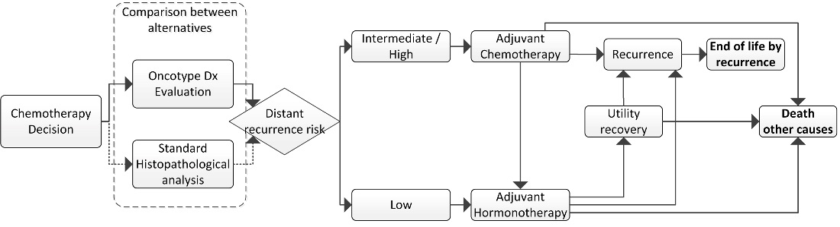

Figure A2. Cost-effectiveness plane for the use of oncotype from the perspective of the Basque Health Service and Social perspective without discount. QALY: quality adjusted life year.
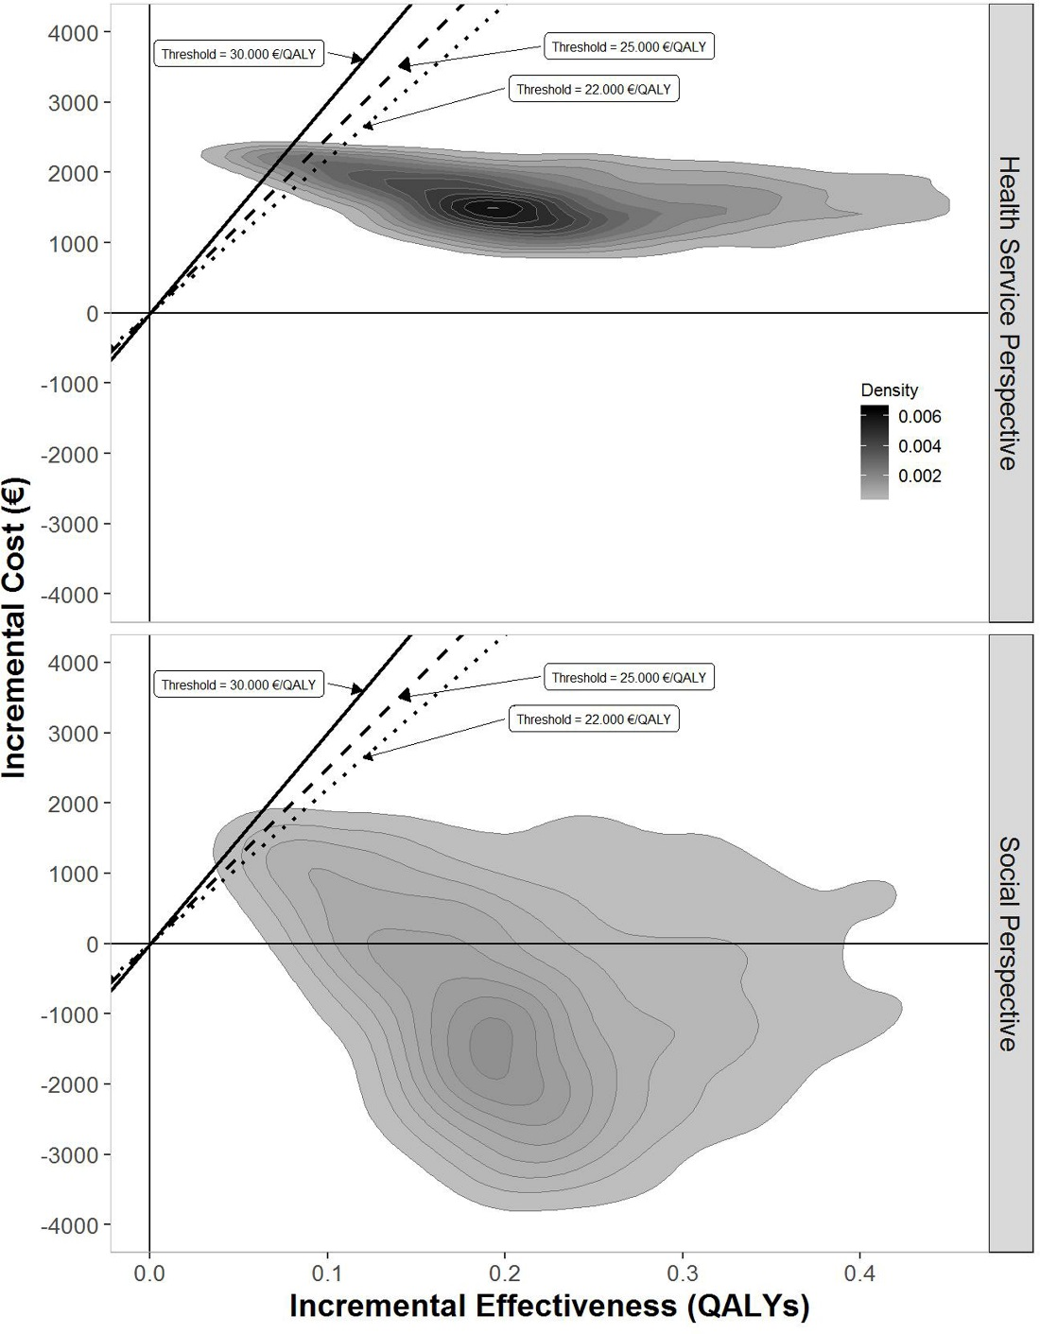

Figure A3. Calibration curves of required iterations to stabilize the mean incremental cost-effectiveness ratio (with and without discount).
