Appendix

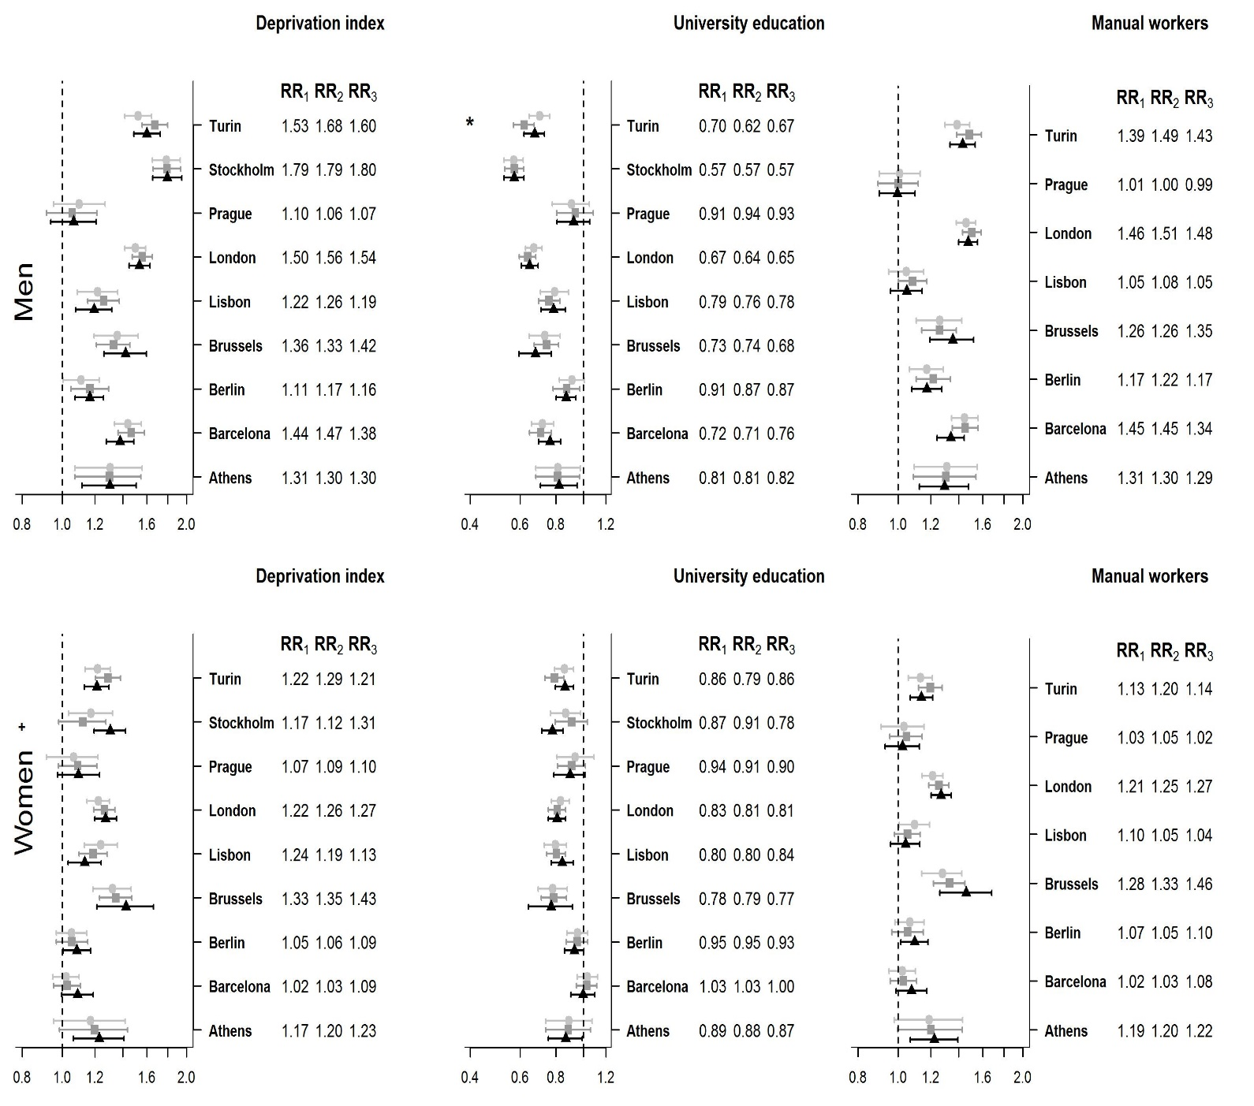
Figure I. Association between socioeconomic indicators and mortality, relative risk (RR) and 95% credible intervals (CI) for men and women in nine urban areas (Note 1: RR_{i} corresponds to the increase in risk that would correspond to a change in the composite deprivation index from its 5th percentile value (low deprivation) to its 95th percentile value (severe deprivation) in the period i; Note 2: * indicates that RR₂ is statistically significantly different than RR₁ and + means that RR₃ is statistically significantly different than RR₂).
First period
Second period
Third period

Table I
Relative risk (increase in risk that would correspond to a change in the composite deprivation index from its 5th percentile value (low deprivation) to its 95th percentile value (severe deprivation) in each of the periods (1, 2 and 3) along with Lower (LL) and Upper (UL) Limits of the 95% Credible intervals. Significance of P2 vs P1 is 1 if RR2 is statistically significantly different from RR1 and 0 otherwise (the same for Significance of P3 vs P3).
Men
Urban area | RR1 | LL1 | Sup1 | RR2 | Inf2 | Sup2 | RR3 | Inf3 | Sup3 | sign. P2 vs P1 | sign. P3 vs P2
Athens | 1.305366 | 1.0739759 | 1.560217 | 1.301209 | 1.0733382 | 1.551401 | 1.304146 | 1.1158057 | 1.508695 | 0 | 0
Barcelona | 1.442232 | 1.3375679 | 1.554706 | 1.469655 | 1.365582 | 1.581677 | 1.379509 | 1.2776936 | 1.48964 | 0 | 0
Berlin | 1.112282 | 1.0040248 | 1.22871 | 1.16827 | 1.0491407 | 1.296397 | 1.164848 | 1.076418 | 1.258231 | 0 | 0
Brussels | 1.358051 | 1.1956412 | 1.525143 | 1.332959 | 1.2099316 | 1.459113 | 1.424138 | 1.2621498 | 1.598005 | 0 | 0
Lisbon | 1.217454 | 1.0864171 | 1.360967 | 1.259757 | 1.152334 | 1.37495 | 1.193268 | 1.0771179 | 1.318228 | 0 | 0
London | 1.501984 | 1.4174255 | 1.590541 | 1.562949 | 1.4773053 | 1.65247 | 1.537678 | 1.4512327 | 1.628356 | 0 | 0
Prague | 1.098646 | 0.9537376 | 1.269354 | 1.058148 | 0.9158576 | 1.213932 | 1.065305 | 0.9384629 | 1.207313 | 0 | 0
Stockholm | 1.787647 | 1.652731 | 1.931201 | 1.792235 | 1.6598043 | 1.932512 | 1.79545 | 1.6539561 | 1.946082 | 0 | 0
Turin | 1.525897 | 1.4157322 | 1.643918 | 1.676012 | 1.5590402 | 1.800479 | 1.603297 | 1.4896942 | 1.724079 | 0 | 0
Women
Urban area | RR1 | Inf1 | Sup1 | RR2 | Inf2 | Sup2 | RR3 | Inf3 | Sup3 | sigP2.1 | sigP3.2
Athens | 1.172281 | 0.9538119 | 1.420789 | 1.199288 | 0.9848163 | 1.439201 | 1.228596 | 1.0643781 | 1.410397 | 0 | 0
Barcelona | 1.022708 | 0.9491507 | 1.100309 | 1.028509 | 0.9539568 | 1.107524 | 1.090115 | 0.9989442 | 1.188256 | 0 | 0
Berlin | 1.054098 | 0.9684402 | 1.145647 | 1.056924 | 0.967774 | 1.152513 | 1.08548 | 1.0040342 | 1.171616 | 0 | 0
Brussels | 1.325079 | 1.1871093 | 1.468714 | 1.349745 | 1.2305993 | 1.472587 | 1.427654 | 1.2135791 | 1.66271 | 0 | 0
Lisbon | 1.239713 | 1.130805 | 1.357889 | 1.189395 | 1.0994434 | 1.284274 | 1.134572 | 1.0327561 | 1.241837 | 0 | 0
London | 1.222807 | 1.147647 | 1.30201 | 1.264891 | 1.1908339 | 1.342492 | 1.274068 | 1.1984326 | 1.353837 | 0 | 0
Prague | 1.066613 | 0.9170787 | 1.220144 | 1.091462 | 0.9778622 | 1.2123 | 1.095352 | 0.9741196 | 1.231605 | 0 | 0
Stockholm | 1.173894 | 1.0359955 | 1.325172 | 1.120697 | 0.9805181 | 1.274983 | 1.305274 | 1.1948528 | 1.423084 | 0 | 1
Turin | 1.217500 | 1.1348325 | 1.306411 | 1.291661 | 1.2053393 | 1.383677 | 1.211839 | 1.1315849 | 1.298983 | 0 | 0

Table II
Relative risk (increase in risk that would correspond to a change in the unemployment indicator from its 5th percentile value (low deprivation) to its 95th percentile value (severe deprivation) in each of the periods (1, 2 and 3) along with Lower (LL) and Upper (UL) Limits of the 95% Credible intervals. Significance of P2 vs P1 is 1 if RR2 is statistically significantly different from RR1 and 0 otherwise (the same for Significance of P3 vs P3).

Men
Urban area | RR1 | Inf1 | Sup1 | RR2 | Inf2 | Sup2 | RR3 | Inf3 | Sup3 | sigP2.1 | sigP3.2
Athens | 1.283714 | 1.0520082 | 1.546081 | 1.288231 | 1.057564 | 1.544763 | 1.31307 | 1.127135 | 1.517599 | 0 | 0
Barcelona | 1.155934 | 1.1028671 | 1.210274 | 1.165115 | 1.115533 | 1.215918 | 1.192811 | 1.139858 | 1.247193 | 0 | 0
Berlin | 1.173376 | 1.0652863 | 1.287412 | 1.267258 | 1.162753 | 1.376625 | 1.19671 | 1.108766 | 1.287385 | 0 | 0
Brussels | 1.261737 | 1.1217797 | 1.408552 | 1.238733 | 1.130733 | 1.350413 | 1.283499 | 1.134647 | 1.442709 | 0 | 0
Lisbon | 1.104152 | 0.9881126 | 1.22909 | 1.139701 | 1.042074 | 1.243213 | 1.204691 | 1.09194 | 1.325208 | 0 | 0
London | 1.55125 | 1.4691411 | 1.636721 | 1.583717 | 1.502558 | 1.667936 | 1.567831 | 1.484213 | 1.655146 | 0 | 0
Prague | 1.007883 | 0.8719322 | 1.153816 | 1.139414 | 0.994944 | 1.288904 | 1.173238 | 1.046741 | 1.303288 | 0 | 0
Stockholm | 1.696158 | 1.5796031 | 1.818268 | 1.7046 | 1.588902 | 1.826148 | 1.710798 | 1.588729 | 1.839159 | 0 | 0
Turin | 1.339805 | 1.2767478 | 1.404944 | 1.383724 | 1.319576 | 1.449851 | 1.369269 | 1.305311 | 1.435417 | 0 | 0
Women
Urban area | RR1 | Inf1 | Sup1 | RR2 | Inf2 | Sup2 | RR3 | Inf3 | Sup3 | sigP2.1 | sigP3.2
Athens | 1.182837 | 0.960632 | 1.435656 | 1.234667 | 1.0177522 | 1.476873 | 1.268621 | 1.1044635 | 1.442842 | 0 | 0
Barcelona | 1.021975 | 0.9755196 | 1.06978 | 1.051638 | 1.0043033 | 1.100488 | 1.075425 | 1.0217692 | 1.130998 | 0 | 0
Berlin | 1.046767 | 0.9587137 | 1.139673 | 1.056428 | 0.9652318 | 1.153886 | 1.101632 | 1.0183638 | 1.188381 | 0 | 0
Brussels | 1.243088 | 1.1091665 | 1.382345 | 1.290053 | 1.1859238 | 1.396462 | 1.351004 | 1.1672397 | 1.547603 | 0 | 0
Lisbon | 1.017647 | 0.9213064 | 1.1211 | 1.062102 | 0.9762114 | 1.153126 | 1.076916 | 0.9797453 | 1.180819 | 0 | 0
London | 1.285844 | 1.2090086 | 1.366553 | 1.338165 | 1.2627986 | 1.416829 | 1.347785 | 1.2685646 | 1.431604 | 0 | 0
Prague | 1.045091 | 0.8979221 | 1.199187 | 1.001703 | 0.8895074 | 1.118409 | 1.163374 | 1.0490474 | 1.283603 | 0 | 1
Stockholm | 1.2832 | 1.1403376 | 1.43823 | 1.225723 | 1.0783789 | 1.387369 | 1.381437 | 1.2662353 | 1.503771 | 0 | 0
Turin | 1.140552 | 1.085694 | 1.197254 | 1.162063 | 1.1080443 | 1.218112 | 1.133497 | 1.0799751 | 1.188972 | 0 | 0

Table III
Relative risk (increase in risk that would correspond to a change in the primary education indicator from its 5th percentile value (low deprivation) to its 95th percentile value (severe deprivation) in each of the periods (1, 2 and 3) along with Lower (LL) and Upper (UL) Limits of the 95% Credible intervals. Significance of P2 vs P1 is 1 if RR2 is statistically significantly different from RR1 and 0 otherwise (the same for Significance of P3 vs P3).

Men
Urban area | RR1 | Inf1 | Sup1 | RR2 | Inf2 | Sup2 | RR3 | Inf3 | Sup3 | sigP2.1 | sigP3.2
Athens | 1.237486 | 1.0314091 | 1.467866 | 1.230457 | 1.026364 | 1.455559 | 1.234837 | 1.0687052 | 1.41699 | 0 | 0
Barcelona | 1.38655 | 1.2952082 | 1.48297 | 1.420115 | 1.3301077 | 1.515647 | 1.304198 | 1.2175408 | 1.395973 | 0 | 0
Berlin | 1.044588 | 0.9343896 | 1.165342 | 1.127364 | 1.0008142 | 1.265946 | 1.120487 | 1.0248809 | 1.224091 | 0 | 0
Brussels | 1.326367 | 1.1671606 | 1.492085 | 1.292368 | 1.1706247 | 1.417455 | 1.374113 | 1.2102278 | 1.546931 | 0 | 0
Lisbon | 1.248299 | 1.1297559 | 1.37621 | 1.261664 | 1.1663511 | 1.3625 | 1.195061 | 1.0897341 | 1.306987 | 0 | 0
London | 1.527431 | 1.426686 | 1.633881 | 1.603566 | 1.5003057 | 1.712413 | 1.577965 | 1.4732373 | 1.688918 | 0 | 0
Prague | 1.215236 | 1.0325095 | 1.430222 | 1.061917 | 0.9026645 | 1.234904 | 1.06358 | 0.9239909 | 1.218555 | 0 | 0
Stockholm | 1.492796 | 1.3680765 | 1.624925 | 1.567687 | 1.4429591 | 1.700053 | 1.68987 | 1.5501785 | 1.838812 | 0 | 0
Turin | 1.399339 | 1.3236705 | 1.478486 | 1.500841 | 1.4214512 | 1.583404 | 1.488058 | 1.4082682 | 1.571154 | 1 | 0
Women
Urban area | RR1 | Inf1 | Sup1 | RR2 | Inf2 | Sup2 | RR3 | Inf3 | Sup3 | sigP2.1 | sigP3.2
Athens | 1.123089 | 0.9256005 | 1.34299 | 1.151836 | 0.9594498 | 1.365981 | 1.184863 | 1.0366598 | 1.348922 | 0 | 0
Barcelona | 1.072147 | 1.0001403 | 1.148762 | 1.033416 | 0.9632263 | 1.107028 | 1.122316 | 1.0357986 | 1.214895 | 0 | 0
Berlin | 1.006748 | 0.9274479 | 1.092314 | 1.029214 | 0.9453888 | 1.119944 | 1.042464 | 0.9624201 | 1.129132 | 0 | 0
Brussels | 1.320468 | 1.1783594 | 1.468165 | 1.336109 | 1.2194525 | 1.456615 | 1.40565 | 1.2012469 | 1.626707 | 0 | 0
Lisbon | 1.249198 | 1.1518154 | 1.35269 | 1.19715 | 1.1146888 | 1.282909 | 1.129456 | 1.0355517 | 1.227503 | 0 | 0
London | 1.213548 | 1.1287059 | 1.303832 | 1.257717 | 1.1728116 | 1.347619 | 1.25813 | 1.1718797 | 1.35037 | 0 | 0
Prague | 1.062014 | 0.8905205 | 1.245837 | 1.077806 | 0.9421896 | 1.22099 | 1.069259 | 0.937446 | 1.213217 | 0 | 0
Stockholm | 1.188169 | 1.0365565 | 1.355146 | 1.19296 | 1.029365 | 1.375216 | 1.272064 | 1.1552367 | 1.398657 | 0 | 0
Turin | 1.2194 | 1.1563448 | 1.284912 | 1.247852 | 1.1837752 | 1.314604 | 1.233039 | 1.1680906 | 1.301246 | 0 | 0

Table IV
Relative risk (increase in risk that would correspond to a change in the university education indicator from its 5th percentile value (low deprivation) to its 95th percentile value (severe deprivation) in each of the periods (1, 2 and 3) along with Lower (LL) and Upper (UL) Limits of the 95% Credible intervals. Significance of P2 vs P1 is 1 if RR2 is statistically significantly different from RR1 and 0 otherwise (the same for Significance of P3 vs P3).

Men
Urban area | RR1 | Inf1 | Sup1 | RR2 | Inf2 | Sup2 | RR3 | Inf3 | Sup3 | sigP2.1 | sigP3.2
Athens | 0.8136065 | 0.680064 | 0.9745479 | 0.8126909 | 0.6813008 | 0.9707564 | 0.8216814 | 0.7072727 | 0.9522214 | 0 | 0
Barcelona | 0.7194073 | 0.6572795 | 0.7845133 | 0.7079612 | 0.6477972 | 0.770799 | 0.7631063 | 0.6967926 | 0.8322413 | 0 | 0
Berlin | 0.9122604 | 0.8233774 | 1.0079042 | 0.8738935 | 0.7835485 | 0.971937 | 0.8700935 | 0.8028859 | 0.9413237 | 0 | 0
Brussels | 0.7321529 | 0.644323 | 0.8298122 | 0.7424566 | 0.6719621 | 0.8192833 | 0.6794863 | 0.5940504 | 0.7714718 | 0 | 0
Lisbon | 0.7941446 | 0.7075732 | 0.8872105 | 0.7589255 | 0.6951935 | 0.826562 | 0.7845884 | 0.7099234 | 0.8645457 | 0 | 0
London | 0.6709811 | 0.6264431 | 0.7174419 | 0.6373096 | 0.5960763 | 0.6803108 | 0.6478419 | 0.6044738 | 0.6929909 | 0 | 0
Prague | 0.9102042 | 0.7783553 | 1.0503691 | 0.936665 | 0.8054337 | 1.0845915 | 0.9256251 | 0.8073819 | 1.0532651 | 0 | 0
Stockholm | 0.5691093 | 0.5257327 | 0.61474 | 0.5723398 | 0.529804 | 0.6171672 | 0.5718983 | 0.5265099 | 0.619877 | 0 | 0
Turin | 0.7026434 | 0.6456061 | 0.7615322 | 0.6193376 | 0.5684127 | 0.6724949 | 0.6738393 | 0.6187977 | 0.7313751 | 1 | 0
Women
Urban area | RR1 | Inf1 | Sup1 | RR2 | Inf2 | Sup2 | RR3 | Inf3 | Sup3 | sigP2.1 | sigP3.2
Athens | 0.8894261 | 0.7362592 | 1.0722149 | 0.8845379 | 0.7371728 | 1.0593197 | 0.8662601 | 0.7544042 | 0.9906353 | 0 | 0
Barcelona | 1.0332727 | 0.9520063 | 1.1205083 | 1.0281772 | 0.9463642 | 1.1156781 | 0.997135 | 0.9035571 | 1.0969245 | 0 | 0
Berlin | 0.953501 | 0.8761061 | 1.0351522 | 0.9513114 | 0.871157 | 1.0360815 | 0.9289572 | 0.8591149 | 1.0026984 | 0 | 0
Brussels | 0.7819507 | 0.6946583 | 0.8770992 | 0.788303 | 0.7114573 | 0.8717149 | 0.7697751 | 0.6415283 | 0.91645 | 0 | 0
Lisbon | 0.7995198 | 0.7290727 | 0.8735288 | 0.8038995 | 0.7447853 | 0.8657957 | 0.8434372 | 0.7703474 | 0.9221176 | 0 | 0
London | 0.8326244 | 0.7740989 | 0.8935386 | 0.8096229 | 0.7547942 | 0.8668136 | 0.8095363 | 0.7535631 | 0.8675442 | 0 | 0
Prague | 0.9351962 | 0.8073231 | 1.0896252 | 0.9099264 | 0.8114064 | 1.0175108 | 0.8978487 | 0.7893801 | 1.0120392 | 0 | 0
Stockholm | 0.8683824 | 0.7665897 | 0.9793031 | 0.9099695 | 0.7970051 | 1.0341547 | 0.7791977 | 0.7132847 | 0.8493425 | 0 | 0
Turin | 0.8593103 | 0.7937683 | 0.9255669 | 0.7915719 | 0.7316209 | 0.8538235 | 0.8618164 | 0.7986892 | 0.9247273 | 0 | 0

Table V
Relative risk (increase in risk that would correspond to a change in the percentage of manual workers indicator from its 5th percentile value (low deprivation) to its 95th percentile value (severe deprivation) in each of the periods (1, 2 and 3) along with Lower (LL) and Upper (UL) Limits of the 95% Credible intervals. Significance of P2 vs P1 is 1 if RR2 is statistically significantly different from RR1 and 0 otherwise (the same for Significance of P3 vs P3).

Men
Urban area | RR1 | Inf1 | Sup1 | RR2 | Inf2 | Sup2 | RR3 | Inf3 | Sup3 | sigP2.1 | sigP3.2
Athens | 1.310703 | 1.0936602 | 1.551576 | 1.303577 | 1.0888811 | 1.542474 | 1.2932549 | 1.1252467 | 1.477962 | 0 | 0
Barcelona | 1.448691 | 1.3466384 | 1.558536 | 1.451743 | 1.3509321 | 1.56028 | 1.3389848 | 1.2424063 | 1.443003 | 0 | 0
Berlin | 1.171935 | 1.0641479 | 1.285229 | 1.216845 | 1.1044452 | 1.336319 | 1.1728588 | 1.0783735 | 1.274523 | 0 | 0
Brussels | 1.261237 | 1.1053017 | 1.424418 | 1.258811 | 1.1397036 | 1.382335 | 1.3540036 | 1.1933254 | 1.522621 | 0 | 0
Lisbon | 1.046762 | 0.9480191 | 1.153174 | 1.08435 | 1.0013232 | 1.172401 | 1.0484006 | 0.9592609 | 1.143343 | 0 | 0
London | 1.458898 | 1.383574 | 1.537461 | 1.506388 | 1.4303488 | 1.585594 | 1.4774599 | 1.4014602 | 1.556781 | 0 | 0
Prague | 1.008553 | 0.9009523 | 1.129034 | 1.001606 | 0.8939995 | 1.117825 | 0.9944687 | 0.8998885 | 1.098553 | 0 | 0
Turin | 1.3895 | 1.2964298 | 1.48983 | 1.485374 | 1.3862768 | 1.590672 | 1.4323425 | 1.3345032 | 1.536463 | 0 | 0
Women
Urban area | RR1 | Inf1 | Sup1 | RR2 | Inf2 | Sup2 | RR3 | Inf3 | Sup3 | sigP2.1 | sigP3.2
Athens | 1.1896 | 0.9785905 | 1.430594 | 1.200547 | 0.9981116 | 1.428865 | 1.223315 | 1.0688793 | 1.394275 | 0 | 0
Barcelona | 1.024625 | 0.9513393 | 1.101001 | 1.030217 | 0.9561564 | 1.108081 | 1.077872 | 0.988988 | 1.172859 | 0 | 0
Berlin | 1.066885 | 0.9829701 | 1.155538 | 1.054448 | 0.9660096 | 1.149002 | 1.095476 | 1.0143064 | 1.180081 | 0 | 0
Brussels | 1.281421 | 1.1398777 | 1.425954 | 1.331945 | 1.2177176 | 1.449393 | 1.461356 | 1.2599546 | 1.682198 | 0 | 0
Lisbon | 1.095796 | 1.0069923 | 1.190447 | 1.053501 | 0.979306 | 1.130919 | 1.041698 | 0.9594028 | 1.128334 | 0 | 0
London | 1.211823 | 1.1431442 | 1.283818 | 1.254942 | 1.1870797 | 1.325639 | 1.269871 | 1.2004961 | 1.342447 | 0 | 0
Prague | 1.032687 | 0.9094537 | 1.155285 | 1.048197 | 0.9545218 | 1.141955 | 1.02408 | 0.9309911 | 1.124539 | 0 | 0
Turin | 1.131645 | 1.0590554 | 1.209327 | 1.196423 | 1.1196167 | 1.278265 | 1.138251 | 1.0697696 | 1.21238 | 0 | 0

