Figure 1. Transition treatment algorithm.
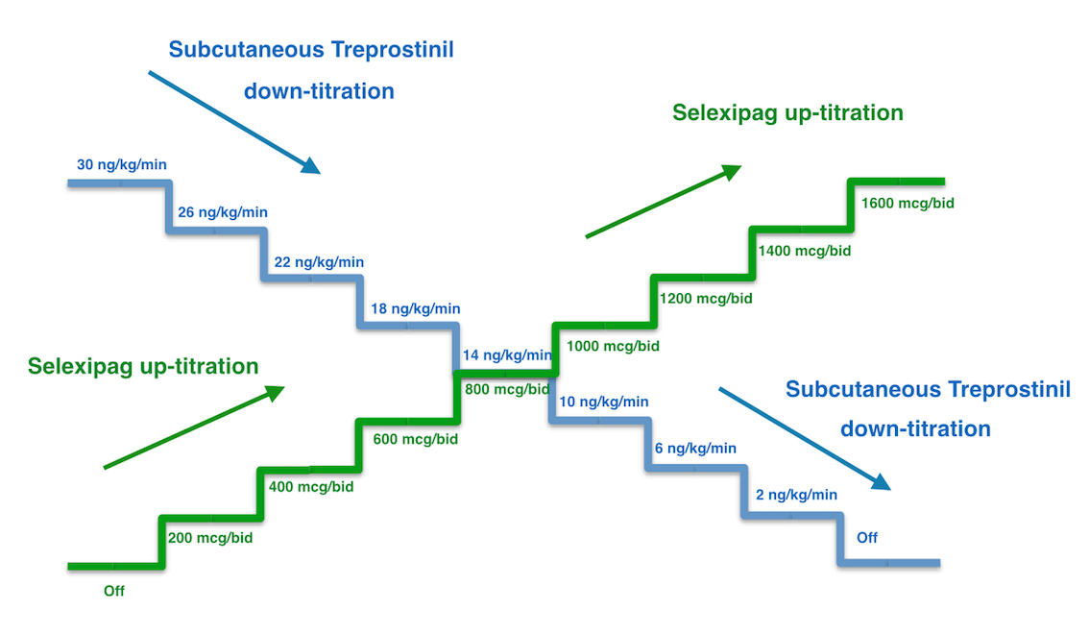
bid: every 12 hours.

