Supplementary material
PREOPERATIVE BODY WEIGHT AND ALBUMIN PRIOR TO THORACOTOMY PREDICT SURVIVAL IN PATIENTS WITH RESECTABLE LUNG NEOPLASMS: ROLE OF COPD

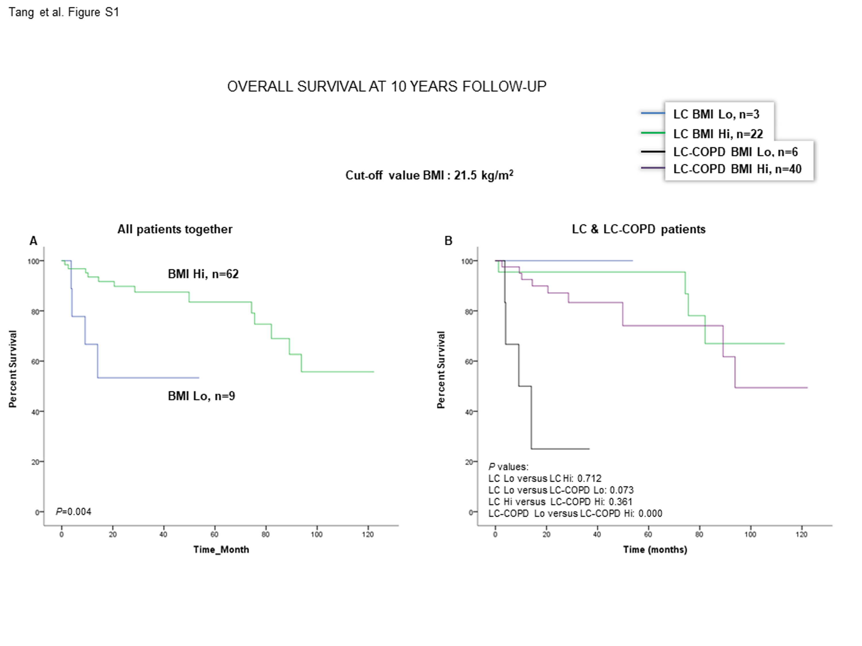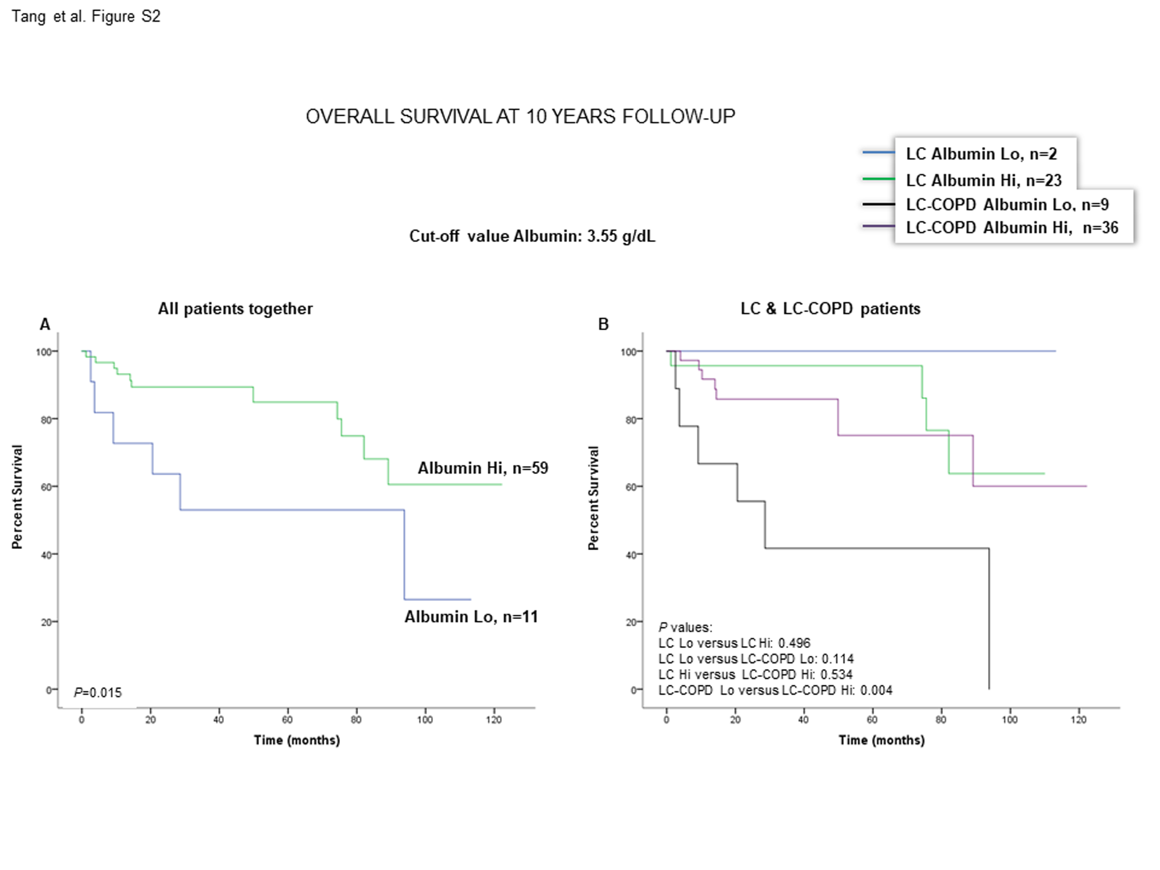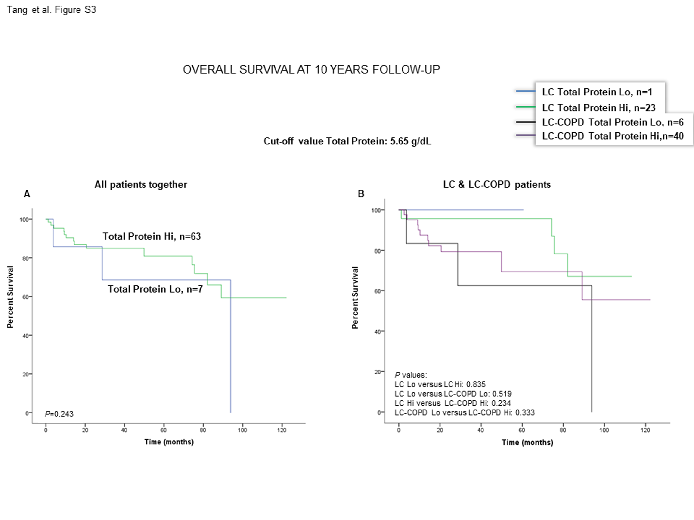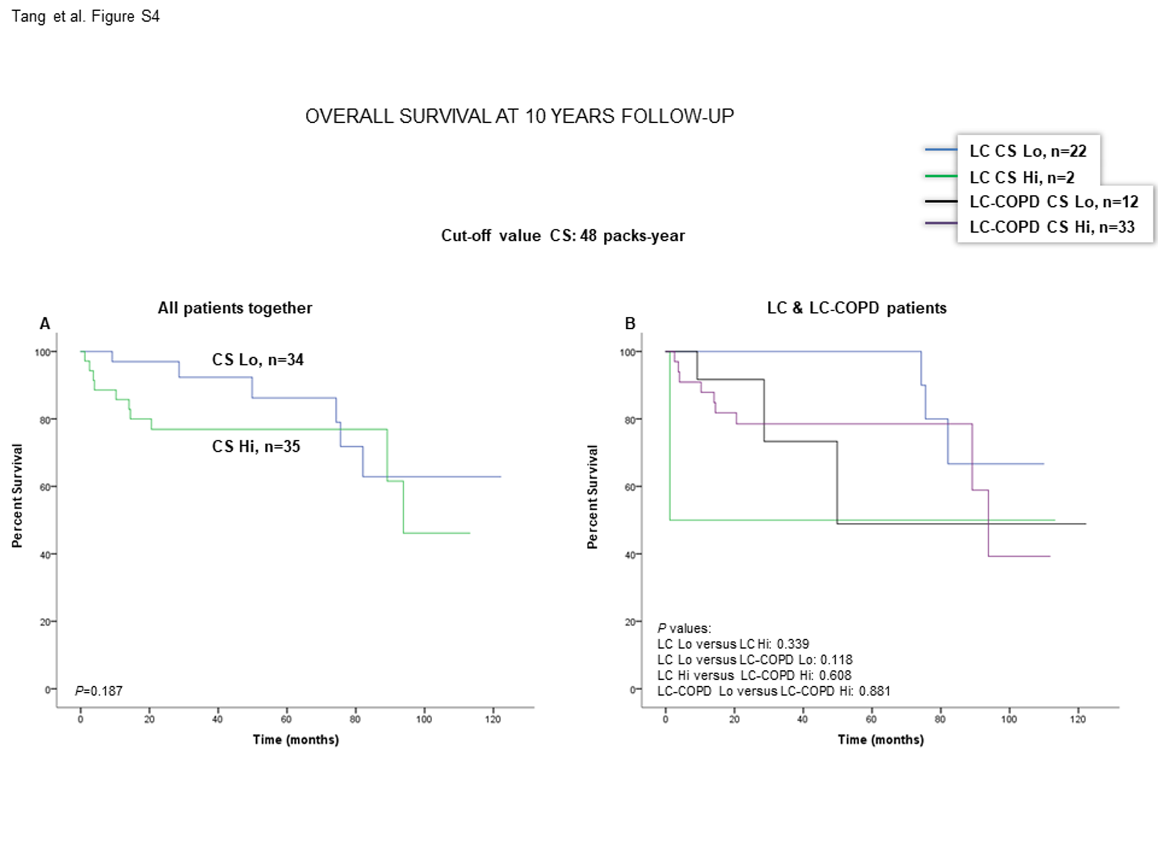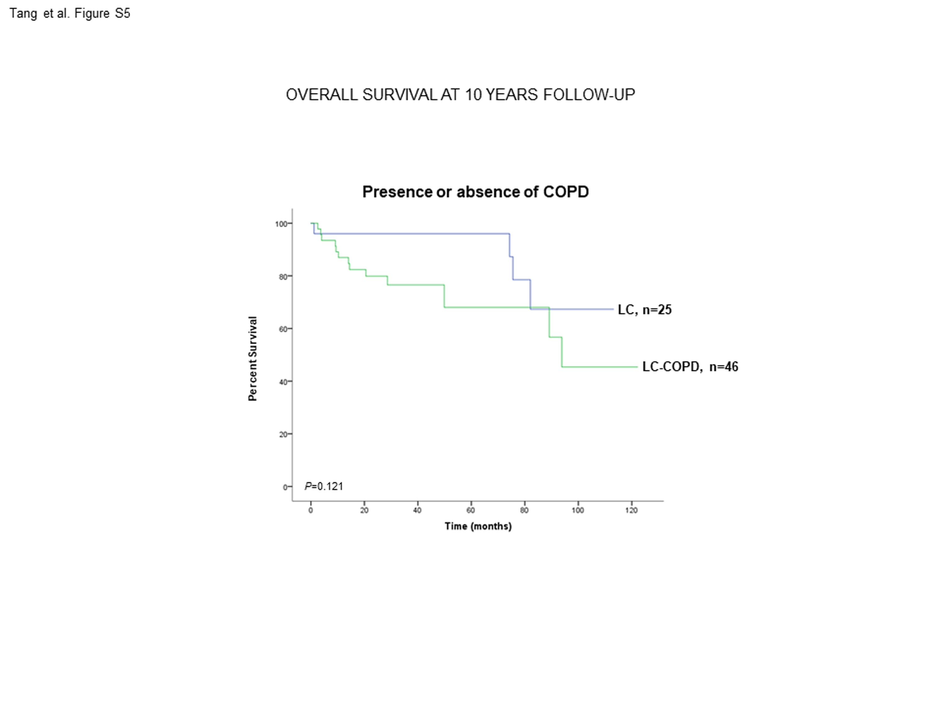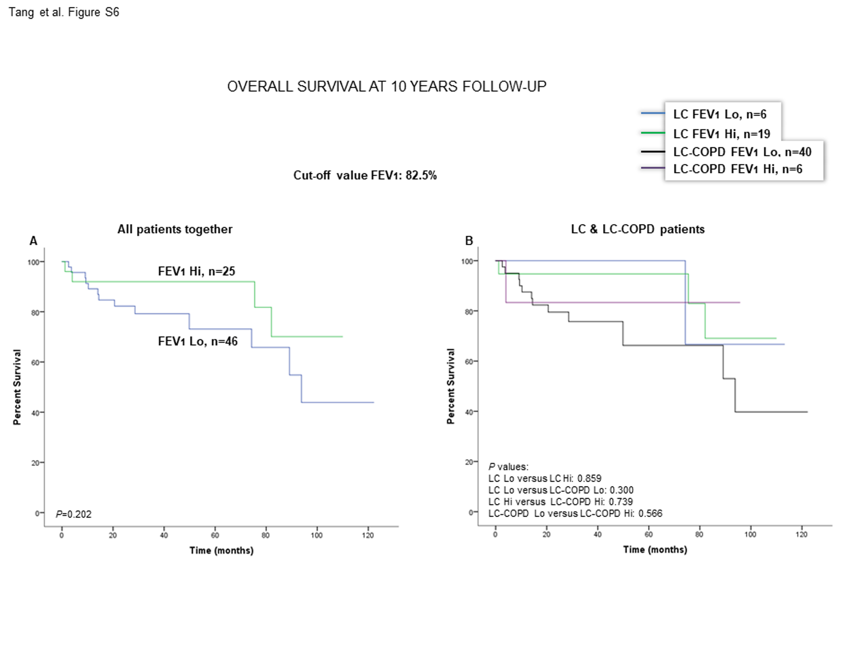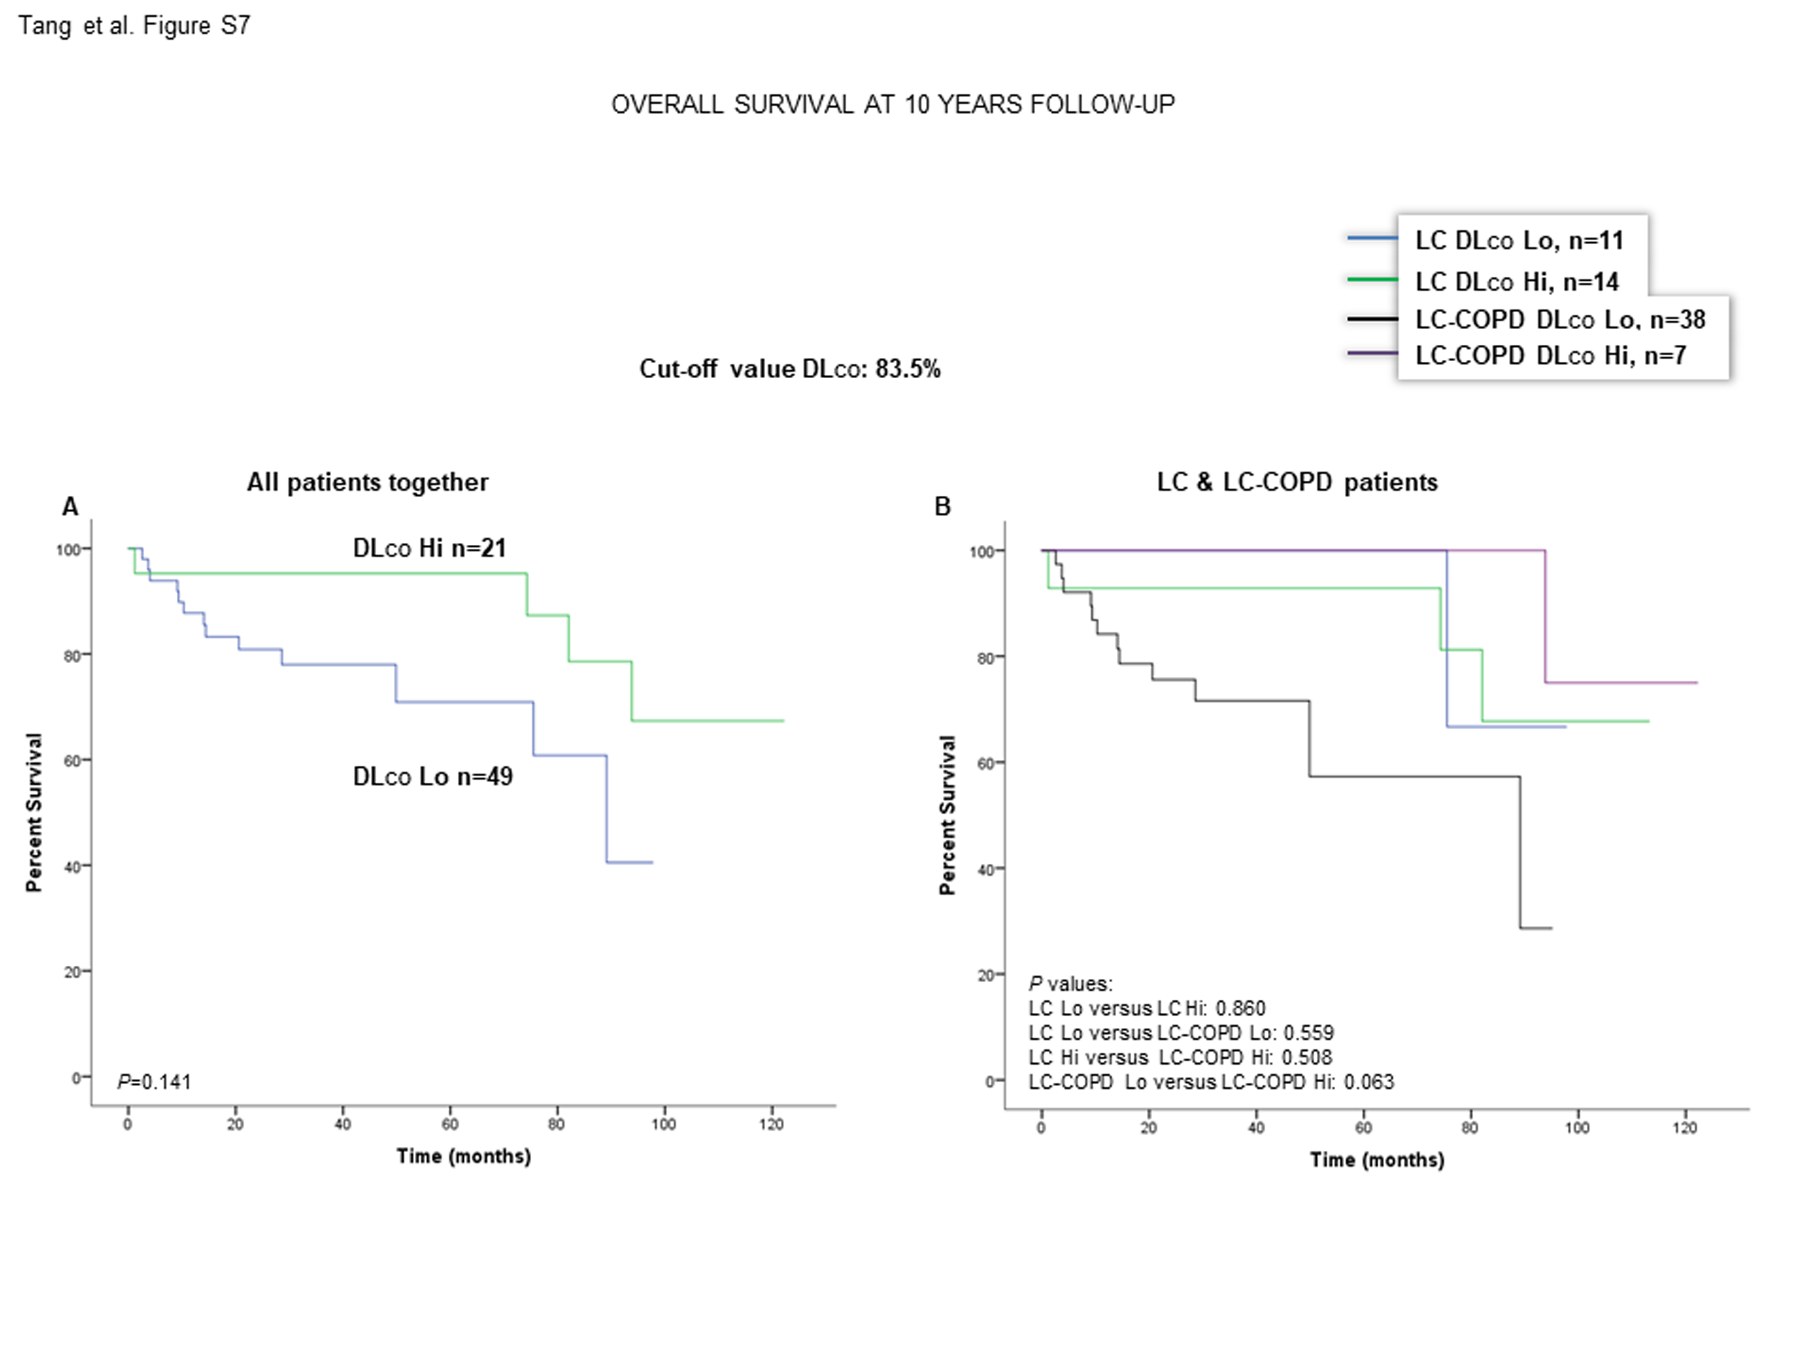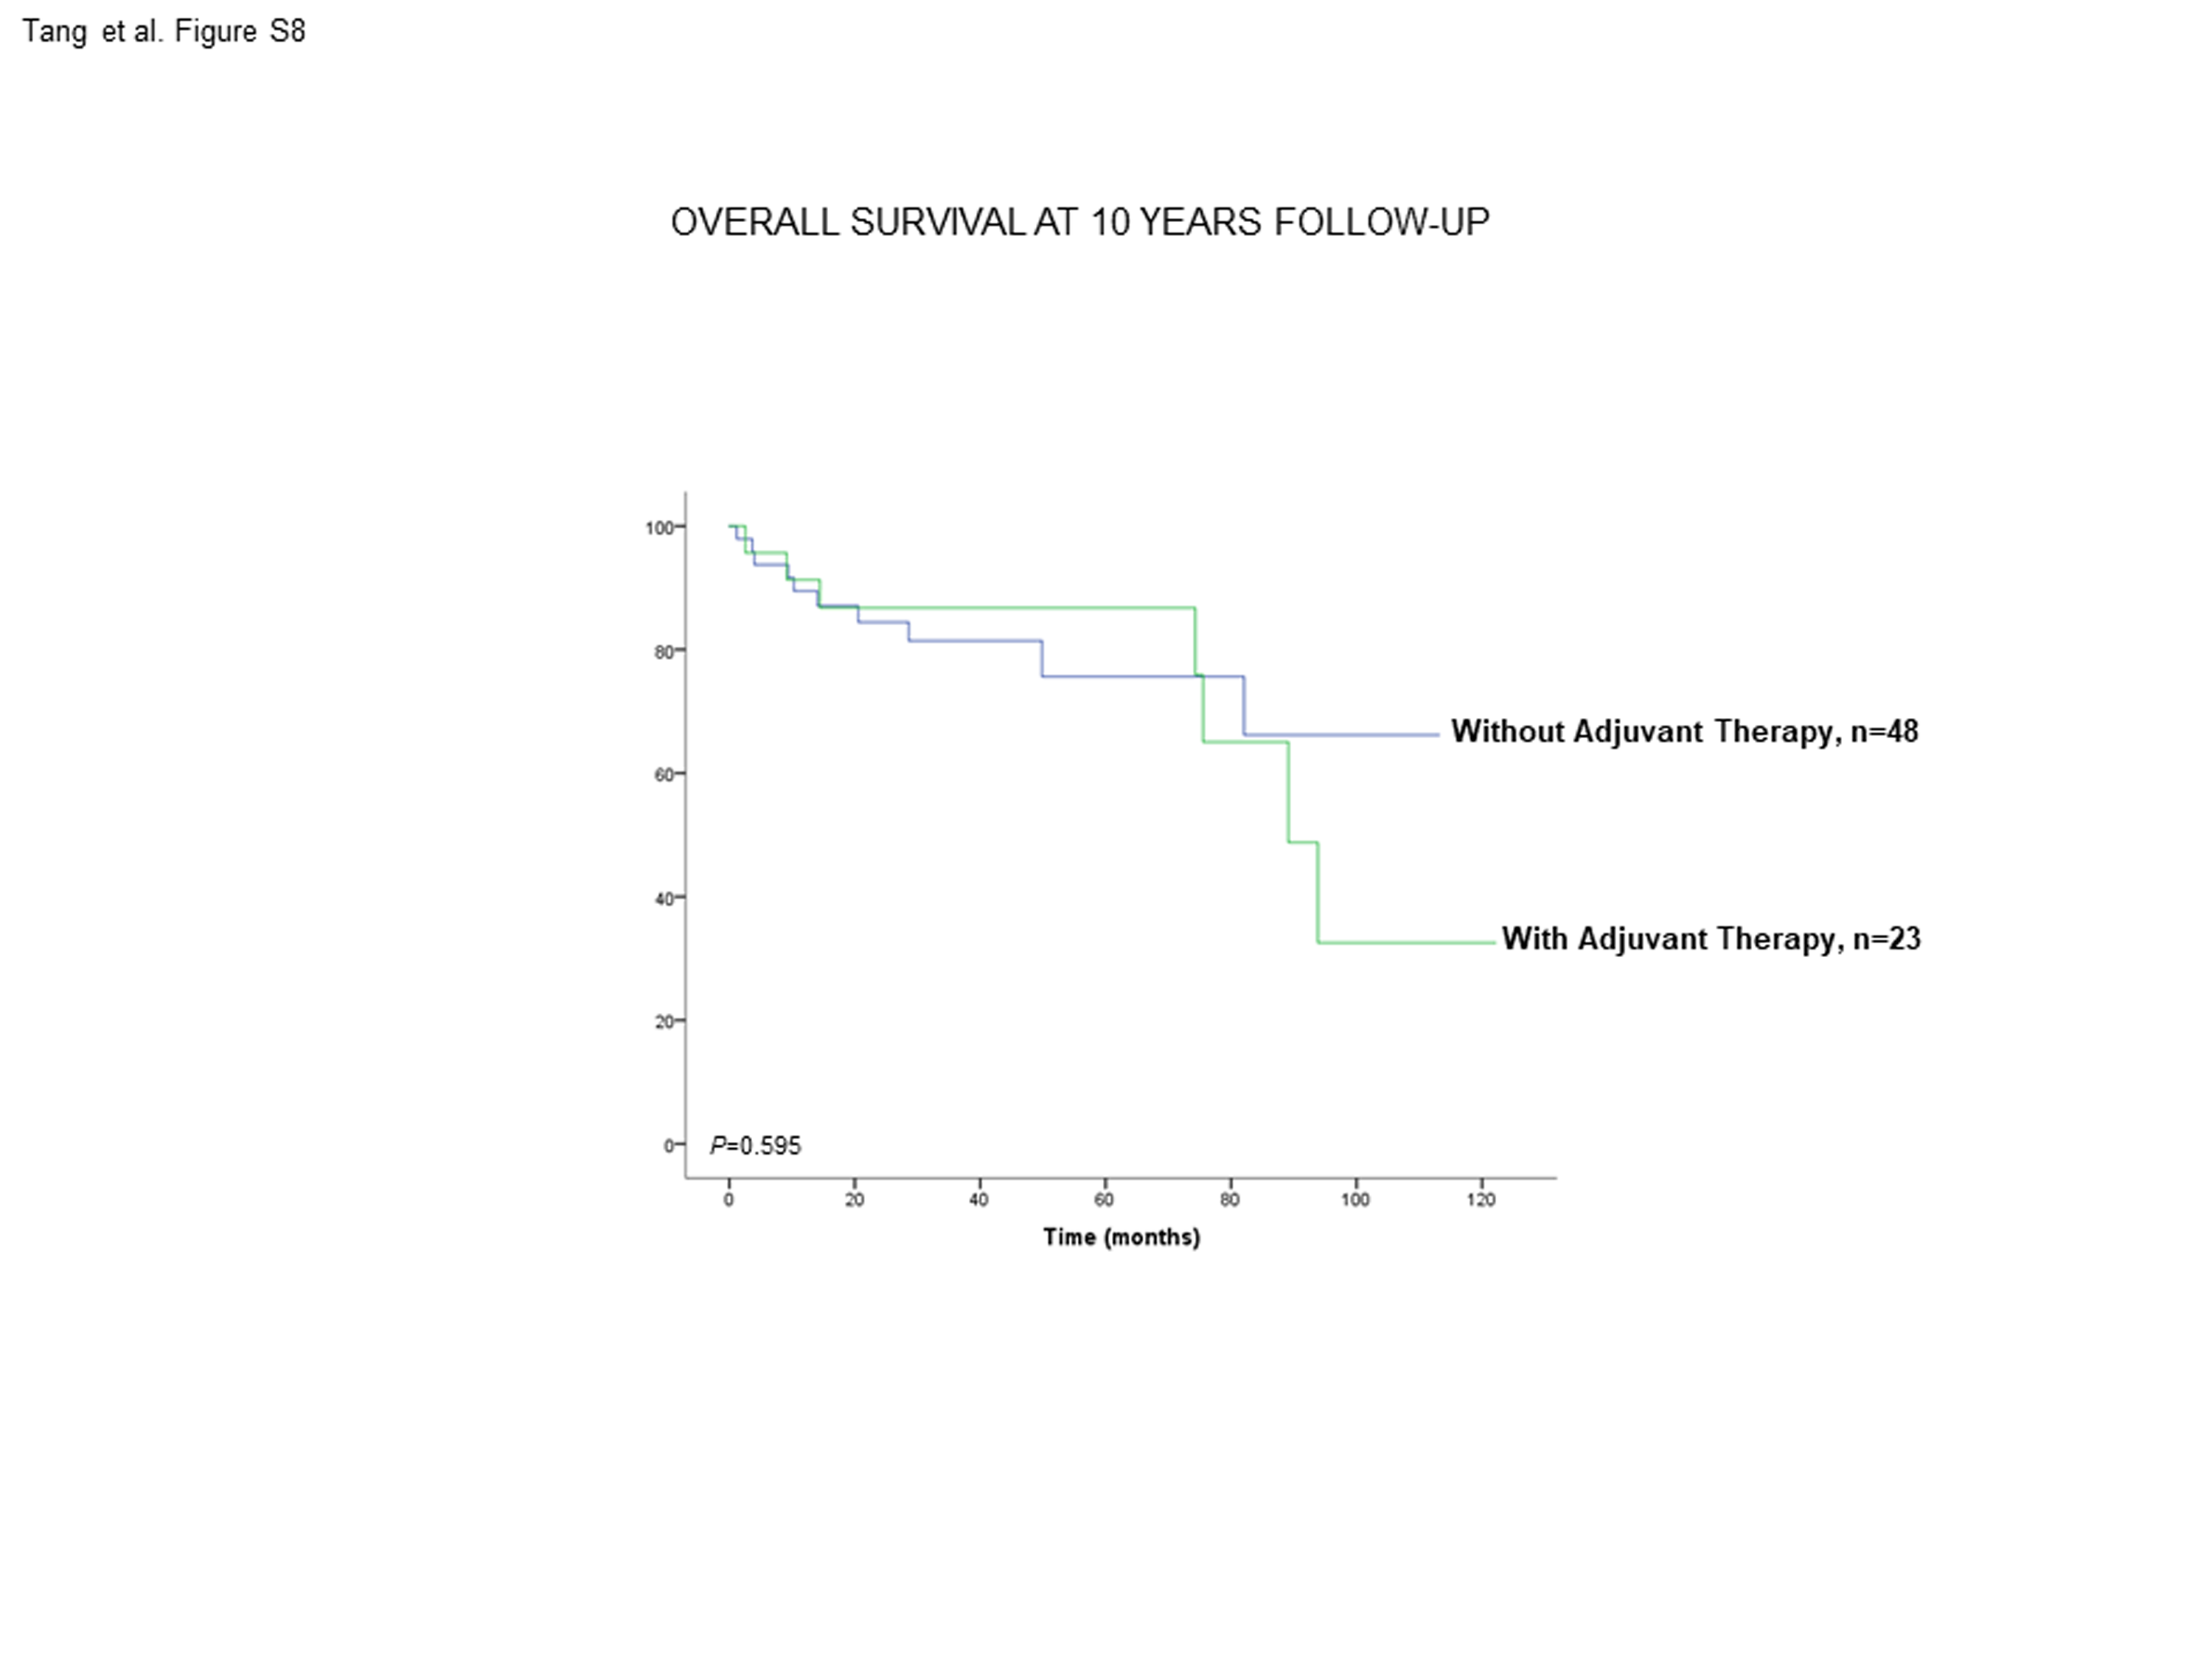

LEGENDS TO FIGURES
Figure S1: (A) Kaplan-Meier survival curves for OS in non-smokers (never-smokers + ex-smokers) of LC patients based on the cut-off value of the BMI (above and below the cut-off value: 21.5 kg/m²). (B) Kaplan-Meier survival curves for OS in non-smokers (never-smokers + ex-smokers) of LC patients with and without COPD based on the cut-off value of the BMI (above and below the cut-off value: 21.5 kg/m²). This information was not available in one patient. Definition of abbreviations: BMI, body mass index; LC, lung cancer; COPD, chronic obstructive pulmonary disease; Hi, high level (above cut-off value); Lo, low level (below cut-off value).
Figure S2: (A) Kaplan-Meier survival curves for OS in non-smokers (never-smokers + ex-smokers) of LC patients based on the cut-off value of the albumin level (above and below the cut-off value: 3.55 g/dL) in blood. (B) Kaplan-Meier survival curves for OS in non-smokers (never-smokers + ex-smokers) of LC patients with and without COPD based on the cut-off value of the albumin level (above and below the cut-off value: 3.55 g/dL) in blood. This information was not available in two patients. Definition of abbreviations: LC, lung cancer; COPD, chronic obstructive pulmonary disease; Hi, high level (above cut-off value); Lo, low level (below cut-off value).
Figure S3: (A) Kaplan-Meier survival curves for OS in non-smokers (never-smokers + ex-smokers) of LC patients based on the cut-off value of the total protein level (above and below the cut-off value: 5.65 g/dL) in blood. (B) Kaplan-Meier survival curves for OS in non-smokers (never-smokers + ex-smokers) of LC patients with and without COPD based on the cut-off value of protein levels (above and below the cut-off value: 5.65 g/dL) in blood. This information was not available in two patients. Definition of abbreviations: LC, lung cancer; COPD, chronic obstructive pulmonary disease; Hi, high level (above cut-off value); Lo, low level (below cut-off value).
Figure S4: (A) Kaplan-Meier survival curves for OS in non-smokers (never-smokers + ex-smokers) of LC patients based on the cut-off value of cigarette smoking burden (above and below the cut-off value: 48 packs-year). (B) Kaplan-Meier survival curves for OS in non-smokers (never-smokers + ex-smokers) of LC patients with and without COPD based on the cut-off value of cigarette smoking burden (above and below the cut-off value: 48 packs-year). This information was not available in three patients. Definition of abbreviations: LC, lung cancer; COPD, chronic obstructive pulmonary disease; CS, cigarette smoking; Hi, high level (above cut-off value); Lo, low level (below cut-off value).
Figure S5: Kaplan-Meier survival curves for OS in non-smokers (never-smokers + ex-smokers) of LC patients according to the presence of underlying COPD. This information was not available in one patient. Definition of abbreviations: LC, lung cancer; COPD, chronic obstructive pulmonary disease.
Figure S6: (A) Kaplan-Meier survival curves for OS in non-smokers (never-smokers + ex-smokers) based on the cut-off value of FEV₁ (above and below the cut-off value: 82.5%). (B) Kaplan-Meier survival curves for OS in non-smokers (never-smokers + ex-smokers) with and without COPD based on the cut-off value of FEV₁ (above and below the cut-off value: 82.5%). This information was not available in one patient. Definition of abbreviations: LC, lung cancer; COPD, chronic obstructive pulmonary disease; FEV₁, forced expiratory volume in one second; Hi, high level (above cut-off value); Lo, low level (below cut-off value).
Figure S7: (A) Kaplan-Meier survival curves for OS in non-smokers (never-smokers + ex-smokers) of LC patients based on the cut-off value of DL_{CO} (above and below the cut-off value: 83.5%). (B) Kaplan-Meier survival curves for OS in non-smokers (never-smokers + ex-smokers) of LC patients with and without COPD based on the cut-off value of DL_{CO} (above and below the cut-off value: 83.5%). This information was not available in two patients. Definition of abbreviations: LC, lung cancer; COPD, chronic obstructive pulmonary disease; DL_{CO}, transfer factor of the lung for carbon monoxide; Hi, high level (above cut-off value); Lo, low level (below cut-off value).
Figure S8: Kaplan-Meier survival curves for OS in non-smokers (never-smokers + ex-smokers) of LC patients based on the presence or absence of administration of adjuvant therapy to all patients together (LC and LC-COPD). This information was not available in one patient. Definition of abbreviations: LC, lung cancer; COPD, chronic obstructive pulmonary disease.

