Supplementary material

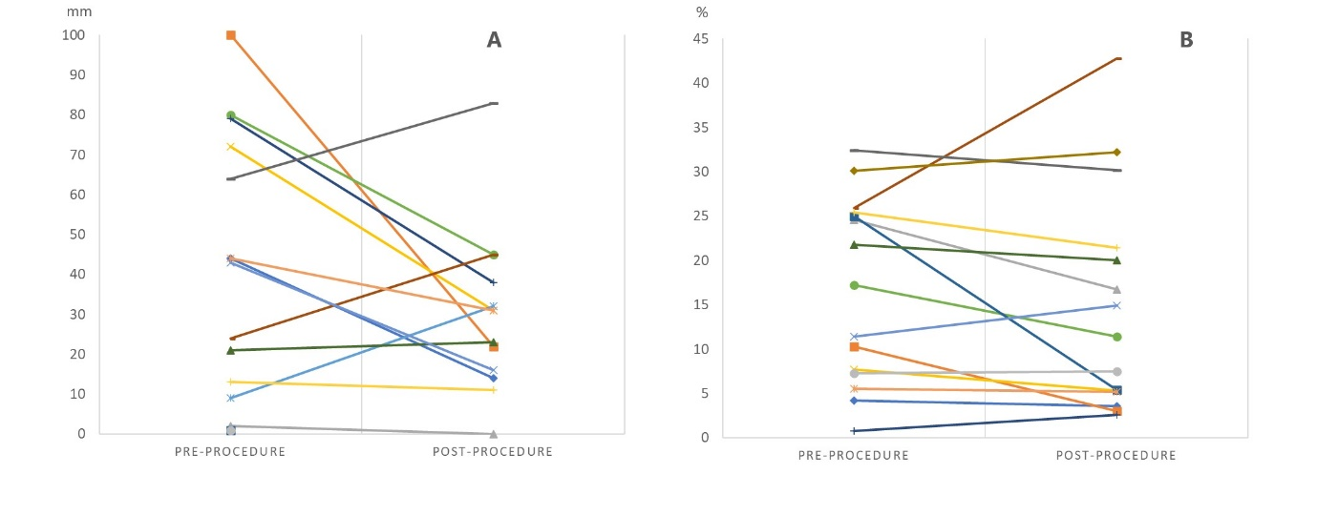
Panel A: Changes in the 100 mm visual analogue scale (VAS) score for dyspnoea before (left) and after (right) pleural intervention. Panel B: Changes in the percent of waking time per day spent in non sedentary activity before (left) and after (right) pleural intervention.

Table S: Sensewear® armband data during the peri-drainage period. Data expressed as median (IQR)
Variable | Pre-drainage | Post-drainage
Number of days armband worn | 6 (5-7) | 4.6 (2.5 – 6.75)
On body time/day hour | 12.4 (10 - 14) | 11.2 (8 - 12.5)
Total Energy Expenditure/day KJ | 7558 (6146 - 9700) | 7039 (4300 - 9292)
Steps/day | 785 (53 - 2410) | 244 (30 - 1380)
Percentage of the waking time spent per day in activities worth 1.5 MET or more (non-sedentary) | 14.3 (6 - 25) | 13.1 (4 - 21)
Average MET during waking time | 1.2 (1.02 – 1.37) | 1.15 (1 - 1.3)
MET: metabolic equivalent of tasks

Figure 1

