Supplementary materials

Table S1-Oligonucleotide sequences of primers used in this study for quantitative real time PCR
Genes | Forward | Reverse
CTLA4 | F; 5'-TCCCGCCCTACTACGGAAA-3' | R; 3'-GTAGGGATCCATGAAGCAGAGG-5'
Il4 | F; 5'-TCTTTGCTGCCTCCAAGAACA-3' | R; 3'-TGTCGAGCCGTTTCAGGAAT-5'
Il5 | F; 5'-GTGTATGCCATCCCCACAGA-3' | R; 3'-CTCTCCAGTGTGCCTATTCCC-5'
Il10 | F; 5'-GACTTTAAGGGTTACCTGGGTTG-3' | R; 3'-TCTTGGTTCTCAGCTTGGGG-5'
GAPDH | F; 5'-GAGAAGGCTGGGGCTCATTT-3' | R; 3'-TAAGCAGTTGGTGGTGCAGG-5'

Table S2. Immunological findings at the time of diagnosis of immunodeficiency
Immunologic data | Patients
 | LRBA (N=12) | CVID (N=12) | p-value
IgG, mg/dL | 320 (111-548) | 113 (17-305) | 0.09
IgA, mg/dL | 8.5 (1.7-43.7) | 7.0 (4.2-32.0) | 0.92
IgM, mg/dL | 56.5 (25.7-151.0) | 17.0 (5.5-20.0) | <0.01*
IgE, IU/mL | 0.6 (0.0-2.8) | 1.0 (0.7-12.5) | 0.25
WBC, cell/µL | 7805 (5342-8697) | 7003 (5600-8210) | 0.64
Neutrophil, cell/µL | 3922 (3136-6024) | 4200 (3587-5350) | 0.82
Lymphocyte, cell/µL | 2235 (2035-2934) | 2150 (1800-4320) | 0.71
CD3⁺ T cells, cell/µL | 1717 (1492-1765) | 1908 (1630-3214) | 0.36
CD4⁺ T cells, cell/µL | 649 (451-882) | 833 (625-1917) | 0.12
CD8⁺ T cells, cell/µL | 967 (670-1554) | 1175 (777-1406) | 0.62
CD19⁺ B cells, cell/µL | 147 (93-451) | 111 (70-384) | 0.51
LRBA; LPS-Responsive-Beige-like Anchor, CVID; Common variable immune deficiency, N; Count, Ig; Immunoglobulin, WBC; White blood cell.
The median is shown [with 25th and 75th percentiles]. Mann-Whitney U test was used.
* p-value is statistically significant <0.05

Table S3. History of clinical complications in patients with CVID and LRBA deficiency
Type of complication | Patients
 | LRBA (N=12) | CVID (N=12) | p-value
Pneumonia (%) | 9 (75.0) | 5 (41.7) | 0.09
Otitis media (%) | 7 (58.3) | 5 (41.7) | 0.41
Sinusitis (%) | 8 (66.7) | 7 (58.3) | 1.0
meningitis (%) | 2 (16.7) | 0 (0.0) | 0.47
Skin infection (%) | 1 (8.3) | 4 (33.3) | 0.31
Bronchiectasis (%) | 7 (58.3) | 1 (8.3) | 0.02*
Osteomyelitis (%) | 1 (8.3) | 0 (0.0) | 1.0
Septicemia (%) | 1 (8.3) | 0 (0.0) | 1.0
Oral candidiasis (%) | 3 (25.0) | 1 (8.3) | 0.59
Arthritis (%) | 3 (25.0) | 2 (16.7) | 1.0
Chronic diarrhea (%) | 10 (83.3) | 6 (50.0) | 0.19
Lymphadenopathy (%) | 7 (58.3) | 6 (50.0) | 0.68
Splenomegaly (%) | 9 (75.0) | 4 (33.3) | 0.04*
Hepatomegaly (%) | 7 (58.3) | 2 (16.7) | 0.04*
Granulomas (%) | 4 (33.3) | 0 (0.0) | 0.09
Failure to thrive (%) | 4 (33.0) | 2 (16.7) | 0.64
Allergy (%) | 2 (16.7) | 0 (0.0) | 0.4
Enteropathy (%) | 9 (75.0) | 1 (8.3) | <0.01*
Autoimmunity (%) | 8 (66.7) | 0 (0.0) | <0.01*
LRBA; LPS-Responsive-Beige-like Anchor, CVID; Common variable immune deficiency, N; Count.
The median is shown [with 25th and 75th percentiles]. Mann-Whitney U test was used.
* p-value is statistically significant <0.05

Table S4. Changes in absolute count of lymphocyte and CD4⁺ T cell at time of immunodeficiency diagnosis with current study
Cells | Patients
 | LRBA (N=12) |  |  | CVID (N=12)
 | Time of diagnosis | Current study | p-value | Time of diagnosis | Current study | p-value
Lymphocyte, cell/µL | 2235 (2035-2934) | 2370 (1800-3400) | <0.01* | 2150 (1800-4320) | 2050 (1375-2800) | <0.01*
CD4⁺ T cells, cell/µL | 649 (451-882) | 694 (433-1022) | 0.92 | 833 (625-1917) | 585 (375-770) | 0.07
LRBA; LPS-Responsive-Beige-like Anchor, CVID; Common variable immune deficiency, N; Count,
The median is shown [with 25th and 75th percentiles]. Wilcoxon Signed Ranks Test was used.
* p-value is statistically significant <0.05

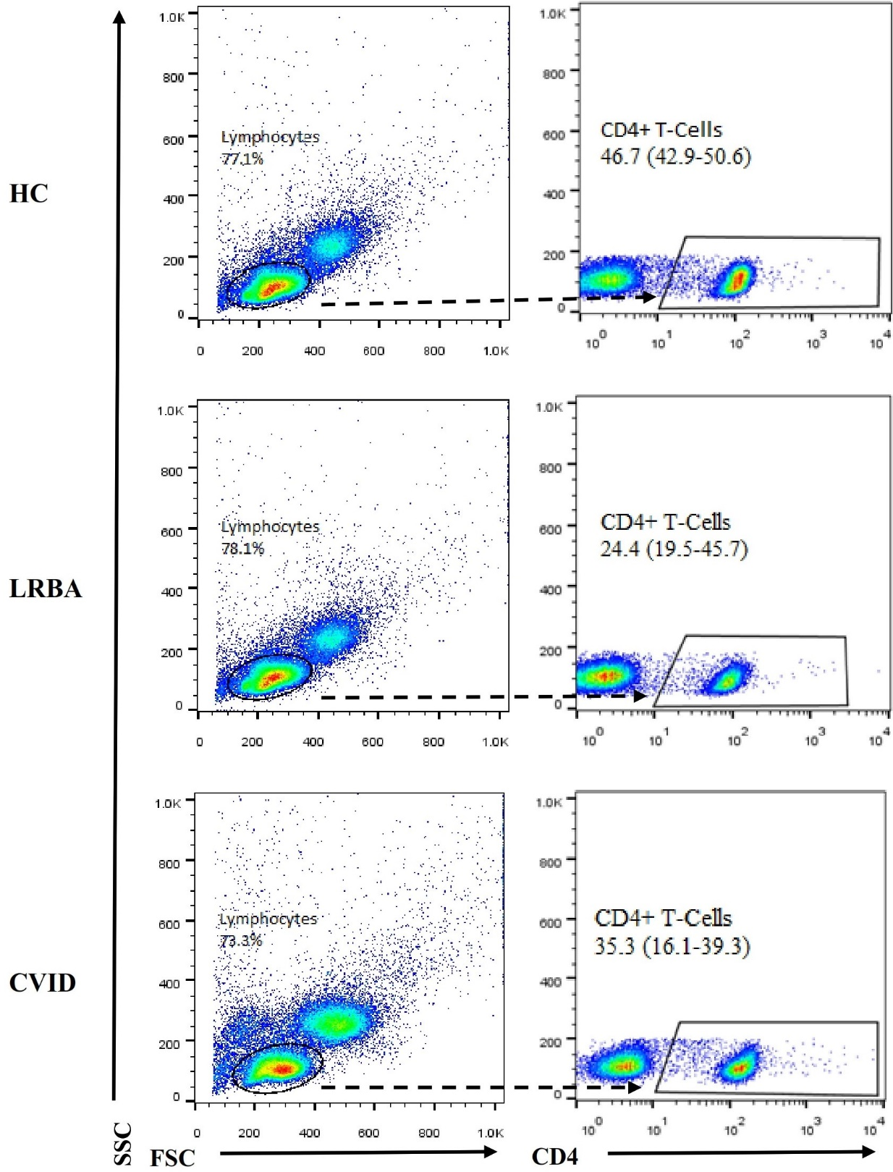
Figure S1. Flow cytometry analysis of CD4+ T cells. Three examples demonstrate the ﬂow cytometric analysis of peripheral blood samples from HC, LRBA patient and CVID patient. PBMCs were isolated and stained with anti-CD4 PerCP-cy5.5. The cells were gated on lymphocytes for analysis of the CD4⁺ cells. Data are expressed as the median values of 13 participants in each group. Arrows indicate the gated population subsequently analyzed. LRBA; LPS responsive beige-like anchor protein, CVID; Common variable immunodeficiency, HC; Healthy controls.

