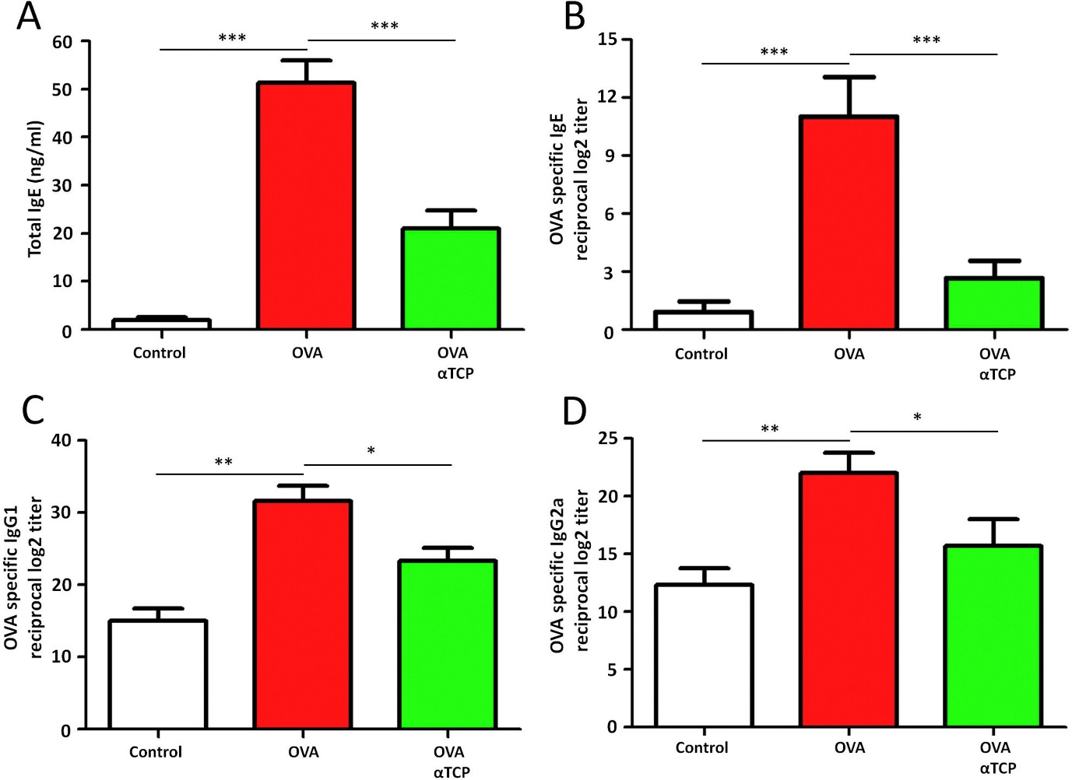
Supplemental Figure 1. Effects of α-TCP on levels of total IgE (A), OVA-specific IgE (B), OVA-specific IgG1 (C) and, OVA-specific IgG2a (D) in the serum. n = 10 each group. Data are representative of at least two independent experiments. n.s.: not significant; *: p < 0.05; **: p < 0.01; ***: p < 0.001. Error bar values represent SEM. For comparison between two groups, Student's two-tailed t test was used.

