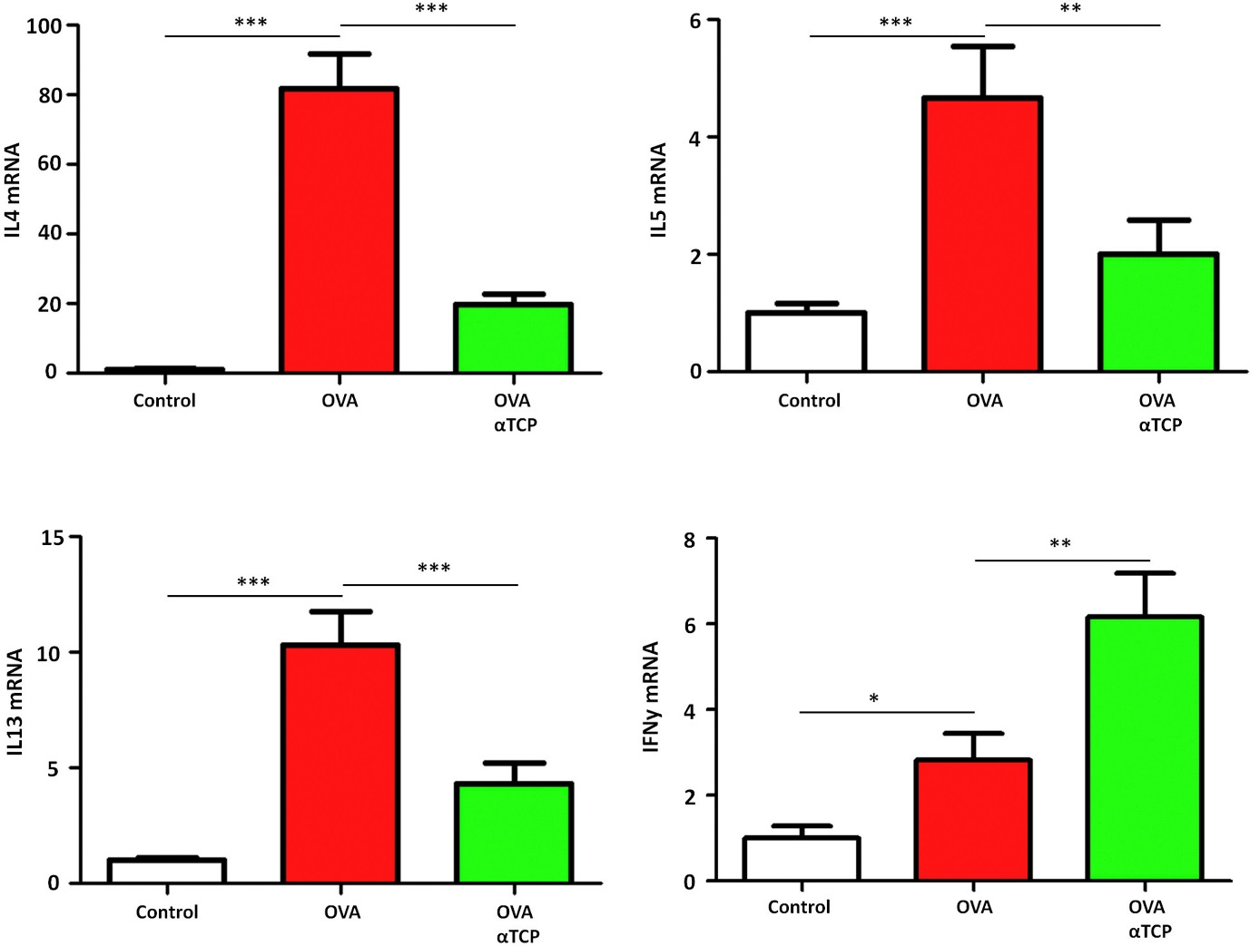
Supplemental Figure 2. Effects of α-TCP on the expressions of IL-4, IL-5, IL-13, and IFNy mRNAs in the nasal mucosa. nasally administration of α-TCP reduced the expressions of IL-4, IL-5, IL-13 mRNAs compared to OVA group. n = 10 each group. Data are representative of at least two independent experiments. n.s.: not significant; *: p < 0.05; **: p < 0.01; ***: p < 0.001. Error bar values represent SEM. For comparison between two groups, Student's two-tailed t test was used.

