Effect of the pH pre-adjustment on the formation of In₂W₃O₁₂ and In₆WO₁₂ powders: Cluster coordination and optical band gap
R.T. de Paiva¹, I.C. Nogueira², J.C. Sczancoski³, P.S. Lemos³, J.M.E. Matos¹, R.S. Santos⁵, E. Longo⁴, and L.S. Cavalcante^{1,5*}
¹Programa de Pós-Graduação em Ciência dos Materiais-PPCM,Universidade Federal do Piauí, Teresina–PI, 64049-550, Brazil
²ICE-Universidade Federal do Amazonas, Av. Rodrigo Otávio Japiim, P.O. Box 670, 69077-000, Manaus–AM, Brazil
³DQ-UFSCar,Universidade Federal de São Carlos, P.O. Box 676, São Carlos–SP, 13565-905, Brazil
⁴Departamento de Físico-Química, Universidade Estadual Paulista, 14800-060, Araraquara–SP, Brazil
⁵PPGQ-GERATEC, Universidade Estadual do Piauí, Rua: João Cabral, N. 2231, P.O. Box 381, 64002-150, Teresina–PI, Brazil
Keywords: In₂W₃O₁₂, In₆WO₁₂, Rietveld refinement, Clusters, Optical band gap
Efecto del preajuste de pH en la formación de polvos In₂W₃O₁₂ e In₆WO₁₂: Coordinación de grupo y banda óptica
R.T. de Paiva¹, I.C. Nogueira², J.C. Sczancoski³, P.S. Lemos³, J.M.E. Matos¹, R.S. Santos⁵, E. Longo⁴, and L.S. Cavalcante^{1,5*}
¹Programa de Pós-Graduação em Ciência dos Materiais-PPCM,Universidade Federal do Piauí, Teresina–PI, 64049-550, Brazil
²ICE-Universidade Federal do Amazonas, Av. Rodrigo Otávio Japiim, P.O. Box 670, 69077-000, Manaus–AM, Brazil
³DQ-UFSCar,Universidade Federal de São Carlos, P.O. Box 676, São Carlos–SP, 13565-905, Brazil
⁴Departamento de Físico-Química, Universidade Estadual Paulista, 14800-060, Araraquara–SP, Brazil
Palabras clave: In₂W₃O₁₂, In₆WO₁₂, refinamiento Rietveld, Clusters, brecha de banda óptica
____________________________________________________________________________________________________
* Telefono: +55 86 3221-4749, Móvel: +55 86 99940-9556. Dirección de correo electrónico: laeciosc@gmail.com (L.S. Cavalcante)

Preimpresión reenviado a BOLETÍN DE LA SOCIEDAD ESPAÑOLA DE Cerámica y Vidrio Febrero 09, 2019

Electronic Supplementary Material

Fig. SM1 illustrate XRD patterns of the amorphous system synthesized by the co-precipitation method (363 K for 1 h) by using a pH at 4, without any heat treatment.
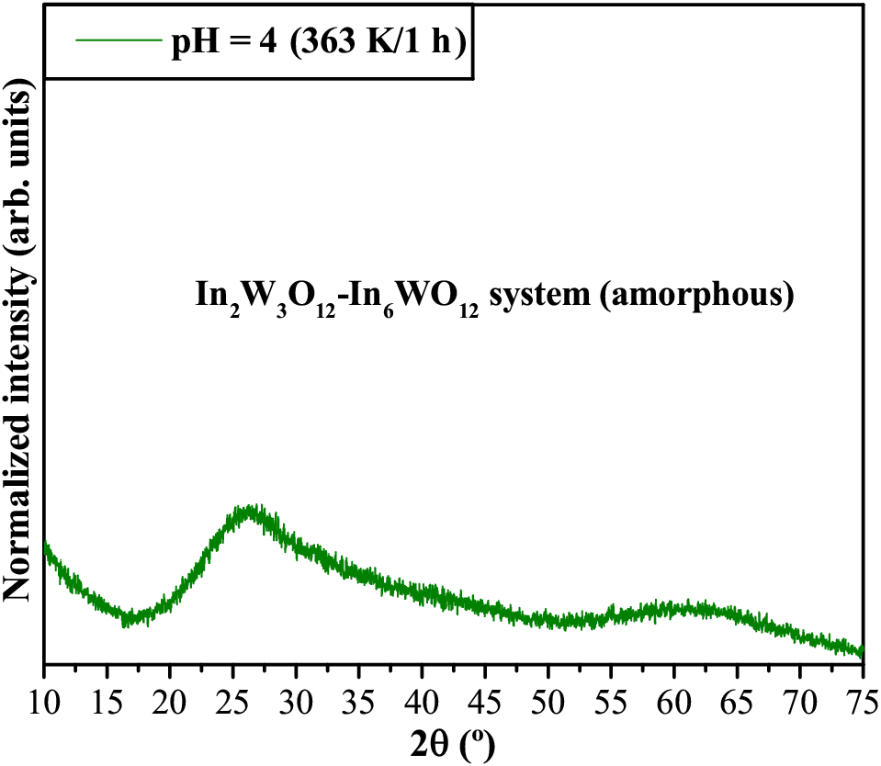
Fig. SM1: XRD patterns of In₂W₃O₁₂-In₆WO₁₂ (amorphous) synthesized at 363 K for 1 h with pH at 4.

This figure revealed that the In₂W₃O₁₂−In₆WO₁₂ precipitates formed at 363 K for 1 h have an amorphous state. Particularly, this powder have several defects as well as a high degree of structural disordering.
Thermogravimetric analysis (TGA) was carried out in a TGA-50 thermal analyzer (Shimadzu, Japan). These thermal measurements were performed in a temperature range from 298 K to 1123 K under synthetic air ﬂow (30 cm³/min), maintaining a heating rate of 278 K/min. TGA analysis is shown in Fig. SM2.
Fig. SM2: TGA curve from 298 K to 1123 K for In₂W₃O₁₂−In₆WO₁₂ precipitates synthesized at 363 K for 1 h with pH at 4.

As it can be noted in Fig. SM2, the TGA curves indicates a mass loss of approximately 11.3 % from 348 K to 1073 K, which is related to dehydration or evaporation of the residual aqueous in In₂W₃O₁₂−In₆WO₁₂ amorphous.

