**SUPPORTING INFORMATION**

**Thermomechanical Properties of Compositions Based on Polysilicates Modified with Boron Cluster Anions or SiO2 Nanoparticles**

**IR Spectra**

(a)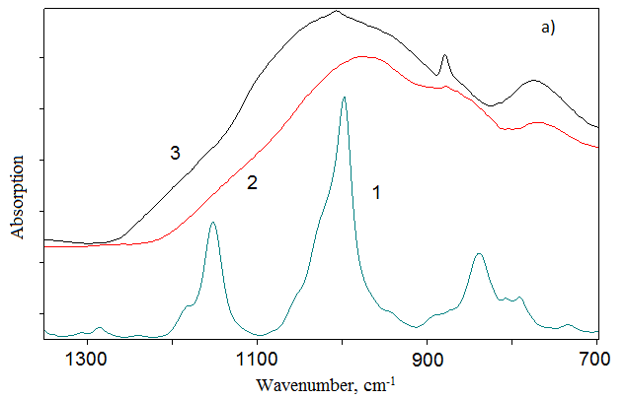

(b)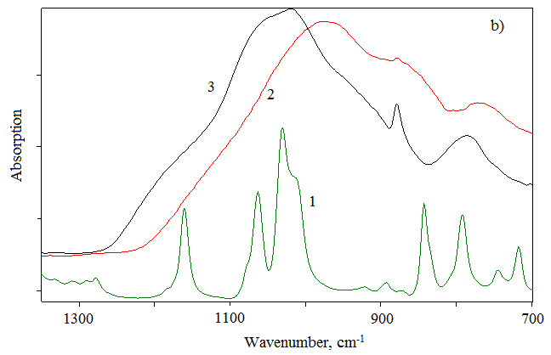

**Fig. S1.** IR spectra: (a) 1 – (*Et*3NH)2[B10Cl10], 2 – LG, 3 – LG/(*Et*3NH)2[B10Cl10] (80/20) (**IV**); (b) 1 – (*Et*3NH)2[B10H10], 2 – LG, 3 – LG/(*Et*3NH)2[B10H10] (70/30) (**IX**).

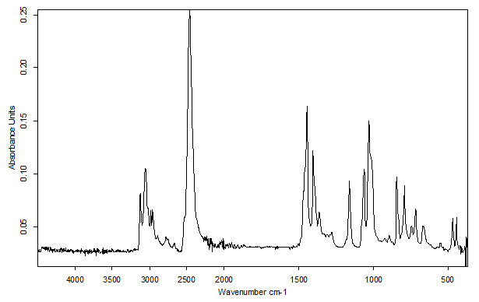

**Fig. S2.** IR spectra of (*Et*3NH)2[B10H10].

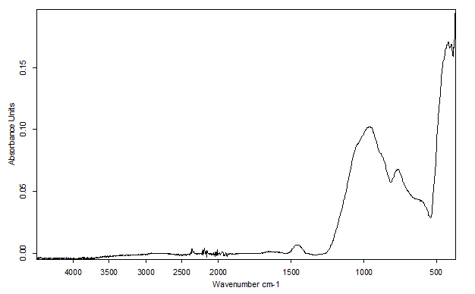

**Fig. S3.** IR spectra of sodium liquid glass (LG).

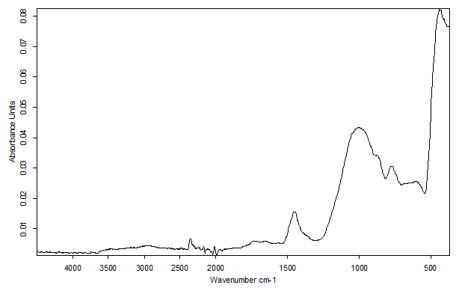

**Fig. S4.** IR spectra of composition **II** (LG/(*Et*3NH)2[B10Cl10], 95/5).

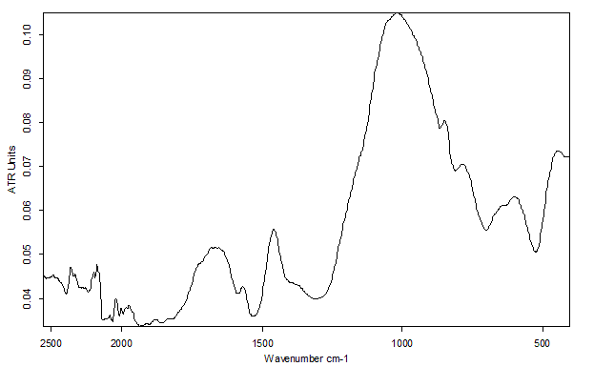

**Fig. S5.** IR spectra of composition **VIII** (LG/(*Et*3NH)2[B10H10], 80/20).

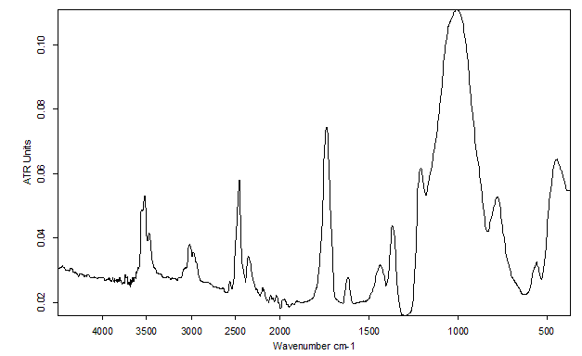

**Fig. S6.** IR spectra of composition **IX** (LG/(*Et*3NH)2[B10H10], 70/30).

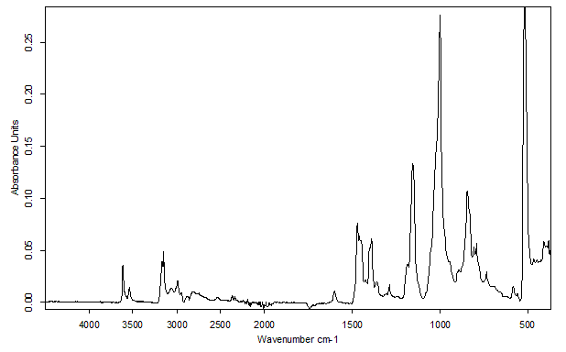

**Fig. S7.** IR spectra of (*Et*3NH)2[B10Cl10].

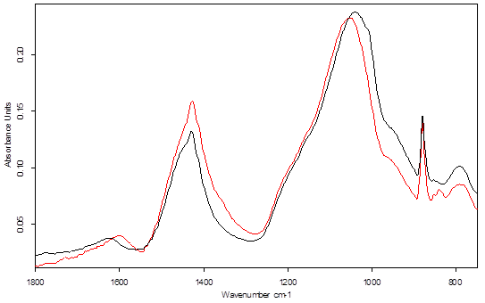

**Fig. S8.** IR spectra of composition **III** (LG/(*Et*3NH)2[B10Cl10], 90/10) (black) and LG (red).

**TGA data**



**Fig. S9.** TGA data for LG.

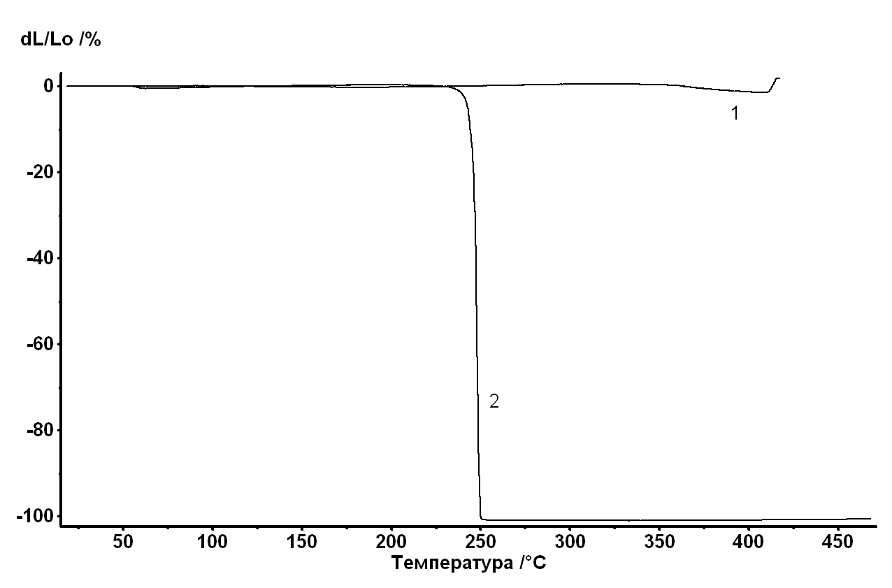

**Fig. S10.** TGA data for started (Et3NH)2[B10Cl10] (*1*) and (Et3NH)2[B10H10] (*2*).

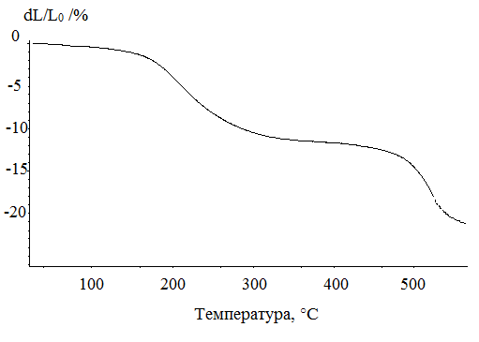

**Fig. S11.** TGA data for composition **I** (LG/(*Et*3NH)2[B10Cl10], 97.6/2.4).



**Fig. S12.** TGA data for composition **II** (LG/(*Et*3NH)2[B10Cl10] , 95/5).



**Fig. S13.** TGA data for composition **III** (LG/(*Et*3NH)2[B10Cl10], 90/10).



**Fig. S14.** TGA data for composition **IV** (LG/(*Et*3NH)2[B10Cl10], 80/20).



**Fig. S15.** TGA data for composition **V** (LG/(*Et*3NH)2[B10H10], 98/2).



**Fig. S16.** TGA data for composition **VI** (LG/(*Et*3NH)2[B10H10], 95/5).

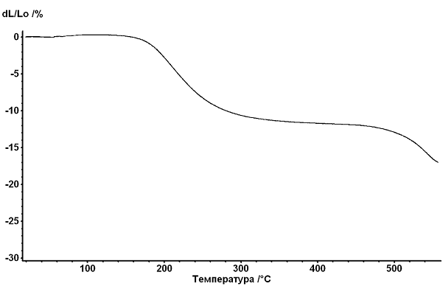

**Fig. S17.** TGA data for composition **VII** (LG/(*Et*3NH)2[B10H10], 90/10).



**Fig. S18.** TGA data for composition **VIII** (LG/(*Et*3NH)2[B10H10], 80/20).



**Fig. S19.** TGA data for composition **IX** (LG/(*Et*3NH)2[B10H10], 70/30).

**TGA and DSC data**

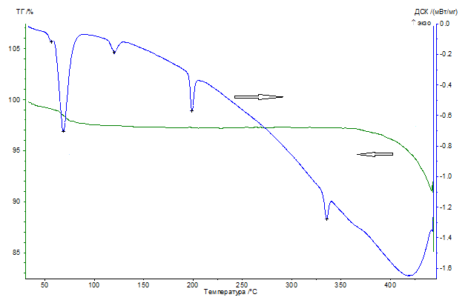

**Fig. S20.** TGA/DSC for starting (*Et*3NH)2[B10Cl10].



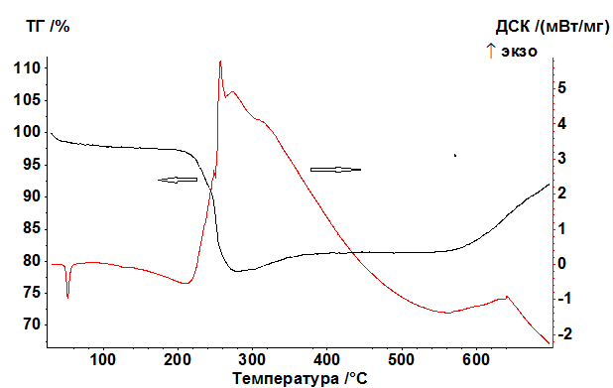

**Fig. S21.** TGA/DSC for starting (*Et*3NH)2[B10H10].

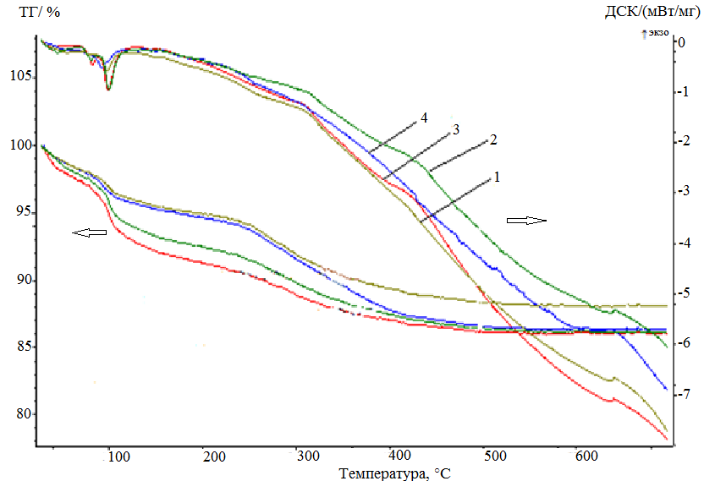

**Fig. S22.** TGA/DSC for LG (4) and compositions **II** (1), **III** (2), and **IV** (3).

TGA/DSC data for samples **I** (the content of (Et3NH)2[B10Cl10] is 2.4%) and **V** (the content of (Et3NH)2[B10Н10] is 2%) are not given because of the low concentrations of the modifying additives.

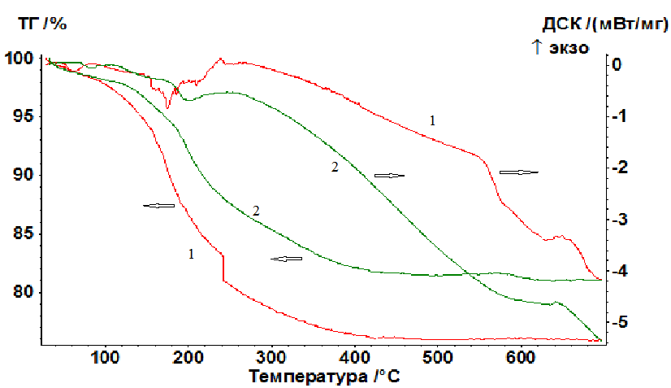

**Fig. S23.** TGA/DSC for LG (*1*) and **VI** (*2*).

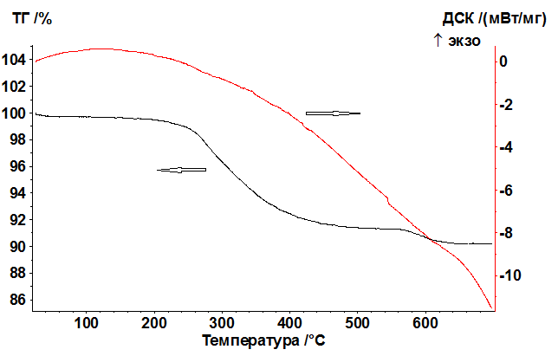

**Fig. S24.** TGA/DSC for composition **VII**.



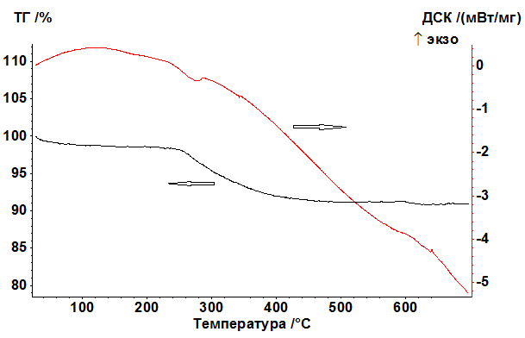

**Fig. S25.** TGA/DSC for composition **VIII**.



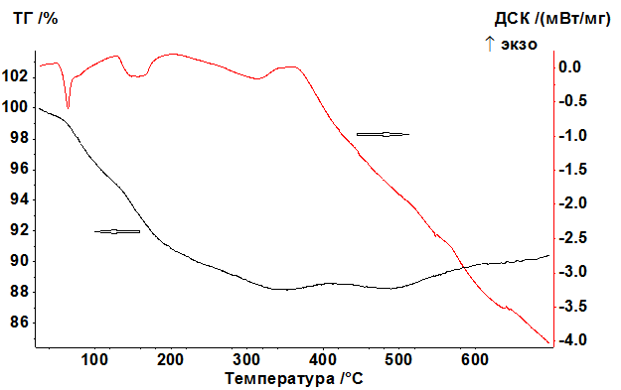

**Fig. S26.** TGA/DSC for composition **IX**.

**SEM and TEM data**

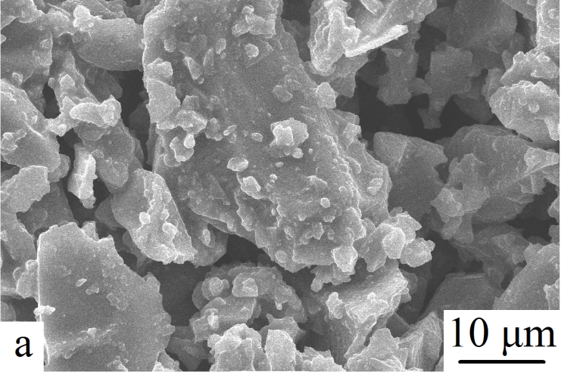 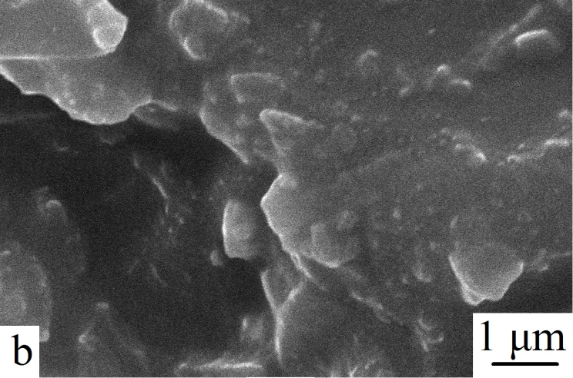

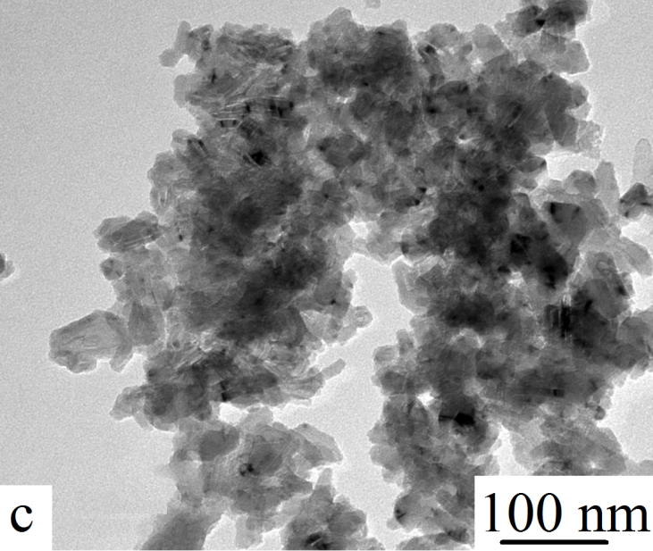 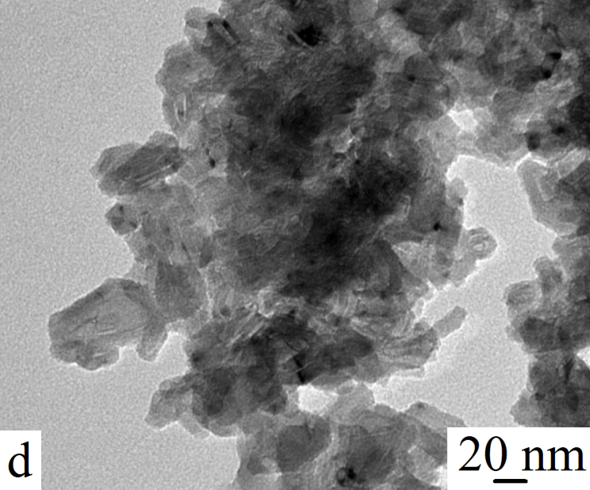

**Fig. S27.** SEM (a,b) and TEM (c,d) images for sample **IV** (LG/(Et3NH2)2[B10Cl10], 80/20).

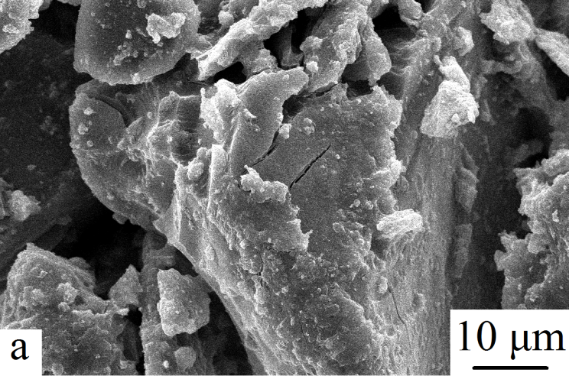 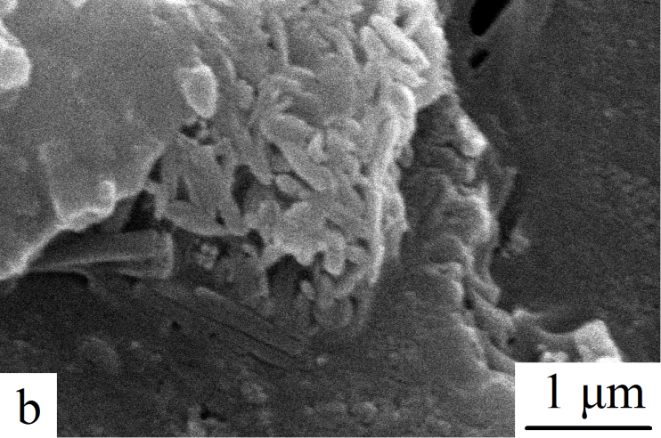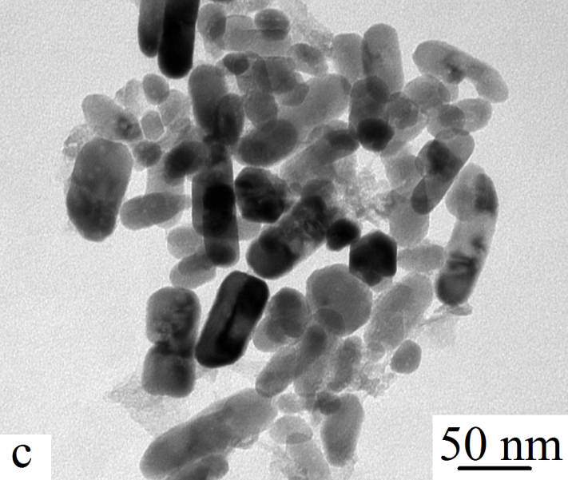

**Fig. S28.** SEM (a,b) and TEM (c) images |for sample **IX** (LG/(Et3NH2)2[B10H10], 70/30).

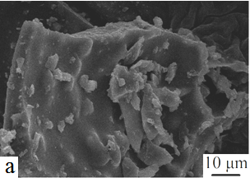 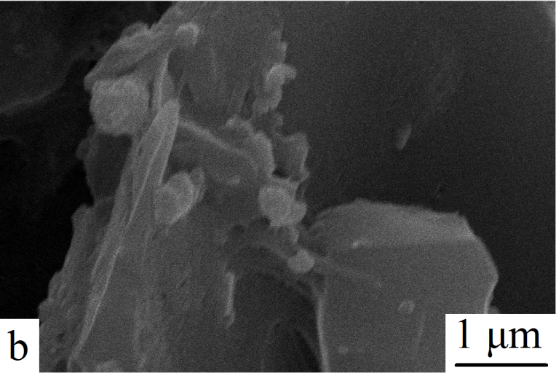

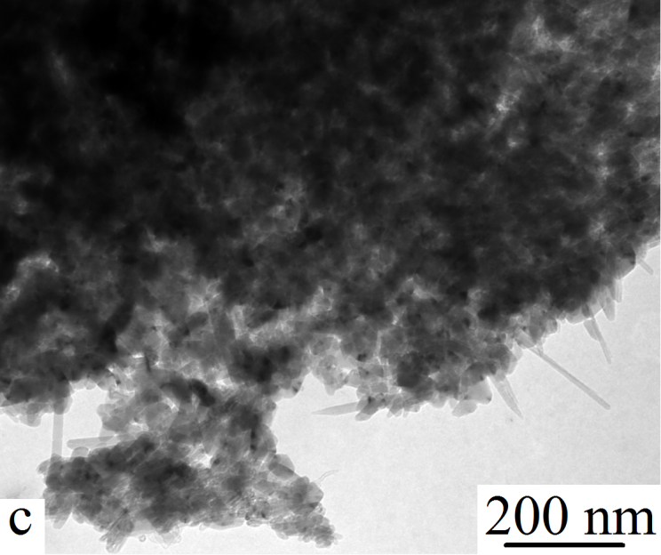 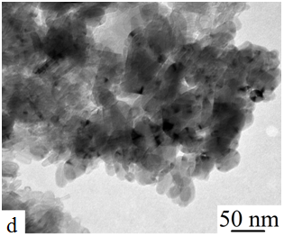

**Fig. S29.** SEM (a,b) and TEM (c,d) images |for sample **II** (LG/(Et3NH2)2[B10Cl10] 95/5).

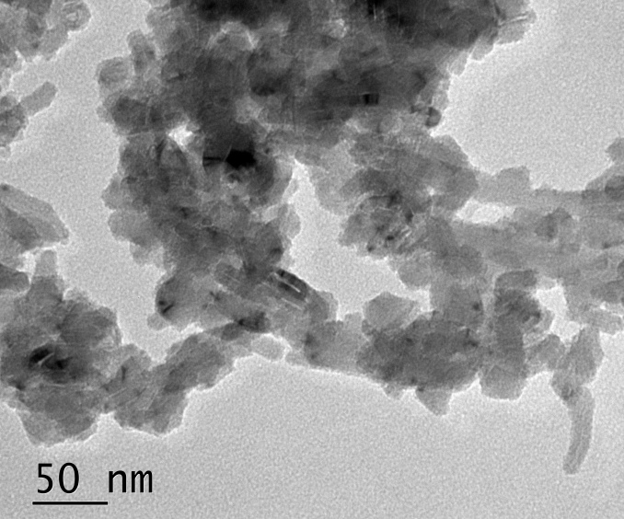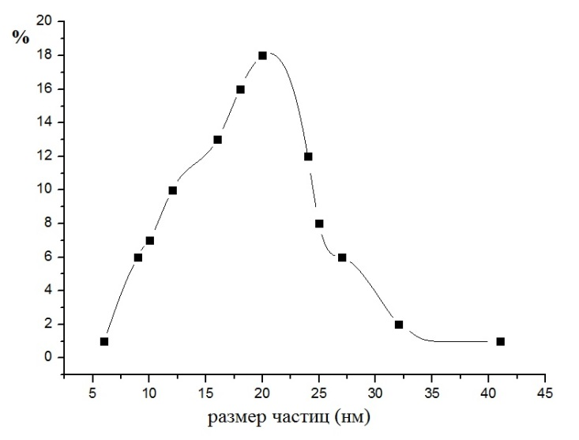

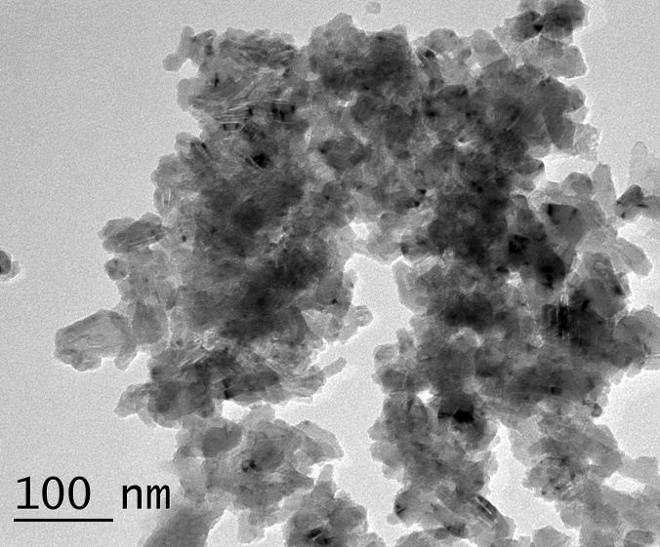 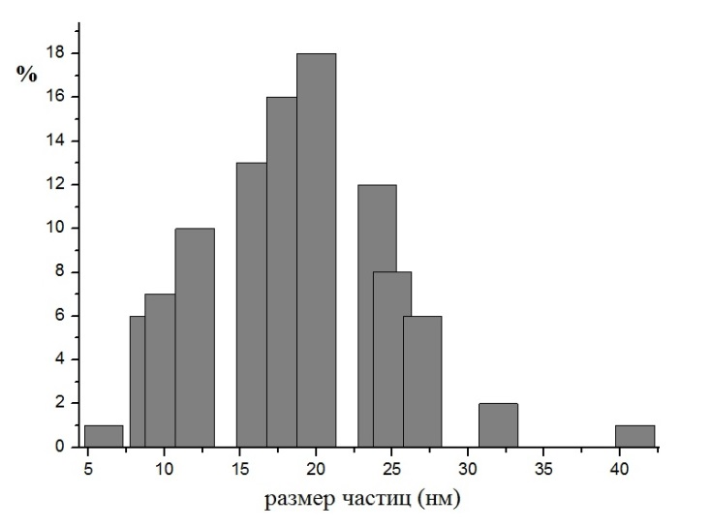

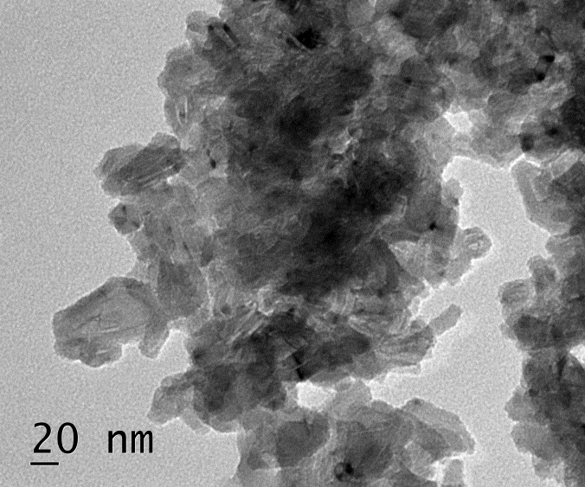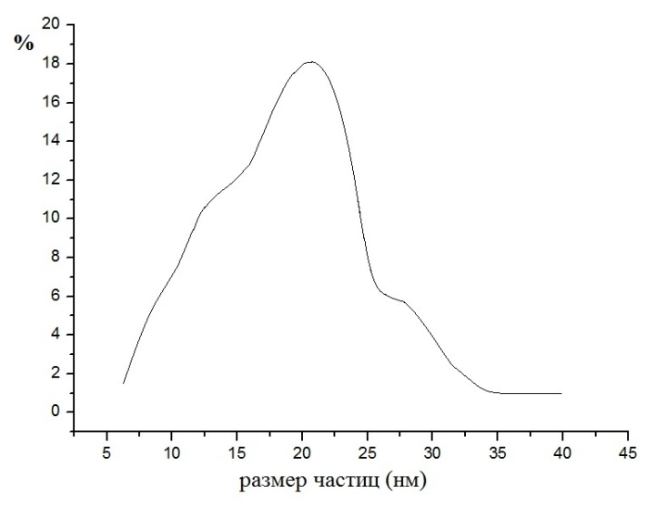

**Fig. S30.** TEM data and size distribution curves for sample **IV** (LG/(Et3NH2)2[B10Cl10], 80/20).

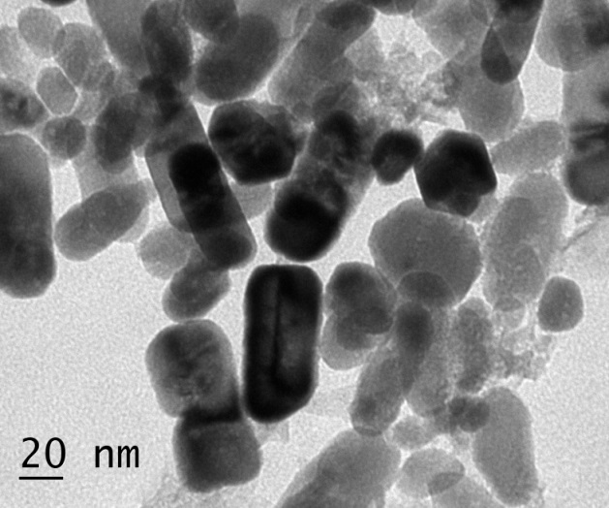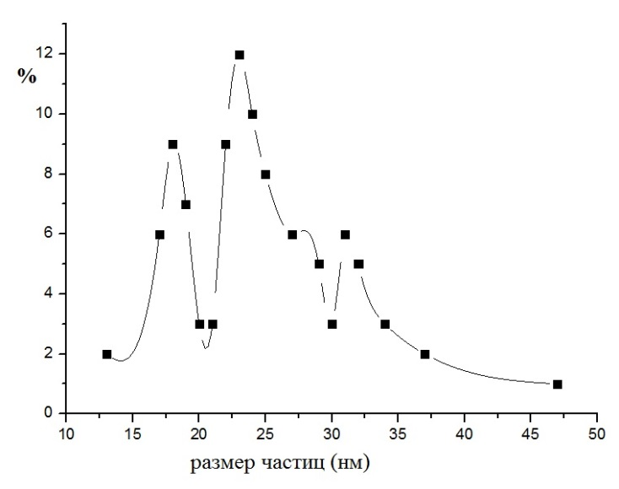

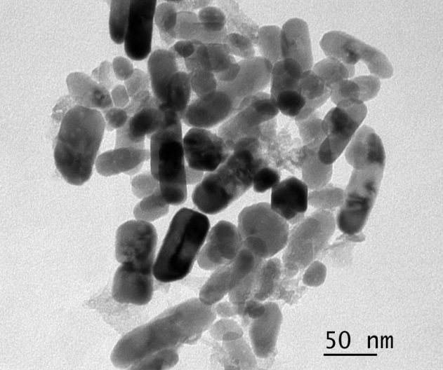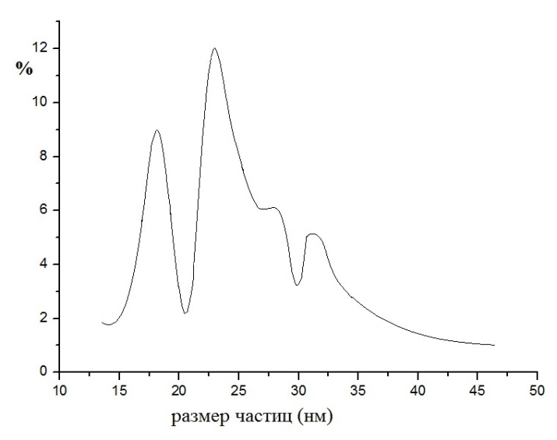

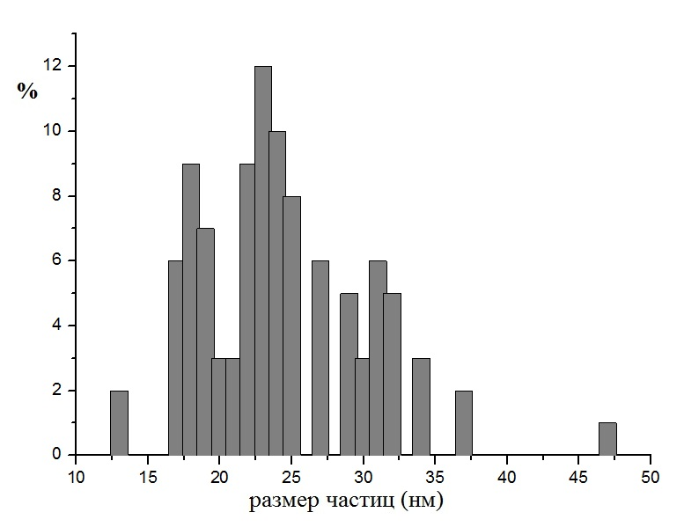

**Fig. S31.** TEM data and size distribution curves for sample **II** (LG/(Et3NH2)2[B10H10], 95/5).

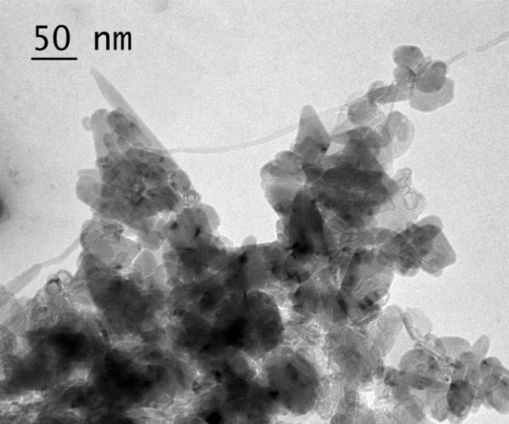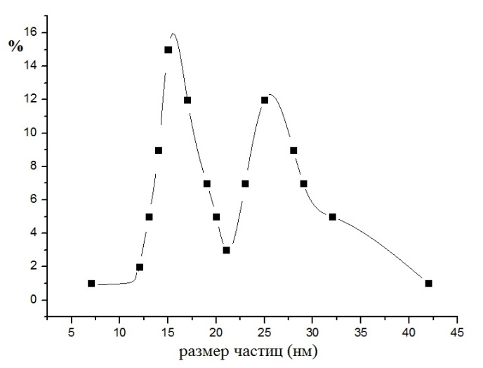

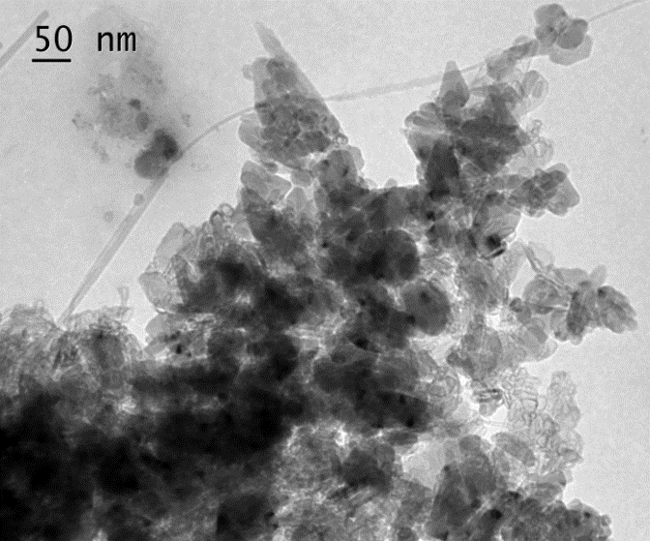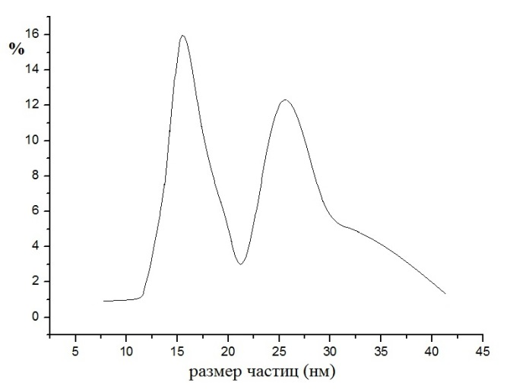

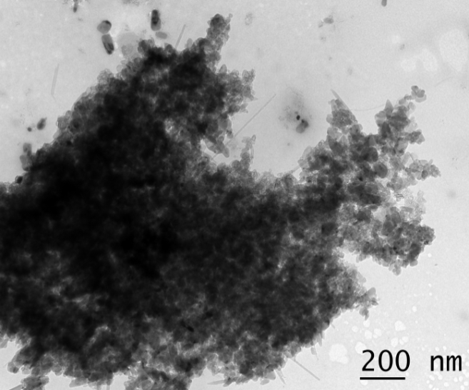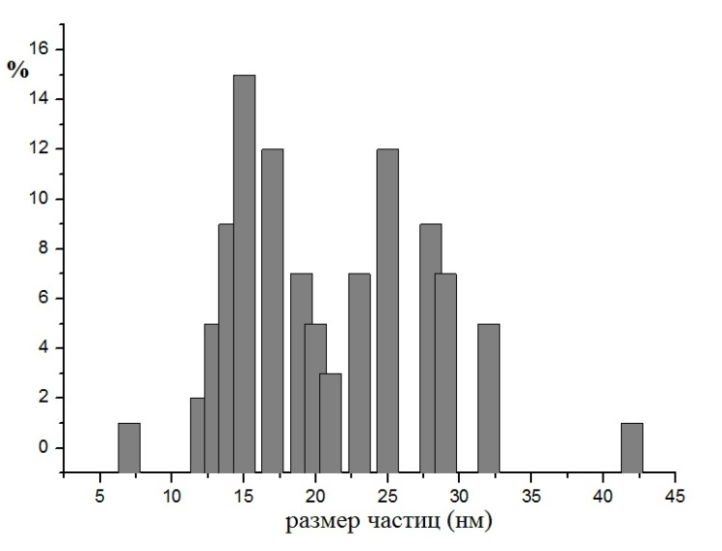

**Fig. S32.** TEM data and size distribution curves for sample **IX** (LG/(Et3NH2)2[B10H10] 70/30).

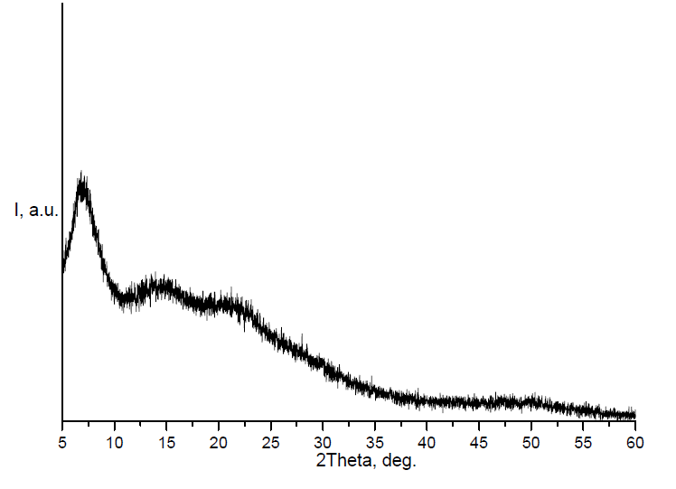

**Fig. S33.** X-ray powder diffraction pattern for sample **IV**.