Electronic supplementary information for
Biomolecule-assisted route to obtain nanostructured bismuth oxybromide with enhanced photocatalytic activity
Genesis de O. Limaª, Thaylan P. Araújoª, José Renato de O. Lima^{b}, Gilza Maria P. Prazeresª, Carlos William A. Paschoal^{c}, Elson Longo^{d}, Auro A. Tanakaª, Adeilton P. Macielª, Diego A. B. Barbosa^{e}, Marcio Aurélio P. Almeida^{b*}

*Corresponding author.
E-mail address: almeida.marcio@ufma.br (Marcio Almeida).

(a) | 190 nm  (b)
5.8 μm  5.3 μm  (c) | (d)
Fig. S1 FEG-SEM images of the as-prepared samples. a, b, c) BOB-gly. c) BOB-phe.

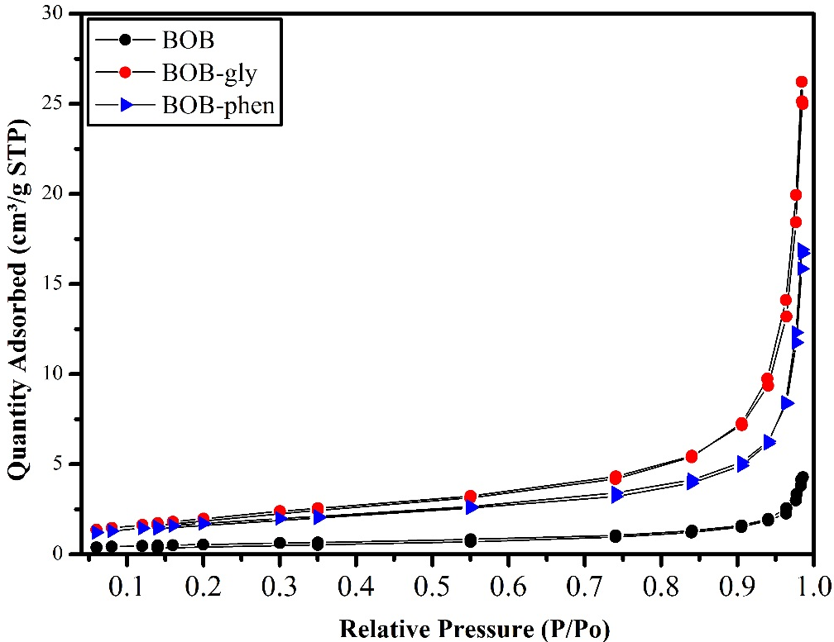
Fig. S3 Nitrogen adsorption–desorption isotherms of the BiOBr compounds.

Table S1. Refined structural data for the BiOBr samples, based on tetragonal symmetry.
Space group: P4/nmm (#129); Z=2
BOB
Cell parameters: a=3.91716(15) Å; c=8.08797(33) Å; cell volume 124.10(1) Å³
Fractional coordinates
Label | Wyckoff site | x | y |  | z |  | Occ. | Uiso
Bi1 | 8j | 0.25 | 0.25 |  | 0.15389(16) |  | 1 | 0.02876(35)
Br1 | 8j | 0.25 | 0.75 |  | 0.65743(40) |  | 1 | 0.03449(101)
O1 | 4d | 0.25 | 0.75 |  | 0 |  | 1 | 0.025
Bismuth bond angles
Atom 1 | Atom 2 | Distance 1,2 (Å) |  | Atom 3 | Distance 1,3 (Å) |  | Bond angle (°)
Bi | Br | 3.1698(17) |  | O | 2.3251(8) |  | 74.786(41)
 | Br | 3.1698(17) |  | Br | 3.1698(17) |  | 76.465(51)
 | O | 2.3251(8) |  | O | 2.3251(8) |  | 73.251(25)
Bonds
Atom 1 | Atom 2 |  | Bond distance (Å)
Bi | Br | 4x | 3.1698(17)
 | O1 | 4x | 2.3251(8)
BOB-phe
Cell parameters: a=3.91937(48) Å; c=8.09242(116) Å; cell volume 124.31(3) Å³
Fractional coordinates
Label | Wyckoff site | x | y |  | z |  | Occ. | Uiso
Bi1 | 8j | 0.25 | 0.25 |  | 0.15218(18) |  | 1 | 0.03946(54)
Br1 | 8j | 0.25 | 0.75 |  | 0.65919(43) |  | 1 | 0.04905(167)
O1 | 4d | 0.25 | 0.75 |  | 0 |  | 1 | 0.025
Bismuth bond angles
Atom 1 | Atom 2 | Distance 1,2 (Å) |  | Atom 3 | Distance 1,3 (Å) |  | Bond angle (°)
Bi | Br | 3.1676(17) |  | O | 2.3173(8) |  | 74.492(41)
 | Br | 3.1676(17) |  | Br | 3.1676(17) |  | 76.531(51)
 | O | 2.3173(8) |  | O | 2.3225 (9) |  | 73.539(25)
Bonds
Atom 1 | Atom 2 |  | Bond distance (Å)
Bi | Br | 4x | 3.1676(17)
 | O1 | 4x | 2.3173(8)

Space Group: P4/nmm (#129); Z=2
BOB-gly
Cell parameters: a=3.91936(15) Å, c=8.09196(32) Å; Cell volume 124.30(1) Å³
Fractional Coordinates
Label | Wyckoff Site | x | y |  | z |  | Occ. | Uiso
Bi1 | 8j | 0.25 | 0.25 |  | 0.15340(15) |  | 1 | 0.02908(30)
Br1 | 8j | 0.25 | 0.75 |  | 0.65951(38) |  | 1 | 0.03492(87)
O1 | 4d | 0.25 | 0.75 |  | 0 |  | 1 | 0.025
Bismuth Bond Angles
Atom 1 | Atom 2 | Distance 1.2 (Å) |  | Atom 3 | Distance 1.3 (Å) |  | Bond Angle (°)
Bi | Br | 3.1680(17) |  | O | 2.3248(7) |  | 74.723(39)
 | Br | 3.1680(17) |  | Br | 3.1680(17) |  | 76.522(51)
 | O | 2.3248(7) |  | O | 2.3248(7) |  | 73.265(22)
Bonds
Atom 1 | Atom 2 |  | Bond Distance (Å)
Bi | Br | 4x | 3.1680(17)
 | O1 | 4x | 2.3248(7)
Table S2. Refined structural data for samples BOB-gly in the basis of the tetragonal symmetry

Table S3. Parameters of nitrogen adsorption–desorption isotherms of the BiOBr compounds
Parameter | BOB | BOB-gly | BOB-phe
Correlation Coefficient | 0.9999078 | 0.9995173 | 0.9998873
Specific area, S_{BET} (m²/g) | 2.0217 | 7.6950 | 6.3410
Total pore volume, V_{BJH} (cm³/g) | 0.006697 | 0.038963 | 0.026159
Pore diameter, Dp (Å)* | 129.435 | 161.975 | 147.092
* BJH Desorption average pore diameter.

