Supplementary Information
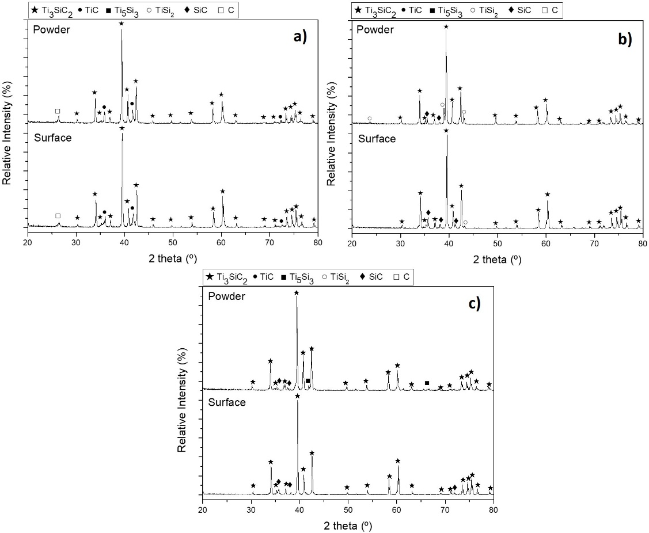
Fig. S1. XRD profiles of a) Ti:Si:C_{f} = 3:1,1:3,1 , b) Ti:SiC = 3:2 and c) Ti:SiC:C_{c} = 3:1,5:0,5 of surface and powders heat treated in vacuum atmosphere for 2 hours at 1300 ºC temperature (XRD data represented in the manuscript in Table X).
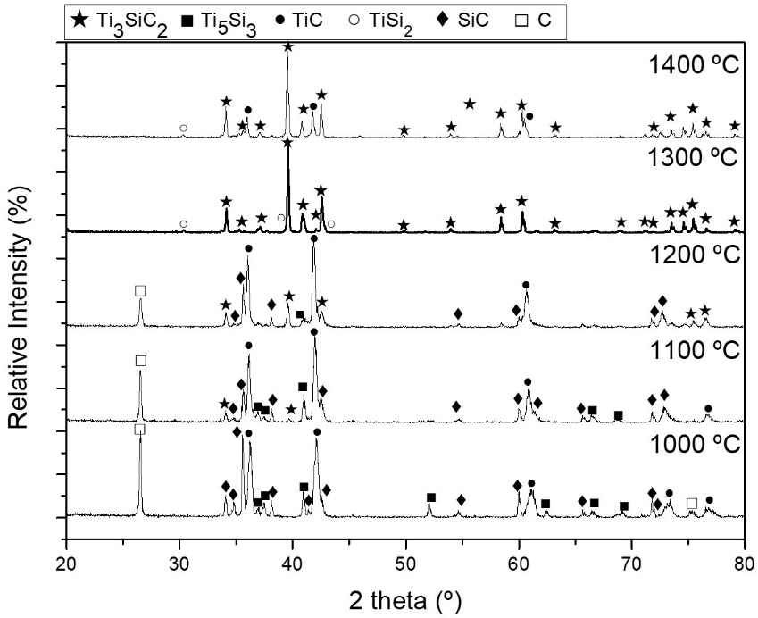
Fig. S2. XRD profiles of mixture Ti:SiC:C_{c} with a molar ratio of 3:1,5:0,5 heat treated with a holding time of 6 hours at 1000 ºC, 1100 ºC, 1200 ºC, 1300 ºC and 1400 ºC (XRD data represented in the manuscript in Table X).
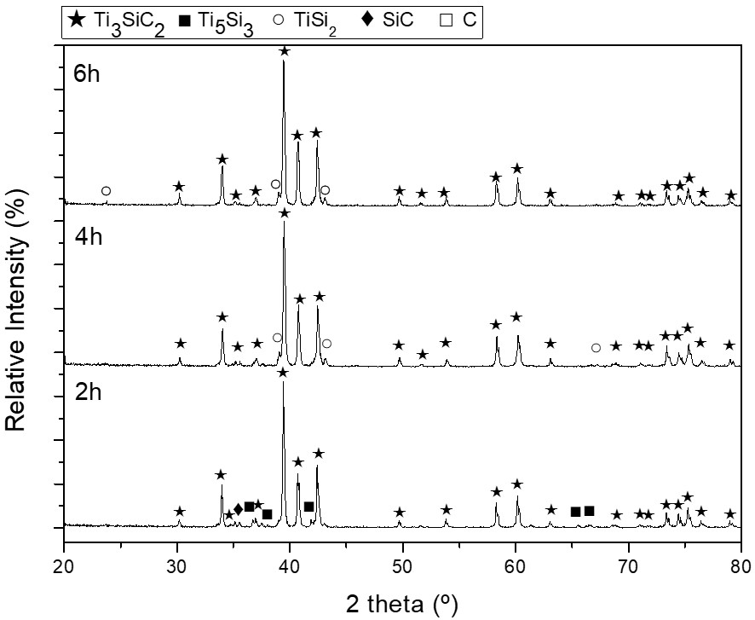
Fig. S3. XRD profiles of mixture Ti:SiC:C_{c} powders with a molar ratio of 3:1,5:0,5 heat treated at 1300 ºC for 2, 4 and 6 hours (XRD data represented in the manuscript in Table X).

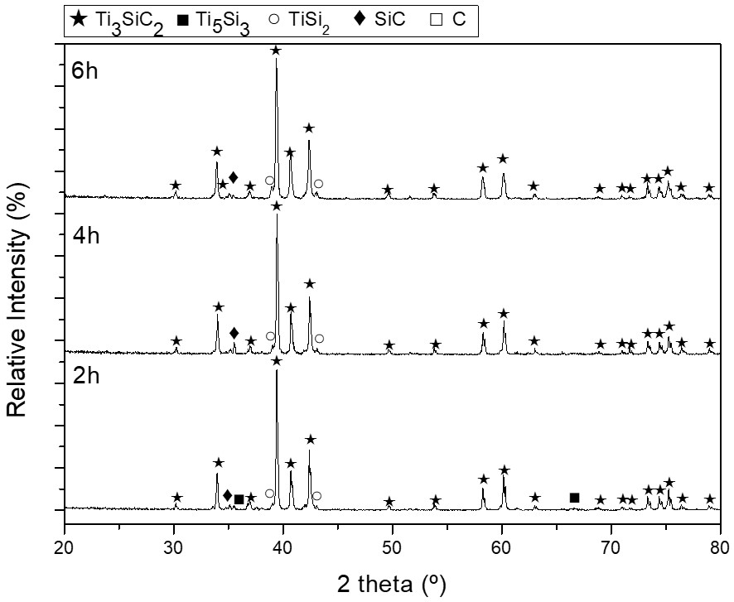
Fig. S4. XRD profiles of mixture Ti:SiC:C_{f} powders with a molar ratio of 3:1,5:0,5 heat treated at 1300 ºC for 2, 4 and 6 hours (XRD data represented in the manuscript in Table X).

