**Supplementary data**

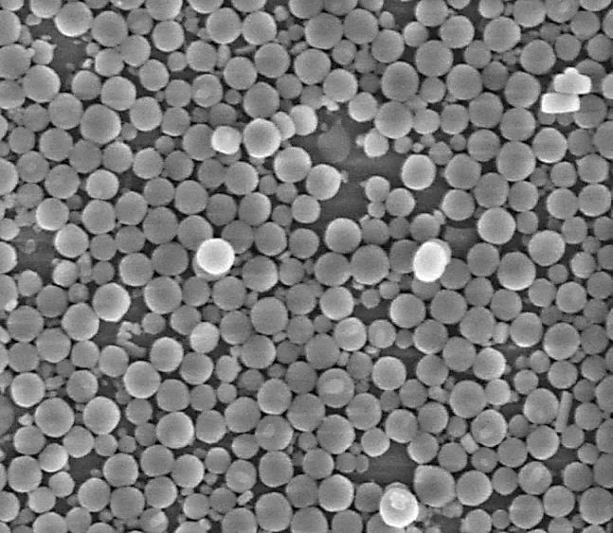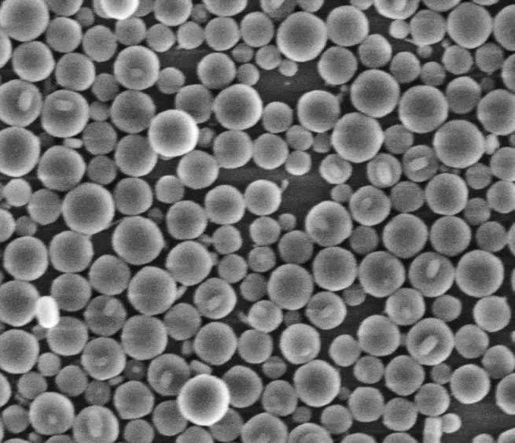

**1 µm**

**SS24**

**SS36**

**1 µm**

**SS48**

**SS62**

**1 µm**

**1 µm**

**1 µm**

**SS88**

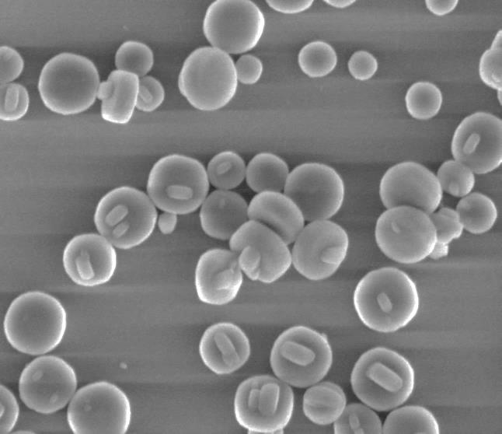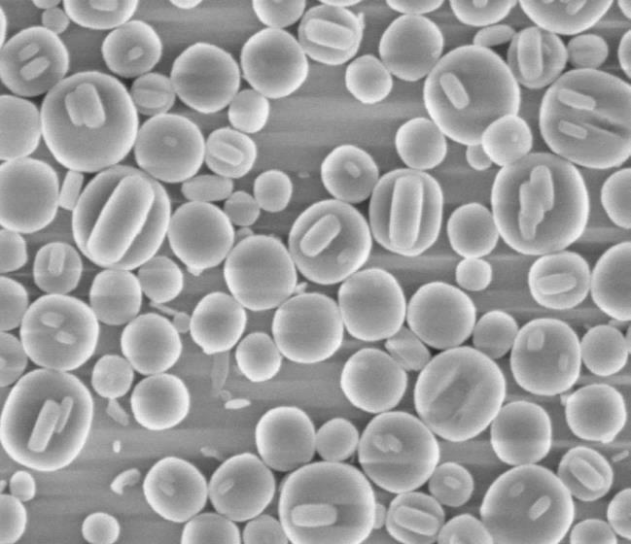

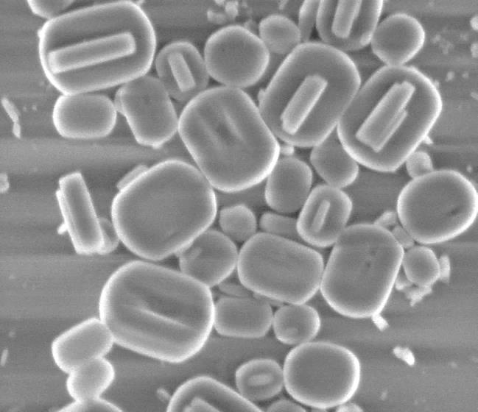

Figure 1.S. SEM image of oriented samples coated on the glass plate.