Rapid removal of fluoride from water using core@shell and @shell nanoparticles of SiO₂@ZrO₂ and @ZrO₂. Investigation of the mechanisms involved and impact of elemental leaching

Supplementary Information

Deduction of equation (8)
 | $$\frac{{mol}_{F}}{{mol}_{Zr}}=\frac{\frac{m_{F}}{{AW}_{F}}}{\frac{m_{Zr}}{{AW}_{Zr}}}$$ | (1)

 | $$\left(…\right)=\frac{\frac{{ppm}_{F}. V_{sc}}{{AW}_{F}}}{\frac{{ppm}_{Zr}. V_{sc}}{{AW}_{Zr}}}$$ | (2)

 | $$\left(…\right)=\frac{\frac{{ppm}_{F}}{{AW}_{F}}}{\frac{{ppm}_{Zr}}{{AW}_{Zr}}}$$ | (3)

 | $$\left(…\right)=\frac{{{ppm}_{F} . AW}_{Zr}}{{{ppm}_{Zr} . AW}_{F}}$$ | (4)

 | $$\%F=100 . \frac{mol F in ZrF_{6}^{2-}}{mol F}$$ | (5)

 | $$\%F=100 . 6 . \frac{ mol Zr }{mol F}$$ | (6)

Introducing (4) in (6) yields
 |  | $$\%F=600 . \frac{{{ppm}_{Zr} . AW}_{F}}{{{ppm}_{F} . AW}_{Zr}}$$ | (7)

Where (7) is shown above.
Replacing ppm_{Zr} and ppm_{F} by [Zr] and [F-] in (7) yields:

 | $$\%F=600 . \frac{\left[Zr\right]{ . AW}_{F}}{{[F^{-}] . AW}_{Zr}}$$ | (8)

Figure S1. The size distribution of solid core@shell and @shell particles in dilute dispersions.

Table S1. The concentration of elements Na, Si and Zr (ppm) in the liquid phase measured with ICP-MS for each of the four types of material in the 17 different experiments performed in each face-centered central composite experimental

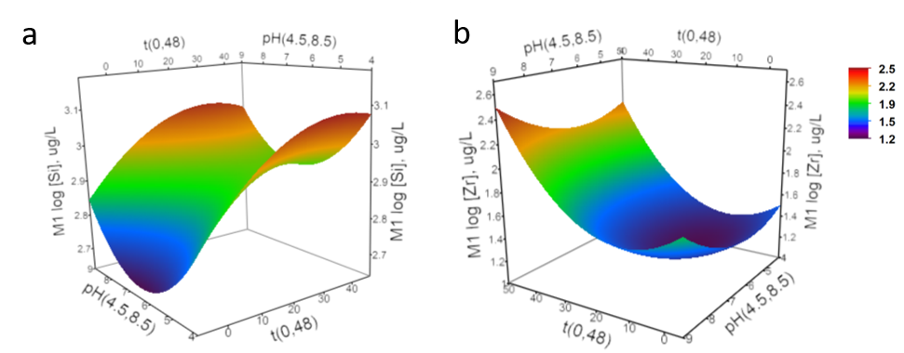
Figure S2. Modeled response surface plot showing the log concentration of leached a) Si and b) Zr as a function of pH and time.

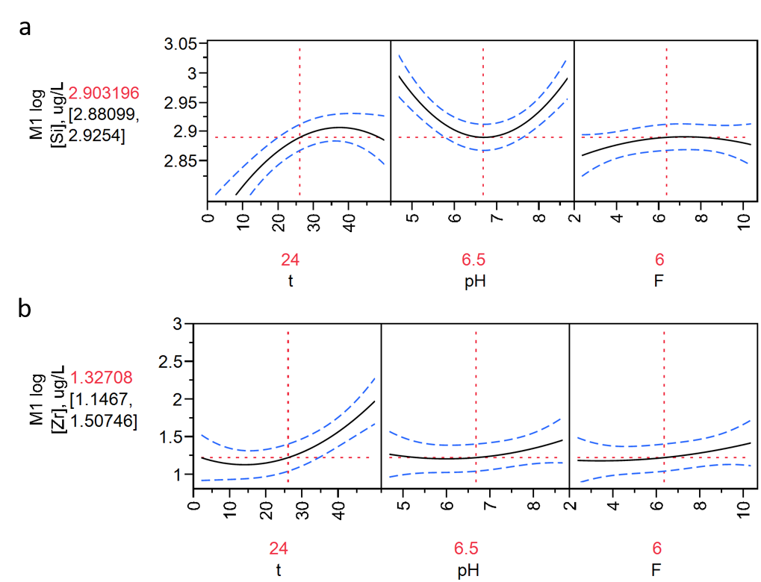
Figure S3. Predicted individual response plots showing the log concentration of leached a) Si and b) Zr as a function of pH and time. To calculate an individual response the remaining variables were fixed to t= 24, pH = 6.5 and [F] = 6 ppm.

