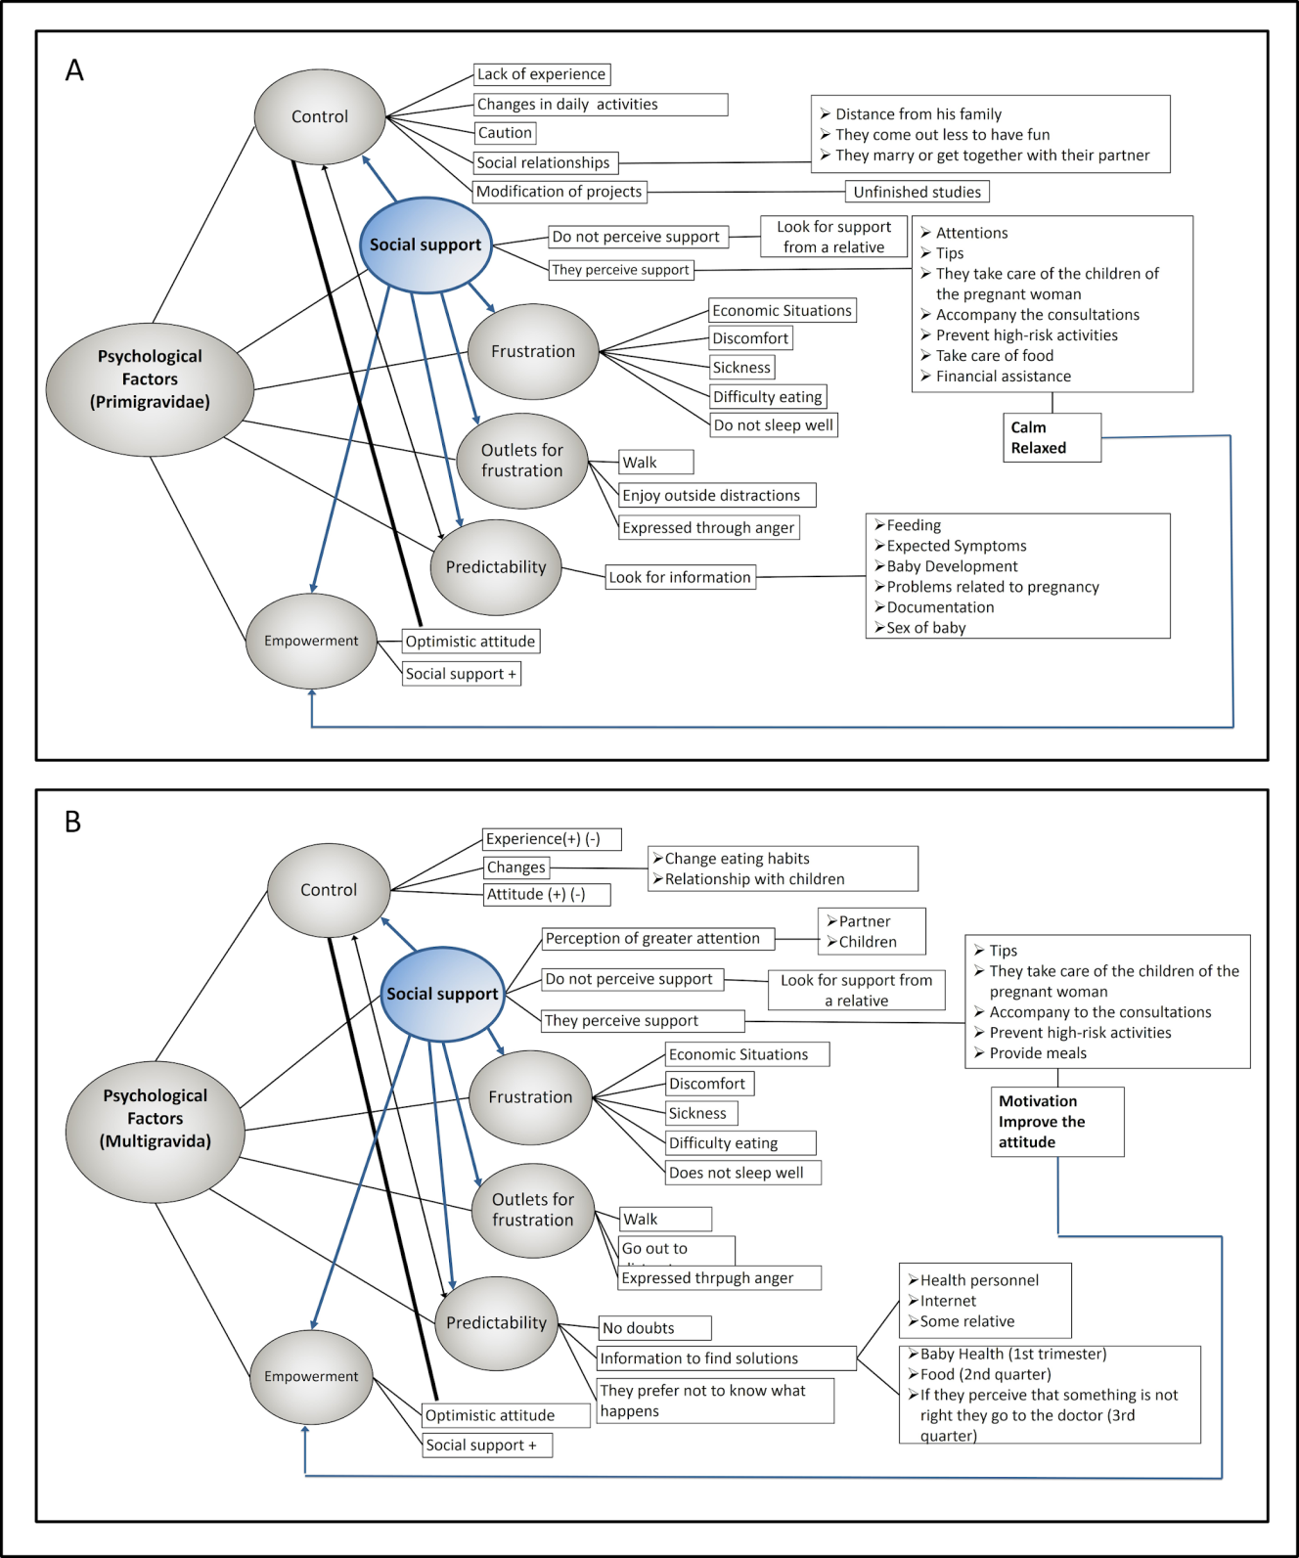
Figure A.1. Gestational stressors of multigravida and primigravida women.

