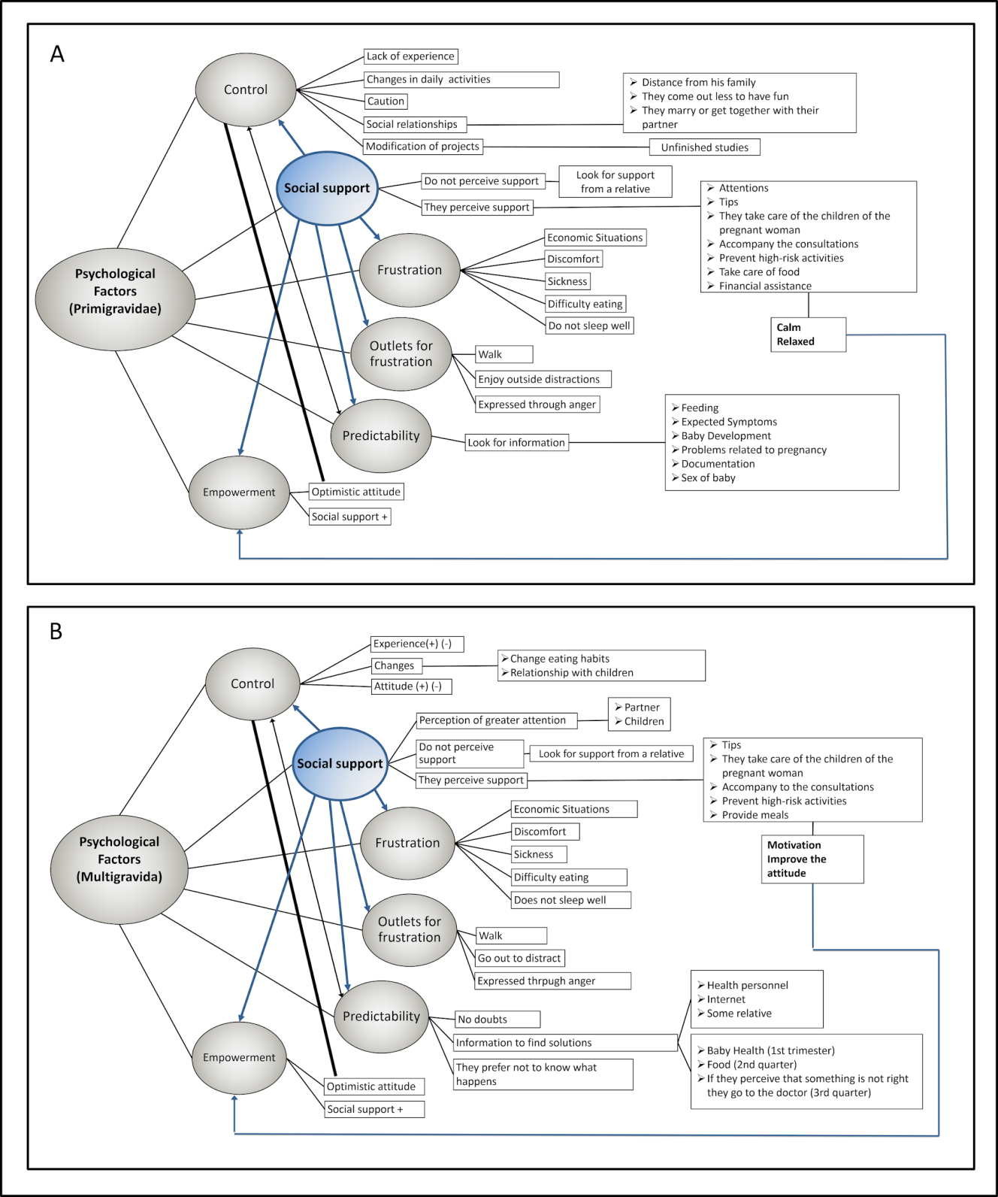
Figure B.2. Psychological factors of multigravida and primigravida women.

