Appendix C
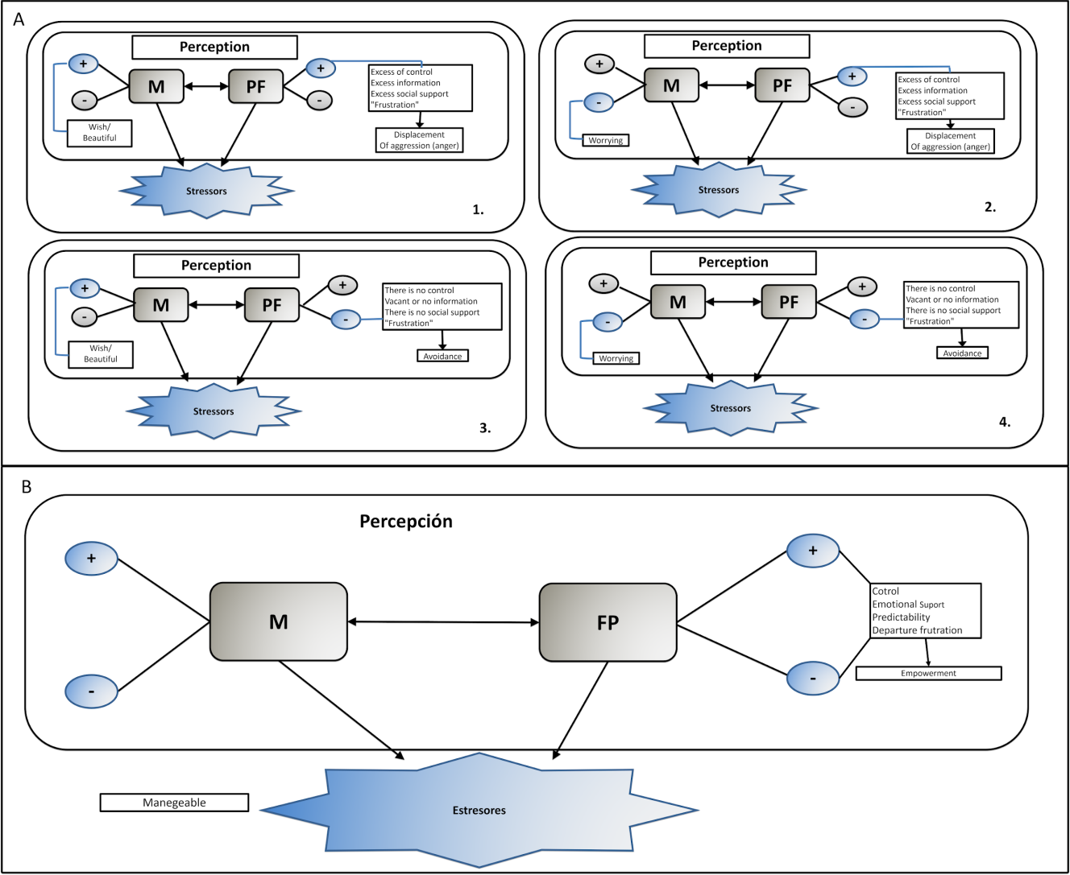
Figure C.3. Interaction of the three core factors of gestational stress (perception of motherhood, pregnancy stressors and psychological factors).

