SUPPLEMENTARY MATERIAL
BJPT_2017_326_R1

PROTOCOLS (Exercise_description_illustration)
TREATMENT PROTOCOL PERFORMED BY THE SUBJECTS

APPENDIX A

QUADRICEPS GROUP

1.Bike – 15 minutewarmup
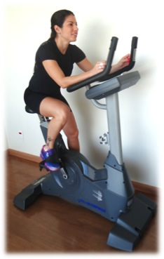

2.Straight Leg Raise – 3 sets of 10 repetitions with ankle weights resistence*.

*Resistance = the weights were increased based on the patient’s reportson the Rating of Perceived Exertion (RPE) scale based on Borg's Scale of Effort.

3.Seated knee extension (open kinetic chain exercise, 90º – 60º of knee flexion) - 3 sets of 10 repetitions with resistence*.

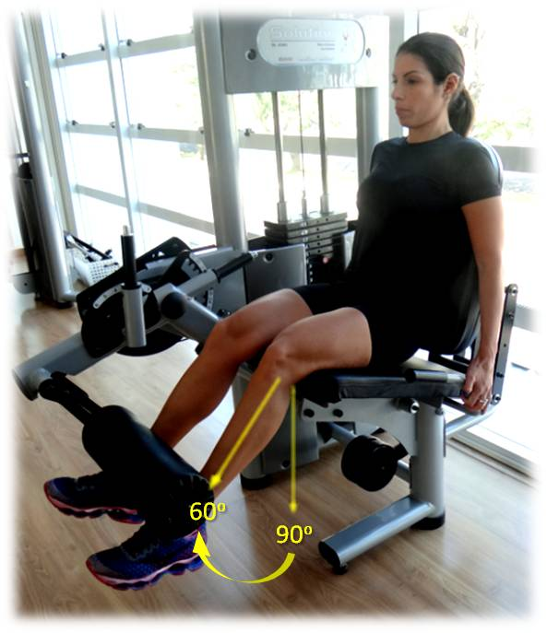

4.Leg Press (closed kinetic chain exercise, 0º – 45º of knee flexion) - 3 sets of 10 repetitions with resistence*.

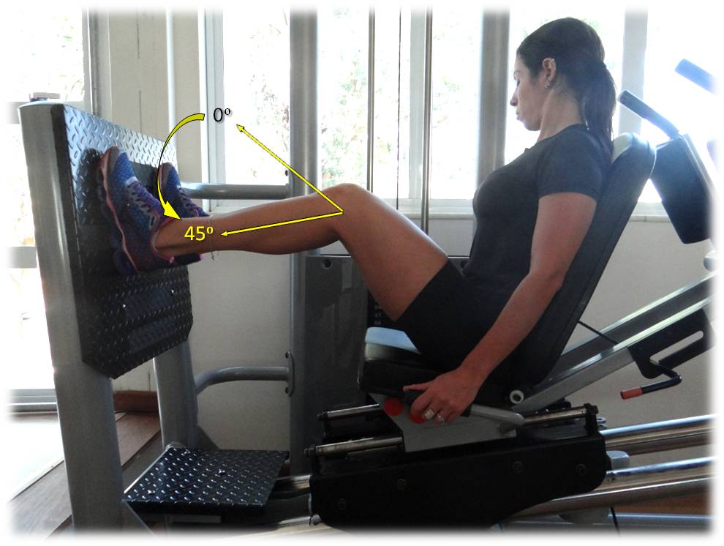

5.Wall Slide Squat at 90°- 3 setsof 1 minute

APPENDIX B

HIP GROUP

1.Bike – 15 minutes warmup

2.Straight Leg Raise in side lying– 3 sets of 10 repetitions using ankle weights asresistance*.
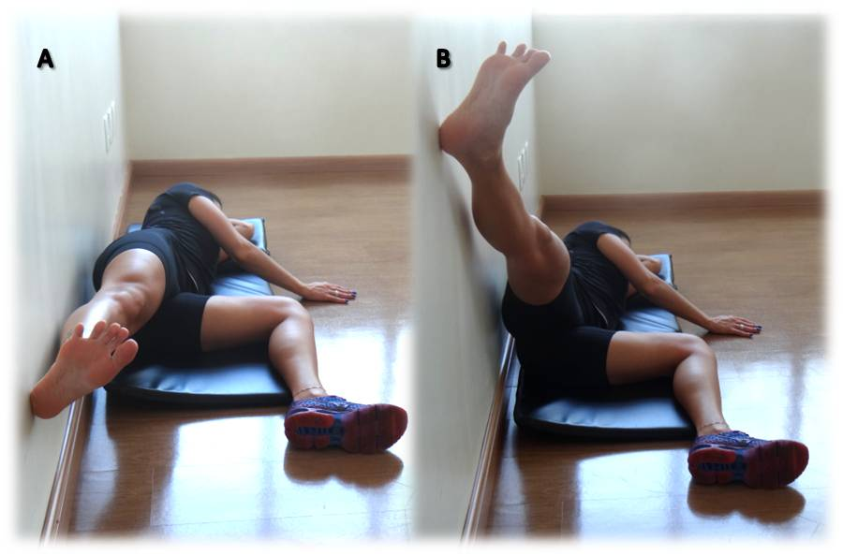

PS.: Exercise performed with slight extension and external rotation of the hip to emphasize posterior fibers of gluteus medius.
*Resistance = the weights were increased based on the patient’s reportson the Rating of Perceived Exertion (RPE) scale based on Borg's Scale of Effort.

3.Supine Bridge on Ball (A-1 start position, A-2 final position) and Lateral bridge (B-1 start position, B-2 final position) - 3 sets of 10 repetitions with 10 second isometric hold on the last repetition
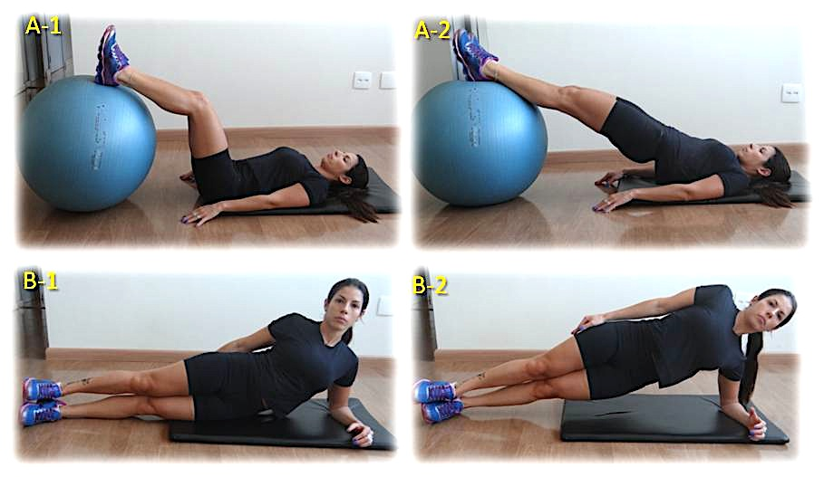

4.Seated Hip Abduction - 3 sets of 10 repetitions with resistance*.

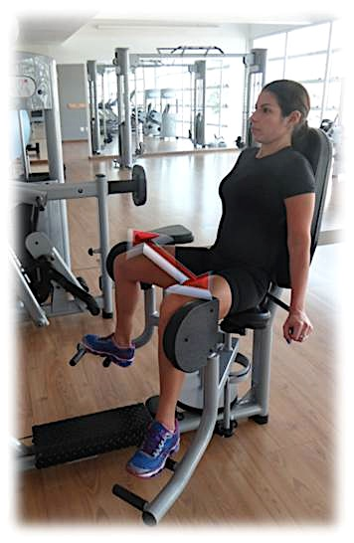

5.Strengthening the extensors, abductors and hip external rotators at four support positions (A – start position, B – intermediary position, C – final position) - 3 sets of 10 repetitions with ankle weights resistance*.
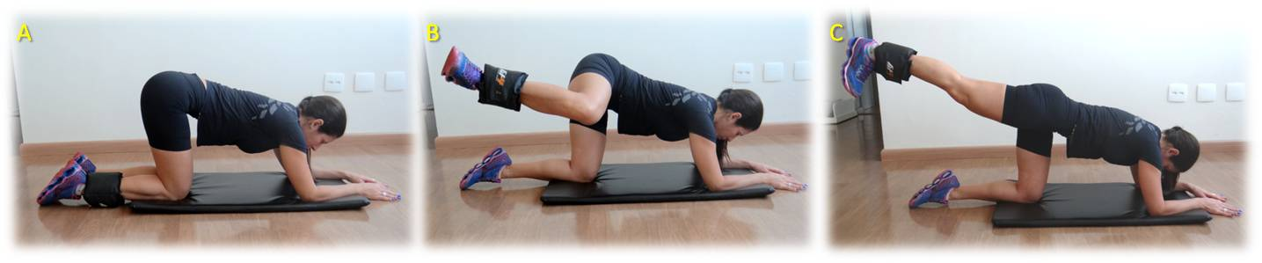

APPENDIX C

STRETCHING GROUP

1.Quadriceps stretching (A – standing position, B – variation in lying position) - 3 - 30 second stretches
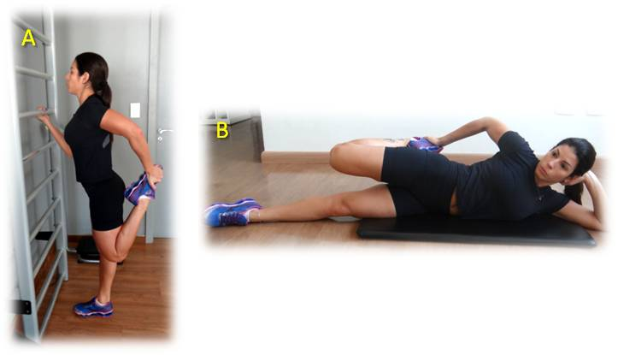

2.Hamstrings stretching (A – supine position, B – variation in seated position) - 3 -30 second stretches
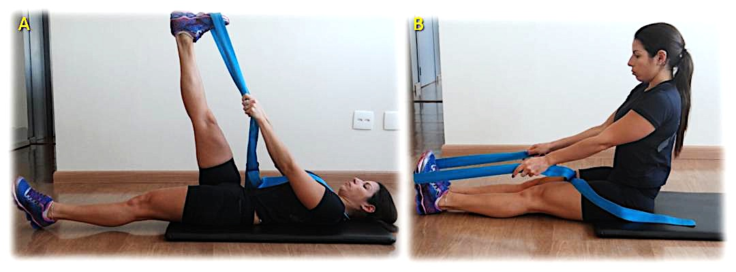

3.Gastrocnemius and soleus stretching (A – with assistance of ramp, B – standing position) - 3 - 30 second stretches
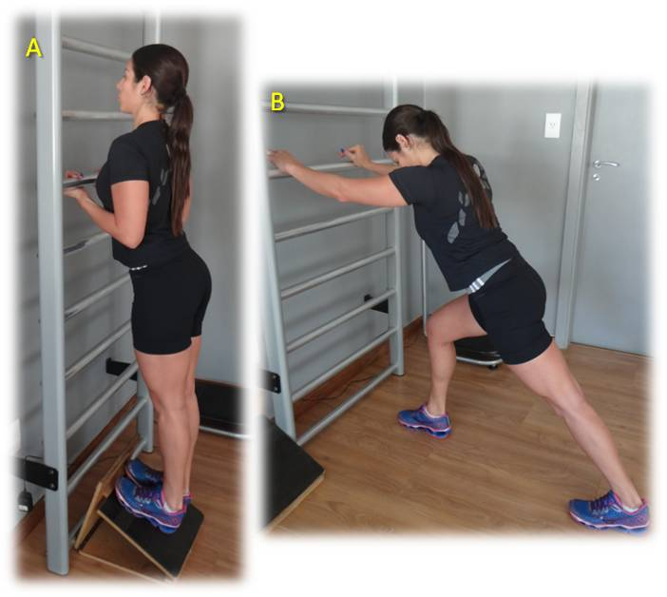

4.External rotators of hip and iliotibial band stretching (A – start position, B – intermediary position, C – final position) - 3 - 30 second stretches

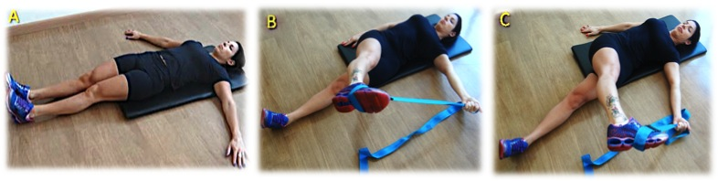

5.Flexors of hip stretching (A – on the floor, B – with assistance of the therapist) - 3 -30 second stretches
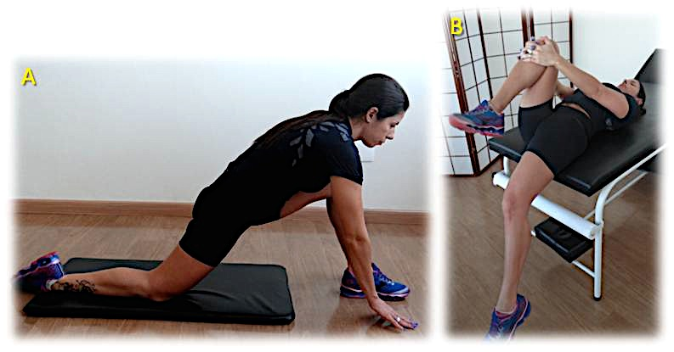

6.Aductors stretching - 3 - 30 second stretches

7.Abdominal stretching - 3 -30 second stretches
