Appendix 1.
Search terms and flow diagram of literature used for content validity.

Search terms included: core (core, trunk, lumbopelvic spine, assessment), stability (stability, strength, neuromuscular control, assessment, upper extremity, lower extremity), movement (system, screening, impairment), pre-participation (screen, injury, risk, upper extremity, lower extremity), and injury (risk, assessment, screen, upper extremity, lower extremity). Articles were excluded if the tests/assessments were not specific to athletes [athlete] or peer reviewed.
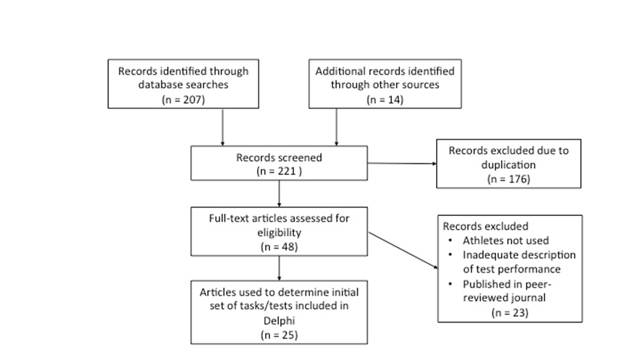

First round of questions provided to Delphi panel of experts.
Experts were provided a photograph of each test and asked the following questions.

Which of the following constructs is this test primarily assessing?

Stability: Ability to control the body region's position to withstand internal and external perturbations
Mobility: Range of motion within one or multiple joints
Movement pattern efficiency: the coordination of motion (timing and amount) between segments and/or extremities that demonstrates effective acceptance, generation, or transfer of forces to accomplish a skill or task. For bilateral tasks, this includes equal motion and weight bearing through the extremities.

- Stability
- Mobility
- Movement Pattern Efficiency

If Mobility is selected, skip the next question.

Would you classify/categorize this test as primarily a test of:

Neuromuscular control: Ability to accurately orchestrate a synchronized muscular response to internal and external perturbations based on sensory feedback
Muscle capacity/performance: strength, endurance, or power of the involved musculature

- Neuromuscular Control
- Muscle Capacity/Performance
- None of these

Which of the following body regions is this test primarily assessing? (you may check more than one answer)

- Trunk/Pelvis
- Hip
- Lower Extremity
- Upper Extremity

Do you think a difference in performance between sides is meaningful?

- Yes
- No

If yes, what amount of difference is meaningful?

Subtle: Questionable or mild differences between sides
Obvious: Marked or clear differences between sides

- Subtle
- Obvious

