SCAPULAR MOVEMENT TRAINING GROUP
Educational phase
Interventions | Details | Figures
Scapular upward rotation deficit | Therapist will provide tactile feedback to assist the upward rotation, and the following instruction will be given: observe the acromion movement and reproduce it during arm elevation. | 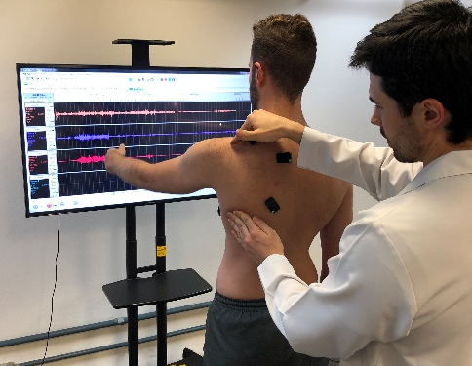  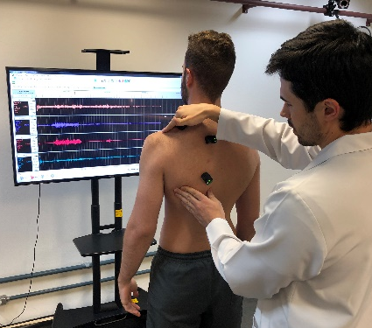
Scapular downward rotation | To stabilize the scapula in upward rotation, place the back and forearms against the wall, with 90º of shoulders abduction and elbows at 90º of flexion. Slide the arms up the wall keeping the back in contact with wall. | 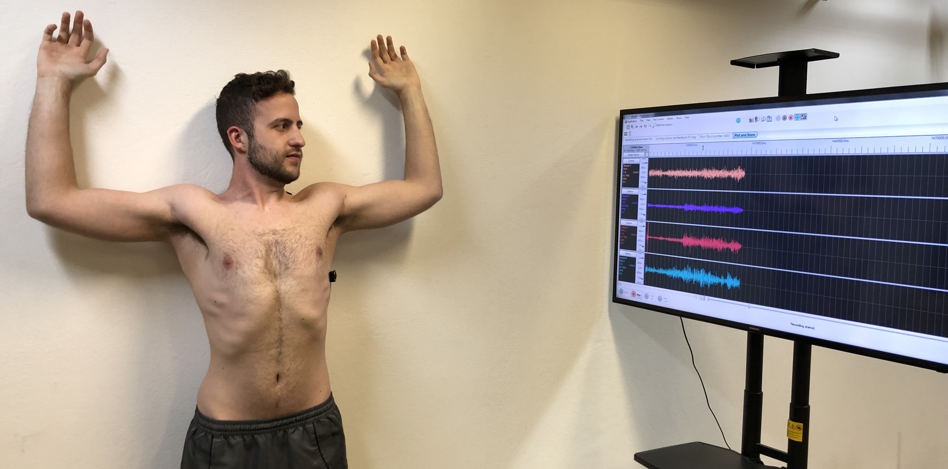
Scapular posterior tilt deficit | Palpate the coracoid process and move it backwards away from your finger. Therapist will provide tactile feedback to assist the posterior tilt by moving the inferior angle forward. | 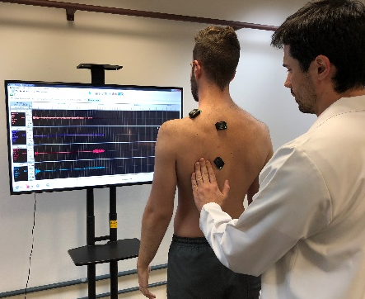  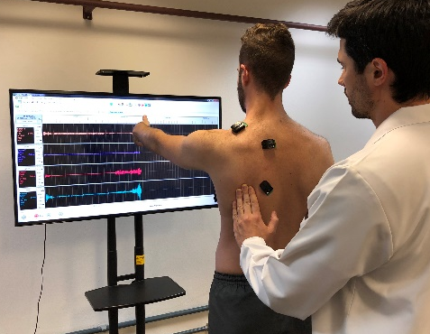
Scapular external rotation deficit | Move the scapula into external rotation. Therapist will provide tactile feedback to assist the external rotation by moving the medial border of the scapula forward. | 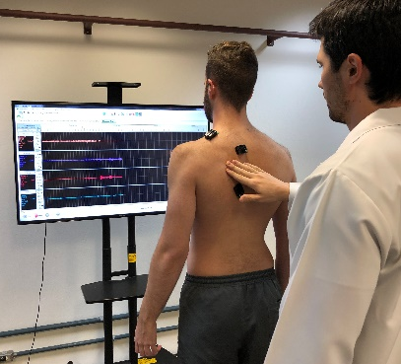  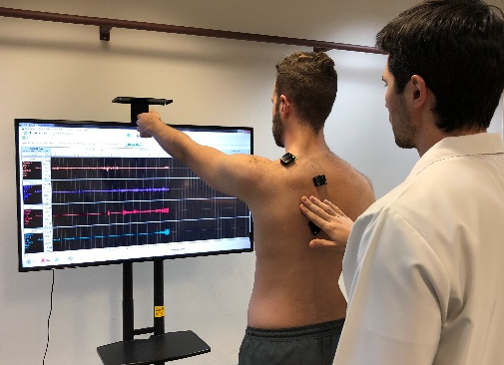
Excessive clavicular elevation  (shoulder shrug) | Therapist will provide tactile feedback by slightly pressing down the superior and distal portion of clavicle. | 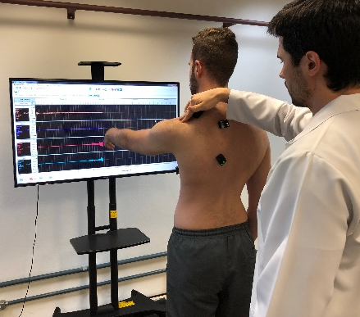  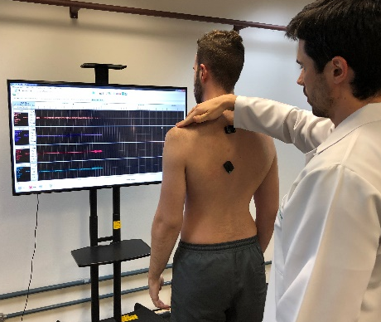

SCAPULAR MOVEMENT TRAINING GROUP
Training phase
3 sets, 10 – 15 repetitions
The range of elevation will be defined according to the individuals’ ability to
control scapular movements at each repetition
Interventions | Details | Figures
Wall slide | Begin with forearms in contact with a smooth wall, elbows at 90º of flexion, and arms with 90º of elevation in the scapular plane. Slide slowly the forearms up and down on the wall while controlling scapular motion.
Arm elevation with elbow flexion | Elevate the arm in the scapular plane with 90º of elbow flexion, holding the scapula in adequate position. | 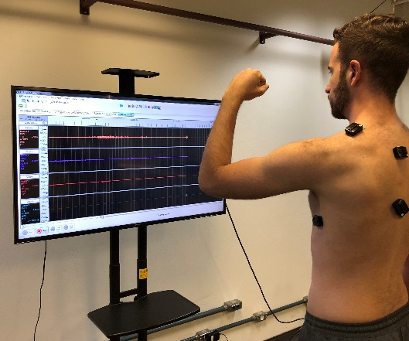
Arm elevation with full elbow extension | Elevate the arm in the scapular plane with full elbow extension, holding the scapula in adequate position.
Arm elevation against resistance | Elevate the arm with full elbow extension, holding a resistance of 0.5 Kg or more. Keep the scapula in adequate position.

STANDARDIZED EXERCISES GROUP
Stretching exercises
3 sets, 10 repetitions
Interventions | Details | Figures
1. Upper trapezius stretching | Flex, side-bend away and rotate towards the side to be stretched, then force down the arm on the side being stretched.
2. Pectoralis minor: unilateral corner stretching | Begin with 90º of shoulder abduction, 90º of elbow flexion and forearm on the corner of a wall. Shift the trunk forward and rotate opposite to the side being stretched. | 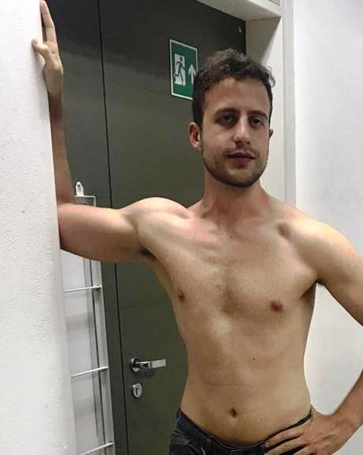
3. Posterior shoulder: cross-body stretching | Bring the arm into horizontal adduction. | 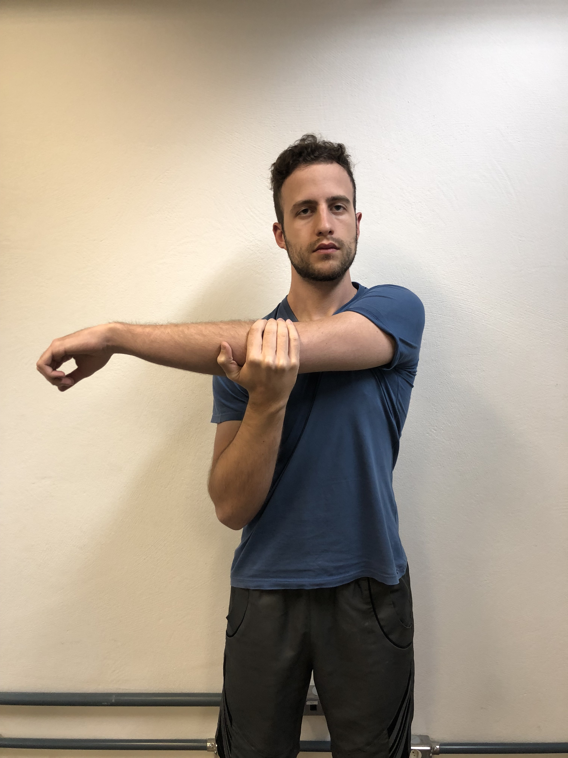

STANDARDIZED EXERCISES GROUP
Strengthening exercises
3 sets of 10 repetitions, progressing from red to green to blue to gray band
Interventions | Details | Figures
1. Prone extension | Grasp band while lying in prone with arm resting at 90° forward flexion. Push the arm back into shoulder extension and keeping arm straight. | 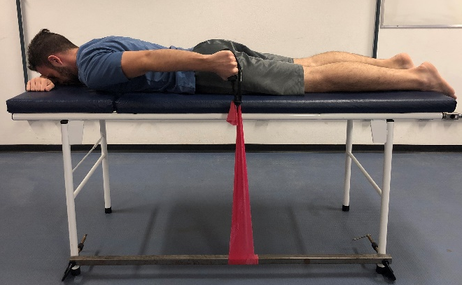
2. Prone horizontal abduction with external rotation | Grasp band while lying in prone with arm resting at 90° forward flexion.  Turn thumb up and lift arm diagonally above shoulder towards the ceiling (horizontal abduction with external rotation). | 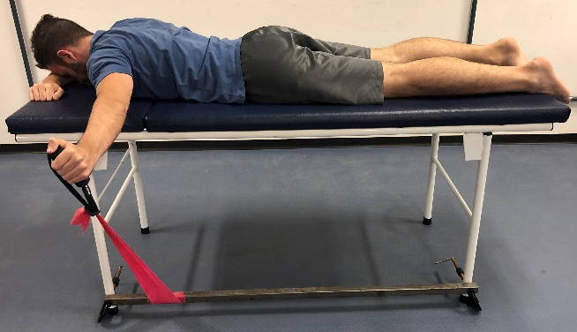
3. Serratus punch | Grasp band while lying on your back with arm flexed at 90°. Punch arm up towards the ceiling, while keeping arm  straight. Shoulder blade should lift off table. | 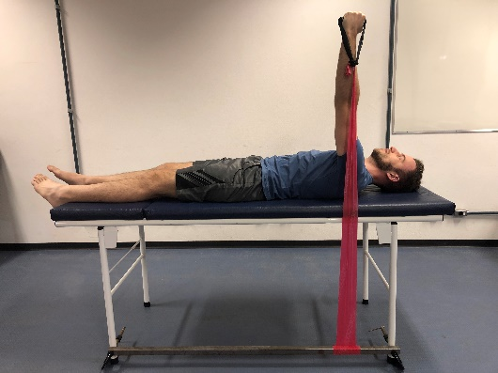
4. Side-lying external rotation | Begin with hand in front of the stomach. Pull up towards the ceiling, while keeping the elbow flexed. | 