Supplementary material – table 1: Subgroup-specific, protocolized interventions
‘High muscle strength subgroup’ | ‘Low muscle strength subgroup’ | ‘Obesity subgroup’
Exercise therapy from physical therapist  Number of sessions:  - 3-5 individual sessions in 12-week treatment period  - 1 ‘booster’ session in post-treatment period  Content:  - subgroup-specific education/ advice  - home exercises | Exercise therapy from physical therapist  Number of sessions:  - 8-12 individual sessions in 12-week treatment period  - 1-2 ‘booster’ sessions in post-treatment period  Content:  - subgroup-specific education/ advice  - supervised exercise therapy, primarily targeting upper leg muscle strength  - home exercises | Exercise therapy from physical therapist  Number of sessions:  - 12-18 individual sessions in 12-week treatment period  - 2-3 ‘booster’ sessions in post-treatment period  Content:  - subgroup-specific education/ advice  - supervised exercise therapy adapted to obesity, targeting upper leg muscle strength, aerobic capacity and weight loss  - home exercises
Dietary intervention from dietician
Number of sessions:
- 5-8 individual sessions, of 150 minutes in total
Content:
- advising and monitoring healthy diet and active lifestyle, aiming at ≥ 10% weight loss
Interprofessional consultation between physical therapist and dietician
- at least one consultation after 3 to 4 weeks of treatment to agree on an approach to achieve sustainable lifestyle change

Supplementary material – Table 2: Definitions of major and minor protocol violations
Major protocol deviations are defined as one of the following:
- For both treatment arms:
  - undergoing total knee arthroplasty between baseline and 12-months follow-up; or
  - undergoing knee injection between baseline and 12-months follow-up; or
  - undergoing sleeve gastrectomy (stomach reduction) between baseline and 12-months follow-up.

- Specifically for control arm:
  - ≤ 2 physical therapy sessions.

- Specifically for experimental arm:
  - for all three subgroups:
    - < 2 months of physical therapy treatment period (recommended: 3 months)
  - for ‘high muscle strength subgroup’ only:
    - ≤ 2 physical therapy sessions in 3-month treatment period (recommended: 3-5 sessions); or
    - absence of the recommended physical therapy interventions: patient education/advice and home exercises
  - for ‘low muscle strength subgroup’ only:
    - ≤ 6 physical therapy sessions in 3-month treatment period (recommended: 8-12 sessions); or
    - absence of the recommended physical therapy interventions: patient education/advice, supervised exercise therapy and home exercises
  - for ‘obesity subgroup’ only:
    - ≤ 10 physical therapy sessions in 3-month treatment period (recommended: 12-18 sessions); or
    - < 3 dietician sessions in 12-month treatment period (recommended: 5-8 sessions); or
    - absence of the recommended physical therapy interventions: patient education/advice, supervised exercise therapy and home exercises.
Minor protocol deviations are defined as one of the following:
- Only for experimental arm:
  - for ‘high muscle strength subgroup’ only:
    - ≥ 7 physical therapy sessions in 3-month treatment period (recommended: 3-5 sessions);
  - for ‘low muscle strength subgroup’ only:
    - ≥ 14 physical therapy sessions in 3-month treatment period (recommended: 8-12 sessions), or
    - no ‘booster physical therapy session’ between 3-months and 12-month follow-up (recommended: 1-2 ‘booster sessions’);
  - for ‘obesity subgroup’ only:
    - ≥ 20 physical therapy sessions in 3-month treatment period (recommended: 12-18 sessions); or
    - no ‘booster physical therapy session’ between 3-months and 12-month follow-up (recommended: 2-3 ‘booster sessions’); or
    - ≥ 10 dietician sessions in 12-month treatment period (recommended: 5-8 sessions).

Supplementary material – Figure 1: OCTOPuS stratification algorithm

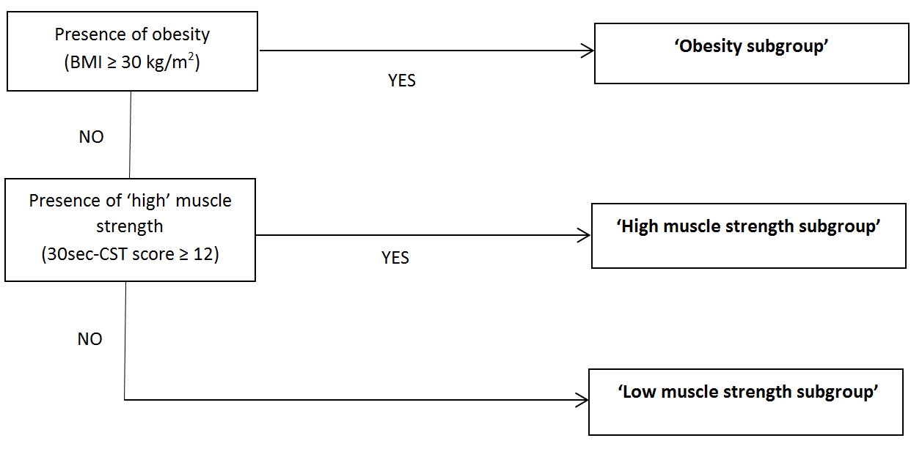

Supplementary material – Figure 2: Flow chart OCTOPUS-study
Excluded (n=18)
♦ Not meeting inclusion criteria (n=4)
- > 50km from research center (n=2)
- < 1 knee OA patient/month (n=2)
♦ Declined to participate (n=14)

Cluster enrollment
Recruitment of PTs (n=155)
PTs withdrawn before start trial (n=2)
♦ Stopped working at PT practice (n=2)
PTs discontinued during trial (n=2)
♦ Stopped working at PT practice (n=2)
Excluded (n=137)
♦ Not meeting inclusion criteria (n=105)
♦ Declined to participate (n=32)
Patients tested for eligibility (n=298)
Patients tested for eligibility (n=290)
Randomization of PTs on level of PT practice (n=137)
Excluded (n=116)
♦ Not meeting inclusion criteria (n=79)
♦ Declined to participate (n=37)
PTs withdrawn before start trial (n=5)
♦ Declined to participate (n=3)
♦ Stopped working at PT practice (n=2)
PTs discontinued during trial (n=7)
♦ Stopped working at PT practice (n=5)
♦ Not willing to participate anymore (n=2)

PTs in experimental group (n=54) + dieticians (n=21) for ‘obesity subgroup’
PTs in control group (n=83)

Cluster allocation

Patients assessed at:
T0 (n=177) T3 (n=165)
T6 (n=156)
T9 (n=148)
T12 (n=155)
Included and provided informed consent (n=182)

Patient enrollment

Follow-Up

Analysis
Analysed in ITT T0-T3 (n= 151)
Analysed in per-protocol T0-T3 (n=120/107):
♦ Excluding major violators (n=31)
♦ Excluding major and minor violators (n=44)
Analysed in ITT T0-T12 (n=151)
Analysed in per-protocol T0-T12 (n=111/69):
♦ Excluding major violators (n=40)
♦ Excluding major and minor violators (n=82)

Patients assessed at:
T0 (n=151) T3 (n=141)
T6 (n=130)
T9 (n=123)
T12 (n=131)
Lost to FU before T3 (n=4)
♦ Withdrawn before T0 (n=2)
♦ Withdrawn between T0-T3 (n=2)
Lost to FU after T3 (n=15)
♦ Withdrawn between T3-T12 (n=15)

‘obesity subgroup’ (n=35)
‘low muscle strength subgroup’ (n=54)
Included, provided informed consent and allocated (n=153):
Analysed in ITT T0-T3 (n=177)
Analysed in per-protocol T0-T3 (n=165/165):
♦ Excluding major violators (n=12)
♦ Excluding major and minor violators (n=12)
Analysed in ITT T0-T12 (n= 177)
Analysed in per-protocol T0-T12 (n=162):
♦ Excluding major violators (n=15)
♦ Excluding major and minor violators (n=15)

Lost to FU before T3 (n=11)
♦ Withdrawn before T0 (n=5)
♦ Withdrawn between T0-T3 (n=6)
Lost to FU after T3 (n=11)
♦ Withdrawn between T3-T12 (n=11)

Supplementary material – Figure 3: Cost-effectiveness plane (a) and cost-effectiveness acceptability curve (b), for outcome measure QALYs using a healthcare perspective
‘high muscle strength subgroup’ (n=64)
