Search Strategy

|  |  |
| --- | --- |
| 1. Pubmed | |
| #1 | Search (((((("Hip Fractures"[Mesh]) OR "Hip Fractures"[Title/Abstract]) OR "Hip Fracture"[Title/Abstract]) OR "Femoral Neck Fractures"[Mesh]) OR "Femoral Neck Fractures"[Title/Abstract]) OR "Femoral Neck Fracture"[Title/Abstract]) OR ((Intertrochanter[Title/Abstract]) OR intertrochanteric[Title/Abstract]) |
| #2 | Search((("High-Intensity Interval Training"[MeSH]) OR (((((((High-Intensity[Title/Abstract]) OR (High-impact[Title/Abstract])) OR (intensive[Title/Abstract])) OR (intensity[Title/Abstract])) OR (strength[Title/Abstract])) OR (strengthening[Title/Abstract])) OR (endurance[Title/Abstract]))) OR (("Resistance Training"[MeSH]) OR (Resistance[Title/Abstract]))) OR ((Weight-Bearing[MeSH]) OR (weight-bearing[Title/Abstract])) |
| #3 | Search ("Exercise"[Mesh]) OR (((("Physical therapy"[Title/Abstract]) OR exercise[Title/Abstract]) OR training[Title/Abstract])) |
| #4 | #2 AND #3 |
| #5 | Search (((Rehabilitation[MeSH]) OR ("Walking Speed"[MeSH])) OR (Activities of Daily Living[MeSH])) OR ((((((((("Walking Speed"[Title/Abstract]) OR ("gait speed"[Title/Abstract])) OR ("walk distance"[Title/Abstract])) OR (balance[Title/Abstract])) OR (Mobility[Title/Abstract])) OR (physical function[Title/Abstract])) OR (activities of daily living[Title/Abstract])) OR ("Rehabilitation"[Title/Abstract])) OR ("functional recovery"[Title/Abstract])) |
| #6 | #1 AND #4 AND #5 |
| #14 | Filters: Publication date to 2022/1/05.  Items found: 252 |
| 2. Embase | |
| #1 | 'hip fracture'/exp |
| #2 | 'femoral neck fracture'/exp |
| #3 | 'hip fracture':ab,ti OR 'hip fractures':ab,ti OR 'femoral neck fractures':ab,ti OR 'femoral neck fracture':ab,ti OR intertrochanter:ab,ti OR intertrochanteric:ab,ti |
| #4 | #1 OR #2 OR #3 |
| #5 | 'high intensity interval training'/exp OR 'resistance training'/exp OR 'weight bearing'/exp |
| #6 | 'high-intensity':ab,ti OR intensive:ab,ti OR 'high-impact':ab,ti OR intensity:ab,ti OR strength:ab,ti OR strengthening:ab,ti OR endurance:ab,ti OR resistance:ab,ti OR 'weight bearing':ab,ti |
| #7 | #5 OR #6 |
| #8 | 'exercise'/exp OR 'training'/exp OR exercise:ab,ti OR training:ab,ti OR 'physicai therapy':ab,ti |
| #9 | #7 AND #8 |
| #10 | 'walking speed'/exp OR 'activities of daily living'/exp OR 'rehabilitation'/exp OR 'walking speed':ab,ti OR 'gait speed':ab,ti OR 'walk distance':ab,ti OR balance:ab,ti OR  mobility:ab,ti OR 'physical function':ab,ti OR 'activities of daily living':ab,ti OR 'rehabilitation':ab,ti OR 'functional recovery':ab,ti |
| #11 | #4 AND #9 AND #10  293 results for search #11 |
| 3. The Cochrane Library | |
| #1 | MeSH descriptor: [Hip Fractures] explode all trees |
| #2 | (hip fracture):ti,ab,kw |
| #3 | (hip fractures):ti,ab,kw |
| #4 | MeSH descriptor: [Femoral Neck Fractures] explode all trees |
| #5 | ("Femoral Neck Fracture"):ti,ab,kw |
| #6 | ("Femoral Neck Fractures"):ti,ab,kw |
| #7 | (Intertrochanter):ti,ab,kw |
| #8 | (intertrochanteric):ti,ab,kw |
| #9 | #1 OR #2 OR #3 OR #4 OR #5 OR #6 OR #7 OR #8 |
| #10 | MeSH descriptor: [High-Intensity Interval Training] explode all trees |
| #11 | MeSH descriptor: [Weight-Bearing] explode all trees |
| #12 | MeSH descriptor: [Resistance Training] explode all trees |
| #13 | ("High Intensity"):ti,ab,kw |
| #14 | ("High impact"):ti,ab,kw |
| #15 | (intensive):ti,ab,kw |
| #16 | (intensity):ti,ab,kw |
| #17 | (strength):ti,ab,kw |
| #18 | (strengthening):ti,ab,kw |
| #19 | (endurance):ti,ab,kw |
| #20 | ("weight bearing"):ti,ab,kw |
| #21 | (resistance):ti,ab,kw |
| #22 | #10 OR #11 OR #12 OR #13 OR #14 OR #15 OR#16 OR #17 OR #18 OR #19 OR #20 OR #21 |
| #23 | MeSH descriptor: [Exercise] explode all trees |
| #24 | (exercise):ti,ab,kw |
| #25 | (training):ti,ab,kw |
| #26 | ("physical therapy"):ti,ab,kw |
| #27 | #23 OR #24 OR #25 OR #26 |
| #28 | #22 AND #27 |
| #29 | MeSH descriptor: [Rehabilitation] explode all trees |
| #30 | (rehabilitation):ti,ab,kw |
| #31 | ("mobility"):ti,ab,kw |
| #32 | (balance):ti,ab,kw |
| #33 | (walk distance):ti,ab,kw |
| #34 | (gait speed):ti,ab,kw |
| #35 | MeSH descriptor: [Walking Speed] explode all trees |
| #36 | (Walking Speed):ti,ab,kw |
| #37 | MeSH descriptor: [Activities of Daily Living] explode all trees |
| #38 | (activities of daily living):ti,ab,kw |
| #39 | (physical function):ti,ab,kw |
| #40 | (functional recovery):ti,ab,kw |
| #41 | #29 OR #30 OR #31 OR #32 OR #33 OR #34 OR #35 OR #36 OR #37 OR #38 OR #39 OR #40 |
| #42 | #9 AND #28 AND #41 (Custom date range: Publication date to 05/01/2022)  220 results for search #42 |
| 4. CINAHL | |
| S1 | SU "hip fracture" OR SU "hip fractures" OR SU "femoral neck fracture" OR SU intertrochanteric OR SU intertrochanter |
| S2 | SU high-intensity OR SU "resistance training" OR SU endurance OR SU strength OR SU strengthening OR SU intensity OR SU intensive OR SU high-impact OR SU "weight bearing" |
| S3 | SU exercise OR SU "physical therapy" OR SU training |
| S4 | S2 AND S3 |
| S5 | SU "physical function" OR SU "Activities of Daily Living" OR SU "functional recovery" OR SU mobility OR SU balance OR SU "walk distance" OR SU "gait speed" OR SU "walking speed" OR SU rehabilitation |
| S6 | S1 AND S4 AND S5(Publication date: -20220105)  66 results for search S6 |
| 5.CNKI | |
| #1 | (( SU = ‘髋部' OR SU = ‘髋关节' OR SU = ‘股骨颈' OR SU= ‘粗隆' OR SU = ‘转子间') AND( SU = ‘骨折' OR SU = ‘手术' OR SU = ‘术后')) AND (( AB= ‘高强度' OR AB = ‘强化' OR AB = ‘力量' OR AB = ‘耐力') AND (SU = ‘锻炼' OR SU = ‘运动' OR SU = ‘训练' )) |
|  | 57 results for search #1 |
| 6.WANFANG | |
| #1 | (题名或关键词:(髋部+髋关节+股骨颈+转子间+粗隆间)*主题:(骨折+手术+术后))*(全部:(高强度+强化+力量+耐力)*主题:(运动+锻炼+训练)) |
|  | 123results for search #1 |
| 7. CBM | |
| #1 | ((“髋部”[常用字段:智能] OR “髋关节”[常用字段:智能] OR “股骨颈”[常用字段:智能] OR “转子间”[常用字段:智能] OR “粗隆间”[常用字段:智能] ) AND ( “骨折”[常用字段:智能] OR “手术”[常用字段:智能] OR “术后”[常用字段:智能])) AND (( “高强度”[常用字段:智能] OR “强化”[常用字段:智能] OR “力量”[常用字段:智能] OR “耐力”[常用字段:智能] ) AND (“运动”[常用字段:智能] OR “锻炼”[常用字段:智能] OR “训练”[常用字段:智能] )) |
|  | 126 results for search #1 |
| 8. VIP | |
| #1 | (U=(髋部 OR 髋关节 OR 股骨颈 OR 粗隆间 OR 转子间) AND U=(手术 OR 术后 OR 骨折)) AND (U=(高强度 OR 强化 OR 力量 OR 耐力) AND U=(运动 OR 锻炼 OR 训练)) |
|  | 7 results for search #1 |

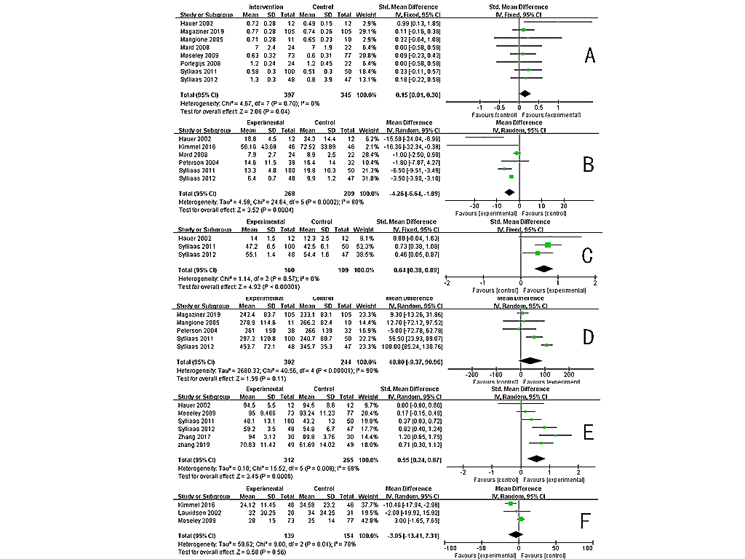

Figure 4 Effect of intensive exercise on mobility after hip fracture surgery, with the following six measures: gait speed(A), Timed Up-and-Go test(B), balance(C), 6-min walk test(D); independence in ADL after hip fracture surgery(E), length of stay in a hospital(F).