Supplementary data files
These files presented the results of the standardization of the Protein A capture assay for all antigens, their antigen characterization, comparative use in serum and saliva, reproducibility studies and ROC curves for definition of adequate cut-offs, as shown in Table 1.
Viral antigens
Recombinant antigens from measles virus nucleocapsid (Priorix 60kDa) of the Schwartz viral strain, the rubella virus capsid (35kDa) and the surface protein of the wild type mumps virus of the Gloucester lineage (66 KDa) were obtained from . ABCAM® (Eugene, Mass., USA). Toxoplasma gondii RH strain tachyzoites soluble antigen (STAG) was processed as elsewhere described (Sampaio et al., 2013). All of those antigens were labelled with biotinamido hexanoic acid hydroxysuccinimide according supplier protocol (B2643- Sigma Chem Co. St Louis USA), and purified on BioGel P2 molecular exclusion chromatography on ÄKTA liquid chromatography system. The labelled products had 4- 6 biotin residues added to the protein and were adjusted to 0.1 ug/ml in phosphate buffered saline 0,02M pH 7.5 containing Bovine serum albumin 1 mg/ml and Tween 20 0.02% (PBSTA).
High protein binding certified 96- or 384-well microplates were adsorbed with 1 ug staphylococcal Protein A in carbonate buffer 0.1M pH9.0 overnight at 4º C. Eventual free binding sites were blocked with PBSTA for additional 4 hs incubation. All subsequent steps were followed by 5 washings with PBSTA. IgG containing samples were adequately diluted in PBSTA and reacted to the wells for protein A IgG capture by 1 h at 37º C in humid chamber. The wells were reacted with biotinylated antigen by 1 h at 37º C in humid chamber, and avidin-peroxidase complex (ABC) 0.1 ug/ml added and incubated by 1 h at 37º C in humid chamber. Finally, peroxidase of bound complex was detected using TMB commercial reagent by 30 min and the reaction stopped by HCl 4N addition. A_{450nm} was determined in a spectrofluorometer M5 microplate reader.

Figure S1 – Molecular weight of biotinylated antigens.
Antigens were submitted to SDSPAGE and transferred to nitrocellulose membranes, membrane free bindings sites blocked with phosphate buffered saline containing 0.02% Tween 20 and 0.1% Bovine serum Albumin and biotinylated antigens reacted to Avidin Peroxidase 1/1000, washed and bound conjugate revealed with TMB insoluble peroxidase substrate. After washing, the membrane was immediately digitalized without drying. Stained molecular weight markers were also used in all process for revealing molecular weight of antigens.

Figure S2 – Correlation between intensity of Protein A capture ELISA using both sera or saliva as IgG source. Samples were only positive paired samples of undergraduate positive students. Line represents estimated linear regression curve using Pearson correlation, and r2 and statistical significance are inserted each graph. A= Measles antigen; B= Rubella antigen; C= Mumps antigen and D= Toxoplasma antigen. Broken line represents the 95% confidence interval of the estimation.
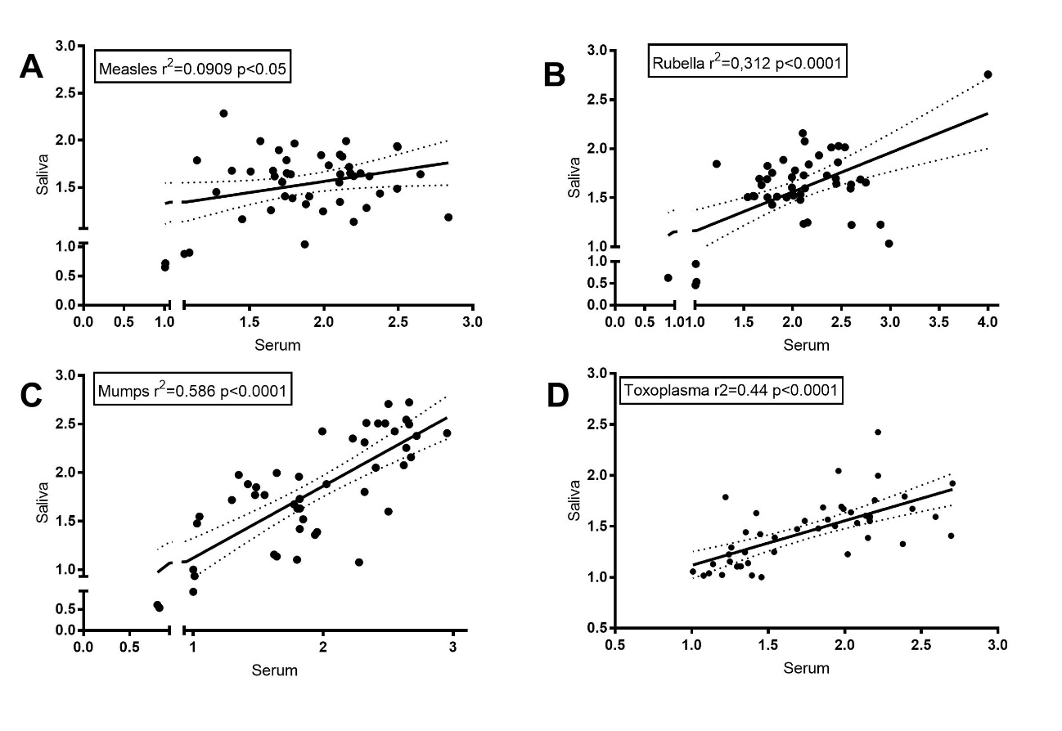

Figure S3. ELISA reproducibility test Capture Protein A for the four antigens studied. Two independent reactions were run at different days and different microplates and reagents, using the same dilution of saliva sample. Antigens: A- Measles, B- Mumps, C- Rubella, and D- T. gondii. Line represents estimated linear regression curve using Pearson correlation, and r2 and statistical significance are inserted each graph. Broken line represents the 95% confidence interval of the estimation.

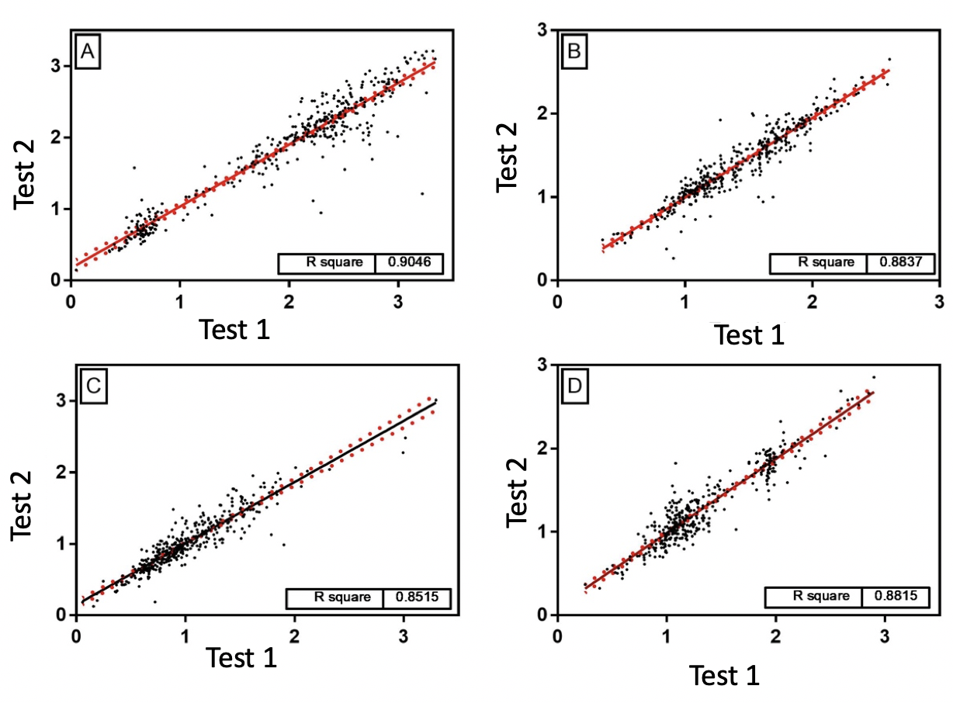

Figure S4- Receiver operator curves for each assyas for determining the ideal cut-off in each specific Protein A capture ELISA and their counterpart antigens. These data were used for estimation of the artificial units used in dot-plots graphs and also for the frequencies estimated in Table 1.

