SUPPLEMENTARY DATA

Title
Differential capacity of CD90+ cells in autophagy activation following chemotherapy in hepatocellular carcinoma

Table S1. List of primers
Gene | Acc. No. | Sequence F (5’ → 3’) | Sequence R (5’ → 3’)
18SRNA | NR_003286 | TAACCCGTTGAACCCCATT | CCATCCAATCGGTAGTAGCG
ACTB | NM_001101 | CGCCGCCAGCTCACCATG | CACGATGGAGGGGAAGACGG
CD90 | NM_006288 | AGAGACTTGGATGAGGAG | CTGAGAATGCTGGAGATG
ATG8 | NM_031412 | ACGCCTTATTCTTCTTTG | AACCACTCATTTCCCATA
ATG18 | NM_017983 | GAGAAGTTATTCCTGAACAT | CACGGCACAAGATTATAG
ATG6 | NM_001313998 | ACCGTGCACCATCCAGGAA | GAAGCTGTTGGCACTTTCTGT
REDD1 | NM_019058.2 | GTGGAGGTGGTTTGTGTA | CAGGTCAGTAGTGATGCT
HGF | NM_001010932 | AAGGTCAAGGAGAAGGCTACAG | TGCTCGTGAGGATACTGAGAATC
AXIN2 | NM_004655.3 | GAATGAAGAAGAGGAGTG | TCTTGAAGGACCTGTATC

Figure S1. mRNA expression of autophagy marker ATG6/Beclin-1. mRNA expression was normalized to two reference genes ACTB and 18sRNA. The expression of a normal sample was considered as 1.0. SNT = surrounding non-tumor; HCC = HCC nodule.

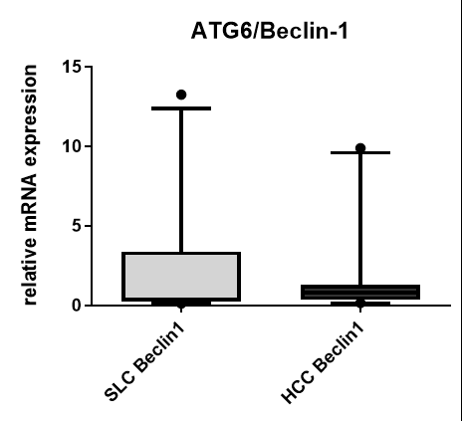
HCC
SNT

