**Supplemental Information**

Supplemental Figure 1. Number of patients within the database by year and age

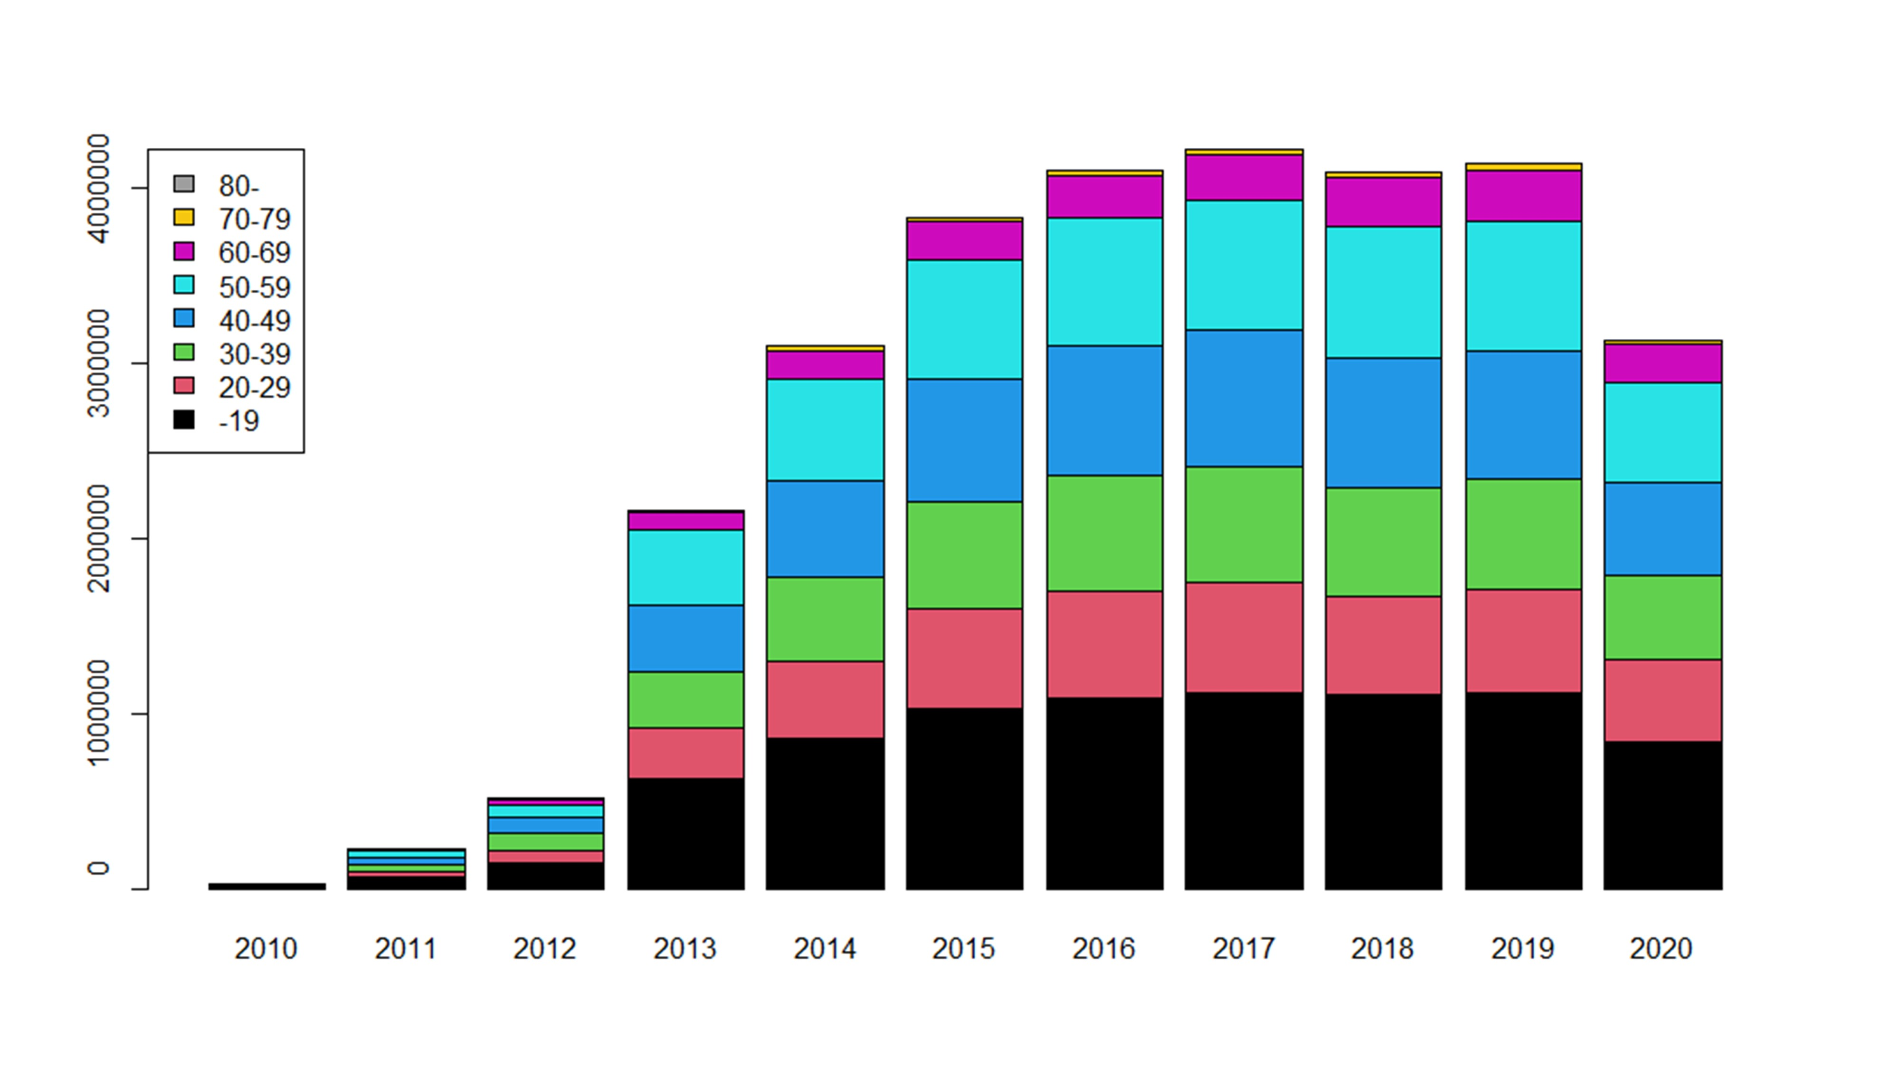

|  |  |  |  |  |  |  |  |  |
| --- | --- | --- | --- | --- | --- | --- | --- | --- |
| **Supplemental Table 1. Characteristics of patients with/without a NASH diagnosis in NAFLD patients** | | | | | | | | |
|  | **2013-2014** | | **2015-2016** | | **2017-2018** | | **2019-2020** | |
|  | **Non-NASH** | **NASH** | **Non-NASH** | **NASH** | **Non-NASH** | **NASH** | **Non-NASH** | **NASH** |
| Cumulative number of patients | 73,963 | 1,679 | 130,565 | 3,559 | 181,141 | 5,765 | 183,946 | 6,640 |
| Number of newly diagnosed patients | 40,291 | 1,075 | 56,612 | 1,824 | 61,112 | 2,380 | 50,446 | 2,135 |
| Age, mean (SD), year | 49.5  (10.6) | 47.1  (11.0) | 49.3  (11.0) | 47.3  (11.3) | 49.3  (11.0) | 47.4  (11.4) | 49.4  (11.2) | 47.6  (11.5) |
| Male (%) | 63.4 | 60.8 | 63.0 | 62.6 | 63.7 | 63.0 | 64.6 | 64.4 |
| Patients with T2D (%) | 50.8 | 64.1 | 56.0 | 67.6 | 59.3 | 68.7 | 62.2 | 71.4 |
| Patients with hypertension (%) | 44.6 | 40.0 | 42.6 | 41.3 | 43.1 | 41.0 | 42.7 | 41.8 |
| Patients with dyslipidemia (%) | 67.0 | 71.9 | 67.0 | 72.7 | 68.3 | 73.2 | 69.3 | 75.1 |
| Abbreviations: NAFLD = nonalcoholic fatty liver disease, NASH = nonalcoholic steatohepatitis, SD = standard deviation, T2D = type 2 diabetes mellitus. | | | | | | | | |

|  |  |  |  |  |  |  |  |  |
| --- | --- | --- | --- | --- | --- | --- | --- | --- |
| **Supplemental Table 2. Characteristics of patients with/without a NASH diagnosis in NAFLD patients of the T2D study population** | | | | | | | | |
|  | **Patients without a NASH diagnosis** | | | | **Patients diagnosed with NASH** | | | | |
| Year period | 2013-2014 | 2015-2016 | 2017-2018 | 2019-2020 | 2013-2014 | 2015-2016 | 2017-2018 | 2019-2020 | |
| n | 990 | 2,157 | 2,858 | 2,673 | 40 | 109 | 135 | 151 | |
| Age, mean (SD), year | 52.4  (8.8) | 52.3  (9.2) | 52.3  (9.2) | 52.5  (9.5) | 46.5  (9.8) | 48.5  (10.3) | 49.8  (9.5) | 48.9  (11.0) | |
| Male (%) | 65.9 | 68.2 | 68.5 | 70.2 | 67.5 | 62.4 | 48.9 | 61.6 | |
| **Comorbidities (%)** |  |  |  |  |  |  |  |  | |
| Hypertension | 60.4 | 63.0 | 61.8 | 62.5 | 52.5 | 58.7 | 49.6 | 56.3 | |
| Dyslipidemia | 81.4 | 79.5 | 82.1 | 83.8 | 80.0 | 74.3 | 82.2 | 84.8 | |
| Ischemic heart disease | 18.2 | 23.2 | 25.9 | 27.9 | 17.5 | 22.0 | 25.2 | 22.5 | |
| Heart failure | 12.9 | 19.4 | 21.0 | 23.0 | 12.5 | 17.4 | 19.3 | 21.2 | |
| Stroke | 7.4 | 11.5 | 13.1 | 14.3 | 5.0 | 12.8 | 14.8 | 21.2 | |
| Chronic kidney disease | 4.1 | 5.8 | 6.1 | 7.7 | 2.5 | 7.3 | 4.4 | 9.9 | |
| Abbreviations: NAFLD = nonalcoholic fatty liver disease, NASH = nonalcoholic steatohepatitis, SD = standard deviation. | | | | | | | | |

|  |  |  |  |  |  |  |  |  |  |  |  |
| --- | --- | --- | --- | --- | --- | --- | --- | --- | --- | --- | --- |
| **Supplemental Table 3. Prescription ratio for antidiabetic drugs in patients with/without a NASH diagnosis in NAFLD patients of the T2D study population** | | | | | | | | | | | |
|  | **Patients without a NASH diagnosis** | | | | | **Patients diagnosed with NASH** | | | | | |
| Year period | 2013-2014 | 2015-2016 | 2017-2018 | 2019-2020 | p-valuea | 2013-2014 | 2015-2016 | 2017-2018 | 2019-2020 | p-valuea |
| **Drug class (%)** |  |  |  |  |  |  |  |  |  |  |
| Thiazolidine | 6.8 | 3.3 | 2.6 | 2.4 | <0.001 | 20.0 | 8.3 | 12.6 | 10.6 | 0.477 |
| SGLT2is | 3.5 | 12.3 | 20.2 | 25.3 | <0.001 | 7.5 | 21.1 | 28.1 | 37.1 | <0.001 |
| GLP-1 receptor agonists | 0.3 | 0.1 | 0.4 | 0.7 | <0.001 | 0.0 | 0.0 | 0.0 | 3.3 | 0.012 |
| DPP-4is | 53.2 | 48.2 | 45.2 | 41.3 | <0.001 | 35.0 | 30.3 | 30.4 | 25.2 | 0.195 |
| Biguanide | 21.5 | 24.7 | 24.0 | 25.9 | 0.020 | 20.0 | 33.9 | 28.1 | 17.2 | 0.048 |
| α-GI | 8.7 | 5.6 | 4.8 | 3.7 | <0.001 | 10.0 | 3.7 | 5.9 | 6.6 | 0.955 |
| SU | 6.8 | 4.7 | 2.7 | 2.1 | <0.001 | 5.0 | 2.8 | 0.7 | 2.0 | 0.269 |
| Glinide | 1.4 | 0.7 | 0.6 | 0.4 | 0.002 | 2.5 | 0.9 | 0.0 | 0.0 | 0.040 |
| Long-acting insulin therapy | 1.3 | 1.0 | 1.4 | 1.2 | 0.776 | 0.0 | 0.0 | 0.7 | 0.7 | 0.395 |
| Other insulin therapy | 8.7 | 9.8 | 9.6 | 9.1 | 0.857 | 12.5 | 7.3 | 7.4 | 9.9 | 0.956 |
| Abbreviations: α-GI = α-glucosidase inhibitors, DPP-4i = dipeptidyl peptidase-4 inhibitors, GLP-1 = glucagon-like peptide-1, NAFLD = nonalcoholic fatty liver disease, NASH = nonalcoholic steatohepatitis, SGLT2i = sodium glucose cotransporter 2 inhibitor, SU = sulfonyl urea.  aChi-squared test for trend in proportions | | | | | | | | | | | |

|  |  |  |  |  |  |  |  |  |
| --- | --- | --- | --- | --- | --- | --- | --- | --- |
| **Supplemental Table 4. Characteristics of patients with/without a NASH diagnosis in NAFLD patients of the hypertension study population** | | | | | | | | |
|  | **Patients without a NASH diagnosis** | | | | **Patients diagnosed with NASH** | | | | |
| Year period | 2013-2014 | 2015-2016 | 2017-2018 | 2019-2020 | 2013-2014 | 2015-2016 | 2017-2018 | 2019-2020 | |
| n | 1,737 | 4,114 | 5,420 | 5,180 | 47 | 106 | 171 | 199 | |
| Age, mean (SD), year | 51.6  (8.8) | 51.7  (8.9) | 51.8  (8.9) | 51.7  (9.0) | 51.8  (10.2) | 51.0  (9.1) | 50.6  (10.2) | 49.6  (9.9) | |
| Male (%) | 67.5 | 67.4 | 67.5 | 69.3 | 53.2 | 57.5 | 65.5 | 64.8 | |
| **Comorbidities (%)** |  |  |  |  |  |  |  |  | |
| T2D | 51.5 | 61.1 | 62.9 | 65.3 | 63.8 | 64.2 | 70.2 | 70.4 | |
| Dyslipidemia | 73.3 | 72.7 | 73.6 | 73.9 | 83.0 | 83.0 | 81.9 | 81.9 | |
| Ischemic Heart Disease | 19.7 | 22.8 | 25.8 | 26.6 | 14.9 | 31.1 | 21.1 | 26.1 | |
| Heart Failure | 11.2 | 16.4 | 19.3 | 20.8 | 8.5 | 21.7 | 19.9 | 24.1 | |
| Stroke | 9.8 | 13.1 | 15.0 | 15.5 | 8.5 | 10.4 | 14.6 | 15.1 | |
| Chronic Kidney Disease | 4.1 | 5.7 | 6.3 | 6.4 | 2.1 | 4.7 | 6.4 | 9.5 | |
| Abbreviations: NAFLD = nonalcoholic fatty liver disease, NASH = nonalcoholic steatohepatitis, SD = standard deviation, T2D = type 2 diabetes. | | | | | | | | |

|  |  |  |  |  |  |  |  |  |  |  |
| --- | --- | --- | --- | --- | --- | --- | --- | --- | --- | --- |
| **Supplemental Table 5. Prescription ratio for antihypertensive drugs in patients with/without a NASH diagnosis in NAFLD patients of the hypertension study population** | | | | | | | | | | |
|  | **Patients without a NASH diagnosis** | | | | | **Patients diagnosed with NASH** | | | | | | |
| Year period | 2013-2014 | 2015-2016 | 2017-2018 | 2019-2020 | p-valuea | 2013-2014 | 2015-2016 | 2017-2018 | 2019-2020 | p-valuea | |
| **Drug class (%)** |  |  |  |  |  |  |  |  |  |  | |
| ARBs | 45.8 | 43.1 | 39.3 | 38.8 | <0.001 | 51.1 | 43.4 | 43.9 | 43.2 | 0.493 | |
| ACE inhibitors | 4.0 | 3.5 | 3.1 | 2.4 | <0.001 | 4.3 | 2.8 | 2.9 | 3.5 | 0.993 | |
| CCBs | 46.0 | 46.8 | 51.3 | 53.0 | <0.001 | 44.7 | 41.5 | 47.4 | 42.2 | 0.887 | |
| Beta blockers | 7.3 | 7.8 | 8.1 | 7.7 | 0.749 | 6.4 | 14.2 | 6.4 | 8.5 | 0.534 | |
| Diuretics | 5.8 | 5.2 | 4.6 | 4.2 | 0.002 | 4.3 | 2.8 | 6.4 | 7.0 | 0.172 | |
| Others | 2.6 | 2.0 | 1.7 | 1.8 | 0.047 | 0.0 | 2.8 | 0.6 | 3.5 | 0.207 | |
| Abbreviations: ARB = angiotensin receptor blocker, ACE = angiotensin converting enzyme, CCB = calcium channel blocker, NAFLD = nonalcoholic fatty liver disease, NASH = nonalcoholic steatohepatitis.  aChi-squared test for trend in proportions | | | | | | | | | | |

|  |  |  |  |  |  |  |  |  |
| --- | --- | --- | --- | --- | --- | --- | --- | --- |
| **Supplemental Table 6. Characteristics of patients with/without a NASH diagnosis in NAFLD patients of the dyslipidemia study population** | | | | | | | | |
|  | **Patients without a NASH diagnosis** | | | | **Patients diagnosed with NASH** | | | | |
| Year period | 2013-2014 | 2015-2016 | 2017-2018 | 2019-2020 | 2013-2014 | 2015-2016 | 2017-2018 | 2019-2020 | |
| n | 3,037 | 6,177 | 7,807 | 7,742 | 92 | 228 | 346 | 367 | |
| Age, mean (SD) | 50.8  (9.2) | 50.6  (9.5) | 50.6  (9.5) | 50.5  (9.7) | 47.0  (10.0) | 48.4  (11.1) | 47.0  (11.1) | 47.4  (10.7) | |
| Male (%) | 62.4 | 62.4 | 62.7 | 64.9 | 60.9 | 58.8 | 58.1 | 64.9 | |
| **Comorbidities (%)** |  |  |  |  |  |  |  |  | |
| T2D | 52.2 | 57.6 | 62.0 | 65.8 | 58.7 | 69.3 | 69.1 | 70.6 | |
| Dyslipidemia | 43.6 | 44.3 | 46.3 | 47.5 | 33.7 | 37.3 | 36.1 | 39.2 | |
| Ischemic Heart Disease | 15.6 | 20.2 | 23.3 | 24.9 | 15.2 | 17.1 | 19.7 | 21.5 | |
| Heart Failure | 9.7 | 13.4 | 16.8 | 18.8 | 12.0 | 11.4 | 17.1 | 18.0 | |
| Stroke | 8.4 | 12.5 | 14.0 | 13.8 | 7.6 | 9.6 | 12.4 | 10.6 | |
| Chronic Kidney Disease | 3.5 | 5.3 | 6.3 | 7.0 | 6.5 | 4.8 | 7.8 | 6.0 | |
| Abbreviations: NAFLD = nonalcoholic fatty liver disease, NASH = nonalcoholic steatohepatitis, SD = standard deviation, T2D = type 2 diabetes. | | | | | | | | |

|  |  |  |  |  |  |  |  |  |  |  |
| --- | --- | --- | --- | --- | --- | --- | --- | --- | --- | --- |
| **Supplemental Table 7. Prescription ratio for lipid lowering drugs in patients with/without a NASH diagnosis in NAFLD patients of the dyslipidemia study population** | | | | | | | | | | |
|  | **Patients without a NASH diagnosis** | | | | | **Patients diagnosed with NASH** | | | | |
| Year period | 2013-2014 | 2015-2016 | 2017-2018 | 2019-2020 | p-valuea | 2013-2014 | 2015-2016 | 2017-2018 | 2019-2020 | p-valuea |
| **Drug class (%)** |  |  |  |  |  |  |  |  |  |  |
| HMG-CoA reductase inhibitors | 70.6 | 70.1 | 70.5 | 70.8 | 0.557 | 47.8 | 52.6 | 53.8 | 53.4 | <0.001 |
| Fibrates | 14.7 | 15.5 | 15.2 | 18.1 | <0.001 | 25.0 | 16.7 | 14.5 | 25.3 | 0.001 |
| Ezetimibe | 6.8 | 5.0 | 4.7 | 4.3 | <0.001 | 9.8 | 10.1 | 6.6 | 4.9 | 0.260 |
| Tocopherol | 5.4 | 5.9 | 6.1 | 5.8 | 0.533 | 13.0 | 18.0 | 24.0 | 18.0 | 0.008 |
| Others | 4.2 | 5.3 | 5.5 | 3.6 | 0.004 | 7.6 | 5.7 | 9.0 | 3.3 | 0.659 |
| Abbreviations: HMG-CoA = hydroxymethylglutaryl-CoA, NAFLD = nonalcoholic fatty liver disease, NASH = nonalcoholic steatohepatitis.  aChi-squared test for trend in proportions | | | | | | | | | | |

|  |  |  |  |  |
| --- | --- | --- | --- | --- |
| **Supplemental Table 8. Prevalence of cirrhosis in dyslipidemia study population** | | | | |
|  | 2013-2014 | 2015-2016 | 2017-2018 | 2019-2020 |
| Non-NAFLD | 1.4 | 1.9 | 2.4 | 2.7 |
| NAFLD | 6.3 | 8.9 | 12.1 | 15.3 |
| Within NAFLD study population | | | | |
| Patients without diagnosis of NASH | 5.6 | 7.8 | 10.3 | 13.8 |
| Patients with diagnosis NASH | 29.3 | 38.6 | 52.9 | 48.5 |
| Values are shown by percent.  Abbreviations: NAFLD = nonalcoholic fatty liver disease, NASH = nonalcoholic steatohepatitis. | | | | |