SUPPLEMENTARY MATERIAL
Figure of the supplementary material
Clinical Frailty Scale
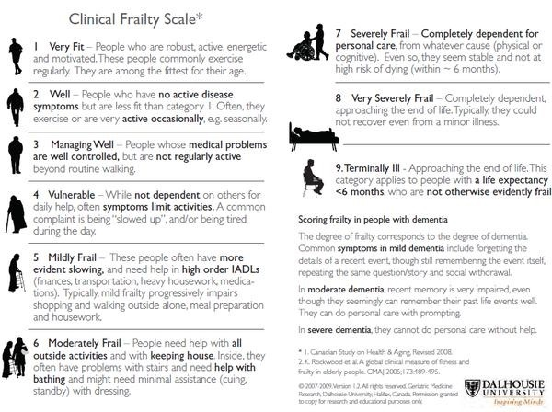

Reproduced with permission from Rockwood K.¹
REFERENCE
- Rockwood K. Clinical Frailty Scale. Available at: http://camapcanada.ca/Frailtyscale.pdf. Accessed 30 Jan, 2018.

