SUPPLIMENTARY MATERIAL

- Figure S1: A flow chart showing the recommended procedure for testing near horizontal fixation disparity with the Mallett Unit. As per the researchers this can also be used for vertical near fixation disparity measurements with some modifications (Karania R, Evans BJW. The Mallett Fixation Disparity Test: influence of test instructions and relationship with symptoms. Ophthalmic & physiological Optics. 2006;26(5):507-22.) (reproduced with permission from Karania and Evans, 2006).
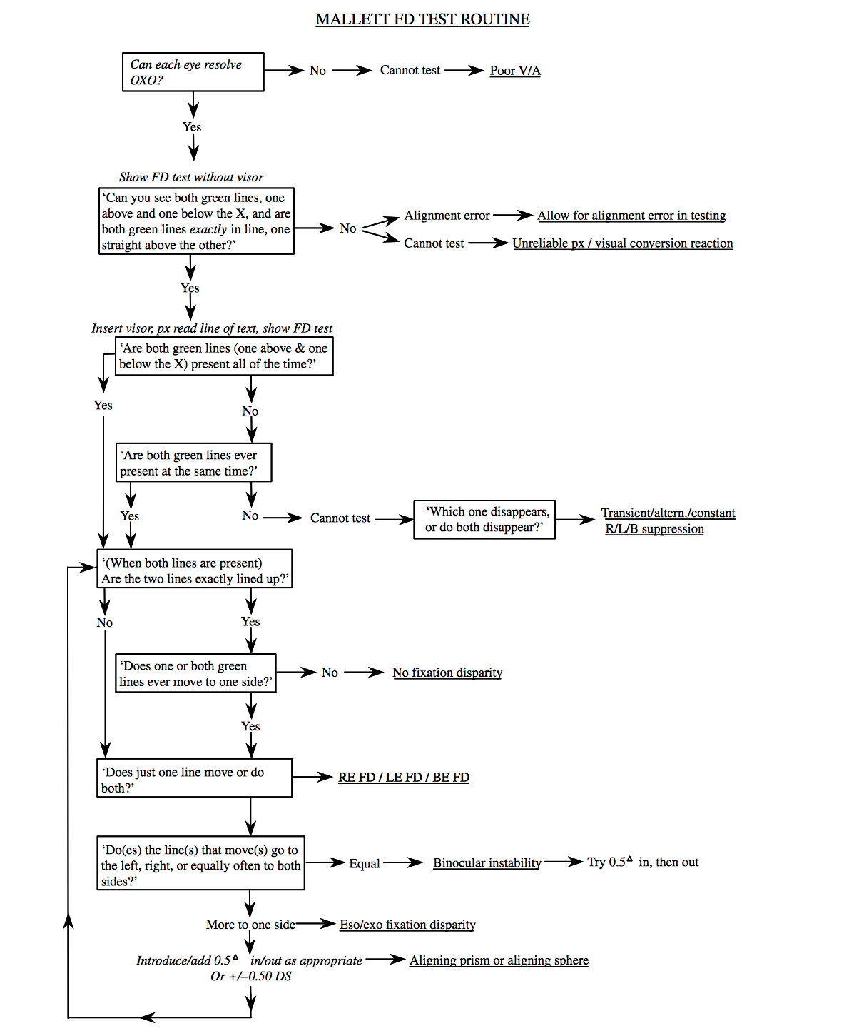

- Table S1: The number of participants who did or did not experience an NPA, together with the possible presence of a fixation disparity (FD), for each instrument. NPA included blurring, flashing or dimming of the Nonius markers.

 | Symptoms and FD on Mallett Unit | Symptoms and no FD on Mallett Unit | No symptoms and FD on Mallett Unit | No Symptoms and no FD on Mallett Unit
Symptoms and FD on iPad | 7 (8.75%) | 2 (2.5%) | 1 (1.25%) | 5 (6.25%)
Symptoms and no FD on iPad | 3 (3.75%) | 5 (6.25%) | 3 (3.75%) | 1 (1.25%)
No symptoms and FD on iPad | 5 (6.25%) | 1 (1.25%) | 3 (3.75%) | 5 (6.25%)
No symptoms and no FD on iPad | 2 (2.5%) | 10 (12.5%) | 18 (22.5%) | 9 (11.25%)

REFERENCES

- Evans BJ. Pickwell's Binocular Vision Anomalies. 5th ed. UK: Butterworth Heinemann; 2007.
- Rowe FJ. Clinical Orthoptics. 3rd ed. ed. Chichester, West Sussex: Hoboken : Wiley; 2012.
- Ogle KN, Mussey F, De HPA. Fixation disparity and the fusional processes in binocular single vision. American journal of ophthalmology. 1949;32(8):1069-87.
- Ogle KN. Researches in binocular vision. Philadelphia: Saunders; 1950.
- Ogle KN, Martens TG, Dyer JA. Oculomotor imbalance in binocular vision and fixation
- Mallett RFJ. The investigation of heterophoria at near and a new fixation disparity technique. Optician. 1964;148(3845):573-81.
- Yekta A, Pickwell L. The relationship between heterophoria and fixation disparity. Clinical and Experimental Optometry. 1986;69(6):228-31.
- Karania R, Evans BJW. The Mallett Fixation Disparity Test: influence of test instructions and relationship with symptoms. Ophthalmic & physiological Optics. 2006;26(5):507-22.
- Jenkins TC, Pickwell LD, Yekta A. Criteria for decompensation in binocular vision. Ophthalmic and Physiological Optics. 1989;9(2):121-5.
- Patel T. Comparison of the Fixation Disparity Test Parameters on different Near Vision Fixation Disparity Units. BSc [Optometry Thesis]. London: City University London; 2012.
- Thomson Software Solutions. Test Chart 2016, http://www.thomson-software- solutions.com/T est%20Chart%202016/Help/T est%20Chart%202016.html?Introduction.html; [accessed 16th August 2017]
- Evans B, Pickwell D. Pickwell's Binocular Vision Anomalies: Investigation and Treatments. 3rd ed: Oxford : Butterworth-Heinemann; 1997.
- Pickwell LD, Yekta AA, Jenkins TCA. Effect of reading in low illumination on fixation disparity. Optometry & Vision Science. 1987;64(7):513-8.
- Bland J, Altman D. Measuring agreement in method comparison studies. Statistical Methods in Medical Research. 1999;8(2):135-60.
- Ukwade MT. Effects of nonius line and fusion lock Parameters on Fixation Disparity. Optometry & Vision Science. 2000;77(6):309-20.
- Wildsoet CF, Cameron KD. The effect of illumination and foveal fixation lock on clinical fixation disparity measurements with the Sheedy Disparometer. Ophthalmic & physiological Optics. 1985;5(2): 171-8
- Brautaset RL, Jennings JAM. Measurements of objective and subjective fixation disparity with and without a central fusion stimulus. Medical science monitor. 2006;12(2):MT1-MT4.
- Pickwell LD, Gilchrist J, Hesler J. Comparison of associated heterophoria measurements using the Mallett test for near vision and the Sheedy Disparometer. Ophthalmic and Physiological Optics. 1988;8(1):19-25.
- Fogt N, Jones R. Comparison of fixation disparities obtained by objective and subjective methods. Vision research. 1998;38(3):411-21.
- Shimono K, Ono H, Saida S, Mapp AP. Methodological caveats for monitoring binocular eye position with nonius stimuli. Vision research. 1998;38(4):591-600.
- Jaschinski W, Kloke W-b, Jainta S, Buchholz J. Horizontal fixation disparity measures with nonius lines. Optometry & Vision Science. 2005;82(11):988-99.
- The Vision Council. Eyes Overexposed: The Digital Device Dilemma. Digital eyestrain Report 2016.
- Köpper M, Mayr S, Buchner A. Reading from computer screen versus reading from paper: does it still make a difference? Ergonomics. 2016;59(5):615-32.
- Hayes JR, Sheedy JE, Stelmack JA, Heaney CA. Computer use, symptoms, and quality of life. Optometry and Vision Science. 2007;84(8):E738-55.
- Agarwal S, Goel D, Sharma A. Evaluation of the Factors which Contribute to the Ocular Complaints in Computer Users. Journal of Clinical & Diagnostic Research. 2013;7(2):331-5.
- Phamonvaechavan P. A comparison between effect of viewing text on computer screen and iPad® on visual symptoms and functions. Siriraj Medical Journal. 2017;69(4):185-9.
- Coles Brennan C, Sulley A, Young G. Management of digital eye strain. Clinical and Experimental Optometry. 2019;102(1):18-29.
- Rosenfield M. Computer vision syndrome: a review of ocular causes and potential treatments. Ophthalmic and Physiological Optics. 2011;31(5):502-15.
- Hue JE, Rosenfield M, Saá G. Reading from electronic devices versus hardcopy text. Work. 2014;47(3):303-7.
- Vancleef K, Read JC, Herbert W, Goodship N, Woodhouse M, Serrano-Pedraza I. Overestimation of stereo thresholds by the TNO stereotest is not due to global stereopsis. Ophthalmic and Physiological Optics. 2017; 37(4):507-20.
- Simons K, Elhatton K. Artefacts in fusion and stereopsis testing based on red/green dichoptic image separation. Journal of paediatric ophthalmology and strabismus. 1994;31(5):290-7.
- Larson WL. Effect of TNO red-green glasses on local stereoacuity. Optometry and Vision Science. 1988;65(12):946-50.
- Grolman B. Binocular refraction—fixation disparity. Optician. 1971;162(4195):16-9.
- Kommerell G, Kromeier M, Scharff F, Bach M. Asthenopia, associated phoria, and self-selected prism. Strabismus. 2015;23(2):51-65.
- Alhassan M, Hovis JK, Chou RB. Repeatability of Associated Phoria Tests. Optometry & Vision Science. 2015;92(8):900-7.
- Payne CR, Grisham DJ, Thomas KL. A clinical evaluation of fixation disparity. Optometry and Vision Science. 1974;51(2):88-90.
- O'Leary CI, Evans BJW. Double-masked randomised placebo-controlled trial of the effect of prismatic corrections on rate of reading and the relationship with symptoms. Ophthalmic and Physiological Optics. 2006;26(6):555-65.
- Jenkins TC, Abd‐Manan F, Pardhan S. Fixation disparity and near visual acuity. Ophthalmic and Physiological Optics. 1995;15(1):53-8.
- Jenkins TC, Abd MF, Pardhan S. The effect of artificially created fixation disparity on near visual acuity. Optom. Vis. Sci. 1994;71:647-8.
- Jenkins TC, Abd‐Manan F, Pardhan S, Murgatroyd RN. Effect of fixation disparity on distance binocular visual acuity. Ophthalmic and Physiological Optics. 1994;14(2):129-31.

