Appendix: Design and use of vignettes to investigate referral decision-making by optometrists

This describes in more detail the design and application of clinical vignettes for measuring the impact of CET and identifying unwarranted variation in referral decision-making. As the study was conducted in the United Kingdom (UK), some background information is provided for readers unfamiliar with the UK eye care environment.

UK Context
Requirements for the content of sight tests in primary care and subsequent referral are set out in legislation in the UK.¹ In Scotland, a ‘sight test’ has been defined as ‘a refraction to measure and correct the refractive error of the eyes by means of an optical appliance’.² However, a sight test in Scotland is part of a more comprehensive National Health Service (NHS) eye examination and package of eye care which allows greater professional freedom for determining which tests and procedures are carried out while providing funded refinement and monitoring appointments before referral.³ In England, Wales and Northern Ireland, a NHS sight test is geared towards the provision of spectacles and identification of abnormality. NHS England contracting is only for the provision of a single sight test appointment, with no ability for monitoring to refine referral decisions and guidelines that deter practitioners from offering frequent appointments to monitor conditions. If a patient requires a review more frequently than may be considered clinically necessary for an NHS sight test, then it has to be paid for privately.⁴ Services for managing minor eye conditions, cataract pre-assessments and repeating suspect tests which improve referral accuracy may be locally contracted with the primary care optometrist separately to the contract for NHS sight tests.^{5,6,7,8} In England, optical practices and practitioners are not mandated to participate in such services; as services are only commissioned in some areas, these can vary from one area to another. Thus, unwarranted variation in commissioning and provision exists for primary eye care services.

Continuing Education and Training
All qualified optometrists and dispensing opticians registered with the General Optical Council (GOC) have a statutory requirement to undertake Continuing Education and Training (CET).⁹ CET equates to ‘Continuing Professional Development (CPD)’, a term commonly used by other professions. Registrants must complete 36 CET points each three-year cycle to remain on GOC registers. In 2016, mandatory participation in peer review discussion was included. Despite the mandatory requirements of the CET scheme in the UK, the impact of CET on clinical decision-making and resulting patient outcomes has been difficult to measure.¹⁰

Expert panel scoring
Each relevant test and management option selected attracted a score agreed by an expert panel of three ophthalmologists and three optometrists. Key tests attracted higher values. Vignette scores, expected management outcomes and total set scores are shown in Table A.1.

Table A.1. Vignette topic areas for Sets A & B and expert panel scoring for each vignette. [A ‘grey’ outcome relates to an uncertain outcome where there can be a range of acceptable patient management choices.]

 | SET A | Outcome | Score |  | SET B | Outcome | Score
1 | Cataract 1 | Referred 1 | 25.5 | 11 | Glaucoma 1 | Grey 1 | 31
2 | Glaucoma 1 | Grey 1 | 33 | 12 | Orthoptics 1 | Referred 1 | 26
3 | Contact lens 1 | Referred 2 | 32.5 | 13 | Retina 1 | Referred 2 | 22
4 | Retina 1 | Grey 2 | 26.5 | 14 | Glaucoma 2 | Not referred 1 | 21
5 | Cornea 1 | Grey 3 | 27 | 15 | Anterior Eye 1 | Not referred 2 | 19.5
6 | Retina 2 | Referred 3 | 28 | 16 | Cornea 1 | Referred 3 | 21
7 | Anterior Eye 1 | Not referred 1 | 26 | 17 | Retina 2 | Grey 2 | 27
8 | Refractive 1 | Not referred 2 | 29 | 18 | Contact lens 1 | Grey 3 | 29.5
9 | Glaucoma 2 | Grey 4 | 31 | 19 | Refractive 1 | Not referred 3 | 26
10 | Orthoptics 1 | Not referred 3 | 22 | 20 | Cataract 1 | Grey 4 | 28
 |  |  | 280.5 |  |  |  | 251

Both sets of vignettes were approximately matched for difficulty, but the set total scores for Sets A & B did not need to be identical due to the use of the Vignette Score Change (VSC) method. Weighted scores were considered important; for example, dilation of the pupils in the case of recent onset of floaters and flashes, and cycloplegic refraction in the case of latent hypermetropia both attracted high scores. Optimum management options were considered important, with their scores weighted according to patient safety and professional guidance.^{11,12} Superfluous tests attracted zero points. The content and score weightings for each vignette can be found in the file labelled ‘Vignette content final’ on the data page at ‘https://optomscenario.wordpress.com’.

Pilot study
A prototype version of the vignettes was piloted with eight participants to test all aspects of the study, but without any intervention. This resulted in modifications to the vignettes and software (Table A.2).

Table A.2. Pilot study feedback and resulting changes

 | Issue identified by pilot study | Change made
1 | Automatic password email blocking | Manual password generation option
2 | Short time-out if no activity required participants to start again | Time-out lengthened
3 | Consolidation of tests at the start of each vignette | Completed using the admin controls; history and symptoms, general health, family history and medications combined under a single score
4 | Need for learning process on how to complete a vignette | Demonstration vignette added
5 | Unable to add comments in management options and reasons section | Add comment box ‘as well as’ rather than ‘instead of’ using other options
6 | Lack of feedback option | A feedback box was incorporated into the website design to enable questions and feedback to one researcher’s (DP) email

Development of vignette content and software, and their subsequent refinement required careful planning. The importance of seeking expert advice, careful piloting and responding to pilot feedback cannot be over-emphasised. Design, vignette content and software are interconnected, so when changes in one are made, the impact on the other should always be considered.

Final website design
The development of the website (Figure A.1) and vignette software design was an iterative process.
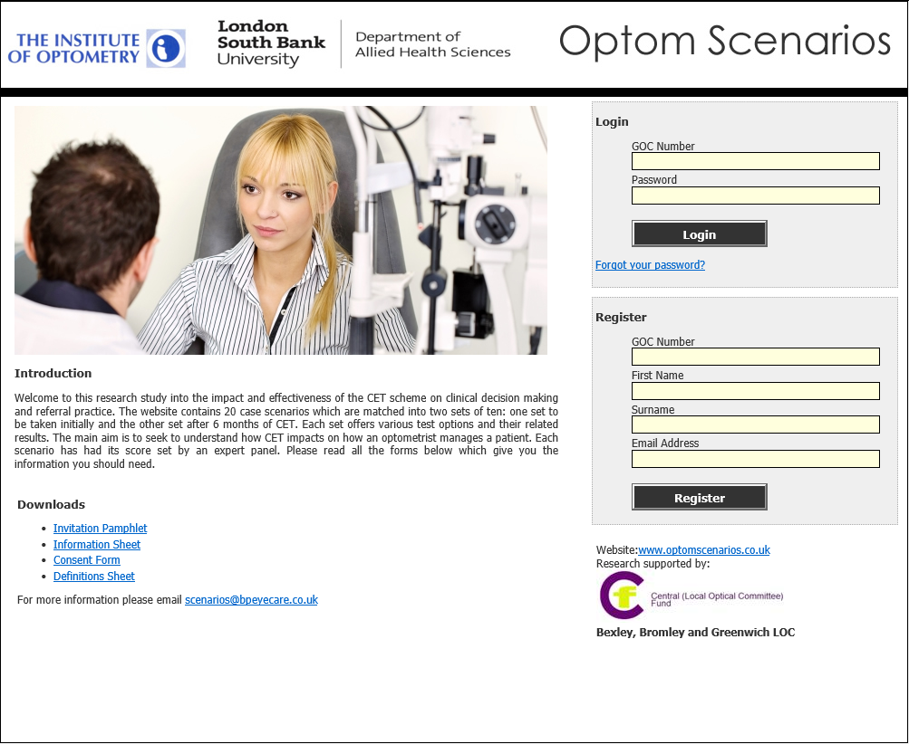
Figure A.1. Website home page

Figure A.2 shows a vignette page demonstrating how the prompt effect was removed with the participant now needing to type which test would be performed next rather than making a choice from several options. Figure A.3 shows a shortened example of a completed vignette with a selection of tests and decisions. The initial design did not permit participants to subsequently change an answer once they had made a selection. There was a concern that participants answering a question multiple times would be able to deduce the answer. However, pilot participants requested this option to correct genuine mistakes or add tests missed out. Considerations in favour of allowing participants to revisit earlier choices were that if participants’ only option was to start again, they might rush through as they now know the results, or they might lose interest and give up. Considerations against the revisiting of earlier choices were the impact on the tracking of tests and the need for more information at the beginning.

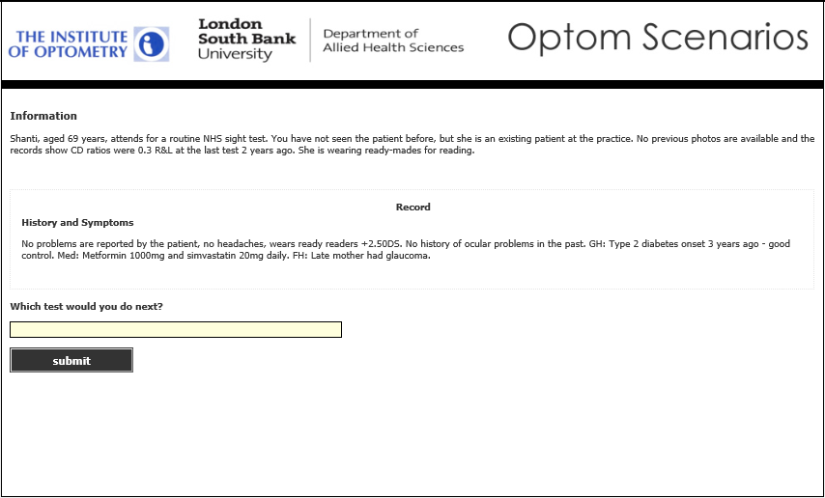
Figure A.2. Initial question removing prompt effect

Resolution to allow extra tests came down to a key point. The instructions said, ‘Please complete these vignettes as if you are examining these patients.’ In the consulting room, practitioners could go back and conduct further tests while considering and discussing the management decision with the patient. As vignettes were completed more rapidly than an eye examination in normal practice, including this option allowed participants more 'thinking time'. This view was supported from qualitative research where it was found that optometrists did not wait until the end of the examination to think about management options, but were formulating them throughout.¹³ However, rather than allowing participants to go back, a software amendment was made which allowed them up to three further tests after the management decision at a point prior to the decision regarding management reasons. This software amendment was a good way of balancing the benefits and risks described above and allowed further consideration of differential diagnoses.

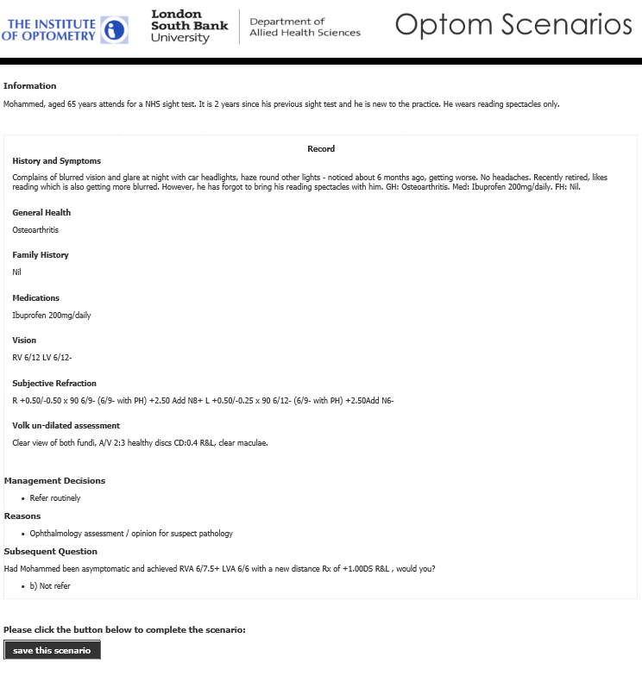
Figure A.3. Shortened example of a completed vignette

Each vignette included a section where participants recorded clinical and non-clinical reasons which had influenced their decision-making; e.g. complying with National Institute for Health and Care Excellence (NICE) Glaucoma guidance (NG81)¹⁴ (evidenced-based guidance to improve health and care in England); or time pressures within practice to fully work up a referral. When a referral was made, the main reason was for an ophthalmology opinion. When the patient was managed in primary care, College of Optometrists guidance of professional practice was quoted. Not having a local scheme in place or not being accredited for a scheme was rarely mentioned. Likewise, time pressure was only raised by one participant in one vignette and concern for litigation featured little in the responses (ten participants across six vignettes).

These supplementary data are included in the file labelled ‘Vignette results data final’ on the data page at https://optomscenario.wordpress.com

Recruitment and communication plan
Extensive efforts were made to engage with optometrists across the UK to encourage recruitment to the first data capture. Flyers and newsletters were distributed through multiple routes and professional organisations (circulation circa 10,000). Optometry email discussion forums (circulation circa 150) were used. A separate short set of CET questions which, if the pass mark was achieved, would result in the award of one CET point from the GOC was offered at the completion of Set B as an incentive to encourage participation.

The website design and examples of communication can be found in the file labelled ‘Website design and communication final’ on the data page at https://optomscenario.wordpress.com

A total of 78 participants showed an interest by registering on the website and eight of these returned a completed consent and data form but did not continue.

Not only did the 31 participants who completed over-represent independent practices, but also over-represented optometrists who practiced in England with 28 participants (90 per cent), with one each in Scotland, Wales and Northern Ireland. In comparison, a breakdown of the UK optometrist workforce estimates England 81 per cent, Scotland 9 per cent, Wales 6 per cent and Northern Ireland 4 per cent.¹⁵

The second group involved newly-qualified optometrists (NQOs). Approaches were made to several optical companies. One large multiple with a workforce of approximately 30 NQOs agreed to participate. The CET chosen was a two-day NQO training course. The study was promoted by the company’s professional services manager.

The third group involved pre-registration optometrists (PROs) and was potentially open to approximately 700 PROs working in practice under supervision. This pre-registration period normally takes place following university graduation and involves regular assessments prior to taking the final assessment (Objective Structured Clinical Examination, OSCE). Successful completion of the assessments and OSCE enables PROs to join the GOC register of qualified optometrists. The CET chosen for PROs was a six-month section of their pre-registration period. The College of Optometrists promoted the study by social media with a link to the information on the College website research opportunities page. A promotional email was sent to all PRO supervisors (circa 500). Further approaches to aid recruitment were made to the professional service managers of the major optical companies.

References

- The Opticians Act, https://www.legislation.gov.uk/ukpga/1989/44/contents; 1989 [accessed 28 August 2019].

- The National Health Service (General Ophthalmic Services) (Scotland) Regulations 2006. 11(135), http://www.legislation.gov.uk/ssi/2006/135/contents/made [accessed 15 February 2019].

- Scottish Government. General Ophthalmic Services, https://nhsnss.org/media/2913/general-ophthalmic-services-pca-o-2018-1.pdf; 2018 [accessed 01 July 2019].

- The General Ophthalmic Services Contract Regulations, Schedule 1 Other Contractual Terms, Part 1, Patients. p14, http://www.legislation.gov.uk/uksi/2008/1185/pdfs/uksi_20081185_en.pdf; 2018 [accessed 23 September 2019].

- Welsh Assembly. Eye Health Examination Wales, http://www.eyecare.wales.nhs.uk/ehew; 2016 [accessed 10 October 2019].

- Parkins DJ, Edgar DF. Comparison of the effectiveness of two enhanced glaucoma referral schemes. Ophthalmic Physiol Opt 2011; 31(4):343–352. https://doi.org/10.1111/j.1475-1313.2011.00853.x

- Konstantakopoulou E, Edgar DF, Harper RA, Baker H, Sutton M, Janikoun S, Larkin G, Lawrenson JG. Evaluation of a minor eye conditions scheme delivered by community optometrists. BMJ Open 2016; 6:e011832. https://doi.org/10.1136/bmjopen-2016-011832

- Clinical Council for Eye Health Commissioning. Primary eye care framework, http://www.ccehc.org.uk; 2018 [accessed 01 August 2019].

- General Optical Council: Continuing Education and Training (CET), https://www.optical.org/en/Education/CET/index.cfm [accessed 01 June 2019].

- Parkins DJ. An investigation into the decision-making of primary care optometrists and whether contemporary continuing education and training (CET) improves referral practice? (Thesis). London South Bank University 2018.

- College of Optometrists. Guidance for Professional Practice, http://guidance.college-optometrists.org/home/; 2017 [accessed 01 October 2019].

- College of Optometrists. Clnical Management Guidelines.
https://www.college-optometrists.org/guidance/clinical-management-guidelines.html [accessed 01 October 2019].

- Faucher C, Tardif J & Chamberland M. Optometrists’ Clinical Reasoning Made Explicit. Optometry and Vision Science 2012; 89:1774-1784. https://doi.org/10.1097/OPX.0b013e3182776002

- National Institue for Health and Care Excellence. Glaucoma: diagnosis and management (NG81), https://www.nice.org.uk/guidance/ng81/chapter/Recommendations; 2017 [accessed 01 October 2019].

- The Optical Workforce Survey, https://www.college-optometrists.org/uploads/assets/uploaded/b8034532-ce20-4e5d-8792039e270a34d1.pdf; 2015 [accessed 01 August 2019].

