SUPPORTING INFORMATION
Lifetime Prevalence and Temporal Trends of Incidence of Child’s Mental Disorder Diagnoses in Catalonia, Spain.
Revista de Psiquiatría y Salud Mental
Michelle S.W. Kusters, Laura Pérez-Crespo, Josefa Canals, Mònica Guxens

Correspondence to
Mònica Guxens, MD, MPH, PhD
Barcelona Institute for Global Health (ISGlobal) – Campus Mar
Carrer Dr. Aiguader 88. 08003-Barcelona, Spain.
Phone: +34 932147330. Fax: +34 932147302. E-Mail: monica.guxens@isglobal.org

Table of Content
Supplementary Table 1 ICD-9 codes for included cases of mood disorder, anxiety disorder, conduct disorder, and eating disorder 3
Supplementary Table 2 Number of children aged 2-18 in Catalonia for each year between 2009 and 2017, overall and stratified by sex and age groups 4
Supplementary Table 3 Annual incidence of diagnoses (%) of mood disorder, anxiety disorder, conduct disorder, and eating disorder in children aged 2-18 for each year between 2009 and 2017, overall and stratified by sex and age groups 5
Supplementary Table 3 (continuation) Annual incidence of diagnoses (%) of mood disorder, anxiety disorder, conduct disorder, and eating disorder in children aged 2-18 for each year between 2009 and 2017, overall and stratified by sex and age groups 6
Supplementary Table 4 Incidence risk ratios for diagnoses of mood disorder, anxiety disorder, conduct disorder, and eating disorder in children aged 2-18 between 2009 and 2017, stratified by time periods 7
Supplementary Figure 1 Lifetime prevalence (%) of diagnoses of mood disorder (A), anxiety disorder (B), conduct disorder (C), and eating disorder (D) per healthcare area in children aged 18 in Catalonia in 2017. 8

Supplementary Table 1 ICD-9 codes for included cases of mood disorder, anxiety disorder, conduct disorder, and eating disorder
Mood disorder |  |  | Anxiety disorder |  |  | Conduct disorder |  |  | Eating disorder
ICD-9 | Description |  | ICD-9 | Description |  | ICD-9 | Description |  | ICD-9 | Description
296.0 | Bipolar 1 disorder, single manic episode |  | 300.00 | Anxiety state, unspecified |  | 312.0 | Undersocialized conduct disorder, aggressive type |  | 307.1 | Anorexia Nervosa
296.1 | Manic disorder, recurrent episode |  | 300.01 | Panic disorder without agoraphobia |  | 312.1 | Undersocialized conduct disorder, unaggressive type |  | 307.50 | Eating disorder, unspecified
296.2 | Major depressive disorder, single episode |  | 300.02 | Generalized anxiety disorder |  | 312.2 | Socialized conduct disorder |  | 307.51 | Bulimia Nervosa
296.3 | Major depressive disorder, recurrent episode |  | 300.09 | Anxiety states, other |  | 312.3 | Disorders of impulse control, not elsewhere classified |  | 307.52 | PICA
296.4 | Bipolar I disorder, most recent episode (or current) manic |  | 300.20 | Phobia, unspecified |  | 312.4 | Mixed disturbance of conduct and emotions |  | 307.53 | Rumination disorder
296.5 | Bipolar I disorder, most recent episode (or current) depressed |  | 300.21 | Agoraphobia with panic disorder |  | 312.8 | Other specified disturbances of conduct, not elsewhere classified
296.6 | Bipolar I disorder, most recent episode (or current) mixed |  | 300.22 | Agoraphobia without mention of panic attacks |  | 312.9 | Unspecified disturbance of conduct
296.7 | Bipolar I disorder, most recent episode (or current) unspecified |  | 300.23 | Social phobia
296.8 | Other and unspecified bipolar disorders |  | 300.29 | Other isolated or specific phobias
296.9 | Other and unspecified episodic mood disorder |  | 309.21 | Separation anxiety disorder
300.4 | Dysthymic disorder |  | 313.0 | Overanxious disorder
311 | Depressive disorder, not elsewhere classified
ICD-9: International Classification of Diseases, 9th revision

Supplementary Table 2 Number of children aged 2-18 in Catalonia for each year between 2009 and 2017, overall and stratified by sex and age groups
 |  |  |  | Sex |  |  | Age group
 |  | Total |  | Boys | Girls |  | 2-6 years | 7-12 years | 13-18 years
2009 |  | 1,312,844 |  | 675,725 | 637,119 |  | 426,751 | 452,302 | 433,791
2010 |  | 1,316,143 |  | 677,307 | 638,836 |  | 427,438 | 455,623 | 433,082
2011 |  | 1,335,285 |  | 687,330 | 647,955 |  | 437,635 | 466,707 | 430,943
2012 |  | 1,336,424 |  | 688,771 | 647,653 |  | 440,127 | 474,592 | 421,705
2013 |  | 1,332,626 |  | 687,303 | 645,323 |  | 433,968 | 477,813 | 420,845
2014 |  | 1,336,888 |  | 689,360 | 647,528 |  | 427,101 | 483,921 | 425,866
2015 |  | 1,326,351 |  | 683,834 | 642,517 |  | 413,024 | 486,847 | 426,480
2016 |  | 1,328,400 |  | 684,189 | 644,211 |  | 395,411 | 498,807 | 434,182
2017 |  | 1,325,132 |  | 682,804 | 642,328 |  | 382,281 | 500,059 | 442,792

Supplementary Table 3 Annual incidence of diagnoses (%) of mood disorder, anxiety disorder, conduct disorder, and eating disorder in children aged 2-18 for each year between 2009 and 2017, overall and stratified by sex and age groups
 |  |  | Annual incidence of diagnoses (%)
 |  |  |  |  | Sex |  |  | Age groups
 |  |  | Total (95% CI) |  | Boys (95% CI) | Girls (95% CI) |  | 2-6 years (95% CI) | 7-12 years (95% CI) | 13-18 years (95% CI)
Mood disorder
 | 2009 |  | 0.18 (0.17-0.19) |  | 0.16 (0.15-0.17) | 0.21 (0.19-0.22) |  | 0.01 (0.01-0.02) | 0.14 (0.13-0.15) | 0.40 (0.38-0.42)
 | 2010 |  | 0.13 (0.13-0.14) |  | 0.11 (0.11-0.12) | 0.16 (0.15-0.17) |  | 0.01 (0.01-0.02) | 0.11 (0.10-0.12) | 0.28 (0.26-0.29)
 | 2011 |  | 0.11 (0.11-0.12) |  | 0.10 (0.09-0.11) | 0.13 (0.12-0.14) |  | 0.01 (0.01-0.01) | 0.09 (0.08-0.10) | 0.25 (0.23-0.26)
 | 2012 |  | 0.15 (0.14-0.16) |  | 0.12 (0.12-0.13) | 0.17 (0.16-0.18) |  | 0.02 (0.01-0.02) | 0.11 (0.10-0.12) | 0.33 (0.31-0.35)
 | 2013 |  | 0.20 (0.19-0.20) |  | 0.16 (0.15-0.17) | 0.24 (0.23-0.25) |  | 0.02 (0.02-0.02) | 0.14 (0.13-0.15) | 0.45 (0.43-0.47)
 | 2014 |  | 0.22 (0.21-0.23) |  | 0.17 (0.16-0.18) | 0.27 (0.25-0.28) |  | 0.03 (0.02-0.03) | 0.15 (0.14-0.16) | 0.49 (0.46-0.51)
 | 2015 |  | 0.21 (0.20-0.22) |  | 0.16 (0.15-0.17) | 0.26 (0.25-0.27) |  | 0.03 (0.02-0.03) | 0.14 (0.13-0.15) | 0.46 (0.44-0.48)
 | 2016 |  | 0.21 (0.20-0.21) |  | 0.17 (0.16-0.18) | 0.25 (0.24-0.26) |  | 0.02 (0.02-0.03) | 0.14 (0.13-0.15) | 0.45 (0.43-0.47)
 | 2017 |  | 0.21 (0.20-0.22) |  | 0.16 (0.15-0.17) | 0.26 (0.25-0.27) |  | 0.02 (0.02-0.03) | 0.15 (0.14-0.16) | 0.44 (0.42-0.46)
Anxiety disorder
 | 2009 |  | 0.34 (0.33-0.35) |  | 0.32 (0.31-0.34) | 0.36 (0.35-0.38) |  | 0.12 (0.11-0.13) | 0.44 (0.42-0.46) | 0.45 (0.43-0.47)
 | 2010 |  | 0.23 (0.22-0.24) |  | 0.21 (0.20-0.22) | 0.24 (0.23-0.26) |  | 0.11 (0.10-0.11) | 0.29 (0.27-0.30) | 0.28 (0.27-0.30)
 | 2011 |  | 0.18 (0.17-0.19) |  | 0.16 (0.15-0.17) | 0.20 (0.19-0.21) |  | 0.07 (0.06-0.08) | 0.23 (0.22-0.24) | 0.24 (0.23-0.26)
 | 2012 |  | 0.20 (0.19-0.20) |  | 0.17 (0.16-0.18) | 0.22 (0.21-0.23) |  | 0.08 (0.07-0.09) | 0.23 (0.22-0.25) | 0.27 (0.26-0.29)
 | 2013 |  | 0.25 (0.24-0.26) |  | 0.22 (0.21-0.23) | 0.29 (0.27-0.30) |  | 0.09 (0.08-0.10) | 0.30 (0.29-0.32) | 0.36 (0.35-0.38)
 | 2014 |  | 0.25 (0.24-0.26) |  | 0.23 (0.22-0.24) | 0.28 (0.27-0.30) |  | 0.09 (0.08-0.10) | 0.28 (0.27-0.30) | 0.39 (0.37-0.41)
 | 2015 |  | 0.25 (0.24-0.25) |  | 0.21 (0.20-0.23) | 0.28 (0.27-0.29) |  | 0.08 (0.07-0.09) | 0.27 (0.25-0.28) | 0.38 (0.36-0.40)
 | 2016 |  | 0.25 (0.24-0.26) |  | 0.22 (0.21-0.23) | 0.28 (0.26-0.29) |  | 0.07 (0.07-0.08) | 0.25 (0.24-0.27) | 0.40 (0.38-0.42)
 | 2017 |  | 0.40 (0.39-0.41) |  | 0.34 (0.33-0.36) | 0.46 (0.44-0.47) |  | 0.08 (0.08-0.09) | 0.24 (0.23-0.25) | 0.84 (0.82-0.87)
CI: Confidence interval; IRR: Incidence risk ratio

Supplementary Table 3 (continuation) Annual incidence of diagnoses (%) of mood disorder, anxiety disorder, conduct disorder, and eating disorder in children aged 2-18 for each year between 2009 and 2017, overall and stratified by sex and age groups
 |  |  | Annual incidence of diagnoses (%)
 |  |  |  |  | Sex |  |  | Age groups
 |  |  | Total (95% CI) |  | Boys (95% CI) | Girls (95% CI) |  | 2-6 years (95% CI) | 7-12 years (95% CI) | 13-18 years (95% CI)
Conduct disorder
 | 2009 |  | 0.35 (0.34-0.36) |  | 0.47 (0.46-0.49) | 0.22 (0.21-0.23) |  | 0.21 (0.20-0.22) | 0.41 (0.40-0.43) | 0.42 (0.40-0.44)
 | 2010 |  | 0.29 (0.28-0.30) |  | 0.38 (0.36-0.39) | 0.19 (0.18-0.20) |  | 0.23 (0.22-0.24) | 0.33 (0.32-0.35) | 0.30 (0.28-0.31)
 | 2011 |  | 0.28 (0.28-0.29) |  | 0.37 (0.34-0.38) | 0.19 (0.19-0.21) |  | 0.26 (0.25-0.28) | 0.33 (0.32-0.35) | 0.26 (0.24-0.27)
 | 2012 |  | 0.45 (0.44-0.46) |  | 0.55 (0.54-0.57) | 0.33 (0.32-0.35) |  | 0.41 (0.39-0.43) | 0.53 (0.51-0.56) | 0.39(0.37-0.41)
 | 2013 |  | 0.56 (0.54-0.57) |  | 0.68 (0.66-0.70) | 0.42 (0.41-0.44) |  | 0.51 (0.49-0.54) | 0.68 (0.66-0.70) | 0.46 (0.44-0.48)
 | 2014 |  | 0.57 (0.56-0.58) |  | 0.71 (0.69-0.73) | 0.43 (0.42-0.45) |  | 0.53 (0.51-0.55) | 0.69 (0.67-0.71) | 0.49 (0.47-0.51)
 | 2015 |  | 0.56 (0.55-0.57) |  | 0.68 (0.66-0.70) | 0.43 (0.42-0.45) |  | 0.53 (0.51-0.55) | 0.66 (0.64-0.69) | 0.47 (0.45-0.49)
 | 2016 |  | 0.56 (0.54-0.57) |  | 0.69 (0.67-0.71) | 0.41 (0.40-0.43) |  | 0.51 (0.49-0.53) | 0.66 (0.64-0.68) | 0.48 (0.46-0.50)
 | 2017 |  | 0.52 (0.51-0.53) |  | 0.65 (0.63-0.67) | 0.38 (0.37-0.40) |  | 0.50 (0.48-0.52) | 0.61 (0.59-0.64) | 0.43 (0.42-0.45)
Eating disorder
 | 2009 |  | 0.13 (0.12-0.13) |  | 0.06 (0.06-0.07) | 0.20 (0.19-0.21) |  | 0.04 (0.04-0.05) | 0.08 (0.08-0.09) | 0.26 (0.24-0.27)
 | 2010 |  | 0.09 (0.09-0.10) |  | 0.04 (0.03-0.04) | 0.15 (0.14-0.16) |  | 0.03 (0.02-0.03) | 0.06 (0.06-0.07) | 0.18 (0.17-0.20)
 | 2011 |  | 0.08 (0.07-0.08) |  | 0.03 (0.03-0.04) | 0.13 (0.12-0.14) |  | 0.02 (0.02-0.03) | 0.05 (0.04-0.05) | 0.17 (0.15-0.18)
 | 2012 |  | 0.13 (0.12-0.13) |  | 0.06 (0.05-0.06) | 0.20 (0.19-0.21) |  | 0.07 (0.06-0.08) | 0.07 (0.06-0.08) | 0.26 (0.24-0.27)
 | 2013 |  | 0.17 (0.16-0.17) |  | 0.07 (0.06-0.08) | 0.27 (0.26-0.28) |  | 0.08 (0.07-0.09) | 0.09 (0.08-0.10) | 0.34 (0.33-0.36)
 | 2014 |  | 0.16 (0.15-0.17) |  | 0.07 (0.07-0.08) | 0.25 (0.24-0.26) |  | 0.07 (0.06-0.08) | 0.08 (0.07-0.09) | 0.33 (0.32-0.35)
 | 2015 |  | 0.15 (0.14-0.15) |  | 0.07 (0.06-0.08) | 0.23 (0.22-0.24) |  | 0.07 (0.06-0.08) | 0.09 (0.08-0.09) | 0.29 (0.28-0.31)
 | 2016 |  | 0.14 (0.13-0.14) |  | 0.08 (0.07-0.09) | 0.20 (0.19-0.21) |  | 0.08 (0.08-0.09) | 0.09 (0.08-0.10) | 0.24 (0.22-0.25)
 | 2017 |  | 0.13 (0.12-0.13) |  | 0.08 (0.07-0.09) | 0.18 (0.17-0.19) |  | 0.08 (0.07-0.09) | 0.08 (0.07-0.09) | 0.22 (0.21-0.24)
CI: Confidence interval; IRR: Incidence risk ratio

Supplementary Table 4 Incidence risk ratios for diagnoses of mood disorder, anxiety disorder, conduct disorder, and eating disorder in children aged 2-18 between 2009 and 2017, stratified by time periods
 |  |  | IRR (95% CI)
 |  |  |  |  | Sex |  |  | Age group
 |  |  | Year |  | Boys | Girls |  | 2-6 years | 7-12 years | 13-18 years
Mood disorder
 | 2009-2011 |  | 0.78 (0.74-0.82) |  | ref | 1.19 (1.09-1.30) |  | 0.11 (0.09-0.13) | ref | 2.76 (2.52-3.03)
 | 2011-2014 |  | 1.24 (1.20-1.28) |  | ref | 1.35 (1.26-1.44) |  | 0.15 (0.13-0.17) | ref | 3.14 (2.92-3.38)
 | 2014-2017 |  | 0.98 (0.95-1.00) |  | ref | 1.40 (1.31-1.49) |  | 0.16 (0.15-0.18) | ref | 3.15 (2.95-3.36)
Anxiety disorder
 | 2009-2011 |  | 0.70 (0.67-0.73) |  | ref | 1.13 (1.06-1.21) |  | 0.30 (0.27-0.33) | ref | 1.07 (0.99-1.16)
 | 2011-2013 |  | 1.20 (1.15-1.25) |  | ref | 1.25 (1.17-1.34) |  | 0.31 (0.28-0.34) | ref | 1.17 (1.09-1.26)
 | 2013-2016 |  | 0.99 (0.97-1.02) |  | ref | 1.21 (1.13-1.28) |  | 0.30 (0.28-0.33) | ref | 1.37 (1.28-1.46)
 | 2016-2017 |  | 1.36 (1.23-1.51) |  | ref | 1.13 (1.02-1.25) |  | 0.32 (0.27-0.36) | ref | 2.28 (2.04-2.55)
Conduct disorder
 | 2009-2011 |  | 0.92 (0.89-0.96) |  | ref | 0.50 (0.47-0.54) |  | 0.64 (0.60-0.70) | ref | 0.96 (0.89-1.03)
 | 2011-2014 |  | 1.26 (1.23-1.28) |  | ref | 0.60 (0.58-0.63) |  | 0.75 (0.71-0.79) | ref | 0.74 (0.70-0.78)
 | 2014-2017 |  | 0.98 (0.96-1.00) |  | ref | 0.61 (0.59-0.64) |  | 0.77 (0.74-0.81) | ref | 0.74 (0.70-0.77)
Eating disorder
 | 2009-2011 |  | 0.77 (0.71-0.83) |  | ref | 2.99 (2.63-3.40) |  | 0.51 (0.43-0.61) | ref | 3.07 (2.66-3.53)
 | 2011-2013 |  | 1.51 (1.40-1.63) |  | ref | 2.97 (2.61-3.37) |  | 0.91 (0.77-1.07 | ref | 3.51 (3.03-4.06)
 | 2013-2017 |  | 0.98 (0.95-1.01) |  | ref | 2.37 (2.17-2.59) |  | 0.98 (0.87-1.09) | ref | 3.04 (2.74-3.37)

CI: confidence interval; IRR: incidence risk ratio; ref: reference category; All models were adjusted for year, sex, age group, and healthcare area. Time periods were based on separate increasing, decreasing and stabilizing parts encountered in visual inspection (as shown in Figure 2-3).

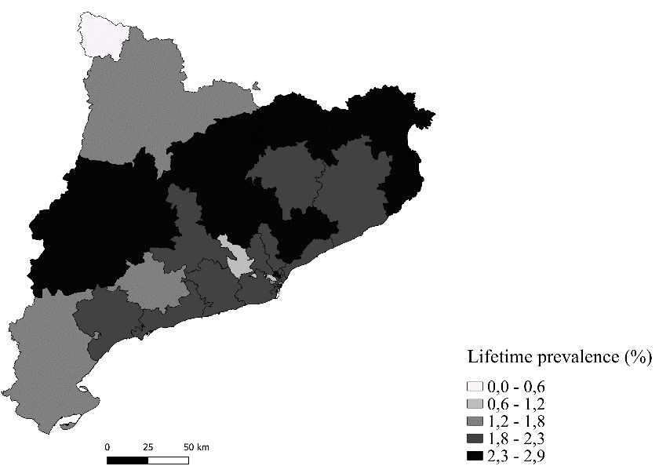
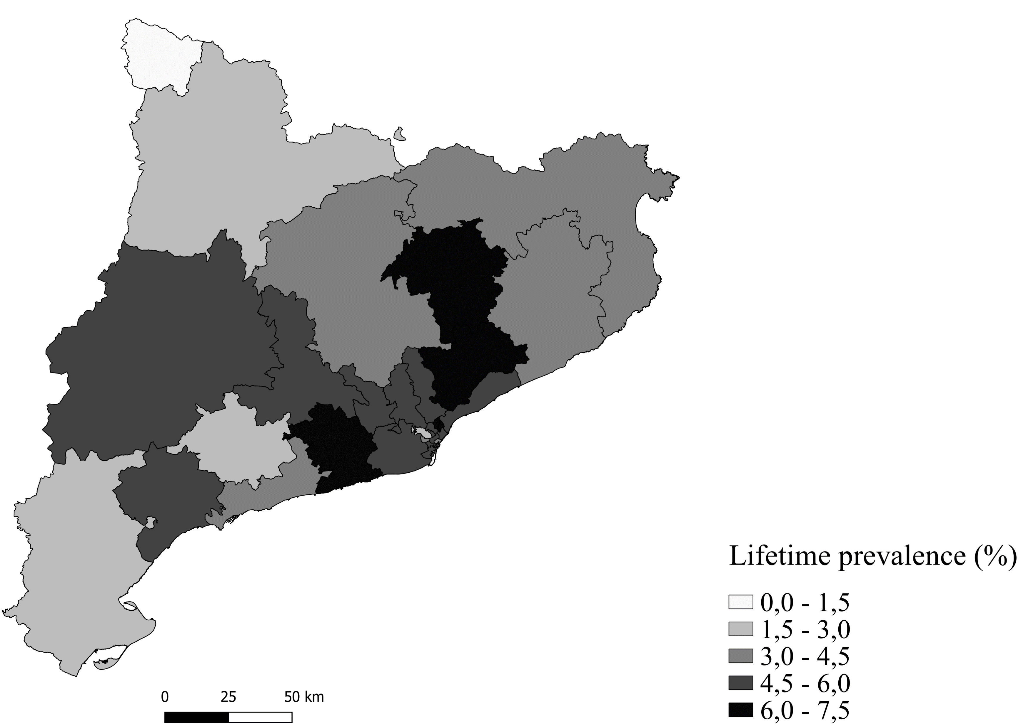
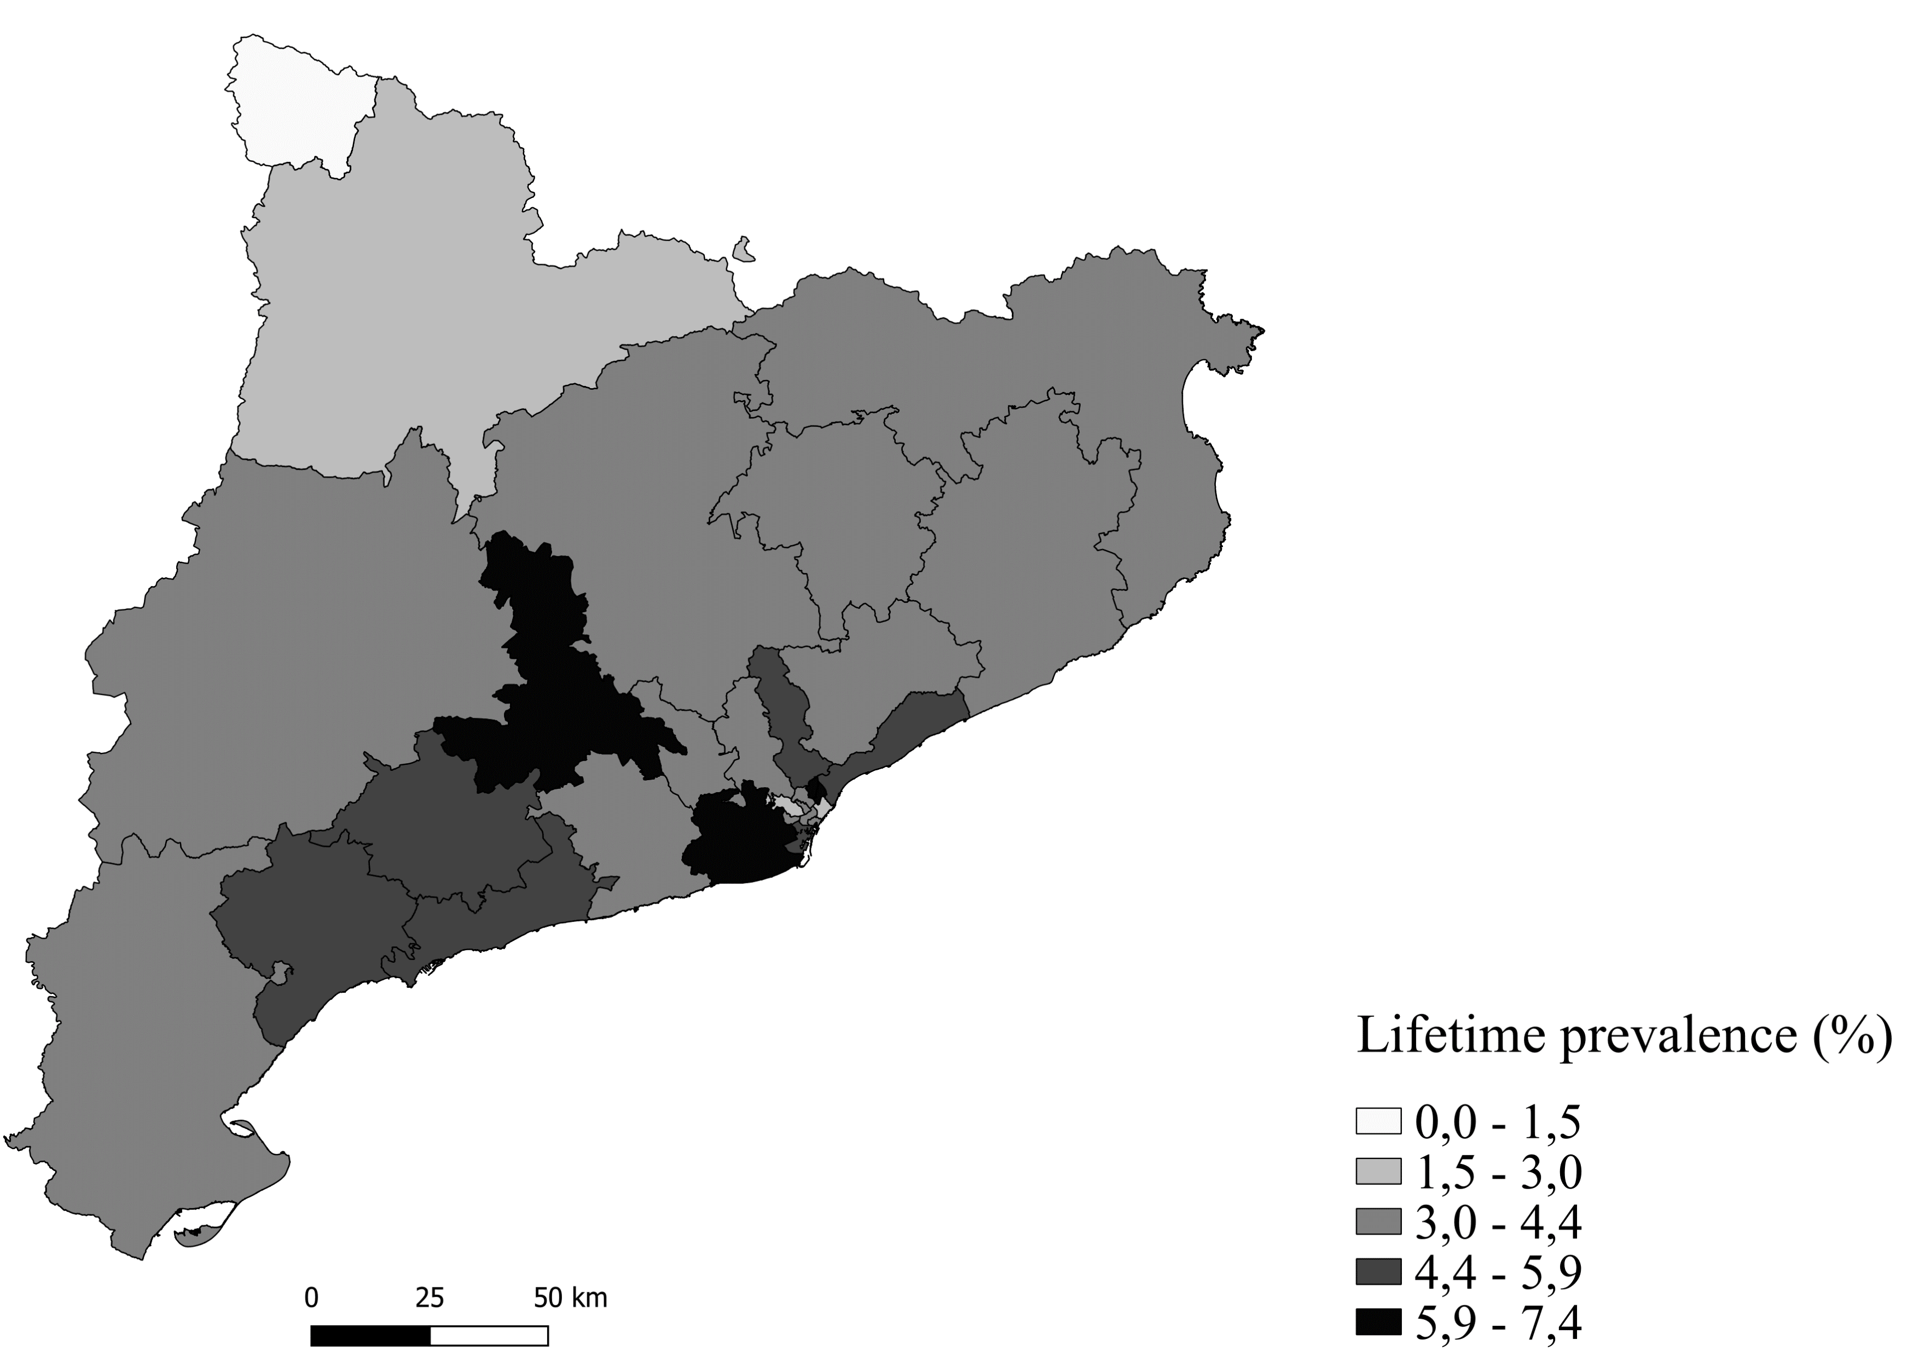
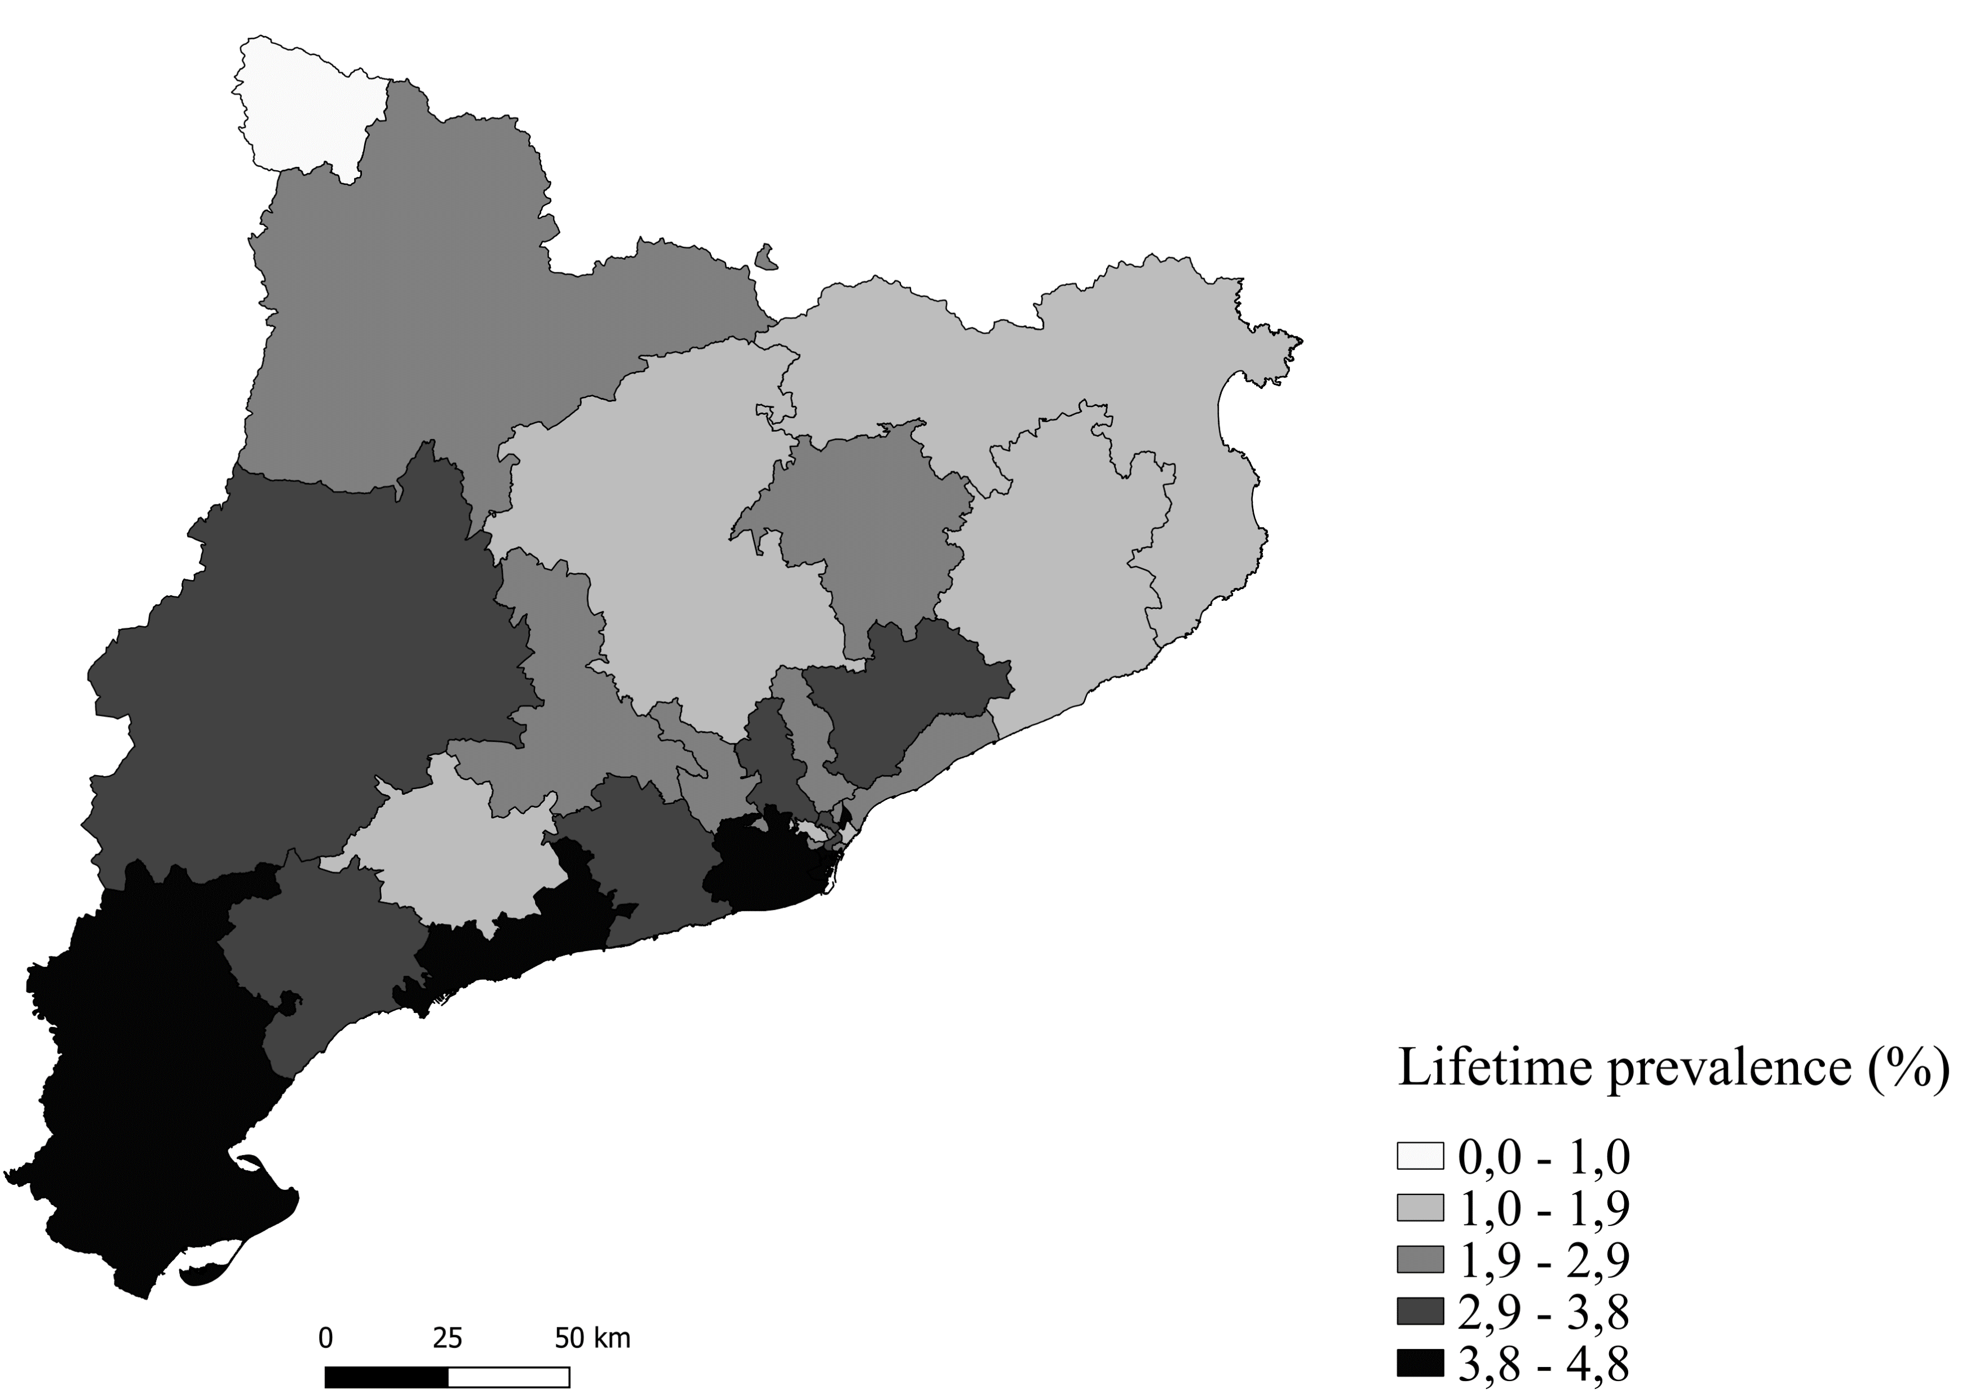
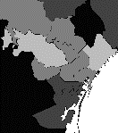
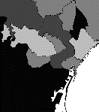
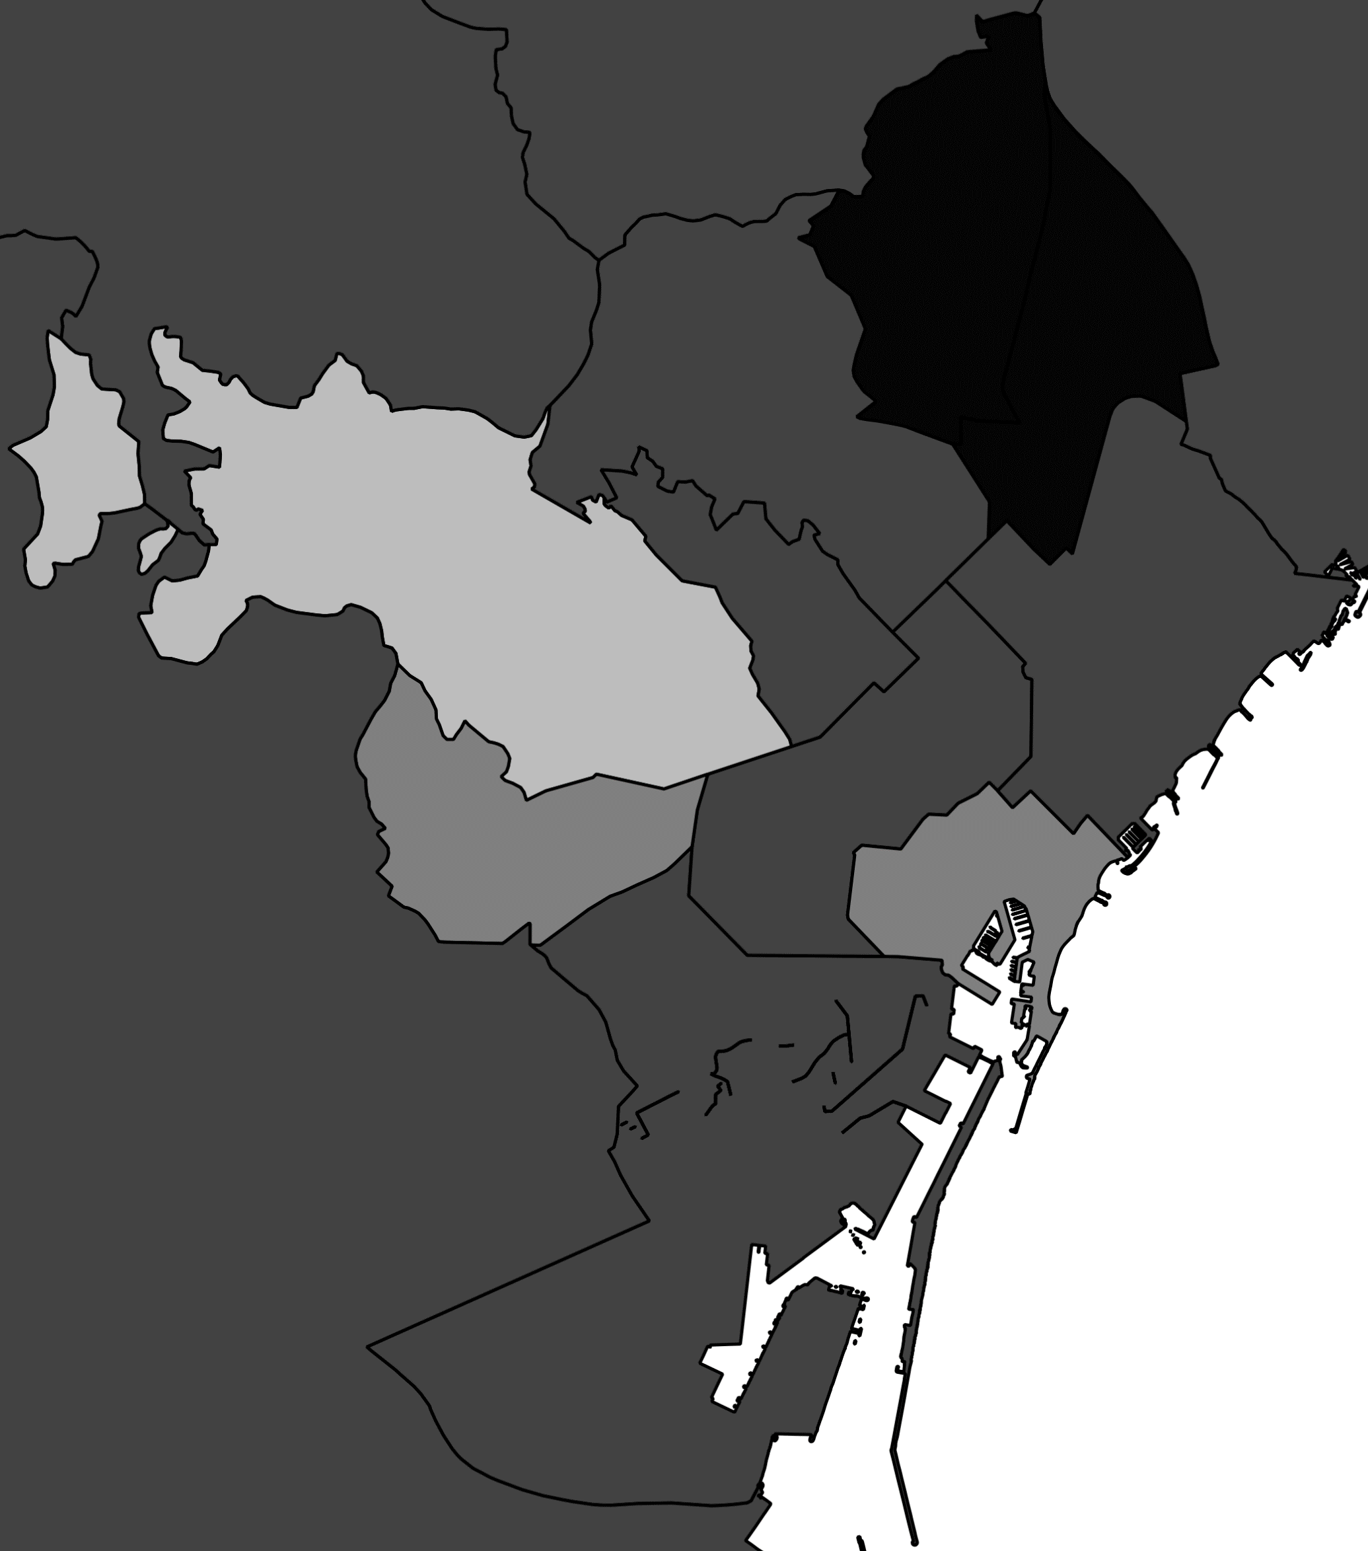
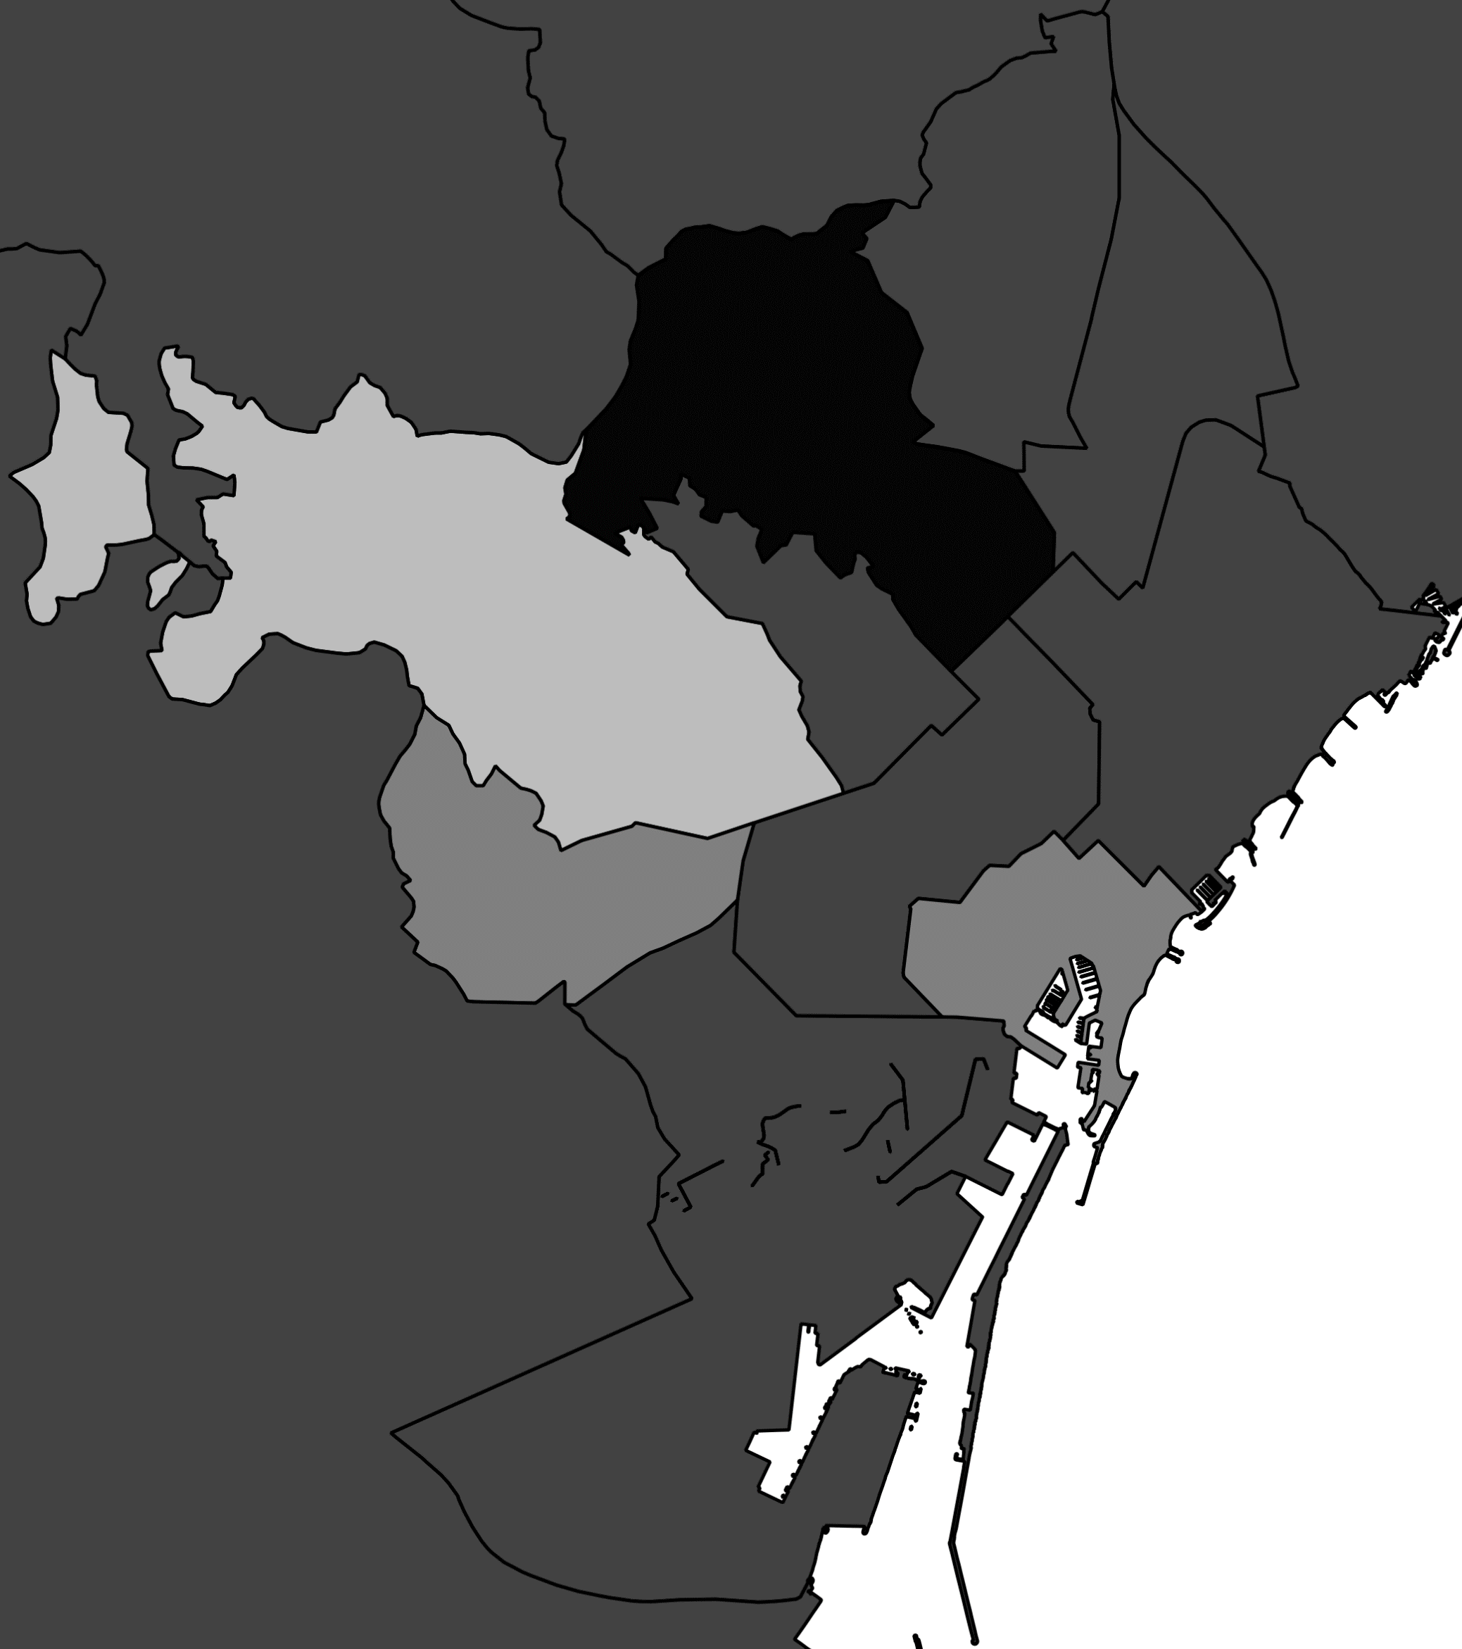
B: Anxiety disorder
C: Conduct disorder
D: Eating disorder
A: Mood disorder

Supplementary Figure 1 Lifetime prevalence (%) of diagnoses of mood disorder (A), anxiety disorder (B), conduct disorder (C), and eating disorder (D) per healthcare area in children aged 18 in Catalonia in 2017. The area of Barcelona is enlarged in the bottom right for each disorder.

