**Appendix 1. Table 1a. Characteristics of observational selected studies. PICO 1.**

|  |  |  |  |  |  |  |  |
| --- | --- | --- | --- | --- | --- | --- | --- |
| **Author,**  **year** | **Study**  **design** | **Sample**  **Size**  **LE / RR** | **Age, y**  **mean**  **LE / RR** | **ERUS/**  **MRI** | **Tumor size**  **cm (mean)**  **LE / RR** | **Intervention**  **LE / RR** | **Outcome**  **measures** |
| **Mellgren et al., 2000** | CS | 69/30 | NM | NA | NA/NA | TAE / LAR, APR | 5-y OS; 5-y LR |
| **Langer et al. 2002** | CS | 40/18 | NM | ERUS (100%) | NM | TAE, *TEMS* /LAR, APR | M&M; % LR; Operative time; LOS; Blood loss |
| **Lee, et al, 2003** | CS | 52/17 | 61,1 / 57,7 (P=0,28) | ERUS (49%) | 2.4/3.8 (P<0,001) | TAE / LAR, APR | 5-y OS;5-y DFS, 5-y LR; Postop m&m |
| **Nascimbeni et al. 2004** | CS | 70/74 | 69 /63,1 (*P<0,001*) | NA | 2/2,4 (P=0,08) | TAE/ LAR, APR | 5-y OS, 5-y DSS; 5-y LR |
| **Bentrem et al, 2005** | CS | 151/168 | 63/61  (*p<0,01*) | 0% (ERUS/MRI) | 2,4/2,8 (P=0.05) | TAE / TME | 5-y OS;5-y DSS, 5-y LR; Postop m&m |
| **Ptok et al, 2007** | PC | 130/359 | 68,5 / 66,5 (*p<0,001*) | NA | <3cm | TAE, *TEMS*/ LAR, APR | 5-y OS;5-y DFS, 5-y LR; Postop m&m |
| **De Graff et al, 2009** | PC | 80/75 | 71/67  (*P<0,001*) | ERUS | NM | *TEMS* /LAR, APR, Hart | 5-y OS;5-y DFS; 5-y DSS; 5-y LR; Postop m&m |
| **Nash et al, 2009** | PC | 137/145 | 65/ 59,3 (*P<0,001*) | ERUS | 2.3/3.2 (P<0,001) | TAE / LAR, APR | 5-y OS, 5-y DSS; 5-y LR |
| **Palma et al, 2009** | PC | 34/17 | 68,4/ 65,6 (p=0,36) | ERUS | 5/5 (p=0,76) | *TEMS* / LAR | 5-y OS, 5-y DSS; 5-y LR |
| **Peng et al, 2011** | CS | 58/66 | 57/59  (p=0,68) | 0% (ERUS/MRI) | NA/NA | TAE / TME | 5-y and 10-y-DFS; 5-y and 10-y LR |
| **Chen et al, 2013** | RCT | 22/30 | 68/66  (p=0.133) | 100% (ERUS +MRI) | 2,3/2,8 (p<0,001) | *TEMS*/LAR | M&M; % LR; % mtts; Operative time; LOS; Blood loss; conversion rate |
| **Elmessiry et al, 2014** | CS | 42/39 | 68/65  (P=0,10) | NA | 1,7/2,2 (P=0.08) | TAE, *TEMS* / TME | 3-y OS; 3-y DFS; 3-y LR rate |
| **Hwang et al. 2018** | CS | 61/207 | 58/59 (P=0.29) | NA | >3cm: 15% /24% (p=0,26) | TAE /TME | 5-y and 10-y OS, DSS, DFS; %LR rate |

**LE:** Local excision; **RR**: Radical resection; **CS**: Cohort study, retrospective; **PC**: Prospective cohort; **RCT**: Randomized control trial**; NM**: Data not matched;

**NA**: not available; **TAE**: Transanal excision; **TME**: Total mesorectal excision; **LAR**: Low anterior resection; **APR:** Abdomioperineal excision; **TEMS:** Transanal

endoscopic microsurgery; **Hart:** Hartmann’s resection; **OS**: Overall survival**; DSS**: Disease specific survival; **DFS:** Disease free survival; **LR**: local recurrence;

**M&M:** Morbility and mortality; **LOS**: Length of stay

**Appendix 1. Table 1b: Characteristics of National population database studies. PICO 1.**

|  |  |  |  |  |  |
| --- | --- | --- | --- | --- | --- |
| **Author,**  **year** | **Database and date** | **Sample Size**  **LE / RR** | **Inclusion criteria/ CRT** | **Intervention**  **LE / RR** | **Outcome**  **measures** |
| **Endreseth et al, 2005** | Norway National Database, 1993-1999 | 35/256 | pT1; no CRT | TAE/LAR, APR | 5-y OS;5-y DFS, 5-y LR; Postop m&m |
| **You et al, 2007** | USA NCDB Database, 1994-1996 | 605/493 | pT1, pT2: report data separately; no CRT | TAE, *TEMS*/LAR, APR | 5-y OS;5-y DSS, 5-y LR; Postop m&m |
| **Hazard et al, 2009** | USA SEER database, 1988-2003 | 418/1035 | pT0, pT1, pT2; 14% CRT, report data separately | LE vs ETM | 5-y OS; 5-y DSS |
| **Bhangu et al, 2013** | USA SEER database, 1998-2009 | 3715-9547 | pT0, pT1, pT2; 9% CRT, report data separately | LE vs ETM | 5-y OS; 5-y DSS |
| **Stitzenberg et al, 2013** | USA NCDB,1998-2010 | 382/2754 | pT1, pT2: report data separately; no CRT | LE vs TME | 5-y OS; 5-y DSS |
| **Cao et el, 2018** | USA SEER database, 1998-2004 | 313/571  (propensity matching study and < 45y) | pT1, no CRT | LE vs TME | 5-y OS; 5-y DSS |
| **Melnitchouk et al, 2020** | USA NCDB, 2004-2013 | 1795/289 | pT1, pT2: report data separately; no CRT | LE vs APR | 5-y OS; 5-y DSS; Morbi-mortality |

**LE:** Local excision; **RR**: Radical resection; **SEER**: Surveillance, Epidemiology and End Results; **NCDB**: National Cancer Data Base. **CRT**: Chemoradiotherapy

|  |  |  |  |  |  |  |  |  |  |
| --- | --- | --- | --- | --- | --- | --- | --- | --- | --- |
| **Study reference** | **Selection** | | | | **Comparability** | **Outcome** | | | **Overall score**  **(⋆)** |
| *Representativeness of the exposed cohort.* | *Selection of the non-exposed cohort* | *Ascertainment of exposure* | *Demonstration that outcome of interest was not present at start of study* | *Comparability of cohorts on the basis of the design or analysis* | *Assessment of outcome* | *Was follow-up long enough for outcomes to occur?* | *Adequacy of follow up of cohorts* |
| Mellgren et al. 2000 | - | **⋆** | **⋆** | **⋆** | **⋆⋆** | **⋆** | - | **⋆** | **⋆⋆⋆⋆⋆⋆⋆ (7)** |
| C. Langer, et al. 2002 | - | - | **⋆** | **⋆** | - | **⋆** | - | **⋆** | **⋆⋆⋆⋆⋆⋆ (4)** |
| W. Lee, et al. 2003 | **⋆** | **⋆** | **⋆** | **⋆** | **⋆-** | **⋆** | - | **⋆** | **⋆⋆⋆⋆⋆⋆⋆ (7)** |
| R. Nascimbeni, et al. 2004 | **⋆** | **⋆** | **⋆** | **⋆** | **⋆⋆** | **⋆** | **⋆** | **⋆** | **⋆⋆⋆⋆⋆⋆⋆⋆⋆ (9)** |
| D.J. Bentrem, et al. 2005 | **⋆** | **⋆** | **⋆** | **⋆** | **⋆** | **⋆** | **⋆** | **⋆** | **⋆⋆⋆⋆⋆⋆⋆⋆ (8)** |
| H. Ptok, et al. 2007 | **⋆** | **⋆** | **⋆** | **-** | **⋆-** | **⋆** | **⋆** | **⋆** | **⋆⋆⋆⋆⋆⋆⋆ (7)** |
| De Graff et al. 2009 | **-** | **⋆** | **⋆** | **⋆** | **-⋆** | **⋆** | **⋆** | **⋆** | **⋆⋆⋆⋆⋆ (7)** |
| G.M. Nash, et al. 2009 | **⋆** | **⋆** | **⋆** | **⋆** | **⋆** | **⋆** | **⋆** | **⋆** | **⋆⋆⋆⋆⋆⋆⋆⋆⋆ (8)** |
| P. Palma, et al. 2009 | **-** | **⋆** | **⋆** | **-** | **⋆** | **⋆** | **⋆** | **⋆** | **⋆⋆⋆⋆⋆⋆ (6)** |
| J. Peng, et al. 2011 | **-** | **-** | **⋆** | **⋆** | **-** | **-** | **⋆** | **-** | **⋆⋆⋆⋆ (3)** |
| Elmessiry et al. 2014 | **-** | **\*** | **\*** | **\*** | **\*** | **\*** | **-** | **\*** | **⋆⋆⋆⋆⋆⋆ (6)** |
| Y. Hwang, et al. 2018 | **⋆** | **⋆** | **-** | **⋆** | **-** | **⋆** | **⋆** | **⋆** | **⋆⋆⋆⋆⋆⋆ (6)** |

**Appendix 1. Table 2. Quality assessment of studies included in PICO 1 question. Newcastle-Ottawa scale.**



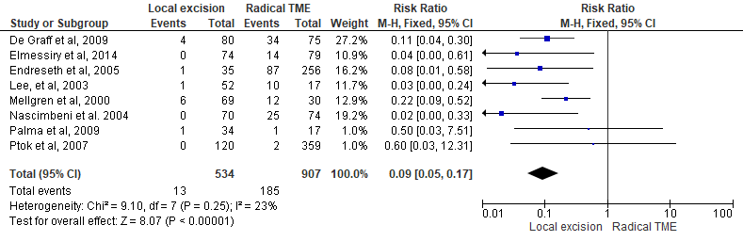**Appendix 1. Figure 2b**. Meta-analysis (Forest plot) of permanent stoma (a), postoperative mortality (b), and postoperative morbidity (c), between local excision and radical TME.

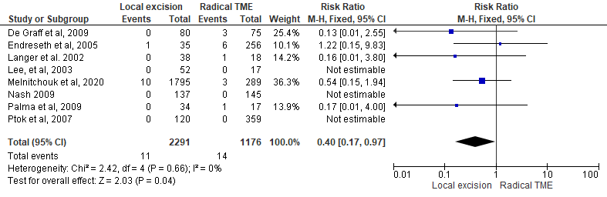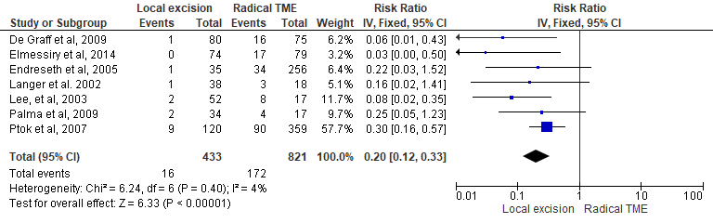

**(a)**

**(b)**

**(c)**

**Appendix 1 (Figure 2b)**. Meta-analysis: Forest plots of permanent stoma rate (sup left), postoperative mortality (sup right) and morbidity (inferior). Local resection vs. radical TME.

