Supplementary Material

Long-term survival after acute decompensated pulmonary hypertension: a propensity-score matched study

Marcos Vinicius Fernandes Garcia, M.D.¹ (0000-0003-4730-3650)
Rogerio Souza, M.D., Ph.D.¹ (0000-0003-2789-9143)
Pedro Caruso, M.D., Ph.D.^{1,2} (0000-0002-1051-8458)

Author affiliations
¹ Divisao de Pneumologia, Instituto do Coracao, Hospital das Clínicas HCFMUSP, Faculdade de Medicina da Universidade de Sao Paulo, Sao Paulo, Brazil.
² Intensive Care Unit, AC Camargo Cancer Center, São Paulo, Brazil.

Methods

The simplified version of the risk assessment strategy proposed by the ESC/ERS PH guidelines, using the following variables: NYHA-FC, BNP, 6MWT, right atrial pressure (RAP) or cardiac index (CI). In this version of ESC/ERS risk assessment each variable was evaluated for the presence of low, intermediate or high-risk criteria and overall risk category was determined by computing the mean of the risk grades from available variables for each patient and rounding to the nearest integer.

Results

Figure S1: Boxplots showing the overlapping of the estimated propensity score between ICU and no ICU matched patients.

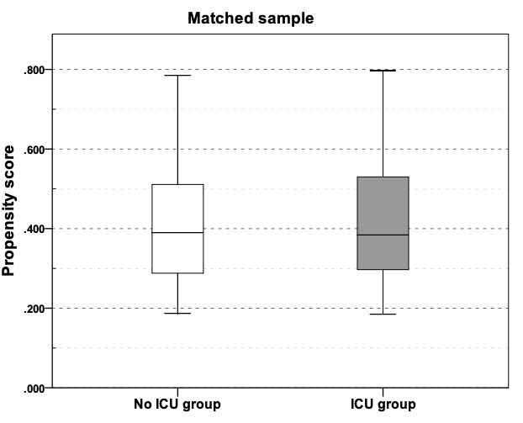

Table S1: Additional characteristics of patients that required ICU admission compared to patients with no previous ICU admission, for unmatched and matched samples during the study period.

 | Unmatched sample |  |  | Matched sample
 | ICU admission (n=46) | No ICU admission  (n=62) | P | ICU admission (n=33) | No ICU admission  (n=33) | P
Median PAP (mmHg) | 50 (48–66) | 57 (44–64) | 0.09 | 51 (48–66) | 56 (46–65) | 0.56
PVR (Woods) | 11.6 (8.7–17.0) | 9.8 (6.2–13.3) | 0.10 | 11.7 (8.7–17.0) | 9.9 (7.6–14.3) | 0.08
PAOP (mmHg) | 10 (7–12) | 12 (10–15) | 0.09 | 10 (7–12) | 12 (10–15) | 0.08
RAP (mmHg) | 12 (6–18) | 10 (7–13) | 0.17 | 12 (5–18) | 12 (8–15) | 0.98
Cardiac output (L/min) | 3.7 (2.8–4.4) | 4.2 (3.4–4.6) | 0.08 | 3.8 (2.8–4.4) | 4.1 (3.1–4.6) | 0.28
Categorical and continuous data are presented as frequencies (percentages) and median (25–75% interquartile range), respectively. ICU: intensive care unit, RHC: right heart catheterization, PAP: pulmonary artery pressure, PVR: pulmonary vascular resistance, PAOP: pulmonary artery occlusion pressure, RAP: right atrial pressure.

Table S2: ICU group patients’ clinical data at ICU admission and during ICU stay

Variables at ICU admission | ICU Admission Group  Matched Sample  (n=33)
SOFA | 5 (4-7)
SAPS 3 | 47 (40-53)
MAP (mmHg) | 72 (70-84)
Heart rate (bpm) | 95 (86-115)
Creatinine (mg/dL) | 1.25 (0.85-2.03)
BNP (pg/mL) | 535 (253-809)
Sodium (mEq/L) | 137 (134-139)
Arterial lactate (mg/dL) | 15 (11-19)
ScvO₂ (%) | 61.3 (53.8-68.1)
Intravenous furosemide use, n (%) | 31 (94.0)
Vasopressors use, n (%) * | 14 (42.4)
Dobutamine use, n (%) | 26 (78.7)
Nitric oxide use, n (%) | 7 (21.1)
Pulmonary artery cateter use, n (%) | 12 (36.3)
Invasive MV use, n (%) | 1 (3.0)
Renal replacement therapy, n (%) | 3 (9.0)

Categorical and continuous data are presented as frequencies (percentages) and median (25-75% interquartile range). SOFA: sequential organ failure assessment; SAPS 3: simplified acute physiology score; MAP: mean arterial pressure; BNP: brain natriuretic peptide; ScvO2%: central venous oxygen saturation; MV: mechanical ventilation.
* Vasopressors defined as any use of norepinephrine, vasopressin or epinephrine

