Suplementary Table 3 – Summary of the studies characteristics non included in the meta-analysis with reasons
Reference | Country | Intervention | Control | Brushing | Patients | Blindness | Age | Reason for not include
(Cabov et al., 2010) (1) | Croatia | 0.2% gel (3x/day) | Placebo | No | General ICU | Double | Adults | Outcomes for patients intubated for at least 48 hours were not clear or available
(Deriso et al., 1996) (2) | USA | 0.12% solution (twice/day) | Placebo | No | Cardiac surgery | Double | Adults | Outcomes for patients intubated for at least 48 hours were not clear or available
(Fourrier et al., 2000) (3) | France | 0.2% gel (3x/day) | Sodium bicarbonate | No | General ICU | Single | Adults | Outcomes for patients intubated for at least 48 hours were not clear or available
(Fourrier et al., 2005) (4) | France | 0.2% gel (3x/day) | Placebo | No | General ICU | Double | Adults | Outcomes for patients intubated for at least 48 hours were not clear or available
(Grap et al., 2011) (5) | USA | 0.12% solution (Once 12 hrs prior intubation; 5mL) | Usual care | No | General ICU | Open | Adults | Pre-operative CHX application
(Jácomo et al., 2011) (6) | Brazil | 0.12% solution (Once 12 hrs prior intubation; 5mL) then twice a day | Placebo | No | Pediatric ICU | Open | Children | Patients in the pediatric ICU
(Kusahara et al., 2012) (7) | Brazil | 0.12% gel | Placebo | Yes | General ICU | Double | Children | Patients in the pediatric ICU
(Lin et al., 2015) (8) | China | 0.2% solution  (4x/day) | Placebo | Yes | Cardiac ICU | Single | Adults | Outcomes for patients intubated for at least 48 hours were not clear or available
(Munro et al., 2009) (9) | USA | 0.12% solution (twice/day; 5mL) | Usual care | No | General ICU | Open | Adults | Outcomes for patients intubated for at least 48 hours were not clear or available
(Macnaughton et al., 2004) (10) | England | 0.2% solution (twice/day) | Placebo | No | General ICU | Double | Adults | Article only in the abstract form
(Sebastian et al., 2012) (11) | India | 1% gel  (3x/day) | Placebol | No | General ICU | Double | Children | Patients in the pediatric ICU

1. Cabov T, Macan D, Husedzinović I, Skrlin-Subić J, Bosnjak D, Sestan-Crnek S, et al. The impact of oral health and 0.2% chlorhexidine oral gel on the prevalence of nosocomial infections in surgical intensive-care patients: a randomized placebo-controlled study. Wiener klinische Wochenschrift. 2010;122(13-14):397-404.
2. DeRiso AJ, 2nd, Ladowski JS, Dillon TA, Justice JW, Peterson AC. Chlorhexidine gluconate 0.12% oral rinse reduces the incidence of total nosocomial respiratory infection and nonprophylactic systemic antibiotic use in patients undergoing heart surgery. Chest. 1996;109(6):1556-61.
3. Fourrier F, Cau-Pottier E, Boutigny H, Roussel-Delvallez M, Jourdain M, Chopin C. Effects of dental plaque antiseptic decontamination on bacterial colonization and nosocomial infections in critically ill patients. Intensive care medicine. 2000;26(9):1239-47.
4. Fourrier F, Dubois D, Pronnier P, Herbecq P, Leroy O, Desmettre T, et al. Effect of gingival and dental plaque antiseptic decontamination on nosocomial infections acquired in the intensive care unit: A double-blind placebo-controlled multicenter study. Critical care medicine. 2005;33:1728-35.
5. Grap M, Munro C, Hamilton V, Elswick RK, Sessler C, Ward K. Early, single chlorhexidine application reduces ventilator-associated pneumonia in trauma patients. Heart & lung : the journal of critical care. 2011;40:e115-22.
6. Jácomo AD, Carmona F, Matsuno AK, Manso PH, Carlotti AP. Effect of oral hygiene with 0.12% chlorhexidine gluconate on the incidence of nosocomial pneumonia in children undergoing cardiac surgery. Infection control and hospital epidemiology. 2011;32(6):591-6.
7. Kusahara DM, Peterlini MA, Pedreira ML. Oral care with 0.12% chlorhexidine for the prevention of ventilator-associated pneumonia in critically ill children: randomised, controlled and double blind trial. International journal of nursing studies. 2012;49(11):1354-63.
8. Lin YJ, Xu L, Huang XZ, Jiang F, Li SL, Lin F, et al. Reduced occurrence of ventilator-associated pneumonia after cardiac surgery using preoperative 0.2% chlorhexidine oral rinse: results from a single-centre single-blinded randomized trial. The Journal of hospital infection. 2015;91(4):362-6.
9. Munro CL, Grap MJ, Jones DJ, McClish DK, Sessler CN. Chlorhexidine, toothbrushing, and preventing ventilator-associated pneumonia in critically ill adults. American journal of critical care : an official publication, American Association of Critical-Care Nurses. 2009;18(5):428-37; quiz 38.
10. MacNaughton PD, Bailey J, Donlin N, Branfield P, Williams A, Rowswell H. A randomised controlled trial assessing the efficacy of oral chlorhexidine in ventilated patients (029). Intensive care medicine. 2004;30.
11. Sebastian MR, Lodha R, Kapil A, Kabra SK. Oral mucosal decontamination with chlorhexidine for the prevention of ventilator-associated pneumonia in children - a randomized, controlled trial. Pediatric critical care medicine : a journal of the Society of Critical Care Medicine and the World Federation of Pediatric Intensive and Critical Care Societies. 2012;13(5):e305-10.

Forest plot including Cardiac patients
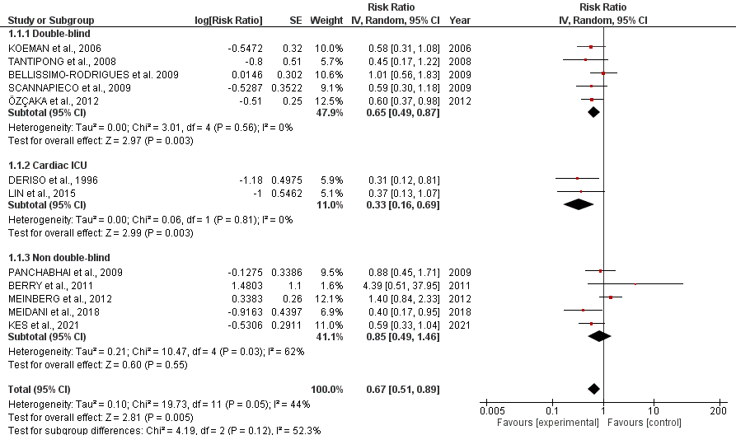

Figure- Forest plot of VAP incidence including all studies
