Annex (supplementary figures and tables)

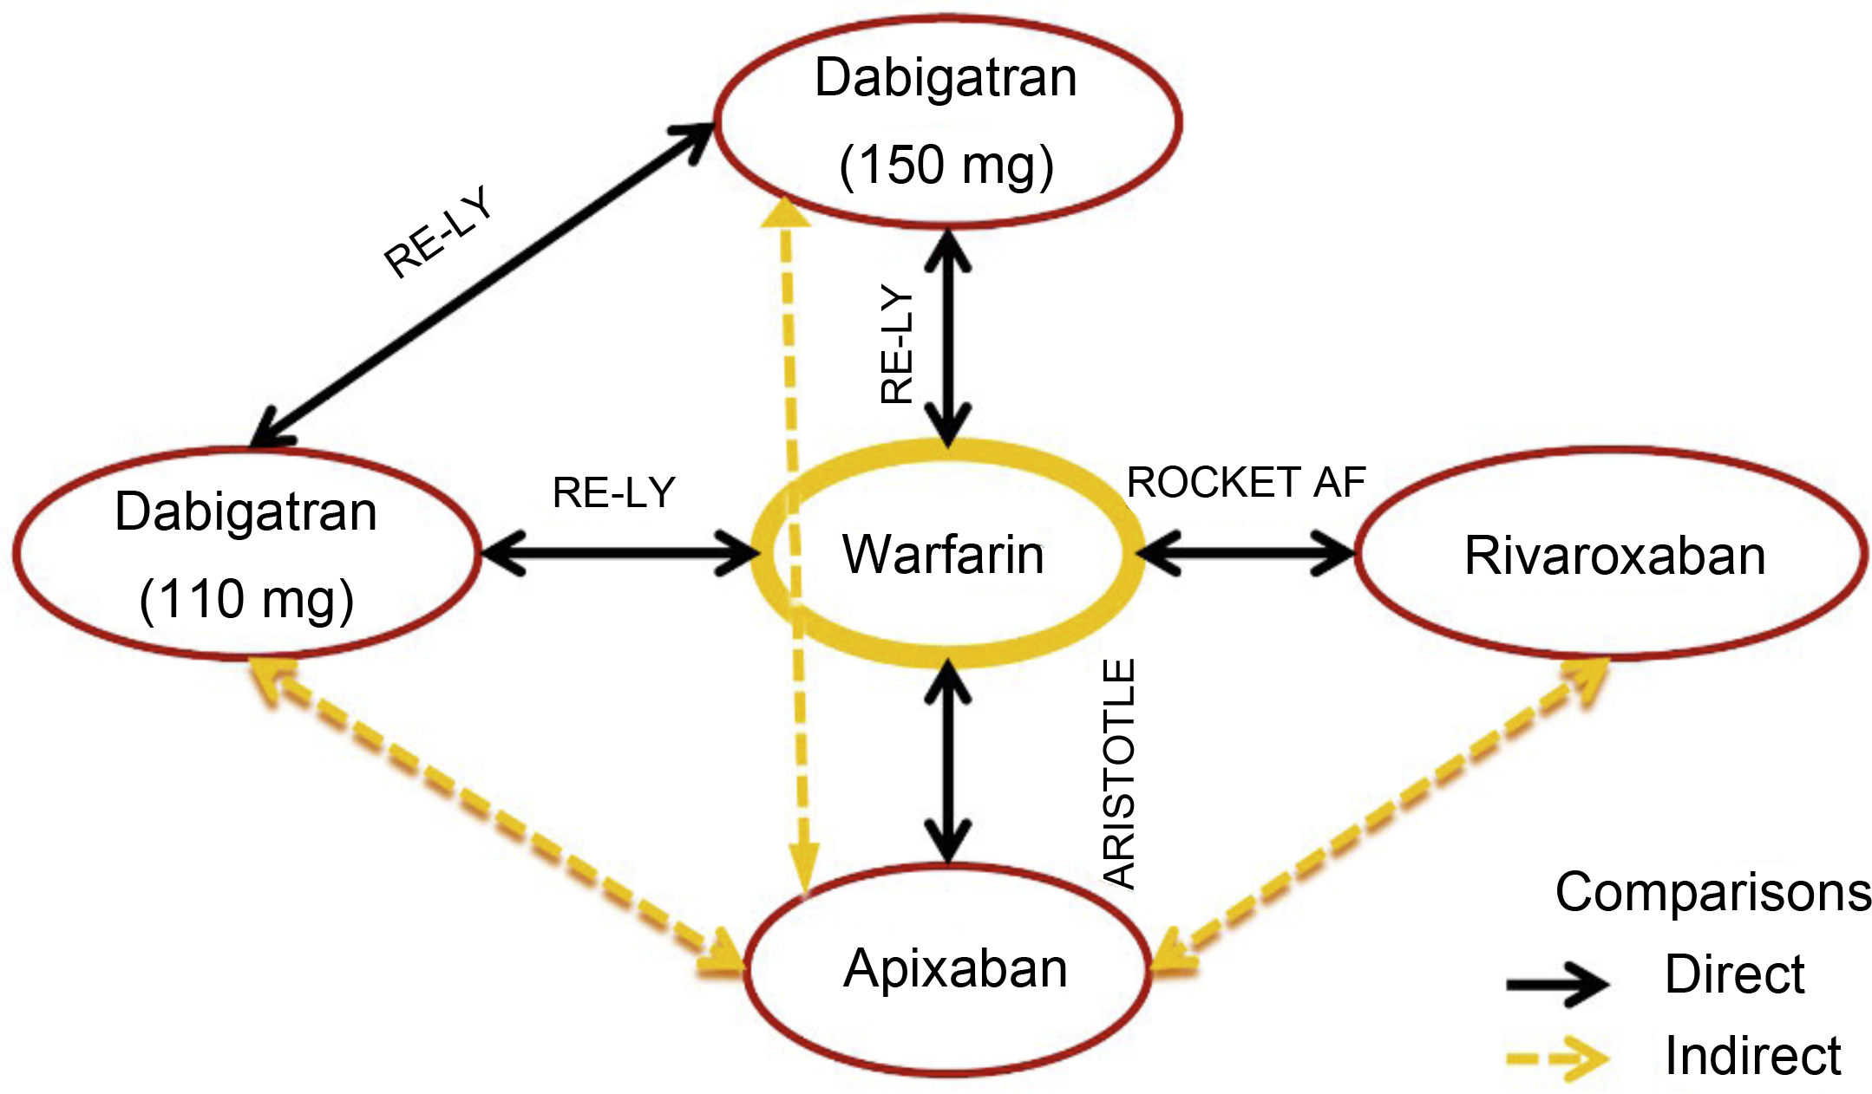

Supplementary Figure 3 Evidence networkused to estimate relative effectiveness in the economic evaluation model.
Supplementary Table 3 Distribution of stroke events by severity.
 | Mild | Moderate | Severe | Fatal
 | mRS (0–2) | mRS (3–4) | mRS (5) | mRS (6)
Apixabanª | 53% | 21% | 8% | 18%
Warfarinª | 45% | 30% | 10% | 15%
Dabigatran (110 mg)^{b} | 35% | 28% | 10% | 27%
Dabigatran (150 mg)^{b} | 35% | 22% | 8% | 35%
Rivaroxaban^{c} | 49% | 18% | 6% | 27%
mRS: modified Rankin scale.
Source: Lip et al.¹⁰
ª Secondary analysis of the ARISTOTLE trial.¹⁴
^{b} The same distribution is assumed for all stroke events (Connolly et al.⁵⁰).
^{c}. The same distribution is assumed for all stroke events (Patel et al.⁵¹).
Supplementary Table 4 Hazard ratios (95% confidence interval) adjusted for median center time in therapeutic range.
 | NOACs |  |  |  |  | Warfarin
cTTRª | Stroke | ICH | Other MB | CRNMB | Stroke |  | ICH | Other MB | CRNMB
<52.38% | 0.92(0.58–1.47) | 0.58(0.22–1.51) | 0.72(0.44–1.19) | 0.71(0.46–1.1) | 1.54(1.02–2.33) |  | 1.05(0.62–1.79) | 0.84(0.57–1.25) | 0.99(0.71–1.37)
52.38%–<66.02%^{b} | 1.00 | 1.00 | 1.00 | 1.00 | 1.00 |  | 1.00 | 1.00 | 1.00
66.02%–<76.51% | 0.69(0.48–0.99) | 0.69(0.38–1.26) | 1.69(1.28–2.23) | 1.25(0.96–1.61) | 0.84(0.59–1.19) |  | 0.68(0.45–1.03) | 1.13(0.88–1.44) | 1.26(1.01–1.56)
≥76.51% | 0.56(0.31–1.01) | 0.36(0.11–1.19) | 1.77(1.22–2.55) | 1.70(1.23–2.35) | 0.72 (0.41–1.25) |  | 0.78(0.42–1.42) | 1.37(0.98–1.9) | 1.27(0.94–1.71)
Source: secondary analysis of the ARISTOTLE trial.¹⁴
ª According to the results of the centers participating in the ARISTOTLE trial.
^{b} Base case.
CRNMB: clinically relevant non-major bleeding; cTTR: median center time in therapeutic range (INR 2–3); ICH: intracranial hemorrhage; MB: major bleeding; NOACs: new oral anticoagulants.
Supplementary Table 5 Distribution of patients by time in therapeutic range.
Center time in therapeutic range, % | Proportion of patients in the Portuguese population | Proportion of patients in the trial population
<52.38 | 55.5% | 25%
52.38–<66.02 | 24.5% | 25%
66.02–<76.51 | 11.1% | 25%
≥76.51 | 8.8% | 25%
Total | 100% | 100%
Source: databases of Centro HospitalarLisboa Central and Hospital Fernando da Fonseca.
Supplementary Table 6 Hazard ratios for treatment discontinuation for reasons other than vascular events.
 | HR (95% CI)
Apixaban | 1
Warfarinª | 1.080 (1.02–1.15)
Dabigatran (110 mg)^{b} | 1.452 (1.31–1.61)
Dabigatran (150 mg)^{b} | 1.505 (1.36–1.67)
Rivaroxaban^{b} | 1.184 (1.08–1.29)
HR: hazard ratio (estimated by indirect pairwise comparison); CI: confidence interval.
The HRs are greater than 1, since the overall discontinuation rate for apixaban was lower than for warfarin, unlike the other new oral anticoagulants.scontinuation for all causes, since the RE-LY and ROCKET AF trials do not report rates of discontinuation due to cardiovascular events and for other causes separately. The HRs are greater than 1, since the overall discontinuation rate for apibaxan was lower than for warfarin, unlike the other new oral anticoagulants.
Supplementary Table 7 Event rates per 100 patient/years for patients on second-line aspirin.
Event | Second-line aspirin
Stroke | 3.45
Systemic embolism | 0.32
ICHª | 0.89
Other major bleeding | 2.94
CRNMB | 1.10
MI | 0.44
Other CV hospitalizations | 13.57
Source: secondary analysis of the AVERROES trial.⁵¹
ª Intracranial hemorrhage includes hemorrhagic stroke and other types of intracranial hemorrhage. The proportion of hemorrhagic stroke in patients taking second-line aspirin was 55%.
CRNMB: clinically relevant non-major bleeding; CV: cardiovascular; ICH: intracranial hemorrhage; MI: myocardial infarction.
Supplementary Table 9 Factors used to adjust mortality risk.
Event | HR (95% CI)
Non-valvular AF | 1.34 (1.20–1.53)
Stroke (ischemic or hemorrhagic)
Mild | 3.18 (1.82–4.92)
Moderate | 5.84 (4.08–7.60)
Severe | 15.75 (13.99–17.51)
Systemic embolism | 1.34 (1.20–1.53)
MI
Men | 2.56 (3.44–5.03)
Women | 4.16 (2.27–2.88)
Source: Brønnum-Hansen et al.,⁵²Henriksson et al.,⁵³Huybrechts et al.⁵⁴
AF: atrial fibrillation; CI: confidence interval; HR: hazard ratio; MI: myocardial infarction.
Supplementary Table 14 Summary of results of sensitivity analyses.
Parameter | Analysis | Warfarin | Dabigatran | Rivaroxaban
 |  | ICUR (€/QALY) | ICUR (€/QALY) | Net benefitª (€)
1 | Use of the HRs estimated by Mitchell et al.²⁰ | 5590.52 | 10599.93 | 737.27
2 | Anticoagulation levels as reported in the clinical trials | 6740.70 | 8229.74 | 874.30
3 | Duration of the acute phase of hospitalization 6 weeks | 5531.95 | 9160.65 | 730.37
4 | Costs of stroke depending on severity, based on UK figures) | 5559.85 | 8449.95 | 723.18
5 | The same distribution of stroke of similar severity for all comparators^{b} | 5601.85 | 12016.36 | 564.64
6 | The same treatment discontinuation rates for non-vascular causes for all comparators from the beginning of treatment^{b} | 5313.84 | 5161.81 | 679.93
7 | Mortality rates after the trial period the same as for the general population | 5234.19 | 8444.37 | 767.13
8 | Utilities estimated by Sullivan et al.⁴⁶ | 5125.67 | 7926.91 | 746.79
9 | Discount rate for costs and utilities of 0% or 3% | 5285.03 and 4908.75 | 8839.03 and 8313.47 | 720.59 and 1096.69
ICUR: incremental cost-utility ratio.
ª Based on a willingness to pay of 20 000€/QALY.
^{b} Based on the results of the apixaban arm of the ARISTOTLE trial.

