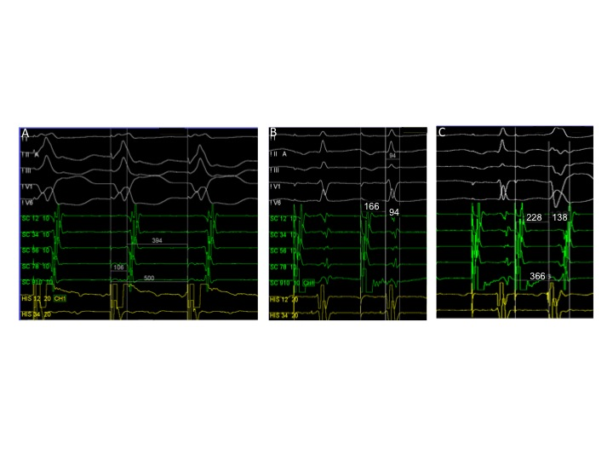

Supplemental Figure 1. Electrophysiological study: (A) Continuous ventricular pacing demonstrating concentric VA conduction; (B,C) Programmed atrial pacing at 500/400 ms and 500/290 ms, respectively, with progressive prolongation of the AV interval (increase in AH interval, reduction in HV interval) and progressive QRS widening (evidence of ventricular pre-excitation via AP with decremental conduction properties). ms: milliseconds

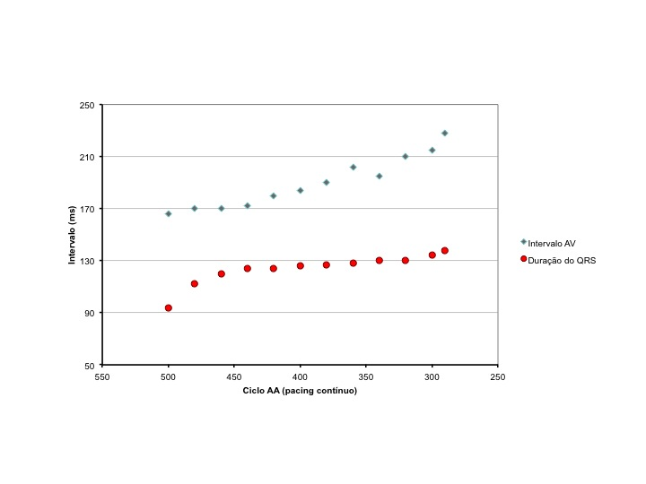
Intervalo (ms) | Interval (ms)
Ciclo AA (pacing continuo) | A-A cycle (continuous pacing)
Intervalo AV | AV interval
Duração do QRS | QRS duration

Supplemental Figure 2. Progressive QRS widening and prolongation of the AV interval under incremental atrial pacing (evidence of ventricular pre-excitation via AP with decremental conduction properties).

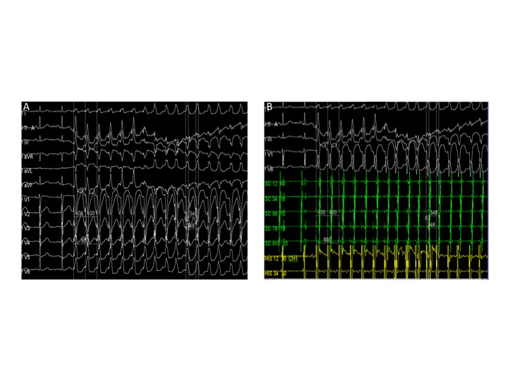
Supplemental Figure 3. Electrophysiological study: (A) Surface ECG with induction of antidromic AVRT with LBBB morphology under continuous atrial pacing; (B) Intracavitary electrograms with induction of antidromic AVRT with LBBB morphology with continuous atrial pacing. Typical LBBB: typical left bundle branch block; AVRT: atrioventricular reentrant tachycardia

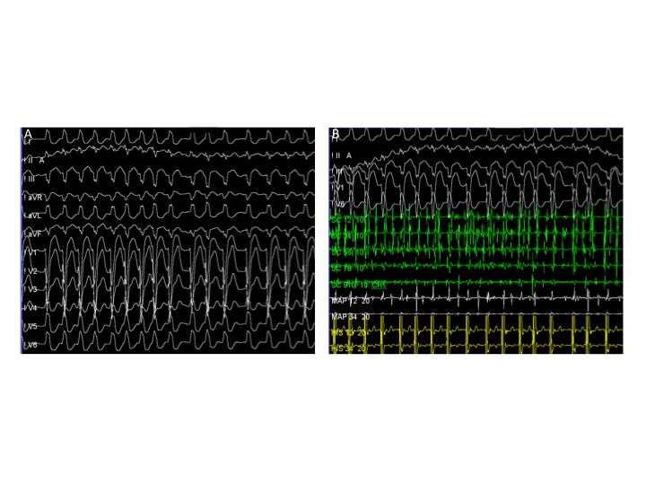
Supplemental Figure 4. Electrophysiological study: (A) Surface ECG with progression of AVRT to pre-excited atrial fibrillation; (B) Intracavitary electrograms with progression of AVRT to pre-excited atrial fibrillation. AVRT: atrioventricular reentrant tachycardia.

