Supplementary Table 1 Echocardiography: methodology and definitions.
In accordance with the design of the Síncrone study and with the practice of the centers involved, echocardiographic studies were performed before device implantation, at hospital discharge, and at three, six and 12±1 months after implantation.
In line with the recommendations of the European and US guidelines on echocardiography, the following parameters were assessed whenever possible, according to the available facilities and practice of the centers:
- LVEF by Simpson’s biplane method
- LV end-diastolic and end-systolic volumes
- Ejection volume
- Cardiac output and cardiac index
- End-diastolic wall thickness
- LA volume index
- E/A ratio of transmitral flow
- E-wave deceleration time
- Early diastolic septal wave velocity (e') by TDI
- E/e' ratio
- Diastolic filling time
- Presence and severity (regurgitant volume) of diastolic MR
- RV diastolic diameter
- RA volume
- IVC diameter and respiratory variation
- Peak tricuspid regurgitation velocity
- Estimated PASP
- RV longitudinal systolic function (TAPSE and/or tricuspid annular systolic velocity, S', by TDI)
IVC: inferior vena cava; LA: left atrial; LV: left ventricular; LVEF: left ventricular ejection fraction; MR: mitral regurgitation; PASP: pulmonary artery systolic pressure; RA: right atrial; TAPSE: tricuspid annular plane systolic excursion; TDI: tissue Doppler imaging.

Definitions
- Atrioventricular dyssynchrony was assessed by measuring left ventricular filling time (LVFT) and the RR interval and defined as LVFT/RR (14) ≤40%.
- Interventricular dyssynchrony was defined as a difference of ≥40 ms between left and right ventricular pre-ejection times (from QRS onset to beginning of aortic and pulmonary flow by pulsed Doppler) or as LV pre-ejection time ≥140 ms.
- Intraventricular dyssynchrony was defined (1) by the method of Pitzalis et al., in left parasternal view on M-mode echocardiography, as time between septal excursion to posterior excursion peak ≥130 ms and (2) by the method of Bax et al., in apical view on tissue Doppler imaging measuring time to peak systolic velocity in the basal segment of the inferior septum and lateral wall in apical 4-chamber view and time to peak systolic velocity s' in the basal segment of the anterior septum and the posterior wall in apical 3-chamber view, as a difference of ≥60 ms between lateral and septal inferior systolic velocity and/or between posterior and anterior septal systolic velocity.
Mechanical dyssynchrony (post-systolic contraction, septal flash, or paradoxical septal motion) was also reported if assessed qualitatively.
Assessment by speckle-tracking echocardiography was considered optional.

Supplementary Table 2 Distribution of patients with cardiac resynchronization devices (n=135) by QRS duration and morphology according to the European guidelines on heart failure.
Distribution according to the 2008 guidelines²
QRS ≥120 ms  (class I recommendation, level of evidence A) | 128 (95%)
Other | 7 (5%)

Distribution according to the 2016 guidelines¹¹
QRS ≥150 ms and LBBB  (class I recommendation, level of evidence A) | 95 (70%)
QRS ≥150 ms and no LBBB  (class IIa recommendation, level of evidence B) | 4 (3%)
QRS 130-149 ms and LBBB  ( class I recommendation, level of evidence B) | 22 (16%)
QRS 130-149 ms and no LBBB  (class IIb recommendation, level of evidence B) | 3 (2%)
Other (QRS <130 ms) | 11 (8%)
LBBB: complete left bundle branch block.

Supplementary Table 3 Demographic, clinical and echocardiographic characteristics of patients who underwent echocardiographic assessment of dyssynchrony (n=82).
Age, years | 68±10
Male, n (%) | 57 (70)
Baseline NYHA class, n (%)  I  II  III  IV | 0  29 (35)  51 (62)  2 (2)
NYHA class at 12 months after implantation, n (%)  I  II  III  IV | 17 (21)  49 (60)  13 (16)  3 (4)
LBBB, n (%) | 74 (90)
QRS, n (%)  ≥150 ms  130-149 ms | 66 (80)  8 (10)
LVEF, % | 27±6
LVEDD index, ml/m² | 113±40
LVESD index, ml/m² | 79±32
Atrioventricular dyssynchrony, n (%) | 15 (18)
Intraventricular dyssynchrony, n (%) | 55 (67)
Interventricular dyssynchrony, n (%) | 34 (41)
LVEDD: left ventricular end-diastolic diameter; LVEF: left ventricular ejection fraction; LVESD: left ventricular end-systolic diameter; NYHA: New York Heart Association functional class.

Supplementary Table 4 Centers participating in the Síncrone study.
Center | Lead investigator | No. of patients
Centro Hospitalar do Funchal | Nuno Santos | 10
Centro Hospitalar Lisboa Ocidental | Pedro Adragão | 250
Centro Hospitalar Vila Nova de Gaia | João Primo | 2
Hospital da Luz (Lisboa) | Pedro Adragão | 4
Hospital da Universidade de Coimbra | Luís Elvas | 17
Hospital de Faro | Ilídio de Jesus | 12
Hospital de Santa Maria (Lisbon) | João de Sousa | 6
Hospital de Santa Marta (Lisbon) | Manuel Nogueira / Mário Oliveira | 56
Hospital de Santo António (Porto) | Hipólito Reis | 3
Hospital de São João (Porto) | Raquel Taboada | 15
Hospital de São Pedro (V. Real) | Paulo Fontes | 8
Hospital de São Teotónio (Viseu) | António Costa | 21
Hospital Distrital de Santarém | Vítor Martins | 2
Hospital do Divino Espírito Santo (Ponta Delgada) | Dinis Martins | 46
Hospital Fernando da Fonseca (Amadora-Sintra) | Francisco Madeira | 25
Hospital Garcia de Orta (Almada) | Luís Brandão | 9

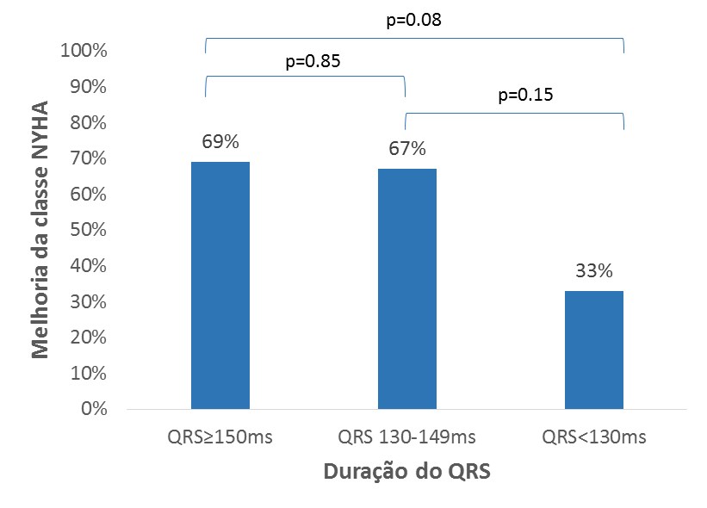
Improvement in NYHA class

QRS duration

Supplementary Figure 1 Distribution of patients with cardiac resynchronization devices (n=135) by QRS duration and percentage with improvement in NYHA functional class. NYHA: New York Heart Association.

Functional class at 12 months
Presence of intraventricular dyssynchrony (n=55)

Absence of intraventricular dyssynchrony (n=27)

Supplementary Figure 2 NYHA functional class at 12 months according to the presence of intraventricular dyssynchrony at baseline assessment (n=82).

